Use Case Specification
Building Materials Warehouse Management System (BMWMS) - Report 3.1
Field | Value
Version | 2.0
Date | 12 August 2026
Prepared by | BMWMS Project Team
Coverage | UC01-UC65

Change Log
Version | Date | Author | Summary
1.0 | 27 July 2026 | BMWMS Project Team | Initial complete Use Case Specification covering UC01-UC65.

Table of Contents
Change Log 1
Table of Contents 2
Glossary 4
Conventions & Notation 5
UC01: View Warehouse Information 11
UC02: View Storage Location Map 14
UC03: Locate Product 17
UC04: View Product List 20
UC05: Create Product 23
UC06: Edit Product 26
UC07: View Product Details 29
UC08: Discontinue Product 32
UC09: Trace Product Movement History 35
UC10: View Supplier List 38
UC11: Create Supplier 41
UC12: Edit Supplier 44
UC13: View Supplier Details 47
UC14: Deactivate Supplier 50
UC15: View Supplier Product List 53
UC16: View Supplier Inbound History 56
UC17: View Inbound Order List 59
UC18: Create Inbound Order 62
UC19: Edit Inbound Order 65
UC20: View Inbound Order Details 68
UC21: Cancel Inbound Order 71
UC22: Confirm Warehouse Receipt 74
UC23: Confirm Putaway to Fixed Location 77
UC24: View Inbound History 80
UC25: View Outbound Order List 83
UC26: Create Outbound Order 86
UC27: Edit Outbound Order 89
UC28: View Outbound Order Details 92
UC29: Cancel Outbound Order 95
UC30: Check and Reserve Inventory 98
UC31: Confirm Warehouse Issue 101
UC32: View Outbound History 104
UC33: View Stocktake Session List 107
UC34: Perform Stock Count 110
UC35: Record Inventory Discrepancy 113
UC36: Approve and Adjust Inventory 116
UC37: View Stocktake History 119
UC38: View Inventory Report 122
UC39: View Inbound Report 125
UC40: View Outbound Report 128
UC41: View In-Out-Stock Report 131
UC42: View Product Statistics 134
UC43: View Supplier Statistics 137
UC44: View Stocktake Result Statistics 140
UC45: Export Report to Excel or PDF 143
UC46: View Operational Dashboard 146
UC47: View Low-Stock Alerts 149
UC48: View Expiring-Lot Alerts 152
UC49: View Overdue Inbound and Outbound Alerts 155
UC50: View System Notifications 158
UC51: View Warehouse Operational KPIs 161
UC52: View User List 164
UC53: Create User 167
UC54: Edit User 170
UC55: View User Details 173
UC56: Lock or Unlock Account 176
UC57: Assign Fixed Role to User 179
UC58: View Personal Profile 182
UC59: Update Personal Profile 185
UC60: Change Password 188
UC61: Sign In 191
UC62: Sign Out 194
UC63: Reset Forgotten Password 197
UC64: Create Sale Order 200
UC65: Create Purchase Order 203

Glossary
Term | Definition
Available quantity | On-hand quantity minus active reserved quantity.
Bin / Storage Location | A predefined physical position within the single warehouse where products can be stored or counted.
Cycle Count | A stocktake covering selected areas, bins, product groups, or products without counting the entire warehouse.
FEFO | First Expired, First Out. The eligible lot with the nearest expiry date is issued first.
FIFO | First In, First Out. The eligible stock received earliest is issued first.
Fixed Location | The default putaway rule assigning a product or product group to a predefined storage position or zone.
Full Count | A stocktake covering every active bin in the warehouse.
Inbound Order | An operational instruction to receive products, optionally referencing a Purchase Order.
Inventory | The current derived balance by Product + Storage Location + Product Lot.
Inventory Transaction | An immutable ledger event that records a posted quantity movement or approved adjustment.
Lot | A traceable batch of one product, optionally controlled by manufacture and expiry dates.
On-hand quantity | Physical quantity recorded as stored before subtracting reservations.
Outbound Order | An operational instruction to issue products, referencing a confirmed Sales Order.
Reservation | Quantity held for a confirmed Sales Order; it reduces available quantity but not on-hand quantity.
Safety stock | The product-specific minimum available quantity below which a low-stock alert is generated.
Stocktake discrepancy | Actual counted quantity minus the controlled book quantity for one product/lot/bin.
Supplemental Inbound Order | A later Inbound Order linked to the original Purchase Order and Inbound Order to cover missing or damaged quantity.
Sales Order | A customer demand record containing one or more product quantities; it is created in DRAFT status by UC64 and may later drive reservation and outbound work.
Purchase Order | A supplier order record containing one or more product quantities; it is created in DRAFT status by UC65 and may later be referenced by inbound work.

Conventions & Notation

Entity State Machines
Critical: Every status used in the use cases is defined below. Terminal states do not permit normal outbound transitions; retained records remain available for history.

User Account status workflow
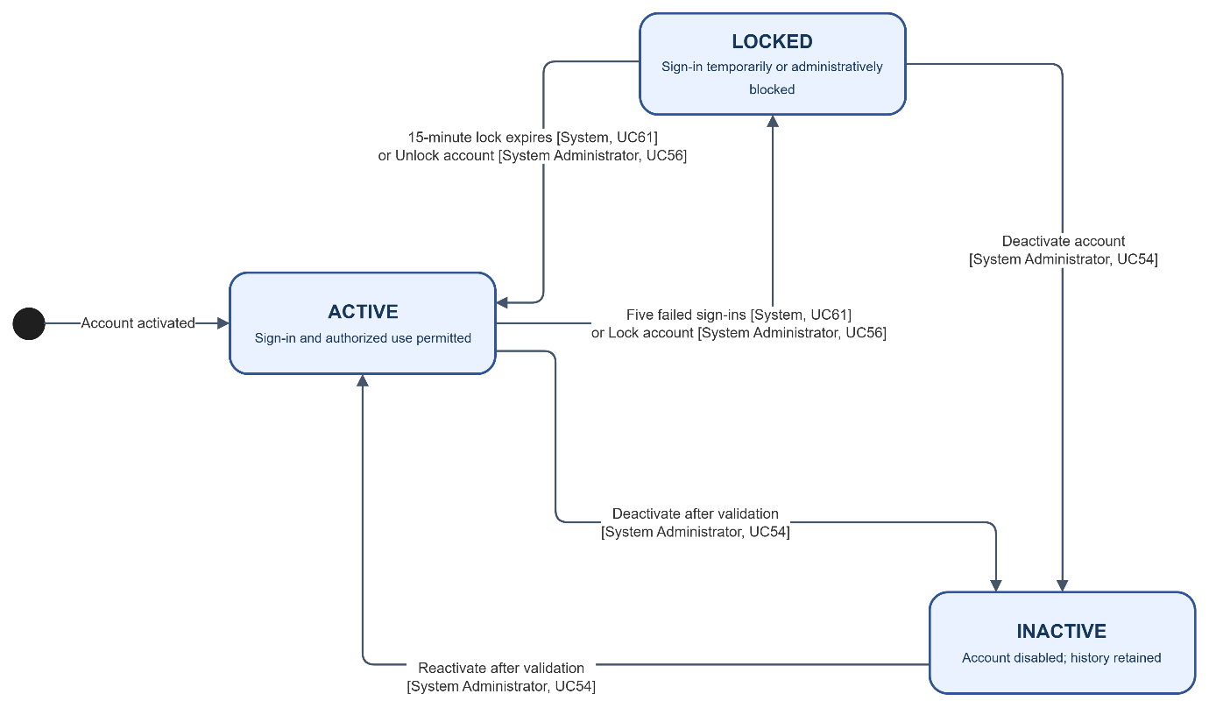
- ACTIVE -> LOCKED (System after five consecutive failed sign-ins, UC61; or System Administrator, UC56).
- LOCKED -> ACTIVE (System after the 15-minute lock period, UC61; or System Administrator, UC56).
- ACTIVE or LOCKED -> INACTIVE (System Administrator, UC54).
- INACTIVE -> ACTIVE (System Administrator, UC54, after validation).
- No terminal state; account history is retained.

Product status workflow
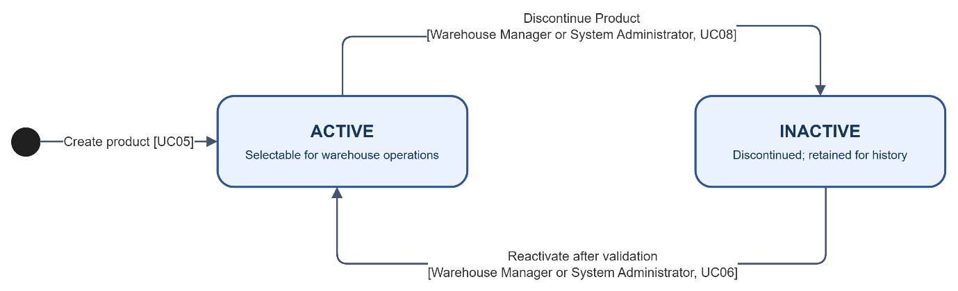
- ACTIVE -> INACTIVE (Warehouse Manager or System Administrator, UC08: Discontinue Product).
- INACTIVE -> ACTIVE (Warehouse Manager or System Administrator, UC06, after reactivation validation).
- No terminal state; historical transactions remain available.

Supplier status workflow
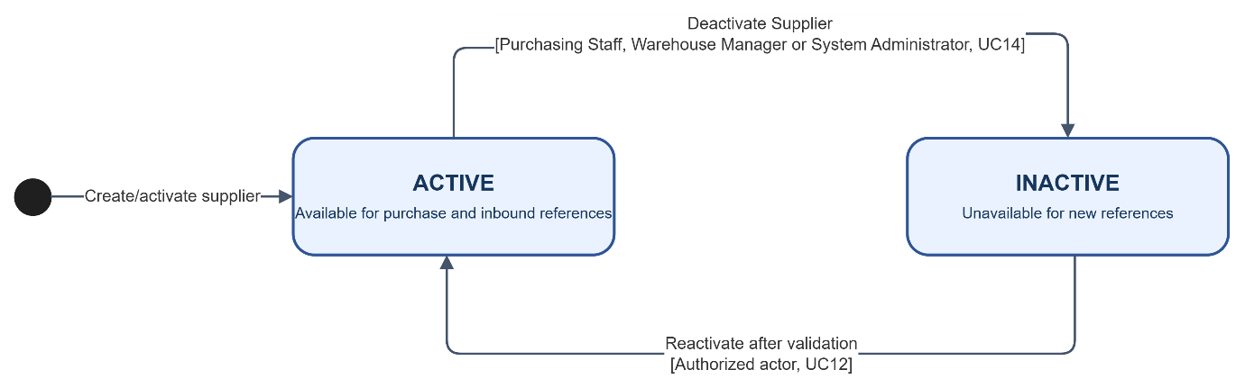
- ACTIVE -> INACTIVE (Purchasing Staff, Warehouse Manager, or System Administrator, UC14: Deactivate Supplier).
- INACTIVE -> ACTIVE (authorized actor, UC12, after reactivation validation).
- No terminal state; historical purchase and inbound references remain available.

Storage Location status workflow
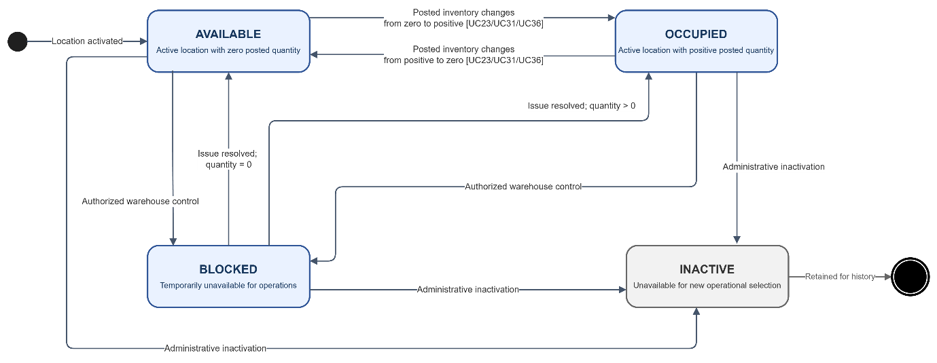
- AVAILABLE <-> OCCUPIED (System when posted inventory changes between zero and positive quantity, UC23/UC31/UC36).
- AVAILABLE or OCCUPIED -> BLOCKED (authorized warehouse control outside the 65-UC operational baseline).
- BLOCKED -> AVAILABLE or OCCUPIED (authorized warehouse control after issue resolution).
- AVAILABLE, OCCUPIED, or BLOCKED -> INACTIVE (administrative configuration outside this UCS baseline).
- INACTIVE is terminal for new operational selection; history remains visible.

Product Lot status workflow
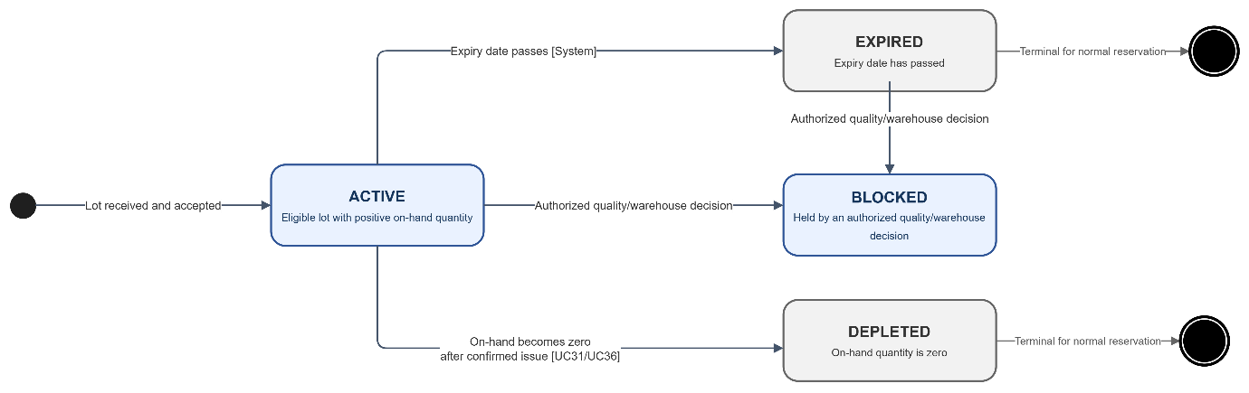
- ACTIVE -> EXPIRED (System when expiry date passes).
- ACTIVE -> DEPLETED (System when on-hand quantity becomes zero after UC31 or UC36).
- ACTIVE or EXPIRED -> BLOCKED (authorized quality/warehouse decision outside the operational baseline).
- EXPIRED and DEPLETED are terminal for normal reservation; BLOCKED may be released only by authorized control.

Purchase Order status workflow
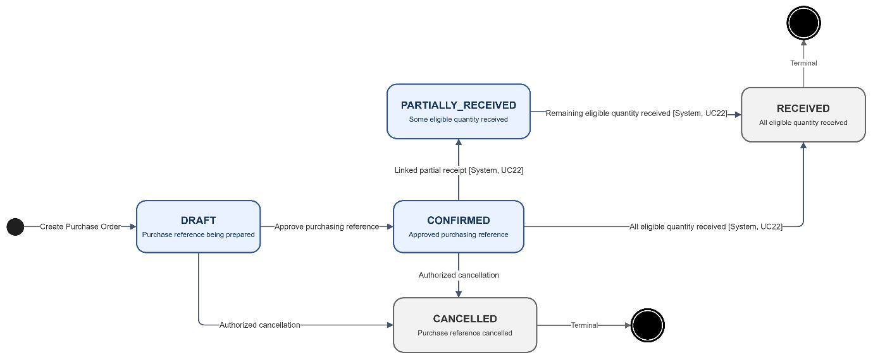
- A new Purchase Order is created in DRAFT status by Purchasing Staff (UC65).
- DRAFT -> CONFIRMED (approved purchasing reference outside this operational UCS baseline).
- CONFIRMED -> PARTIALLY_RECEIVED (System after a linked partial receipt, UC22).
- CONFIRMED or PARTIALLY_RECEIVED -> RECEIVED (System after linked eligible quantities are fully received, UC22).
- DRAFT or CONFIRMED -> CANCELLED (authorized purchasing process outside this UCS baseline).
- RECEIVED and CANCELLED are terminal.

Sales Order status workflow
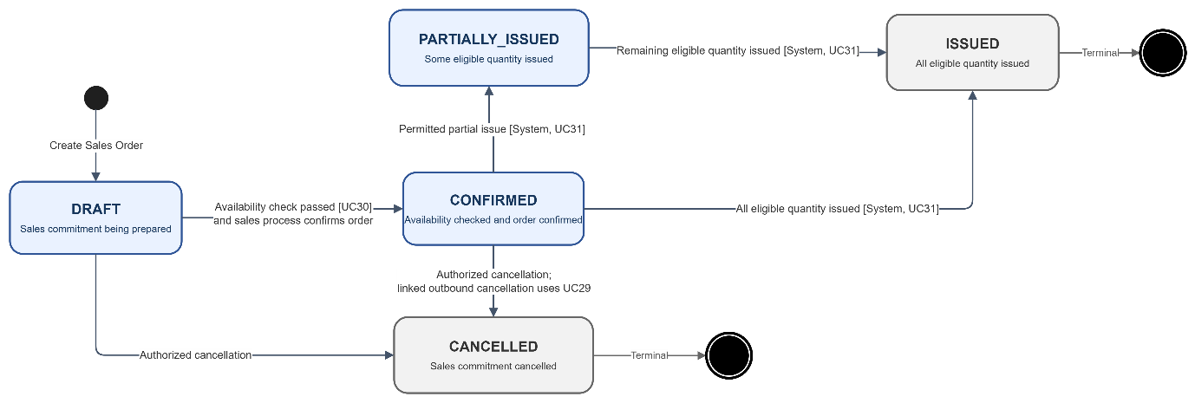
- A new Sales Order is created in DRAFT status by Sales Staff (UC64).
- DRAFT -> CONFIRMED (authorized sales process after availability check in UC30).
- CONFIRMED -> PARTIALLY_ISSUED (System after a permitted partial issue, UC31).
- CONFIRMED or PARTIALLY_ISSUED -> ISSUED (System after all eligible quantity is issued, UC31).
- DRAFT or CONFIRMED -> CANCELLED (authorized sales process; linked outbound cancellation uses UC29).
- ISSUED and CANCELLED are terminal.

Inbound Order status workflow
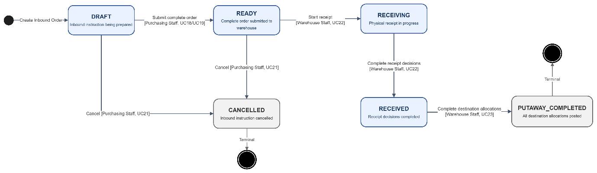
- DRAFT -> READY (Purchasing Staff, UC18 or UC19: submit complete order).
- READY -> RECEIVING (Warehouse Staff, UC22: start receipt).
- RECEIVING -> RECEIVED (Warehouse Staff, UC22: complete receipt decisions).
- RECEIVED -> PUTAWAY_COMPLETED (Warehouse Staff, UC23: complete destination allocations).
- DRAFT or READY -> CANCELLED (Purchasing Staff, UC21).
- PUTAWAY_COMPLETED and CANCELLED are terminal.

Outbound Order status workflow
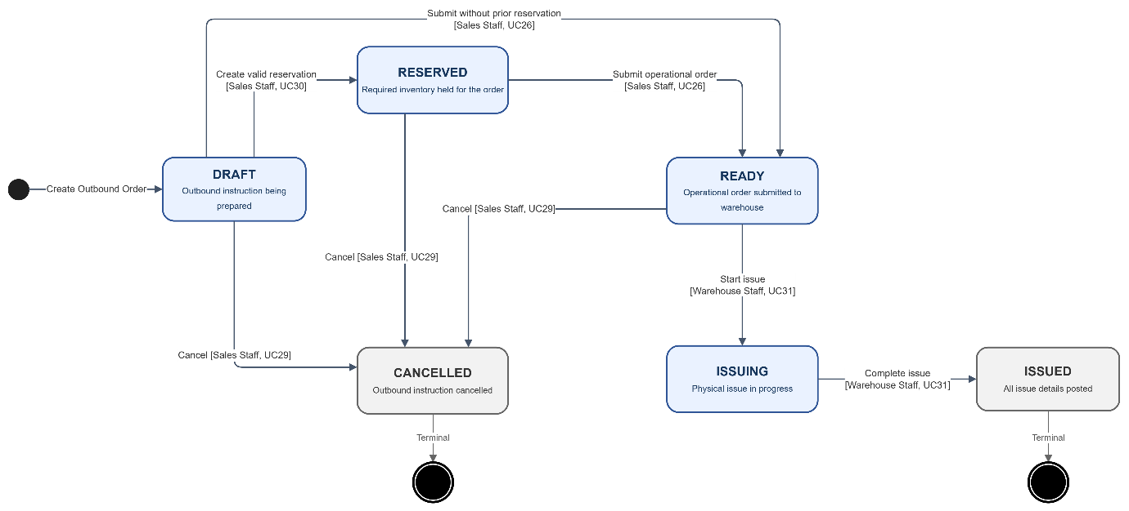
- DRAFT -> RESERVED (Sales Staff, UC30: create valid reservation).
- DRAFT or RESERVED -> READY (Sales Staff, UC26: create/submit operational outbound order).
- READY -> ISSUING (Warehouse Staff, UC31: start issue).
- ISSUING -> ISSUED (Warehouse Staff, UC31: complete issue).
- DRAFT, RESERVED, or READY -> CANCELLED (Sales Staff, UC29).
- ISSUED and CANCELLED are terminal.

Inventory Reservation status workflow
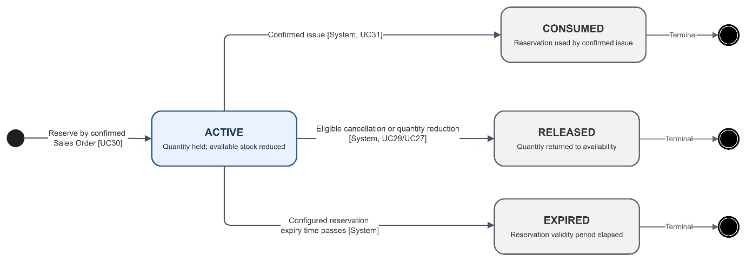
- ACTIVE -> CONSUMED (System after confirmed issue, UC31).
- ACTIVE -> RELEASED (System after eligible outbound cancellation or quantity reduction, UC29/UC27).
- ACTIVE -> EXPIRED (System when the configured reservation expiry time passes).
- CONSUMED, RELEASED, and EXPIRED are terminal.

Stocktake Session status workflow
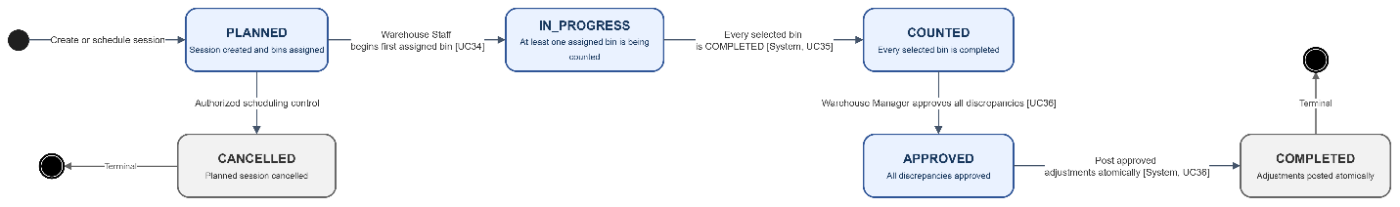
- PLANNED -> IN_PROGRESS (Warehouse Staff begins the first assigned bin, UC34).
- IN_PROGRESS -> COUNTED (System when every selected bin is COMPLETED, UC35).
- COUNTED -> APPROVED (Warehouse Manager approves all discrepancies, UC36).
- APPROVED -> COMPLETED (System after atomic adjustment posting, UC36).
- PLANNED -> CANCELLED (authorized scheduling control outside this UCS baseline).
- COMPLETED and CANCELLED are terminal.

Stocktake Location status workflow
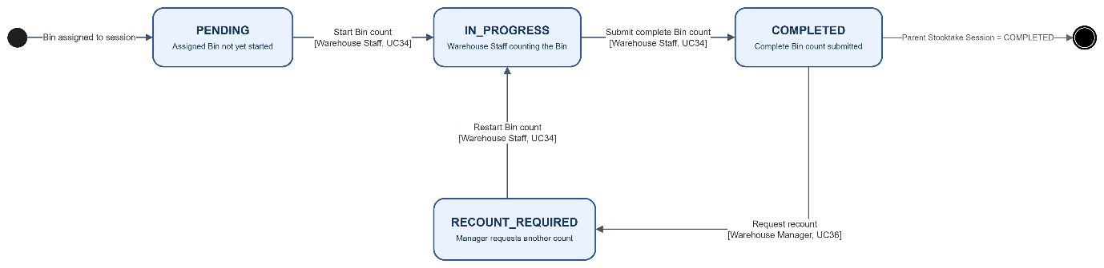
- PENDING -> IN_PROGRESS (Warehouse Staff, UC34: start bin count).
- IN_PROGRESS -> COMPLETED (Warehouse Staff, UC34: submit complete bin count).
- COMPLETED -> RECOUNT_REQUIRED (Warehouse Manager, UC36).
- RECOUNT_REQUIRED -> IN_PROGRESS -> COMPLETED (Warehouse Staff, UC34).
- COMPLETED is terminal only after the parent session reaches COMPLETED.

Notification status workflow
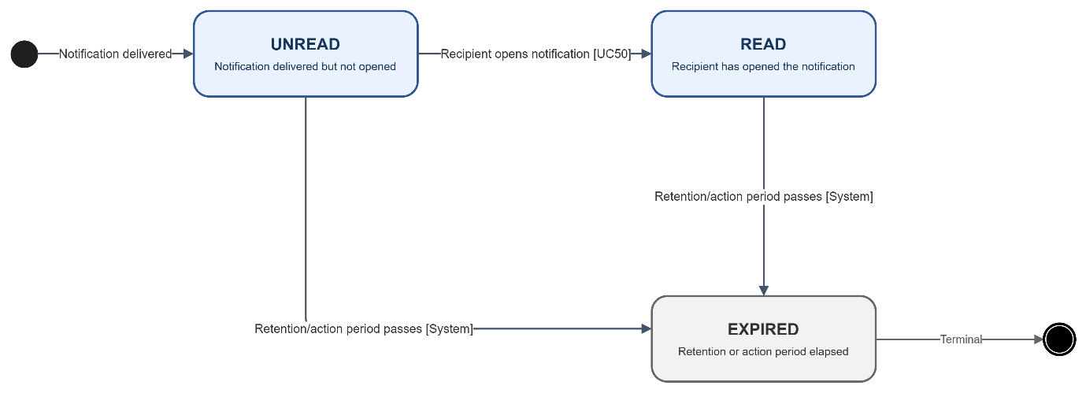
- UNREAD -> READ (recipient opens the notification, UC50).
- UNREAD or READ -> EXPIRED (System after the configured retention or action period).
- EXPIRED is terminal.

Step Notation
Symbol | Meaning
[U] | The person takes an action: clicks, fills in, scans, selects, or submits.
[S] | BMWMS performs an action: validates, calculates, saves, changes status, or displays.
[E] | An external system acts. No external-system UC is included in the current 65-UC baseline.
[J] | A scheduled or event-driven process runs. Jobs are referenced only where they affect observable behavior.
AF-xx | Alternative Flow: an intentional deviation or exception from the main flow.
BR-xx | Business Rule: an independently testable condition enforced within one use case.
GB-xx | Global Business Rule defined in the BMWMS Product Requirements Document.

UC Types at a Glance
Aspect | UI-type baseline
Who starts it | A person using a BMWMS screen or an observable system response triggered from that screen.
Who can access | Named fixed roles listed in Allowed Roles.
What it receives | Form, filter, selected record, scan, or confirmation input.
What it returns | A screen, message, status change, file, or updated operational view.
Authentication | All use cases except sign-in and password reset require an active session.

UC01: View Warehouse Information
Goal: Allows the user to view information about the single warehouse configured in the system.
Field | Value
Type | UI
Primary Actor | Warehouse Manager
Secondary Actor(s) | —
Module | M01 - Warehouse and Fixed Locations
Business Group | Warehouse Information
FT-ID Ref | FT-01
Depends On | —
Preconditions | An active user is signed in and holds one of the allowed fixed roles. The single warehouse configuration exists.
Postconditions | No warehouse data is changed.

Main Flow
- [U] The user opens Warehouse Overview.
- [S] The system identifies the single warehouse configured for this release.
- [S] The system verifies that the warehouse record is visible to the user's role.
- [S] The system displays warehouse code, name, address, contact information, and operational status.
- [S] The system displays summary counts for active, occupied, available, blocked, and inactive storage locations.
- [U] The user reviews the information and may open UC02 View Storage Location Map.

Alternative Flows
- AF-01 - Warehouse configuration missing: No warehouse record is configured. The system displays a configuration-required notice and does not infer or create a warehouse automatically.
- AF-02 - Warehouse inactive: The configured warehouse is INACTIVE. The system displays the record in read-only mode with an operational warning.

Business Rules
- BR-01: Exactly one active Warehouse is permitted in this release (see PRD DR-01).
- BR-02: Warehouse information is read-only in this use case.
- BR-03: Location summary counts must be calculated from locations belonging to the configured warehouse.

Request Fields - WarehouseOverviewRequest
Field | Type | Rule
Warehouse context | System selected | No user input. The system loads the single configured warehouse.

On success: Warehouse Overview displays the configured warehouse and accurate location-status summary.

Allowed Roles
System Administrator, Warehouse Manager, Warehouse Staff

Verification Criteria
Given | When | Then
the single configured warehouse exists | the user opens Warehouse Overview | the warehouse identity, contact data, status, and location summary are displayed without changing any data

Additional scenarios to cover in tests:
- View an ACTIVE warehouse.
- View an INACTIVE warehouse.
- Verify location counts match the location map.
- Attempt access with a role that is not allowed.

Sequence Diagram
Figure UC01. Sequence Diagram - View Warehouse Information
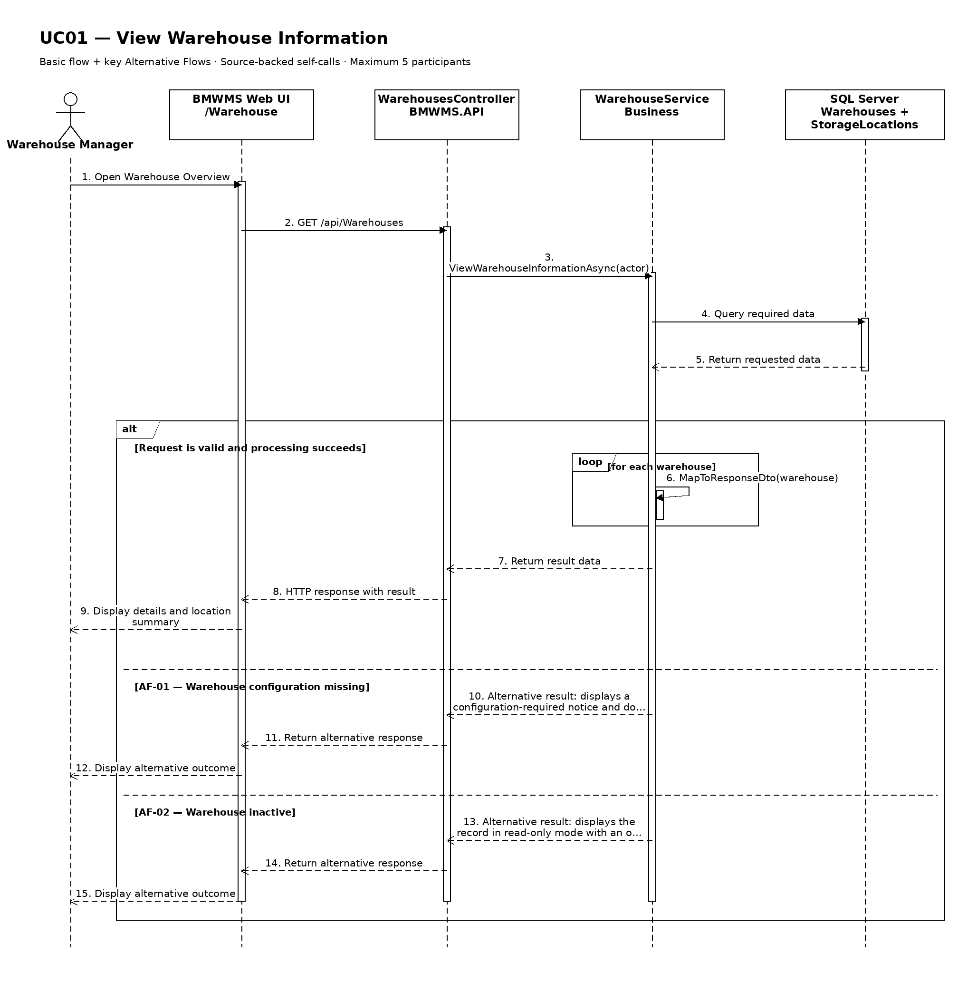

UC02: View Storage Location Map
Goal: Allows the user to view the predefined areas, racks, and storage bins in the warehouse.
Field | Value
Type | UI
Primary Actor | Warehouse Manager
Secondary Actor(s) | —
Module | M01 - Warehouse and Fixed Locations
Business Group | Fixed Storage Locations
FT-ID Ref | FT-02
Depends On | UC01
Preconditions | An active user is signed in and holds one of the allowed fixed roles.
Postconditions | No business record is changed. The current filters may remain in the user session.

Main Flow
- [U] The user opens Storage Location Map.
- [S] The system loads the first page of storage location records allowed for the user's role.
- [U] The user enters or changes one or more search and filter values.
- [S] The system validates the filter values and applies the authorized data scope.
- [S] The system displays the warehouse-area-rack-bin hierarchy, location code, floor area, status, distance rank, and current product count, the matching-record count, and pagination controls.
- [U] The user may change sorting, move between pages, clear filters, or open an available record/action.

Alternative Flows
- AF-01 - No matching records: At the result step, no record satisfies the active filters. The system displays an explicit no-results state and keeps the filters available for revision.
- AF-02 - Invalid filter combination: When a date range or numeric range is invalid, the system does not run the search and identifies the fields that must be corrected.
- AF-03 - Location structure not configured: The warehouse has no storage locations. The map displays a configuration-required empty state.

Business Rules
- BR-01: Only storage location records within the signed-in user's authorized scope may be returned (see PRD GB-02).
- BR-02: Results are sorted by area, rack, and bin code ascending unless the user selects another supported sort.
- BR-03: Pagination must return a stable result order and a total matching-record count.
- BR-04: Every displayed location must belong to the single configured warehouse (see PRD DR-01 and DR-02).
- BR-05: A location code is unique within the warehouse.

Request Fields - StorageLocationListFilter
Field | Type | Rule
Search keyword | Text | Optional. Matches location code, area, rack, shelf, or bin.
Area | Choice | Optional. Must belong to the configured warehouse.
Location status | Choice | Optional. AVAILABLE, OCCUPIED, BLOCKED, or INACTIVE.
Page | Number | Optional. Starts at 1; values below 1 are rejected.
Page size | Number | Optional. Between 10 and 100; defaults to 20.

On success: Storage Location Map displays the matching records and active filter summary.

Allowed Roles
System Administrator, Warehouse Manager, Warehouse Staff

Verification Criteria
Given | When | Then
at least one storage location record exists within the user's authorized scope | the user submits a valid filter combination | only matching storage location records are displayed in area, rack, and bin code ascending order, with an accurate total count

Additional scenarios to cover in tests:
- Open the list with default filters.
- Search using a complete identifier.
- Combine two or more filters.
- Use a filter that returns no results.
- Change page size and verify stable pagination.

Sequence Diagram
Figure UC02. Sequence Diagram - View Storage Location Map
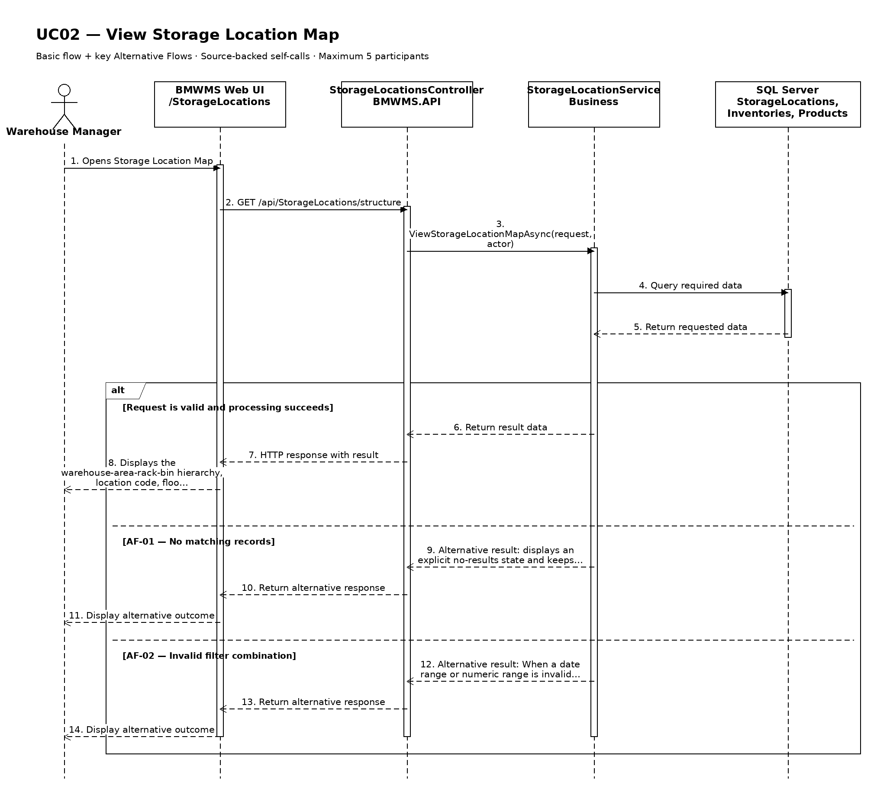

UC03: Locate Product
Goal: Allows the user to find the current storage location and available quantity of a product.
Field | Value
Type | UI
Primary Actor | Warehouse Staff
Secondary Actor(s) | —
Module | M01 - Warehouse and Fixed Locations
Business Group | Product Location Lookup
FT-ID Ref | FT-03
Depends On | UC04
Preconditions | An active user is signed in and holds one of the allowed fixed roles. At least one product master record exists.
Postconditions | No inventory balance or reservation is changed.

Main Flow
- [U] The user opens Product Location Lookup and searches by product code, name, or barcode.
- [S] The system validates the search and resolves the matching product.
- [U] The user optionally narrows the result by lot, area, location status, or available-only filter.
- [S] The system reads the current derived Inventory balance by Product + StorageLocation + ProductLot.
- [S] The system displays each matching bin with lot, expiry date, on-hand, reserved, and available quantity.
- [U] The user may open the selected product detail or movement history.

Alternative Flows
- AF-01 - Product not found: No active or historical product matches the search. The system displays a no-results state and does not infer a location.
- AF-02 - Product exists with zero stock: The product exists but has no positive balance. The system shows zero available quantity and the fixed default location, when configured, as reference only.
- AF-03 - Inventory record changed during lookup: A balance changes after the result loads. The result retains its displayed update time until the user refreshes.

Business Rules
- BR-01: Inventory is displayed by Product + StorageLocation + ProductLot; InventoryTransaction remains the movement source of truth (see PRD DR-14).
- BR-02: Available quantity equals on-hand quantity minus active reserved quantity and may not be negative (see PRD DR-10 and DR-11).
- BR-03: Only bins within the configured warehouse and the user's authorized scope are displayed.

Request Fields - ProductLocationLookupRequest
Field | Type | Rule
Product search | Text | Required. Product code, name, or barcode; maximum 200 characters.
Lot number | Text | Optional. Exact or partial lot number.
Area or location | Choice | Optional. Must belong to the configured warehouse.
Available only | Yes/No | Optional. When Yes, hides rows whose available quantity is zero.

On success: The current location and quantity rows are displayed with their last-update time.

Allowed Roles
System Administrator, Warehouse Manager, Warehouse Staff, Sales Staff

Verification Criteria
Given | When | Then
a product exists with inventory in one or more bins | the user searches for that product | every matching bin, lot, on-hand quantity, reserved quantity, and available quantity is displayed accurately

Additional scenarios to cover in tests:
- Locate a product by product code.
- Locate a product by barcode.
- Locate a product stored in multiple bins and lots.
- Locate a product with zero available quantity.
- Filter to available-only inventory.

Sequence Diagram
Figure UC03. Sequence Diagram - Locate Product
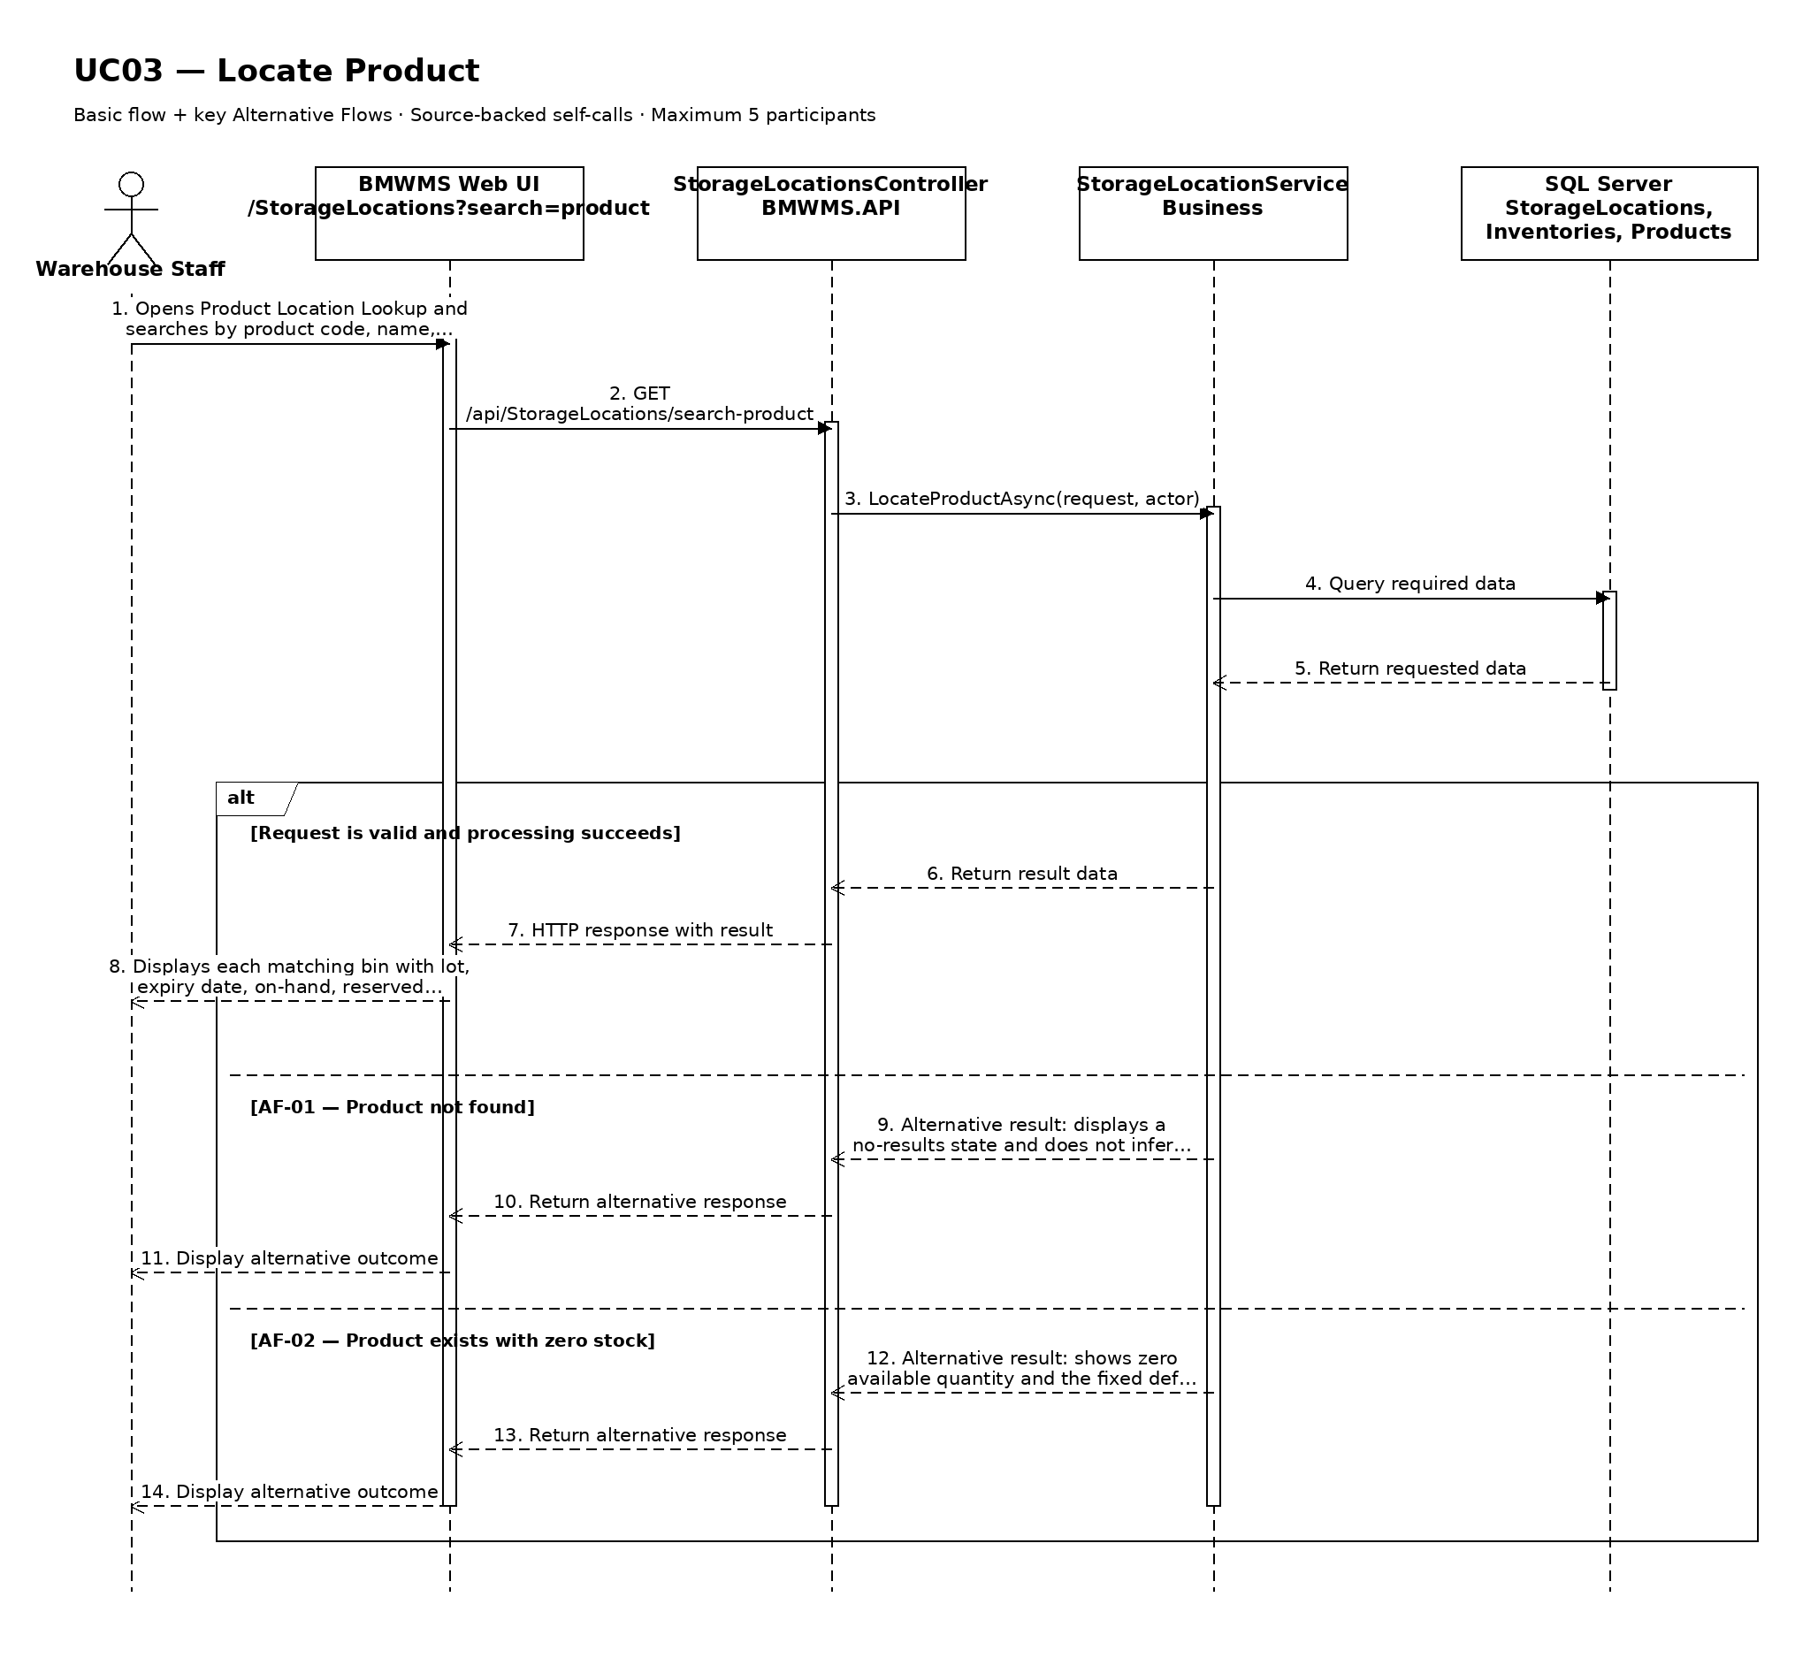

UC04: View Product List
Goal: Allows the user to search and review the products managed by the warehouse.
Field | Value
Type | UI
Primary Actor | Warehouse Manager
Secondary Actor(s) | —
Module | M02 - Product Management
Business Group | Product Management
FT-ID Ref | FT-04
Depends On | —
Preconditions | An active user is signed in and holds one of the allowed fixed roles.
Postconditions | No business record is changed. The current filters may remain in the user session.

Main Flow
- [U] The user opens Product List.
- [S] The system loads the first page of product records allowed for the user's role.
- [U] The user enters or changes one or more search and filter values.
- [S] The system validates the filter values and applies the authorized data scope.
- [S] The system displays product code, product name, group, unit of measure, safety stock, default fixed location, stock-control rule, and status, the matching-record count, and pagination controls.
- [U] The user may change sorting, move between pages, clear filters, or open an available record/action.

Alternative Flows
- AF-01 - No matching records: At the result step, no record satisfies the active filters. The system displays an explicit no-results state and keeps the filters available for revision.
- AF-02 - Invalid filter combination: When a date range or numeric range is invalid, the system does not run the search and identifies the fields that must be corrected.

Business Rules
- BR-01: Only product records within the signed-in user's authorized scope may be returned (see PRD GB-02).
- BR-02: Results are sorted by product name ascending unless the user selects another supported sort.
- BR-03: Pagination must return a stable result order and a total matching-record count.
- BR-04: Inactive products remain visible for history but cannot be selected for new transaction lines (see PRD DR-03).

Request Fields - ProductListFilter
Field | Type | Rule
Search keyword | Text | Optional. Matches product code, name, or barcode.
Product group | Choice | Optional. Active or inactive group.
Product status | Choice | Optional. ACTIVE or INACTIVE.
Page | Number | Optional. Starts at 1; values below 1 are rejected.
Page size | Number | Optional. Between 10 and 100; defaults to 20.

On success: Product List displays the matching records and active filter summary.

Allowed Roles
System Administrator, Warehouse Manager, Warehouse Staff, Purchasing Staff, Sales Staff

Verification Criteria
Given | When | Then
at least one product record exists within the user's authorized scope | the user submits a valid filter combination | only matching product records are displayed in product name ascending order, with an accurate total count

Additional scenarios to cover in tests:
- Open the list with default filters.
- Search using a complete identifier.
- Combine two or more filters.
- Use a filter that returns no results.
- Change page size and verify stable pagination.

Sequence Diagram
Figure UC04. Sequence Diagram - View Product List
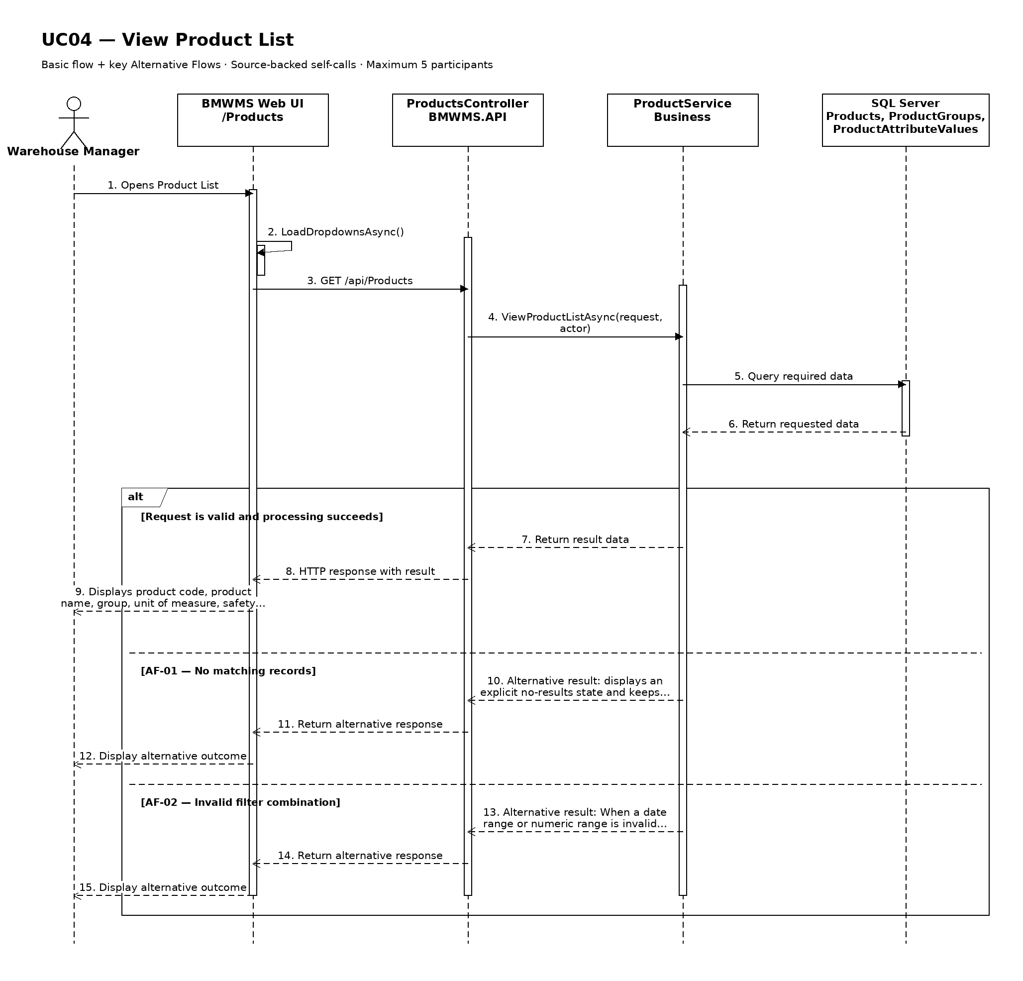

UC05: Create Product
Goal: Allows the manager to create a product under a product group and enter the attributes configured for that group.
Field | Value
Type | UI
Primary Actor | Warehouse Manager
Secondary Actor(s) | —
Module | M02 - Product Management
Business Group | Product Management
FT-ID Ref | FT-05
Depends On | UC04
Preconditions | An active user is signed in and holds one of the allowed fixed roles.
Postconditions | A new product record exists with status ACTIVE.

Main Flow
- [U] The user opens Product Create and selects Create.
- [S] The system displays a blank product form and the permitted reference values.
- [U] The user enters the required and optional information and submits the form.
- [S] The system validates field rules, uniqueness, references, and the user's permission.
- [S] The system creates the product with status ACTIVE and records audit information.
- [S] The system opens the created product and displays a success confirmation.

Alternative Flows
- AF-01 - Required or invalid value: At validation, one or more required values are missing or invalid. The system keeps the form data and identifies every field that must be corrected.
- AF-02 - Duplicate business identifier: The system finds a record that violates this uniqueness rule: Product code and barcode must be unique within BMWMS (see PRD DR-03 and GB-04). No duplicate is created and the conflicting field is identified.
- AF-03 - Invalid reference: A selected reference is unavailable or ineligible. The system keeps the form open and explains that the selected product group, unit, default fixed location, and configured attributes must be active and compatible.

Business Rules
- BR-01: Product code and barcode must be unique within BMWMS (see PRD DR-03 and GB-04).
- BR-02: All required fields must pass business validation before the record is saved.
- BR-03: A successful creation stores the product with status ACTIVE and records the creator and creation time.
- BR-04: The creation action is written to the audit log (see PRD GB-20).
- BR-05: the selected product group, unit, default fixed location, and configured attributes must be active and compatible.
- BR-06: A product belongs to exactly one product group.
- BR-07: The product group determines the displayed attributes and whether lot or expiry information is required (see PRD DR-04 and DR-05).
- BR-08: Safety stock is configured per product and may be zero (see PRD GB-10).

Request Fields - ProductCreateRequest
Field | Type | Rule
Product code | Text | Required. Unique. 2-30 uppercase letters, numbers, hyphen, or underscore.
Product name | Text | Required. Between 2 and 200 characters.
Product group | Choice | Required. Must be an active product group.
Unit of measure | Choice | Required. Must be an active unit.
Barcode | Text | Optional. Unique when provided; maximum 50 characters.
Safety stock | Number | Required. Zero or greater; stored in the product's unit of measure.
Default fixed location | Choice | Required. Must be an active, non-blocked location allowed for the selected group.
Lot control | Yes/No | System-derived from product group; read-only.
Expiry control | Yes/No | System-derived from product group; read-only.
Configured attributes | Dynamic values | Values shown for the selected group; every group-required attribute must be completed.

On success: The new product detail is displayed with status ACTIVE.

Allowed Roles
System Administrator, Warehouse Manager

Verification Criteria
Given | When | Then
the user has create permission and all referenced master data is eligible | the user submits valid product information | exactly one product record is created with status ACTIVE and an audit event is recorded

Additional scenarios to cover in tests:
- Create a product with all valid required values.
- Create a product with valid optional values.
- Submit with a required field missing.
- Submit a duplicate business identifier.
- Cancel creation before saving.

Sequence Diagram
Figure UC05. Sequence Diagram - Create Product
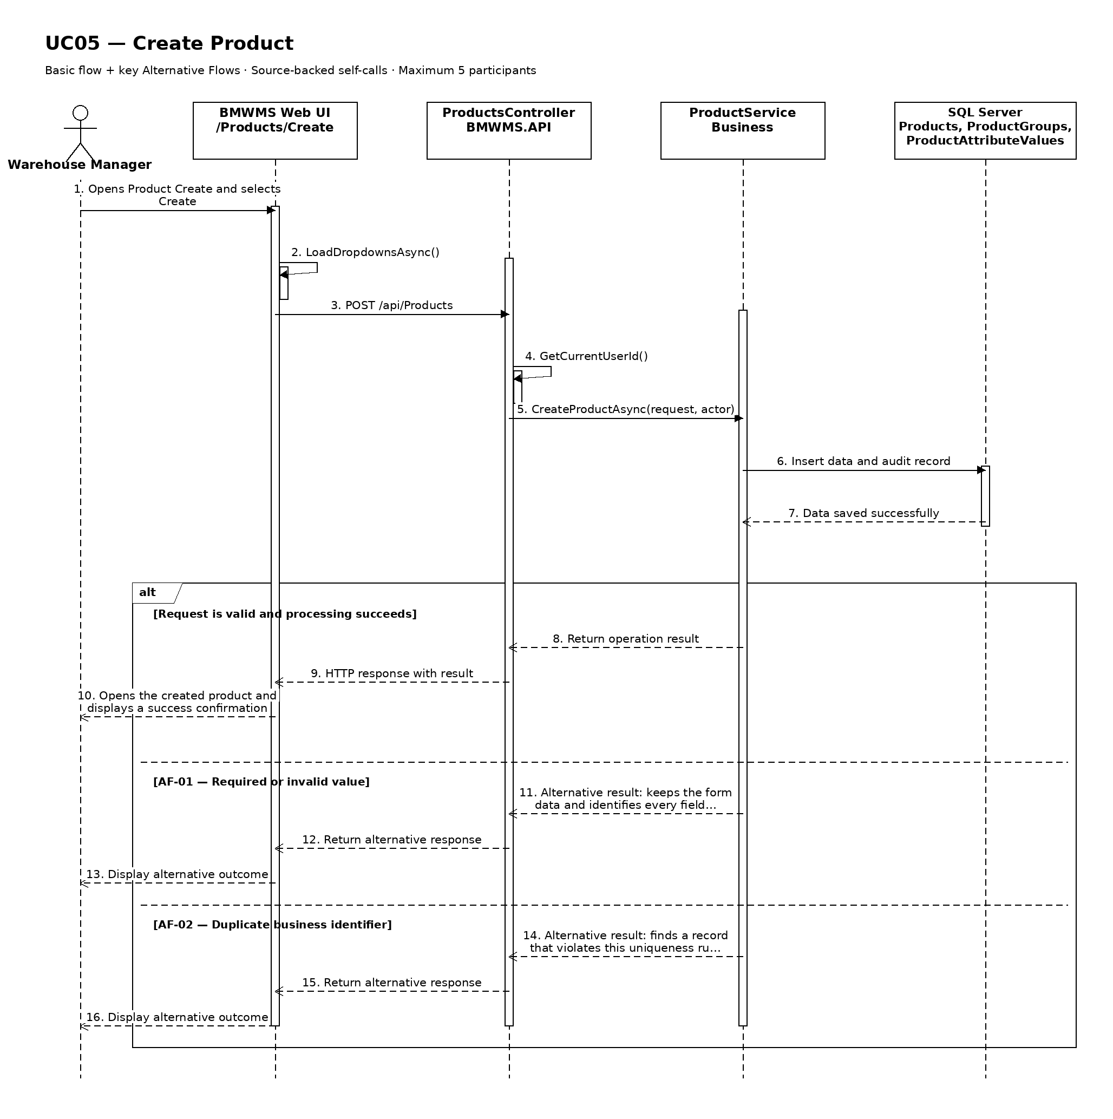

UC06: Edit Product
Goal: Allows the manager to update permitted product information.
Field | Value
Type | UI
Primary Actor | Warehouse Manager
Secondary Actor(s) | —
Module | M02 - Product Management
Business Group | Product Management
FT-ID Ref | FT-06
Depends On | UC07
Preconditions | An active user is signed in and holds one of the allowed fixed roles. The selected product is in an editable state.
Postconditions | The permitted product information is updated; its history is retained.

Main Flow
- [U] The user opens an eligible product and selects Edit.
- [S] The system opens Product Edit with the current values and edit restrictions.
- [U] The user changes one or more permitted values and submits the form.
- [S] The system rechecks the current record version, status, field rules, references, and uniqueness.
- [S] The system saves the permitted changes and records the update in the audit log.
- [S] The system returns to the product detail and confirms the update.

Alternative Flows
- AF-01 - Record state no longer permits editing: At save time, the record is no longer in ACTIVE or INACTIVE. The system rejects the update, reloads the current record, and explains why it cannot be edited.
- AF-02 - Concurrent update: Another user saved a newer version after the form was opened. The system does not overwrite it and asks the user to review the latest values.
- AF-03 - Validation failure: One or more changed values fail validation. The system keeps all unsaved changes and identifies the invalid fields.

Business Rules
- BR-01: The record is editable only in ACTIVE or INACTIVE.
- BR-02: Product code is immutable after the product has any transaction history; barcode must remain unique.
- BR-03: A successful update records the editor, update time, and before/after audit summary (see PRD GB-20).
- BR-04: Changing product group is rejected when existing attribute, lot, or transaction data would become incompatible.
- BR-05: Reactivating an INACTIVE product requires valid active master references.

Request Fields - ProductUpdateRequest
Field | Type | Rule
Product name | Text | Required. Between 2 and 200 characters.
Product group | Choice | Required. Must be an active product group.
Unit of measure | Choice | Required. Must be an active unit.
Barcode | Text | Optional. Unique when provided; maximum 50 characters.
Safety stock | Number | Required. Zero or greater; stored in the product's unit of measure.
Default fixed location | Choice | Required. Must be an active, non-blocked location allowed for the selected group.
Lot control | Yes/No | System-derived from product group; read-only.
Expiry control | Yes/No | System-derived from product group; read-only.
Configured attributes | Dynamic values | Values shown for the selected group; every group-required attribute must be completed.

On success: The updated product detail is displayed with a success confirmation.

Allowed Roles
System Administrator, Warehouse Manager

Verification Criteria
Given | When | Then
an eligible product exists and has not been changed by another user | the user submits valid changes to permitted fields | the product contains the new values, protected values remain unchanged, and the audit trail records the update

Additional scenarios to cover in tests:
- Update one permitted product field.
- Update multiple permitted fields.
- Attempt to change a protected identifier.
- Attempt to update an ineligible state.
- Simulate a concurrent update conflict.

Sequence Diagram
Figure UC06. Sequence Diagram - Edit Product
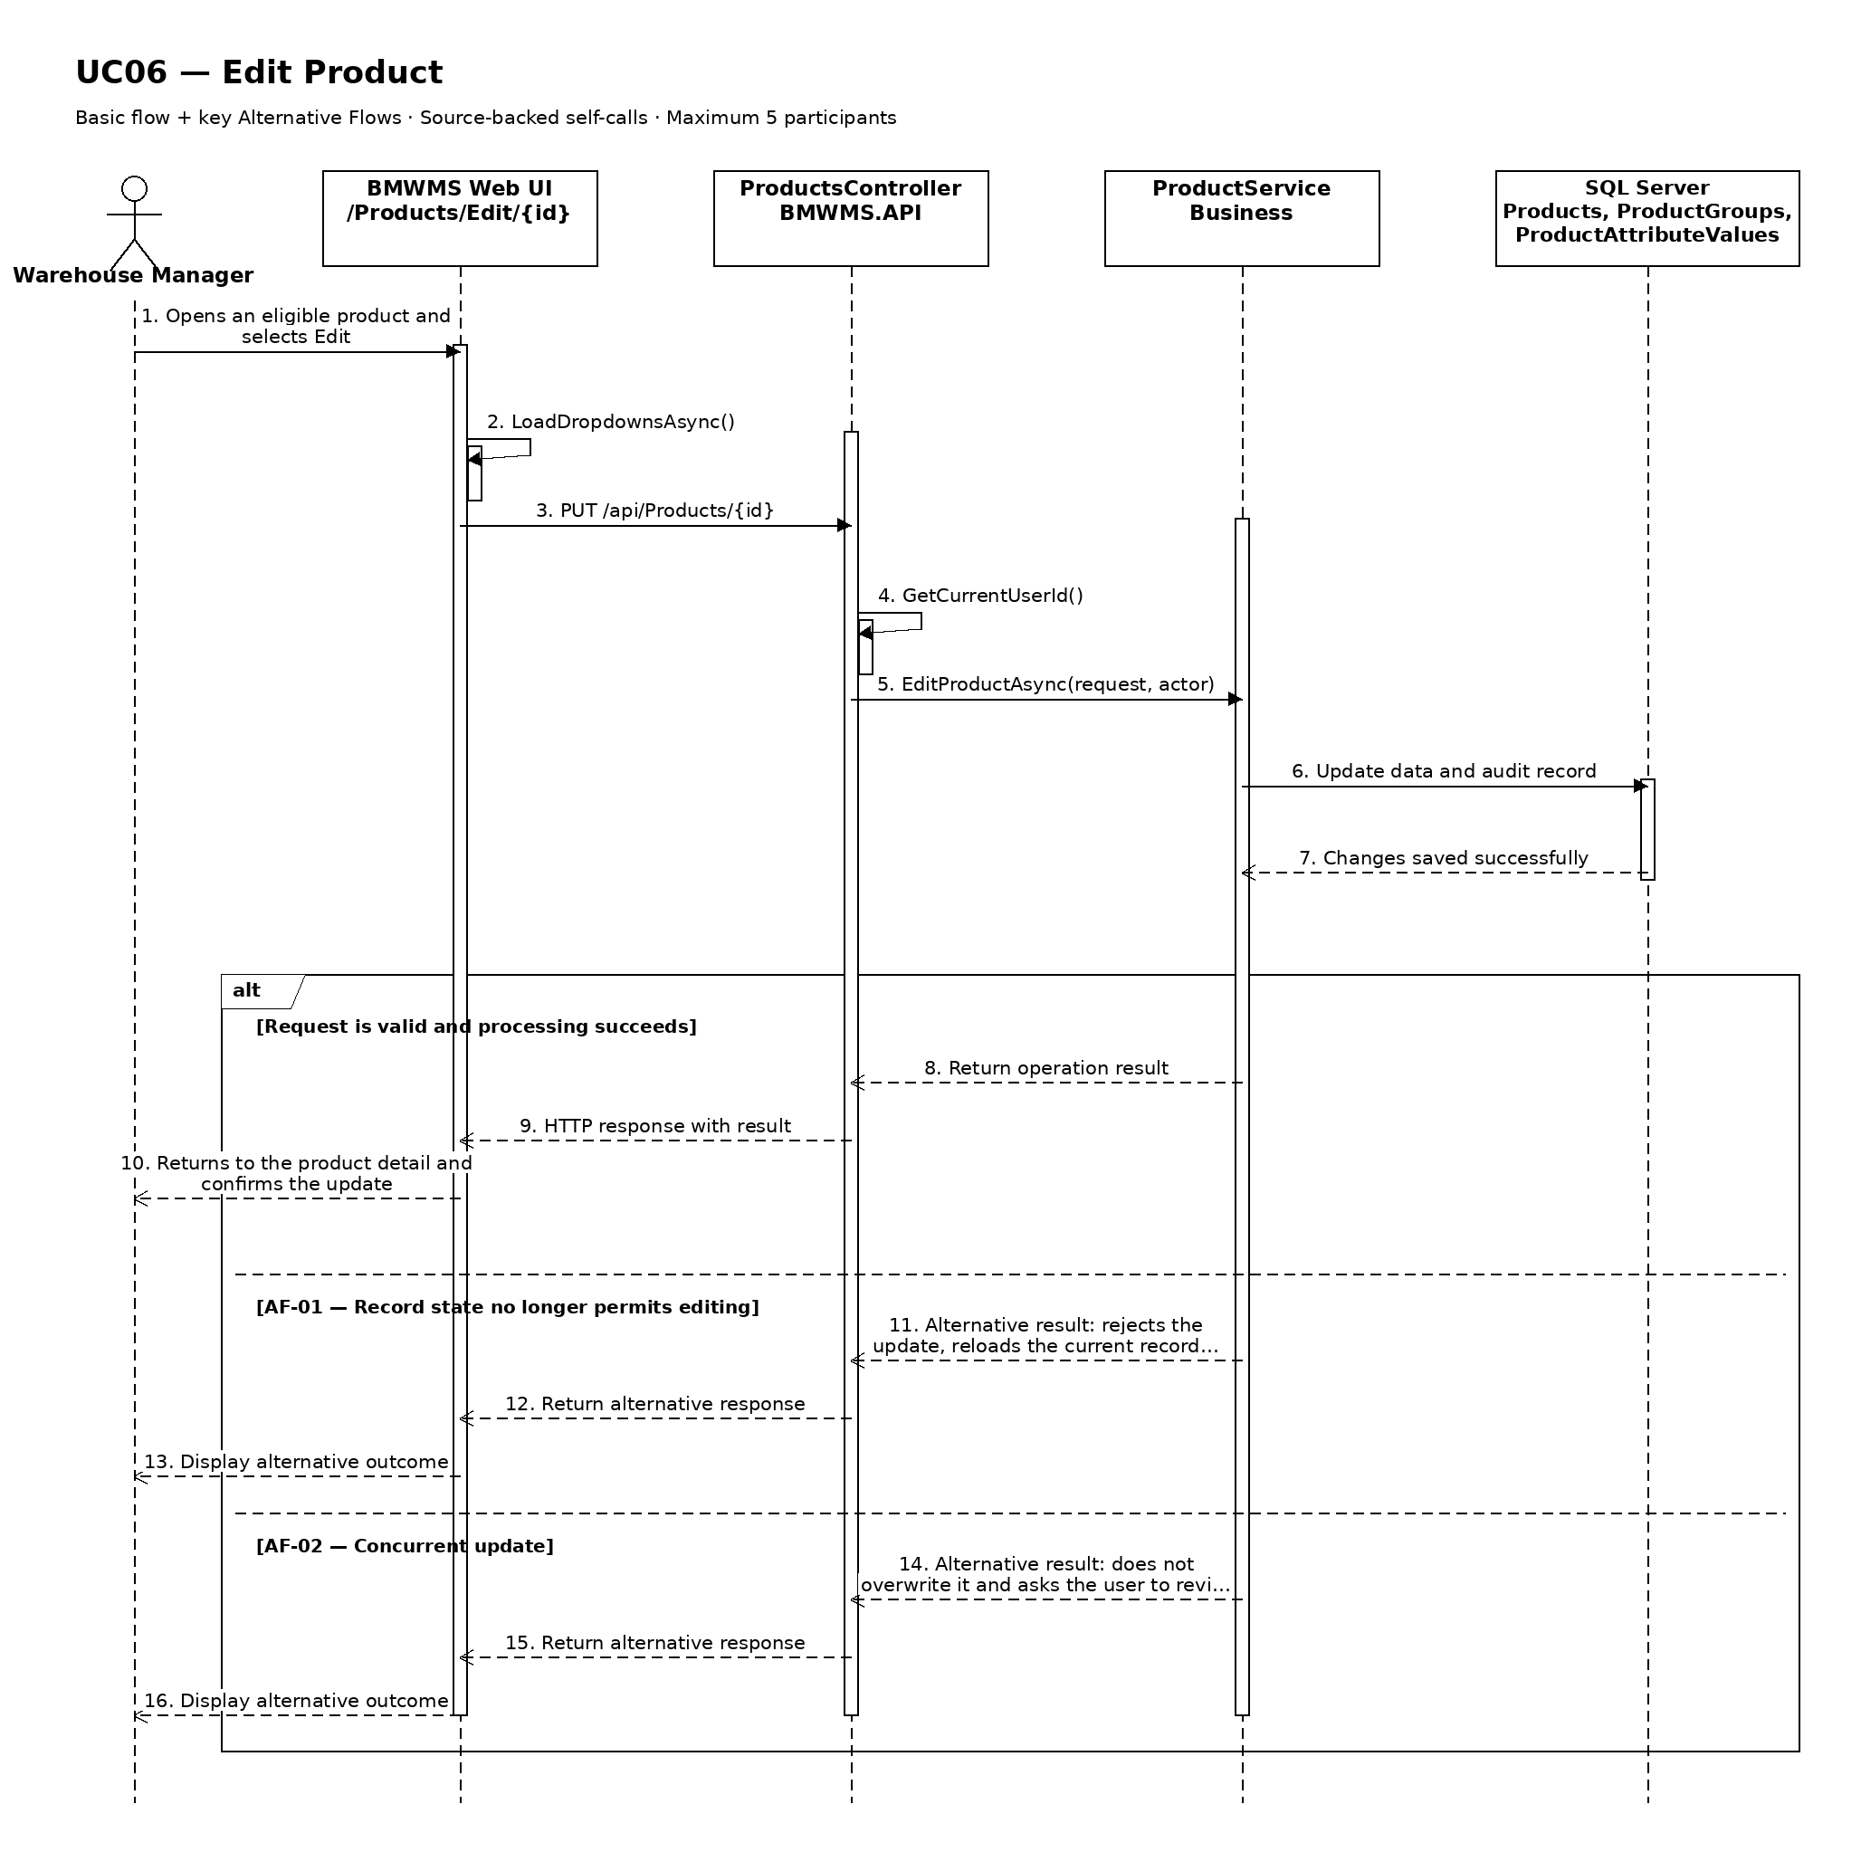

UC07: View Product Details
Goal: Allows the user to view full product master data, group attributes, stock rules, and status.
Field | Value
Type | UI
Primary Actor | Warehouse Manager
Secondary Actor(s) | —
Module | M02 - Product Management
Business Group | Product Management
FT-ID Ref | FT-07
Depends On | UC04
Preconditions | An active user is signed in and holds one of the allowed fixed roles. A product record is available to the user.
Postconditions | No business data is changed.

Main Flow
- [U] The user selects a product record from the related list or search result.
- [S] The system verifies that the record exists and is visible to the user's role.
- [S] The system opens Product Details.
- [S] The system displays identity, group, unit, configured attribute values, lot/expiry rules, safety stock, fixed location, status, current balance summary, and last update.
- [S] The system shows only the actions that are valid for the current status and role.
- [U] The user reviews the information and may navigate to an available related view or action.

Alternative Flows
- AF-01 - Record no longer available: After the user selects the record, the product no longer exists or is outside the user's scope. The system returns to the source view and displays a non-destructive notice.
- AF-02 - Historical or inactive record: The record is inactive or completed. The system still displays retained history but hides actions that are not permitted in the current state.

Business Rules
- BR-01: The selected product identifier must resolve to exactly one record.
- BR-02: Displayed actions are determined by the signed-in user's fixed role and the record's current state (see PRD GB-02).
- BR-03: Historical records remain viewable and are not physically deleted (see PRD GB-03).
- BR-04: Dynamic attribute labels and values must reflect the product's assigned group configuration.
- BR-05: Inventory summary values use the current derived balance and display the calculation time.

Request Fields - ProductDetailRequest
Field | Type | Rule
Product identifier | Text | Required. Must identify an existing record visible to the signed-in user.

On success: Product Details displays the complete authorized view of the selected product.

Allowed Roles
System Administrator, Warehouse Manager, Warehouse Staff, Purchasing Staff, Sales Staff

Verification Criteria
Given | When | Then
a visible product record exists | the user opens that record | identity, group, unit, configured attribute values, lot/expiry rules, safety stock, fixed location, status, current balance summary, and last update are displayed and no unauthorized action is offered

Additional scenarios to cover in tests:
- View an active product record.
- View an inactive or completed product record.
- Open a record through a direct authorized link.
- Attempt to open a missing or unauthorized record.

Sequence Diagram
Figure UC07. Sequence Diagram - View Product Details
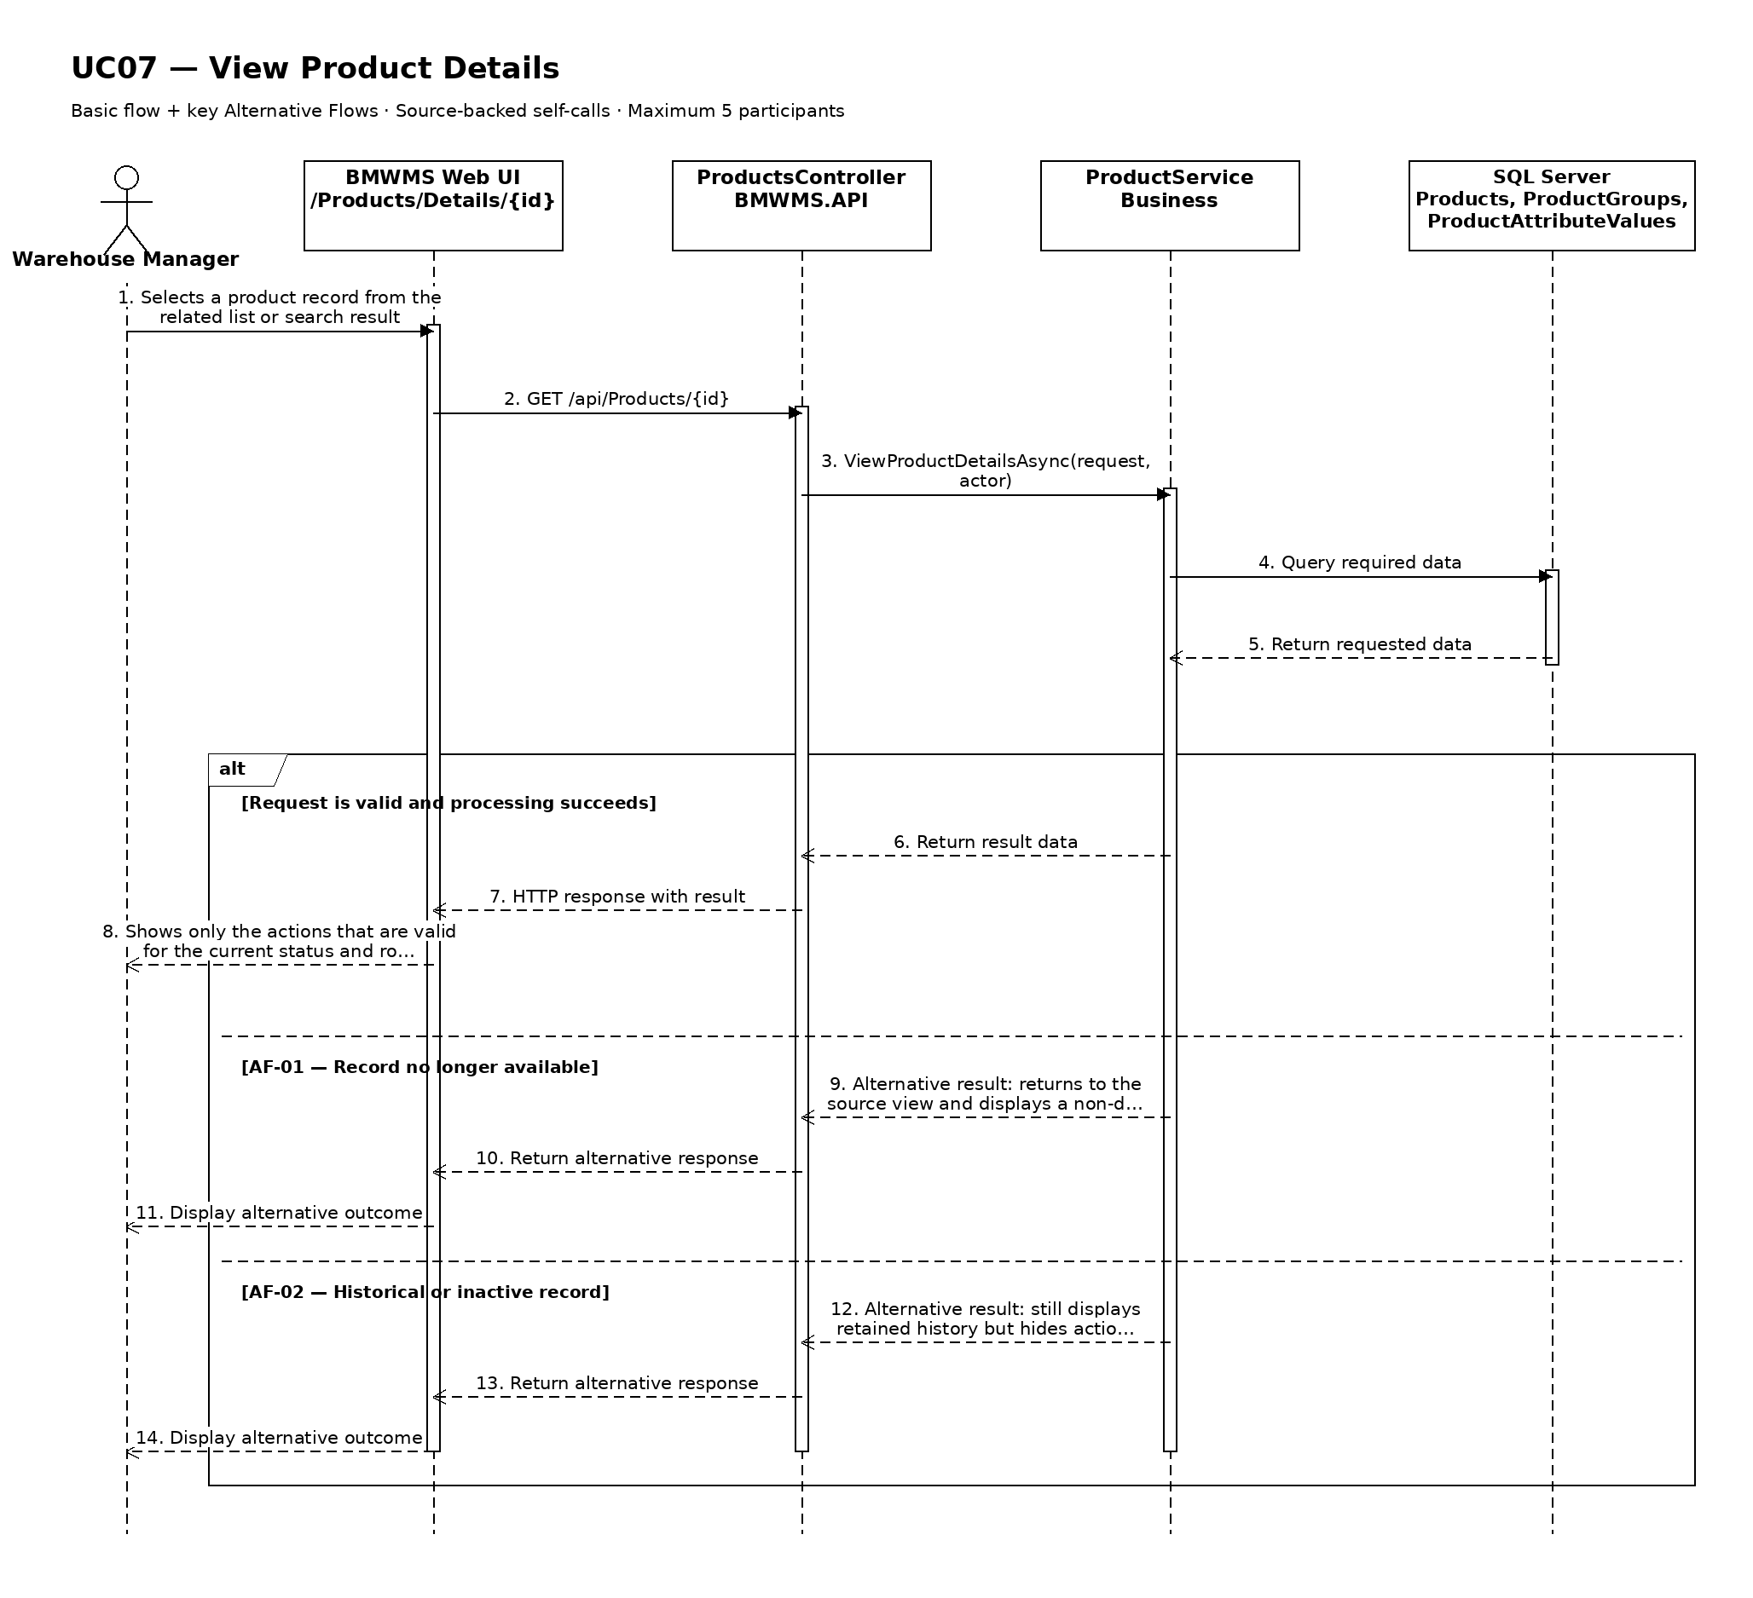

UC08: Discontinue Product
Goal: Allows the manager to prevent a product from being used in new transactions while retaining its history.
Field | Value
Type | UI
Primary Actor | Warehouse Manager
Secondary Actor(s) | —
Module | M02 - Product Management
Business Group | Product Management
FT-ID Ref | FT-08
Depends On | UC07
Preconditions | An active user is signed in and holds one of the allowed fixed roles. The selected product is in ACTIVE.
Postconditions | The product status is INACTIVE; historical data is retained.

Main Flow
- [U] The user opens the eligible product and selects Discontinue.
- [S] The system displays the confirmation, current status, and consequences of the action.
- [U] The user enters the discontinuation reason, selects the intended action if applicable, and confirms.
- [S] The system rechecks the current status, blocking dependencies, and the user's permission.
- [S] The system changes the status to INACTIVE and records the reason and actor.
- [S] The system refreshes the record and displays a success confirmation.

Alternative Flows
- AF-01 - Ineligible current state: The record is not in ACTIVE. The system does not change its status and displays the currently allowed actions.
- AF-02 - Blocking dependency: The system finds a blocking dependency. The action is rejected because the product must not have an uncompleted inbound line, outbound line, or active reservation; historical transactions do not block discontinuation.
- AF-03 - User cancels confirmation: The user closes the confirmation without submitting. The record remains unchanged and no audit event is created for a completed action.

Business Rules
- BR-01: The action may start only when the product is in ACTIVE.
- BR-02: the product must not have an uncompleted inbound line, outbound line, or active reservation; historical transactions do not block discontinuation.
- BR-03: The discontinuation reason is required and is retained in history.
- BR-04: The record is not physically deleted; the status change preserves historical references (see PRD GB-03).
- BR-05: The status change is written to the audit log (see PRD GB-20).

Request Fields - ProductDiscontinueRequest
Field | Type | Rule
Product identifier | Text | Required. Must identify an existing record visible to the user.
Discontinuation reason | Text | Required. Between 5 and 500 characters.
Confirmation | Yes/No | Required. The change is applied only when explicitly confirmed.

On success: The product detail is displayed with status INACTIVE.

Allowed Roles
System Administrator, Warehouse Manager

Verification Criteria
Given | When | Then
an eligible product exists with no blocking dependency | the user confirms discontinue with a valid reason | the status becomes INACTIVE, history is retained, and an audit event records the change

Additional scenarios to cover in tests:
- Complete discontinue from an eligible state.
- Cancel from the confirmation dialog.
- Attempt the action from an ineligible state.
- Attempt the action while a blocking dependency exists.

Sequence Diagram
Figure UC08. Sequence Diagram - Discontinue Product
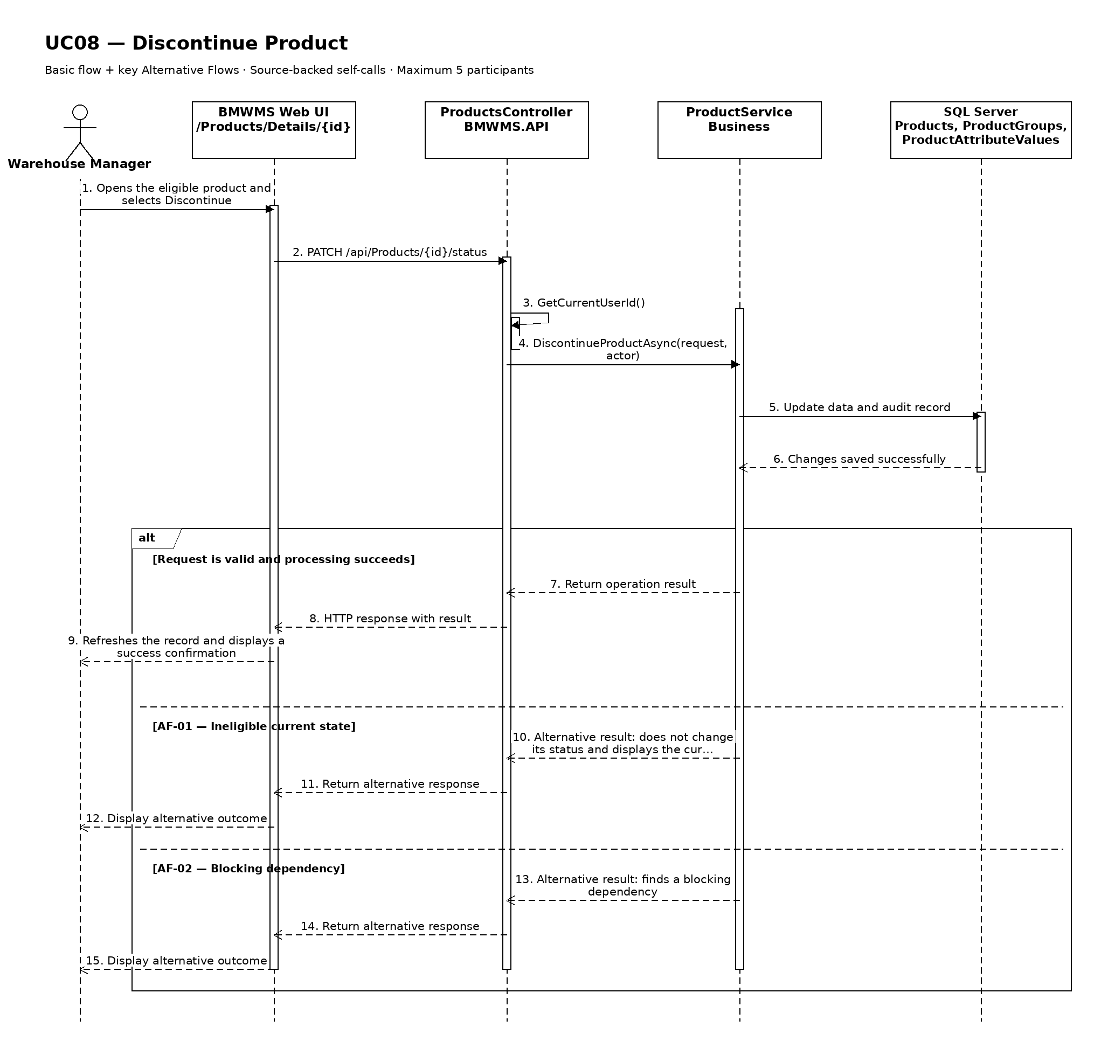

UC09: Trace Product Movement History
Goal: Allows the user to review inbound, outbound, stocktake, reservation, and inventory adjustment history for a product.
Field | Value
Type | UI
Primary Actor | Warehouse Manager
Secondary Actor(s) | —
Module | M02 - Product Management
Business Group | Product History
FT-ID Ref | FT-09
Depends On | UC07
Preconditions | An active user is signed in and holds one of the allowed fixed roles. The selected product is visible to the user.
Postconditions | No business record is changed.

Main Flow
- [U] The user opens Product Movement History for the selected product.
- [S] The system displays the latest authorized inbound, putaway, reservation, release, outbound, stocktake, and approved adjustment events.
- [U] The user enters a date range or selects event, status, product, lot, or location filters when available.
- [S] The system validates the filters and retrieves the retained history.
- [S] The system displays event time, event type, signed quantity effect, lot, bin, source reference, actor, and resulting balance when available.
- [U] The user may change sorting, clear filters, or open an available referenced record.

Alternative Flows
- AF-01 - No history in the selected period: No event matches the filters. The system displays a no-history state without changing the selected record or filters.
- AF-02 - Invalid date range: The start date is after the end date or exceeds the allowed reporting range. The system identifies the invalid range and does not run the query.

Business Rules
- BR-01: History is read-only and is ordered newest first by default.
- BR-02: Only posted or retained business events are shown; cancelled records remain visible for traceability.
- BR-03: The displayed history must be reconcilable to immutable transaction or audit records where applicable (see PRD GB-12 and GB-20).
- BR-04: InventoryTransaction rows are immutable; corrections are shown as compensating events (see PRD GB-12).

Request Fields - ProductHistoryFilter
Field | Type | Rule
Product identifier | Text | Required. Must identify a visible record or history context.
From date | Date | Optional. Must not be later than To date.
To date | Date | Optional. Defaults to the current date.
Event type | Choice | Optional. One of the supported values for inbound, putaway, reservation, release, outbound, stocktake, and approved adjustment events.
Related reference | Text | Optional. Exact or partial order, transaction, lot, or document reference.

On success: Product Movement History displays the matching retained history and active filters.

Allowed Roles
System Administrator, Warehouse Manager, Warehouse Staff, Purchasing Staff, Sales Staff

Verification Criteria
Given | When | Then
historical events exist for the selected product | the user submits a valid date range and event filter | the matching events are displayed in chronological order with their actor, reference, quantity or status effect, and time

Additional scenarios to cover in tests:
- View history with default filters.
- Filter by date range.
- Filter by event type and related reference.
- Use a period with no matching history.

Sequence Diagram
Figure UC09. Sequence Diagram - Trace Product Movement History
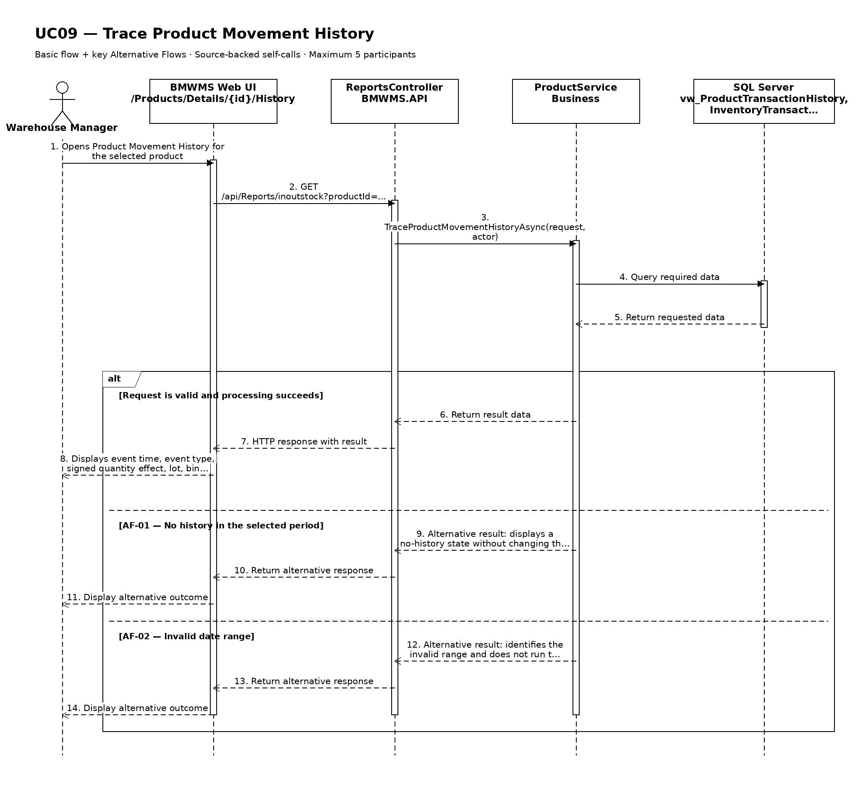

UC10: View Supplier List
Goal: Allows the user to search and view registered suppliers.
Field | Value
Type | UI
Primary Actor | Purchasing Staff
Secondary Actor(s) | —
Module | M03 - Supplier Management
Business Group | Supplier Management
FT-ID Ref | FT-10
Depends On | —
Preconditions | An active user is signed in and holds one of the allowed fixed roles.
Postconditions | No business record is changed. The current filters may remain in the user session.

Main Flow
- [U] The user opens Supplier List.
- [S] The system loads the first page of supplier records allowed for the user's role.
- [U] The user enters or changes one or more search and filter values.
- [S] The system validates the filter values and applies the authorized data scope.
- [S] The system displays supplier code, supplier name, phone, representative, tax number, supplied-product count, last inbound date, and status, the matching-record count, and pagination controls.
- [U] The user may change sorting, move between pages, clear filters, or open an available record/action.

Alternative Flows
- AF-01 - No matching records: At the result step, no record satisfies the active filters. The system displays an explicit no-results state and keeps the filters available for revision.
- AF-02 - Invalid filter combination: When a date range or numeric range is invalid, the system does not run the search and identifies the fields that must be corrected.

Business Rules
- BR-01: Only supplier records within the signed-in user's authorized scope may be returned (see PRD GB-02).
- BR-02: Results are sorted by supplier name ascending unless the user selects another supported sort.
- BR-03: Pagination must return a stable result order and a total matching-record count.
- BR-04: Inactive suppliers remain visible for history but cannot be selected for new inbound orders (see PRD DR-06).

Request Fields - SupplierListFilter
Field | Type | Rule
Search keyword | Text | Optional. Matches supplier code, name, phone, representative, or tax number.
Supplier status | Choice | Optional. ACTIVE or INACTIVE.
Page | Number | Optional. Starts at 1; values below 1 are rejected.
Page size | Number | Optional. Between 10 and 100; defaults to 20.

On success: Supplier List displays the matching records and active filter summary.

Allowed Roles
System Administrator, Warehouse Manager, Purchasing Staff

Verification Criteria
Given | When | Then
at least one supplier record exists within the user's authorized scope | the user submits a valid filter combination | only matching supplier records are displayed in supplier name ascending order, with an accurate total count

Additional scenarios to cover in tests:
- Open the list with default filters.
- Search using a complete identifier.
- Combine two or more filters.
- Use a filter that returns no results.
- Change page size and verify stable pagination.

Sequence Diagram
Figure UC10. Sequence Diagram - View Supplier List
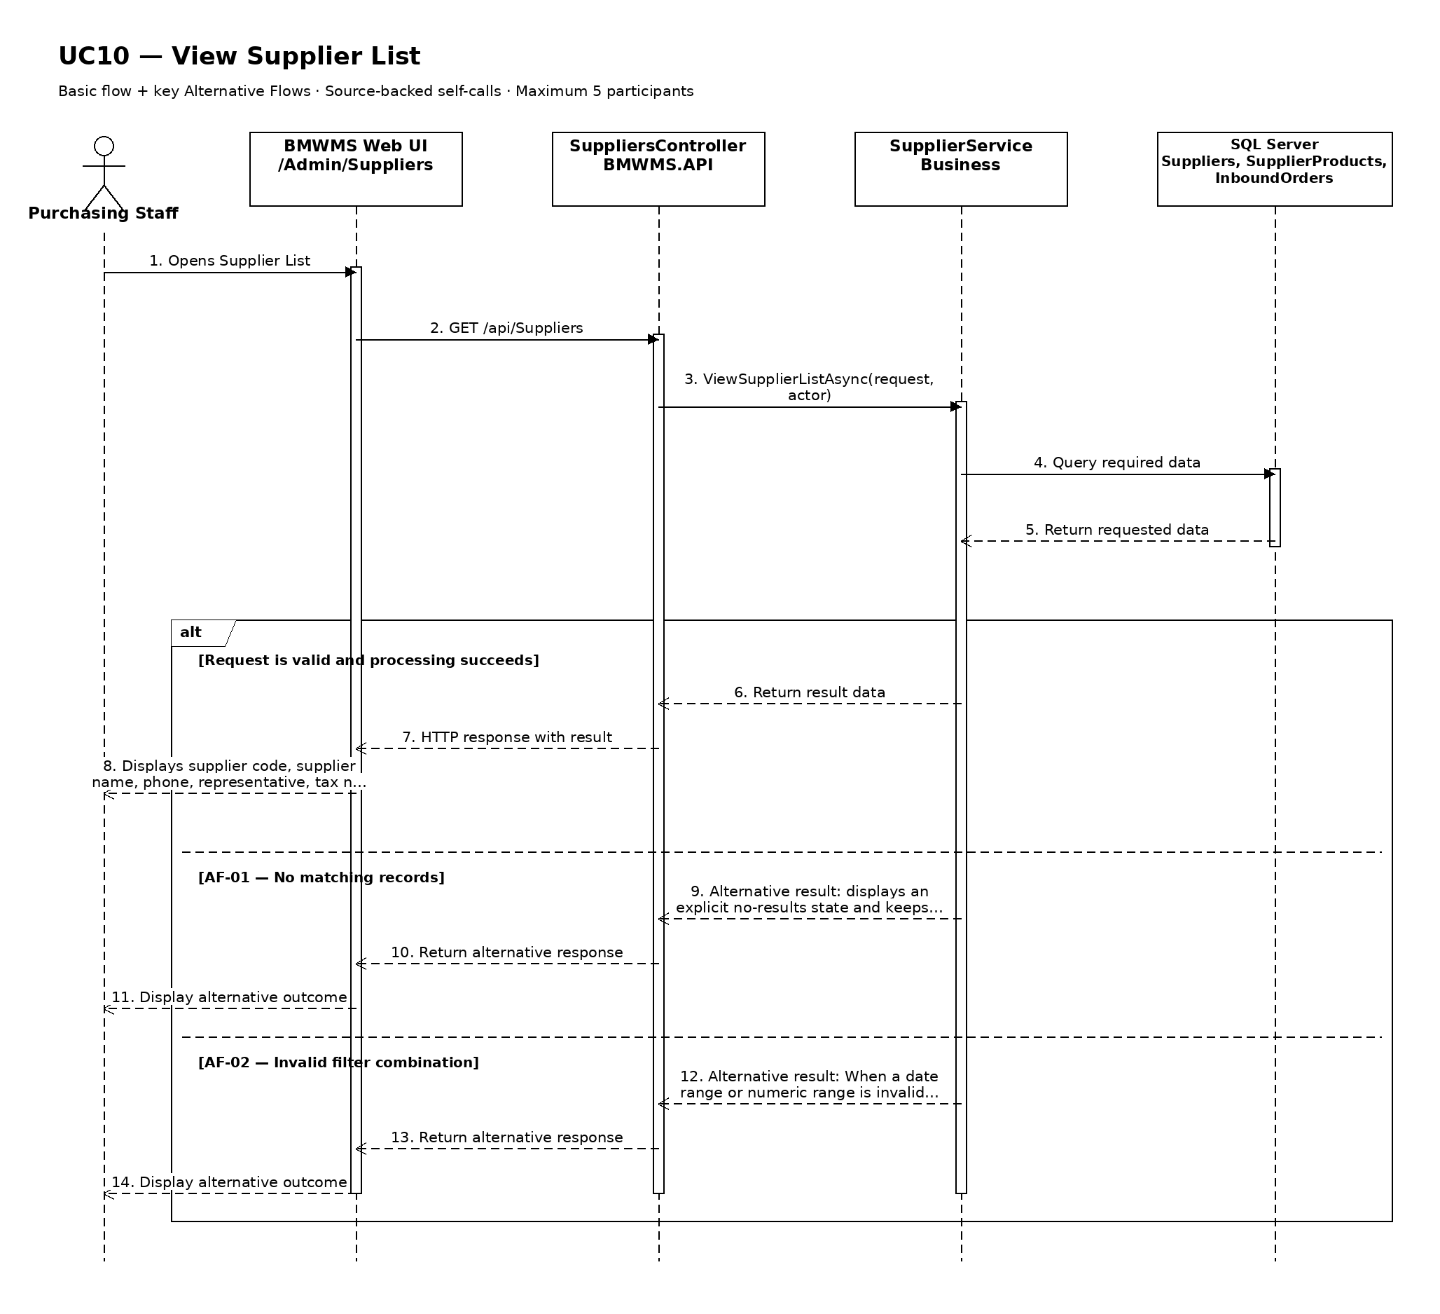

UC11: Create Supplier
Goal: Allows Purchasing Staff to create a supplier master record.
Field | Value
Type | UI
Primary Actor | Purchasing Staff
Secondary Actor(s) | —
Module | M03 - Supplier Management
Business Group | Supplier Management
FT-ID Ref | FT-11
Depends On | UC10
Preconditions | An active user is signed in and holds one of the allowed fixed roles.
Postconditions | A new supplier record exists with status ACTIVE.

Main Flow
- [U] The user opens Supplier Create and selects Create.
- [S] The system displays a blank supplier form and the permitted reference values.
- [U] The user enters the required and optional information and submits the form.
- [S] The system validates field rules, uniqueness, references, and the user's permission.
- [S] The system creates the supplier with status ACTIVE and records audit information.
- [S] The system opens the created supplier and displays a success confirmation.

Alternative Flows
- AF-01 - Required or invalid value: At validation, one or more required values are missing or invalid. The system keeps the form data and identifies every field that must be corrected.
- AF-02 - Duplicate business identifier: The system finds a record that violates this uniqueness rule: Supplier code and tax number must each be unique (see PRD DR-06 and GB-04). No duplicate is created and the conflicting field is identified.

Business Rules
- BR-01: Supplier code and tax number must each be unique (see PRD DR-06 and GB-04).
- BR-02: All required fields must pass business validation before the record is saved.
- BR-03: A successful creation stores the supplier with status ACTIVE and records the creator and creation time.
- BR-04: The creation action is written to the audit log (see PRD GB-20).
- BR-05: Phone, address, representative, and tax number are mandatory master-data values.

Request Fields - SupplierCreateRequest
Field | Type | Rule
Supplier code | Text | Required. Unique. 2-30 uppercase letters, numbers, hyphen, or underscore.
Supplier name | Text | Required. Between 2 and 200 characters.
Phone number | Text | Required. Valid business phone format; maximum 20 characters.
Address | Text | Required. Maximum 500 characters.
Representative | Text | Required. Maximum 150 characters.
Tax number | Text | Required. Unique. Between 10 and 20 characters.

On success: The new supplier detail is displayed with status ACTIVE.

Allowed Roles
System Administrator, Warehouse Manager, Purchasing Staff

Verification Criteria
Given | When | Then
the user has create permission and all referenced master data is eligible | the user submits valid supplier information | exactly one supplier record is created with status ACTIVE and an audit event is recorded

Additional scenarios to cover in tests:
- Create a supplier with all valid required values.
- Create a supplier with valid optional values.
- Submit with a required field missing.
- Submit a duplicate business identifier.
- Cancel creation before saving.

Sequence Diagram
Figure UC11. Sequence Diagram - Create Supplier
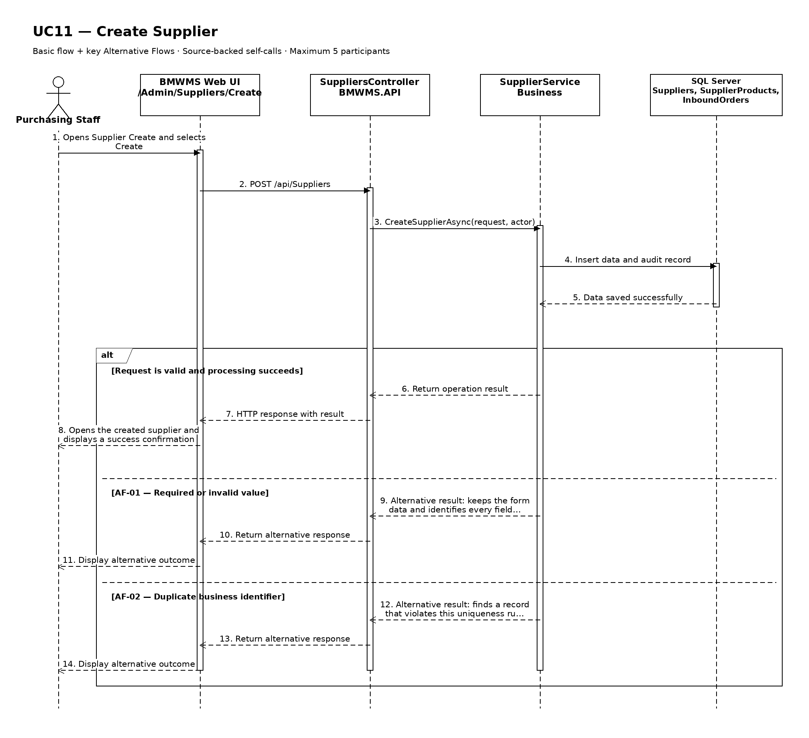

UC12: Edit Supplier
Goal: Allows Purchasing Staff to update permitted supplier information.
Field | Value
Type | UI
Primary Actor | Purchasing Staff
Secondary Actor(s) | —
Module | M03 - Supplier Management
Business Group | Supplier Management
FT-ID Ref | FT-12
Depends On | UC13
Preconditions | An active user is signed in and holds one of the allowed fixed roles. The selected supplier is in an editable state.
Postconditions | The permitted supplier information is updated; its history is retained.

Main Flow
- [U] The user opens an eligible supplier and selects Edit.
- [S] The system opens Supplier Edit with the current values and edit restrictions.
- [U] The user changes one or more permitted values and submits the form.
- [S] The system rechecks the current record version, status, field rules, references, and uniqueness.
- [S] The system saves the permitted changes and records the update in the audit log.
- [S] The system returns to the supplier detail and confirms the update.

Alternative Flows
- AF-01 - Record state no longer permits editing: At save time, the record is no longer in ACTIVE or INACTIVE. The system rejects the update, reloads the current record, and explains why it cannot be edited.
- AF-02 - Concurrent update: Another user saved a newer version after the form was opened. The system does not overwrite it and asks the user to review the latest values.
- AF-03 - Validation failure: One or more changed values fail validation. The system keeps all unsaved changes and identifies the invalid fields.

Business Rules
- BR-01: The record is editable only in ACTIVE or INACTIVE.
- BR-02: Supplier code is immutable after the supplier has any purchase or inbound reference; tax number must remain unique.
- BR-03: A successful update records the editor, update time, and before/after audit summary (see PRD GB-20).
- BR-04: Reactivating an INACTIVE supplier requires complete and valid contact and tax information.

Request Fields - SupplierUpdateRequest
Field | Type | Rule
Supplier name | Text | Required. Between 2 and 200 characters.
Phone number | Text | Required. Valid business phone format; maximum 20 characters.
Address | Text | Required. Maximum 500 characters.
Representative | Text | Required. Maximum 150 characters.
Tax number | Text | Required. Unique. Between 10 and 20 characters.

On success: The updated supplier detail is displayed with a success confirmation.

Allowed Roles
System Administrator, Warehouse Manager, Purchasing Staff

Verification Criteria
Given | When | Then
an eligible supplier exists and has not been changed by another user | the user submits valid changes to permitted fields | the supplier contains the new values, protected values remain unchanged, and the audit trail records the update

Additional scenarios to cover in tests:
- Update one permitted supplier field.
- Update multiple permitted fields.
- Attempt to change a protected identifier.
- Attempt to update an ineligible state.
- Simulate a concurrent update conflict.

Sequence Diagram
Figure UC12. Sequence Diagram - Edit Supplier
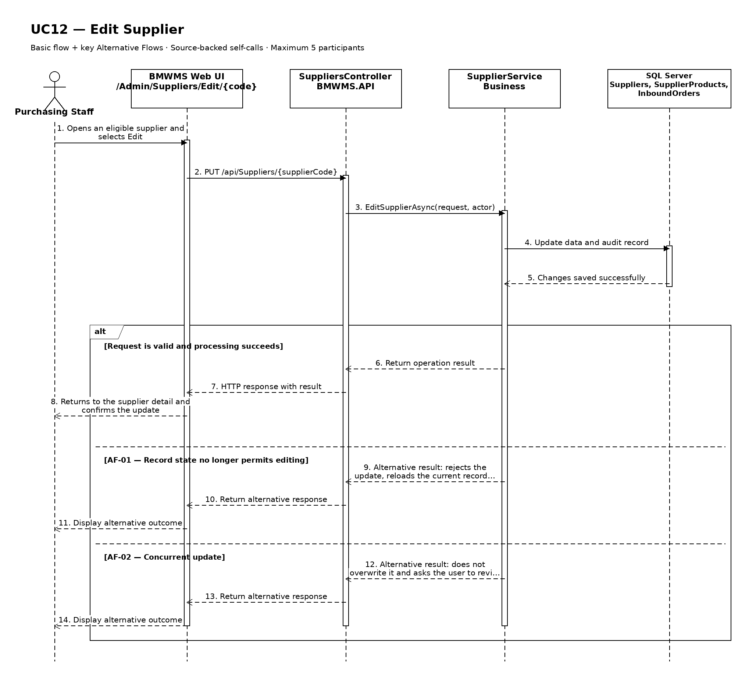

UC13: View Supplier Details
Goal: Allows the user to view supplier contact, tax, supplied-product, and transaction information.
Field | Value
Type | UI
Primary Actor | Purchasing Staff
Secondary Actor(s) | —
Module | M03 - Supplier Management
Business Group | Supplier Management
FT-ID Ref | FT-13
Depends On | UC10
Preconditions | An active user is signed in and holds one of the allowed fixed roles. A supplier record is available to the user.
Postconditions | No business data is changed.

Main Flow
- [U] The user selects a supplier record from the related list or search result.
- [S] The system verifies that the record exists and is visible to the user's role.
- [S] The system opens Supplier Details.
- [S] The system displays identity, phone, address, representative, tax number, status, supplied products, inbound summary, and last update.
- [S] The system shows only the actions that are valid for the current status and role.
- [U] The user reviews the information and may navigate to an available related view or action.

Alternative Flows
- AF-01 - Record no longer available: After the user selects the record, the supplier no longer exists or is outside the user's scope. The system returns to the source view and displays a non-destructive notice.
- AF-02 - Historical or inactive record: The record is inactive or completed. The system still displays retained history but hides actions that are not permitted in the current state.

Business Rules
- BR-01: The selected supplier identifier must resolve to exactly one record.
- BR-02: Displayed actions are determined by the signed-in user's fixed role and the record's current state (see PRD GB-02).
- BR-03: Historical records remain viewable and are not physically deleted (see PRD GB-03).
- BR-04: Supplier transaction summaries include retained cancelled orders but exclude them from received-quantity totals.

Request Fields - SupplierDetailRequest
Field | Type | Rule
Supplier identifier | Text | Required. Must identify an existing record visible to the signed-in user.

On success: Supplier Details displays the complete authorized view of the selected supplier.

Allowed Roles
System Administrator, Warehouse Manager, Purchasing Staff

Verification Criteria
Given | When | Then
a visible supplier record exists | the user opens that record | identity, phone, address, representative, tax number, status, supplied products, inbound summary, and last update are displayed and no unauthorized action is offered

Additional scenarios to cover in tests:
- View an active supplier record.
- View an inactive or completed supplier record.
- Open a record through a direct authorized link.
- Attempt to open a missing or unauthorized record.

Sequence Diagram
Figure UC13. Sequence Diagram - View Supplier Details
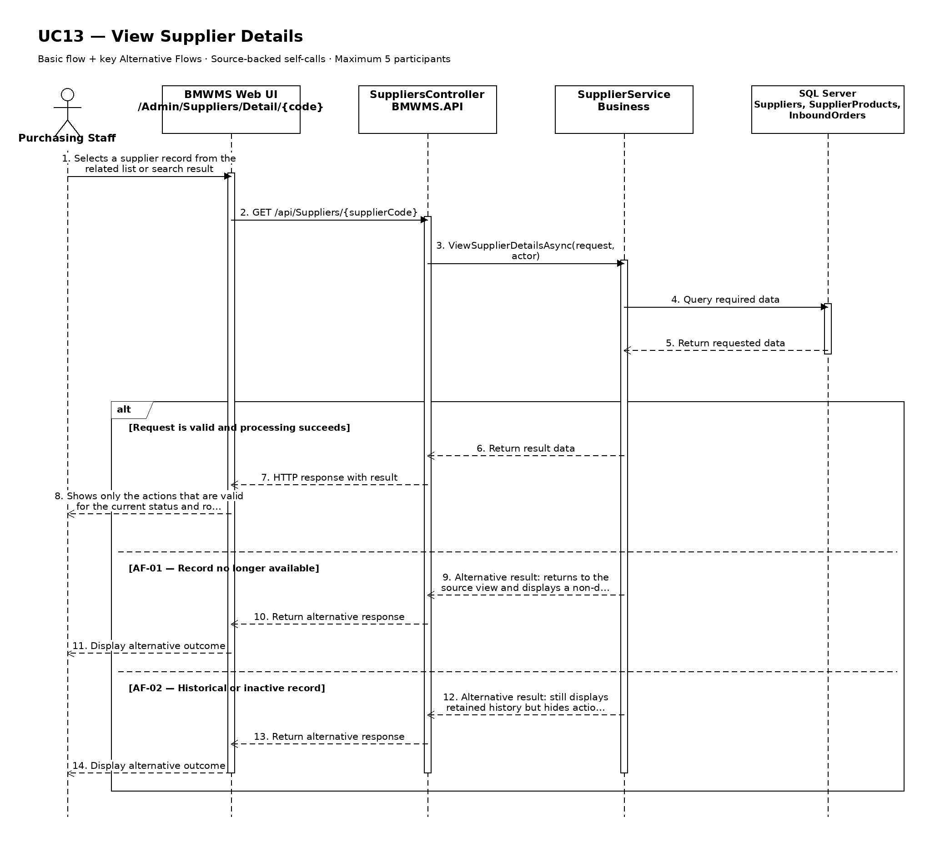

UC14: Deactivate Supplier
Goal: Allows Purchasing Staff to prevent a supplier from being selected for new inbound orders.
Field | Value
Type | UI
Primary Actor | Purchasing Staff
Secondary Actor(s) | —
Module | M03 - Supplier Management
Business Group | Supplier Management
FT-ID Ref | FT-14
Depends On | UC13
Preconditions | An active user is signed in and holds one of the allowed fixed roles. The selected supplier is in ACTIVE.
Postconditions | The supplier status is INACTIVE; historical data is retained.

Main Flow
- [U] The user opens the eligible supplier and selects Deactivate.
- [S] The system displays the confirmation, current status, and consequences of the action.
- [U] The user enters the deactivation reason, selects the intended action if applicable, and confirms.
- [S] The system rechecks the current status, blocking dependencies, and the user's permission.
- [S] The system changes the status to INACTIVE and records the reason and actor.
- [S] The system refreshes the record and displays a success confirmation.

Alternative Flows
- AF-01 - Ineligible current state: The record is not in ACTIVE. The system does not change its status and displays the currently allowed actions.
- AF-02 - Blocking dependency: The system finds a blocking dependency. The action is rejected because the supplier must not have an uncompleted Purchase Order or Inbound Order; completed history does not block deactivation.
- AF-03 - User cancels confirmation: The user closes the confirmation without submitting. The record remains unchanged and no audit event is created for a completed action.

Business Rules
- BR-01: The action may start only when the supplier is in ACTIVE.
- BR-02: the supplier must not have an uncompleted Purchase Order or Inbound Order; completed history does not block deactivation.
- BR-03: The deactivation reason is required and is retained in history.
- BR-04: The record is not physically deleted; the status change preserves historical references (see PRD GB-03).
- BR-05: The status change is written to the audit log (see PRD GB-20).

Request Fields - SupplierDeactivateRequest
Field | Type | Rule
Supplier identifier | Text | Required. Must identify an existing record visible to the user.
Deactivation reason | Text | Required. Between 5 and 500 characters.
Confirmation | Yes/No | Required. The change is applied only when explicitly confirmed.

On success: The supplier detail is displayed with status INACTIVE.

Allowed Roles
System Administrator, Warehouse Manager, Purchasing Staff

Verification Criteria
Given | When | Then
an eligible supplier exists with no blocking dependency | the user confirms deactivate with a valid reason | the status becomes INACTIVE, history is retained, and an audit event records the change

Additional scenarios to cover in tests:
- Complete deactivate from an eligible state.
- Cancel from the confirmation dialog.
- Attempt the action from an ineligible state.
- Attempt the action while a blocking dependency exists.

Sequence Diagram
Figure UC14. Sequence Diagram - Deactivate Supplier
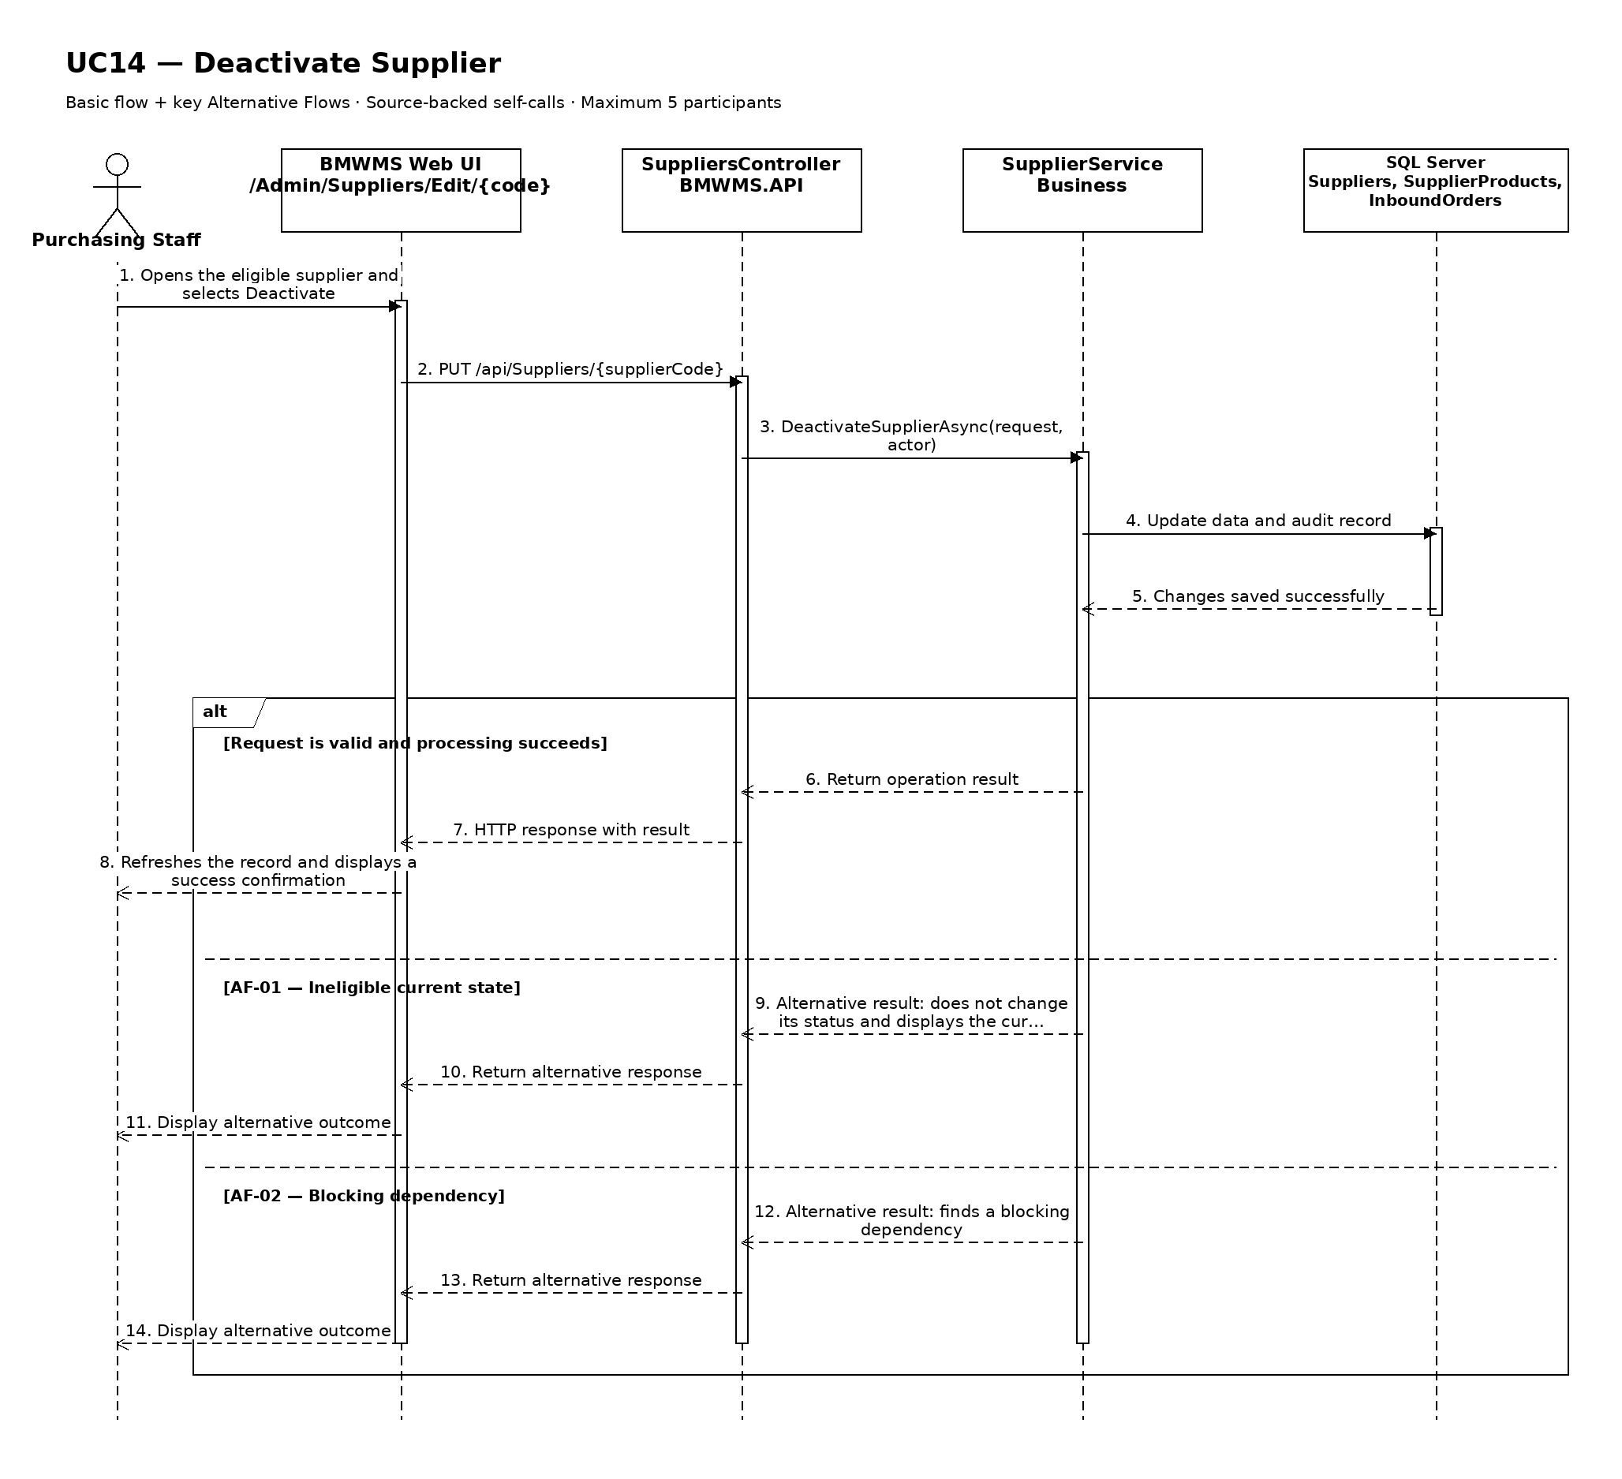

UC15: View Supplier Product List
Goal: Allows the user to view the products that a supplier can provide.
Field | Value
Type | UI
Primary Actor | Purchasing Staff
Secondary Actor(s) | —
Module | M03 - Supplier Management
Business Group | Supplied Products
FT-ID Ref | FT-15
Depends On | UC13
Preconditions | An active user is signed in and holds one of the allowed fixed roles.
Postconditions | No business record is changed. The current filters may remain in the user session.

Main Flow
- [U] The user opens Supplier Products.
- [S] The system loads the first page of supplier product records allowed for the user's role.
- [U] The user enters or changes one or more search and filter values.
- [S] The system validates the filter values and applies the authorized data scope.
- [S] The system displays product code, product name, unit, supplier product code, normal lead time, and relationship status, the matching-record count, and pagination controls.
- [U] The user may change sorting, move between pages, clear filters, or open an available record/action.

Alternative Flows
- AF-01 - No matching records: At the result step, no record satisfies the active filters. The system displays an explicit no-results state and keeps the filters available for revision.
- AF-02 - Invalid filter combination: When a date range or numeric range is invalid, the system does not run the search and identifies the fields that must be corrected.

Business Rules
- BR-01: Only supplier product records within the signed-in user's authorized scope may be returned (see PRD GB-02).
- BR-02: Results are sorted by product name ascending unless the user selects another supported sort.
- BR-03: Pagination must return a stable result order and a total matching-record count.
- BR-04: Each Supplier + Product relationship is unique.
- BR-05: An inactive supplier-product relationship cannot be selected for a new purchase or inbound reference.

Request Fields - SupplierProductListFilter
Field | Type | Rule
Supplier identifier | Text | Required. Identifies the selected supplier.
Product search | Text | Optional. Matches product code, name, or supplier product code.
Relationship status | Choice | Optional. ACTIVE or INACTIVE.
Page | Number | Optional. Starts at 1; values below 1 are rejected.
Page size | Number | Optional. Between 10 and 100; defaults to 20.

On success: Supplier Products displays the matching records and active filter summary.

Allowed Roles
System Administrator, Warehouse Manager, Purchasing Staff

Verification Criteria
Given | When | Then
at least one supplier product record exists within the user's authorized scope | the user submits a valid filter combination | only matching supplier product records are displayed in product name ascending order, with an accurate total count

Additional scenarios to cover in tests:
- Open the list with default filters.
- Search using a complete identifier.
- Combine two or more filters.
- Use a filter that returns no results.
- Change page size and verify stable pagination.

Sequence Diagram
Figure UC15. Sequence Diagram - View Supplier Product List
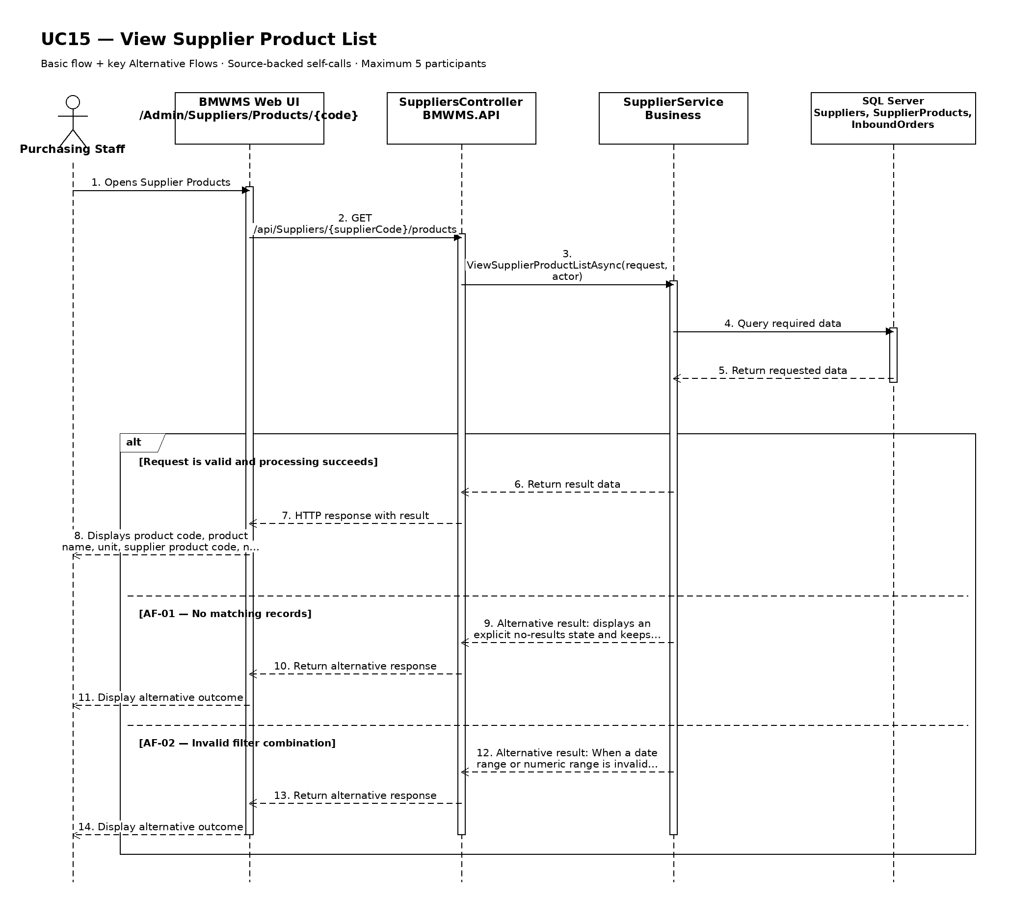

UC16: View Supplier Inbound History
Goal: Allows the user to review inbound transactions associated with a supplier.
Field | Value
Type | UI
Primary Actor | Purchasing Staff
Secondary Actor(s) | —
Module | M03 - Supplier Management
Business Group | Supplier Transaction History
FT-ID Ref | FT-16
Depends On | UC13
Preconditions | An active user is signed in and holds one of the allowed fixed roles. The selected supplier is visible to the user.
Postconditions | No business record is changed.

Main Flow
- [U] The user opens Supplier Inbound History for the selected supplier.
- [S] The system displays the latest authorized inbound order and receipt events.
- [U] The user enters a date range or selects event, status, product, lot, or location filters when available.
- [S] The system validates the filters and retrieves the retained history.
- [S] The system displays inbound number, purchase reference, expected date, receipt date, product quantities, condition summary, completion status, and supplemental-order relationship.
- [U] The user may change sorting, clear filters, or open an available referenced record.

Alternative Flows
- AF-01 - No history in the selected period: No event matches the filters. The system displays a no-history state without changing the selected record or filters.
- AF-02 - Invalid date range: The start date is after the end date or exceeds the allowed reporting range. The system identifies the invalid range and does not run the query.

Business Rules
- BR-01: History is read-only and is ordered newest first by default.
- BR-02: Only posted or retained business events are shown; cancelled records remain visible for traceability.
- BR-03: The displayed history must be reconcilable to immutable transaction or audit records where applicable (see PRD GB-12 and GB-20).
- BR-04: A supplemental inbound order is linked to the original Purchase Order and original Inbound Order (see PRD DR-07 and DR-08).

Request Fields - SupplierHistoryFilter
Field | Type | Rule
Supplier identifier | Text | Required. Must identify a visible record or history context.
From date | Date | Optional. Must not be later than To date.
To date | Date | Optional. Defaults to the current date.
Event type | Choice | Optional. One of the supported values for inbound order and receipt events.
Related reference | Text | Optional. Exact or partial order, transaction, lot, or document reference.

On success: Supplier Inbound History displays the matching retained history and active filters.

Allowed Roles
System Administrator, Warehouse Manager, Purchasing Staff

Verification Criteria
Given | When | Then
historical events exist for the selected supplier | the user submits a valid date range and event filter | the matching events are displayed in chronological order with their actor, reference, quantity or status effect, and time

Additional scenarios to cover in tests:
- View history with default filters.
- Filter by date range.
- Filter by event type and related reference.
- Use a period with no matching history.

Sequence Diagram
Figure UC16. Sequence Diagram - View Supplier Inbound History
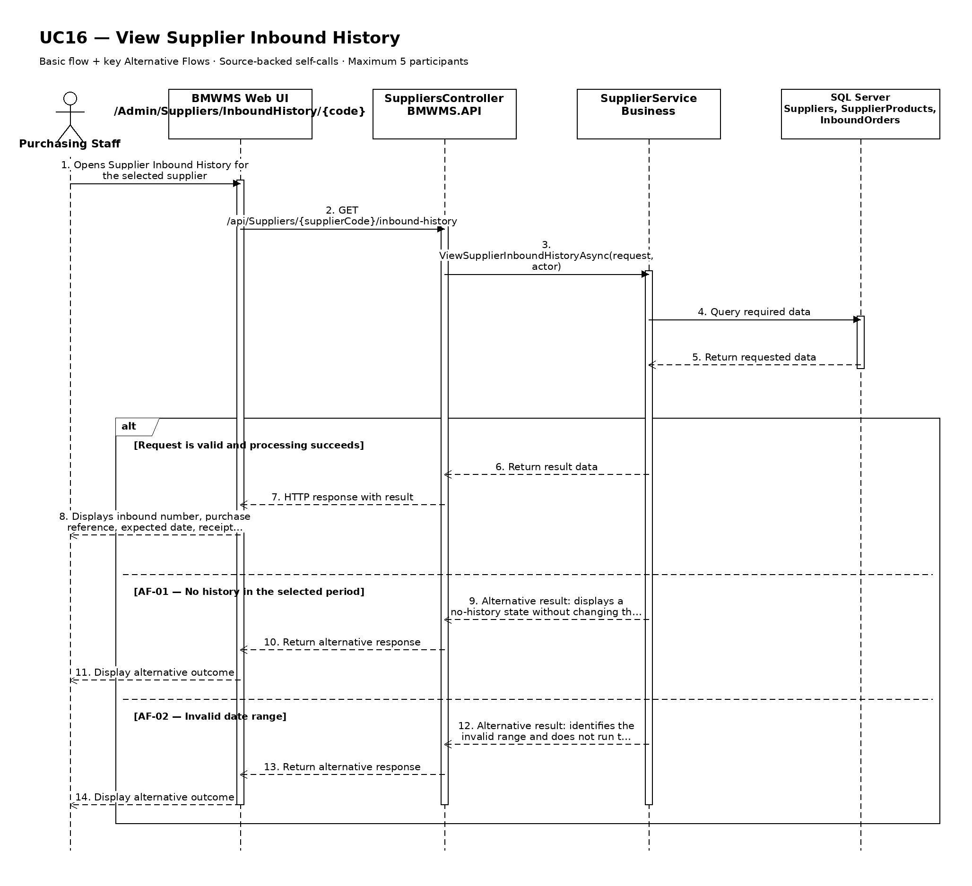

UC17: View Inbound Order List
Goal: Allows the user to search and view inbound orders by reference, supplier, date, and status.
Field | Value
Type | UI
Primary Actor | Purchasing Staff
Secondary Actor(s) | —
Module | M04 - Inbound Management
Business Group | Inbound Order Management
FT-ID Ref | FT-17
Depends On | —
Preconditions | An active user is signed in and holds one of the allowed fixed roles.
Postconditions | No business record is changed. The current filters may remain in the user session.

Main Flow
- [U] The user opens Inbound Order List.
- [S] The system loads the first page of inbound order records allowed for the user's role.
- [U] The user enters or changes one or more search and filter values.
- [S] The system validates the filter values and applies the authorized data scope.
- [S] The system displays inbound number, Purchase Order, supplier, expected date, line count, expected quantity, received quantity, supplemental flag, and status, the matching-record count, and pagination controls.
- [U] The user may change sorting, move between pages, clear filters, or open an available record/action.

Alternative Flows
- AF-01 - No matching records: At the result step, no record satisfies the active filters. The system displays an explicit no-results state and keeps the filters available for revision.
- AF-02 - Invalid filter combination: When a date range or numeric range is invalid, the system does not run the search and identifies the fields that must be corrected.

Business Rules
- BR-01: Only inbound order records within the signed-in user's authorized scope may be returned (see PRD GB-02).
- BR-02: Results are sorted by expected date descending and inbound number descending unless the user selects another supported sort.
- BR-03: Pagination must return a stable result order and a total matching-record count.
- BR-04: Supplemental orders must be visibly identified and linked to the original references.

Request Fields - InboundOrderListFilter
Field | Type | Rule
Search reference | Text | Optional. Inbound number, Purchase Order number, or supplemental reference.
Supplier | Choice | Optional. Active or historical supplier.
Status | Choice | Optional. DRAFT, READY, RECEIVING, RECEIVED, PUTAWAY_COMPLETED, or CANCELLED.
Expected date from/to | Date range | Optional. From date must not be after To date.
Page | Number | Optional. Starts at 1; values below 1 are rejected.
Page size | Number | Optional. Between 10 and 100; defaults to 20.

On success: Inbound Order List displays the matching records and active filter summary.

Allowed Roles
System Administrator, Warehouse Manager, Warehouse Staff, Purchasing Staff

Verification Criteria
Given | When | Then
at least one inbound order record exists within the user's authorized scope | the user submits a valid filter combination | only matching inbound order records are displayed in expected date descending and inbound number descending order, with an accurate total count

Additional scenarios to cover in tests:
- Open the list with default filters.
- Search using a complete identifier.
- Combine two or more filters.
- Use a filter that returns no results.
- Change page size and verify stable pagination.

Sequence Diagram
Figure UC17. Sequence Diagram - View Inbound Order List
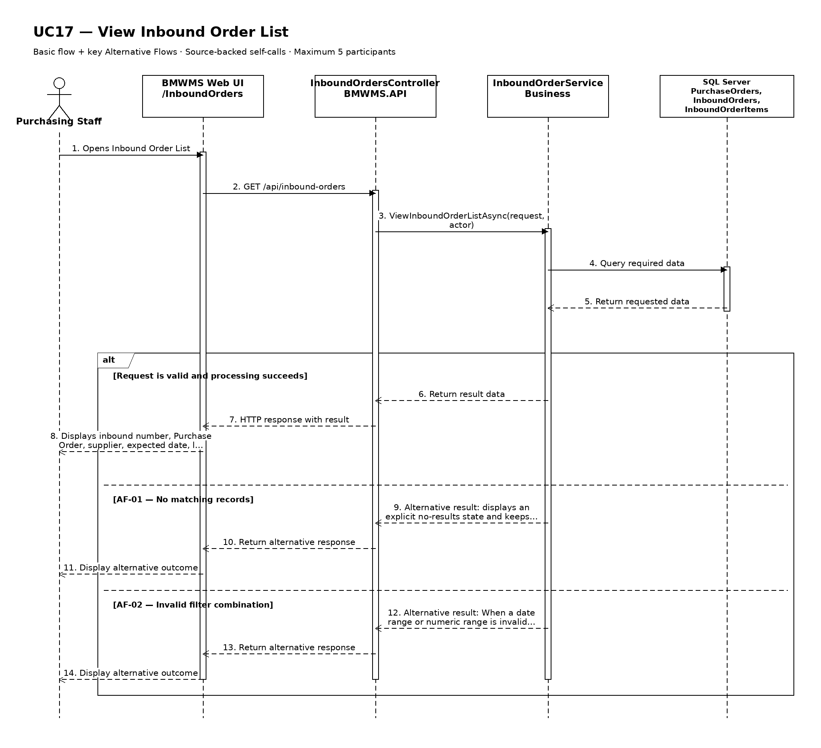

UC18: Create Inbound Order
Goal: Allows Purchasing Staff to create an expected inbound order, optionally referencing an approved purchase order.
Field | Value
Type | UI
Primary Actor | Purchasing Staff
Secondary Actor(s) | Warehouse Staff
Module | M04 - Inbound Management
Business Group | Inbound Order Management
FT-ID Ref | FT-18
Depends On | UC17
Preconditions | An active user is signed in and holds one of the allowed fixed roles. An eligible confirmed Purchase Order or approved supplemental-receipt requirement exists.
Postconditions | A new Inbound Order exists in READY status, or in DRAFT when the user explicitly saves a draft.

Main Flow
- [U] Purchasing Staff opens Inbound Order Create and selects an eligible Purchase Order or supplemental reference.
- [S] The system loads the supplier and remaining eligible Purchase Order lines.
- [U] Purchasing Staff enters the expected date, selected products, expected quantities, and notes.
- [S] The system validates the reference, supplier status, remaining quantities, duplicate lines, and supplemental relationship.
- [U] Purchasing Staff submits the complete order for receiving.
- [S] The system generates a unique inbound number, creates the Inbound Order and lines in READY status, and records the audit event.

Alternative Flows
- AF-01 - Save as draft: Instead of submitting, Purchasing Staff saves the incomplete record. The system creates it in DRAFT status; Warehouse Staff cannot receive it.
- AF-02 - Purchase reference ineligible: The Purchase Order is not CONFIRMED or PARTIALLY_RECEIVED, belongs to another supplier, or has no remaining eligible quantity. The system rejects the reference.
- AF-03 - Supplemental inbound order: Missing or damaged quantities require later supply. Purchasing Staff selects the original Purchase Order and Inbound Order, and the system limits the supplemental lines to the outstanding quantities.
- AF-04 - Duplicate product line: The same product is entered more than once. The system asks the user to combine the quantities into one planned line.

Business Rules
- BR-01: Inbound number is system-generated and unique (see PRD GB-04).
- BR-02: A Purchase Order may generate multiple Inbound Orders, including supplemental orders (see PRD DR-07).
- BR-03: Supplier and product references must be active when the order is submitted.
- BR-04: Expected quantity must be greater than zero and may not exceed the remaining eligible Purchase Order quantity without explicit authorized exception.
- BR-05: Invoice and Goods Receipt accounting documents are outside scope (see PRD DR-19).

Request Fields - InboundOrderCreateRequest
Field | Type | Rule
Purchase Order reference | Choice | Required. CONFIRMED or PARTIALLY_RECEIVED and eligible.
Supplier | Read-only | Derived from the selected Purchase Order.
Expected receipt date | Date | Required. Must be today or later unless authorized as a historical migration.
Supplemental order | Yes/No | Required. Defaults to No.
Original Inbound Order | Choice | Required only for a supplemental order.
Product lines | Repeating group | Required. At least one eligible product and positive expected quantity.
Notes | Text | Optional. Maximum 1,000 characters.

On success: The created Inbound Order detail is displayed with its generated number and READY status.

Allowed Roles
System Administrator, Warehouse Manager, Purchasing Staff

Verification Criteria
Given | When | Then
an eligible confirmed Purchase Order exists with at least one remaining product quantity | Purchasing Staff submits a valid Inbound Order | one READY Inbound Order is created with the correct supplier, Purchase Order reference, lines, creator, and audit record

Additional scenarios to cover in tests:
- Create a standard Inbound Order from a confirmed Purchase Order.
- Save an Inbound Order as DRAFT.
- Create a supplemental Inbound Order for missing quantity.
- Create a supplemental Inbound Order for damaged quantity replacement.
- Attempt to exceed the remaining Purchase Order quantity.

Sequence Diagram
Figure UC18. Sequence Diagram - Create Inbound Order
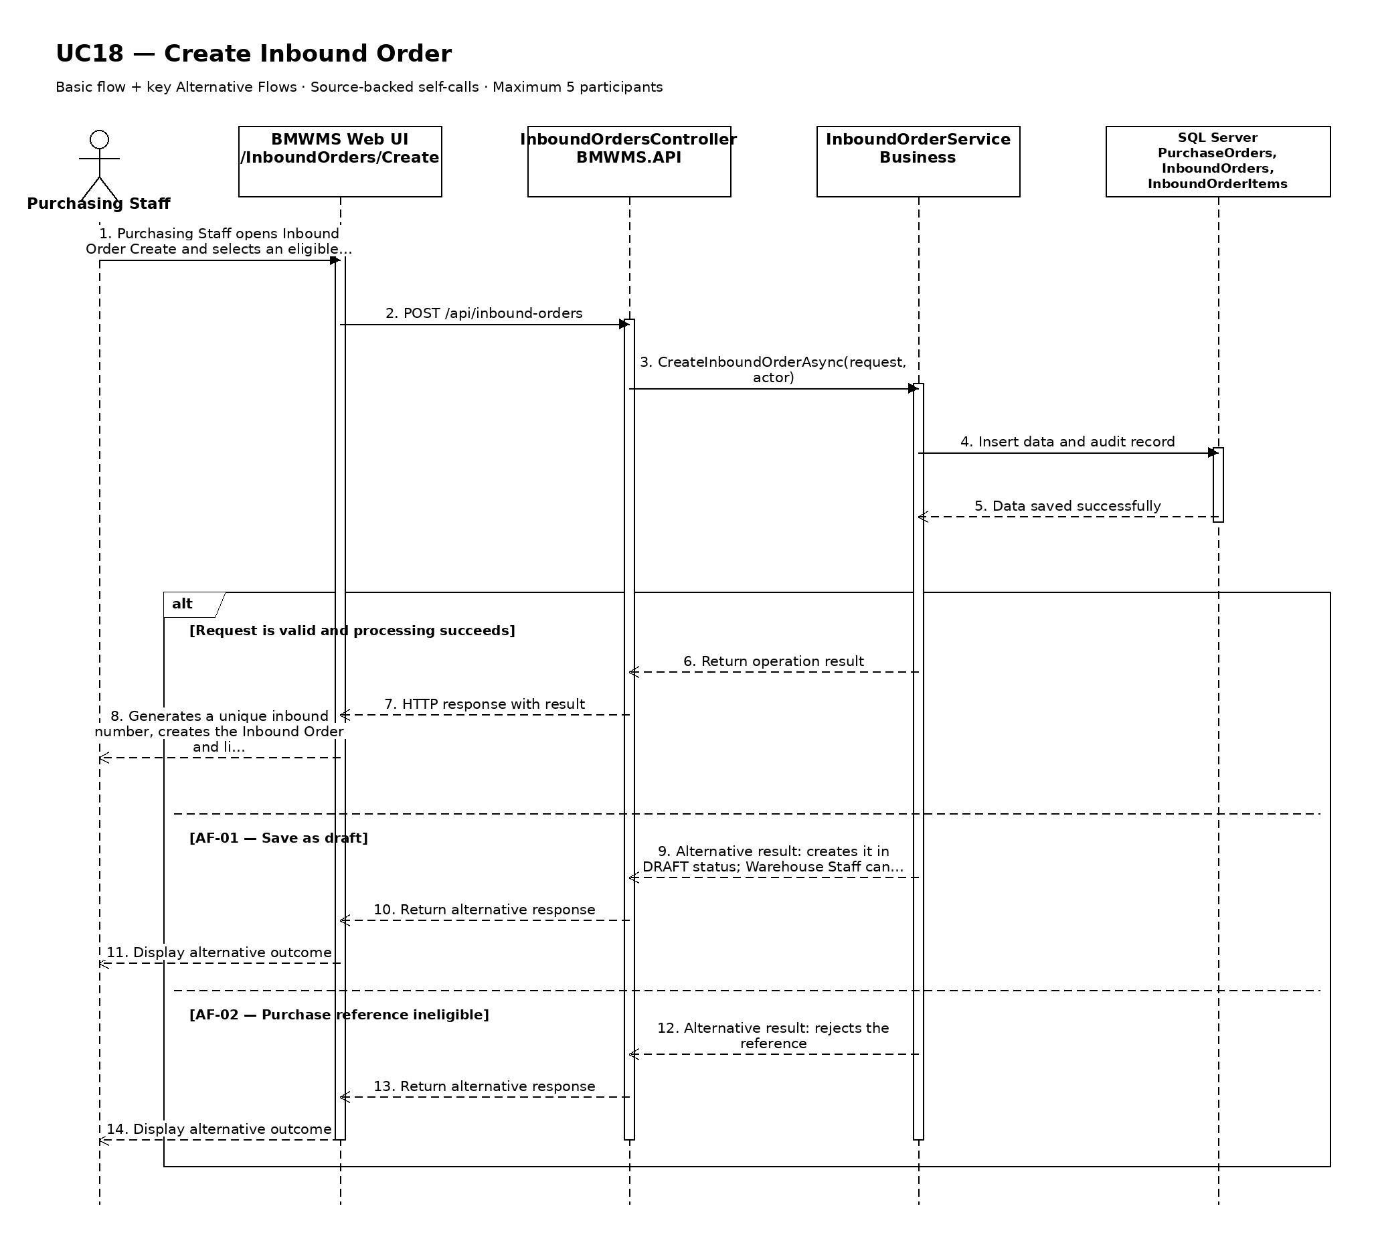

UC19: Edit Inbound Order
Goal: Allows Purchasing Staff to update an inbound order before receiving confirmation.
Field | Value
Type | UI
Primary Actor | Purchasing Staff
Secondary Actor(s) | Warehouse Staff
Module | M04 - Inbound Management
Business Group | Inbound Order Management
FT-ID Ref | FT-19
Depends On | UC20
Preconditions | An active user is signed in and holds one of the allowed fixed roles. The selected inbound order is in an editable state.
Postconditions | The permitted inbound order information is updated; its history is retained.

Main Flow
- [U] The user opens an eligible inbound order and selects Edit.
- [S] The system opens Inbound Order Edit with the current values and edit restrictions.
- [U] The user changes one or more permitted values and submits the form.
- [S] The system rechecks the current record version, status, field rules, references, and uniqueness.
- [S] The system saves the permitted changes and records the update in the audit log.
- [S] The system returns to the inbound order detail and confirms the update.

Alternative Flows
- AF-01 - Record state no longer permits editing: At save time, the record is no longer in DRAFT or READY before receiving has started. The system rejects the update, reloads the current record, and explains why it cannot be edited.
- AF-02 - Concurrent update: Another user saved a newer version after the form was opened. The system does not overwrite it and asks the user to review the latest values.
- AF-03 - Validation failure: One or more changed values fail validation. The system keeps all unsaved changes and identifies the invalid fields.

Business Rules
- BR-01: The record is editable only in DRAFT or READY before receiving has started.
- BR-02: Inbound number, Purchase Order, supplier, supplemental reference, and any confirmed execution detail are immutable.
- BR-03: A successful update records the editor, update time, and before/after audit summary (see PRD GB-20).
- BR-04: Changing submitted quantities must remain within the eligible Purchase Order balance.
- BR-05: A READY order edited successfully remains READY; a DRAFT order remains DRAFT unless separately submitted.

Request Fields - InboundOrderUpdateRequest
Field | Type | Rule
Expected receipt date | Date | Required. Today or later for an operational order.
Product lines | Repeating group | Required. At least one eligible product with positive quantity.
Notes | Text | Optional. Maximum 1,000 characters.

On success: The updated inbound order detail is displayed with a success confirmation.

Allowed Roles
System Administrator, Warehouse Manager, Purchasing Staff

Verification Criteria
Given | When | Then
an eligible inbound order exists and has not been changed by another user | the user submits valid changes to permitted fields | the inbound order contains the new values, protected values remain unchanged, and the audit trail records the update

Additional scenarios to cover in tests:
- Update one permitted inbound order field.
- Update multiple permitted fields.
- Attempt to change a protected identifier.
- Attempt to update an ineligible state.
- Simulate a concurrent update conflict.

Sequence Diagram
Figure UC19. Sequence Diagram - Edit Inbound Order
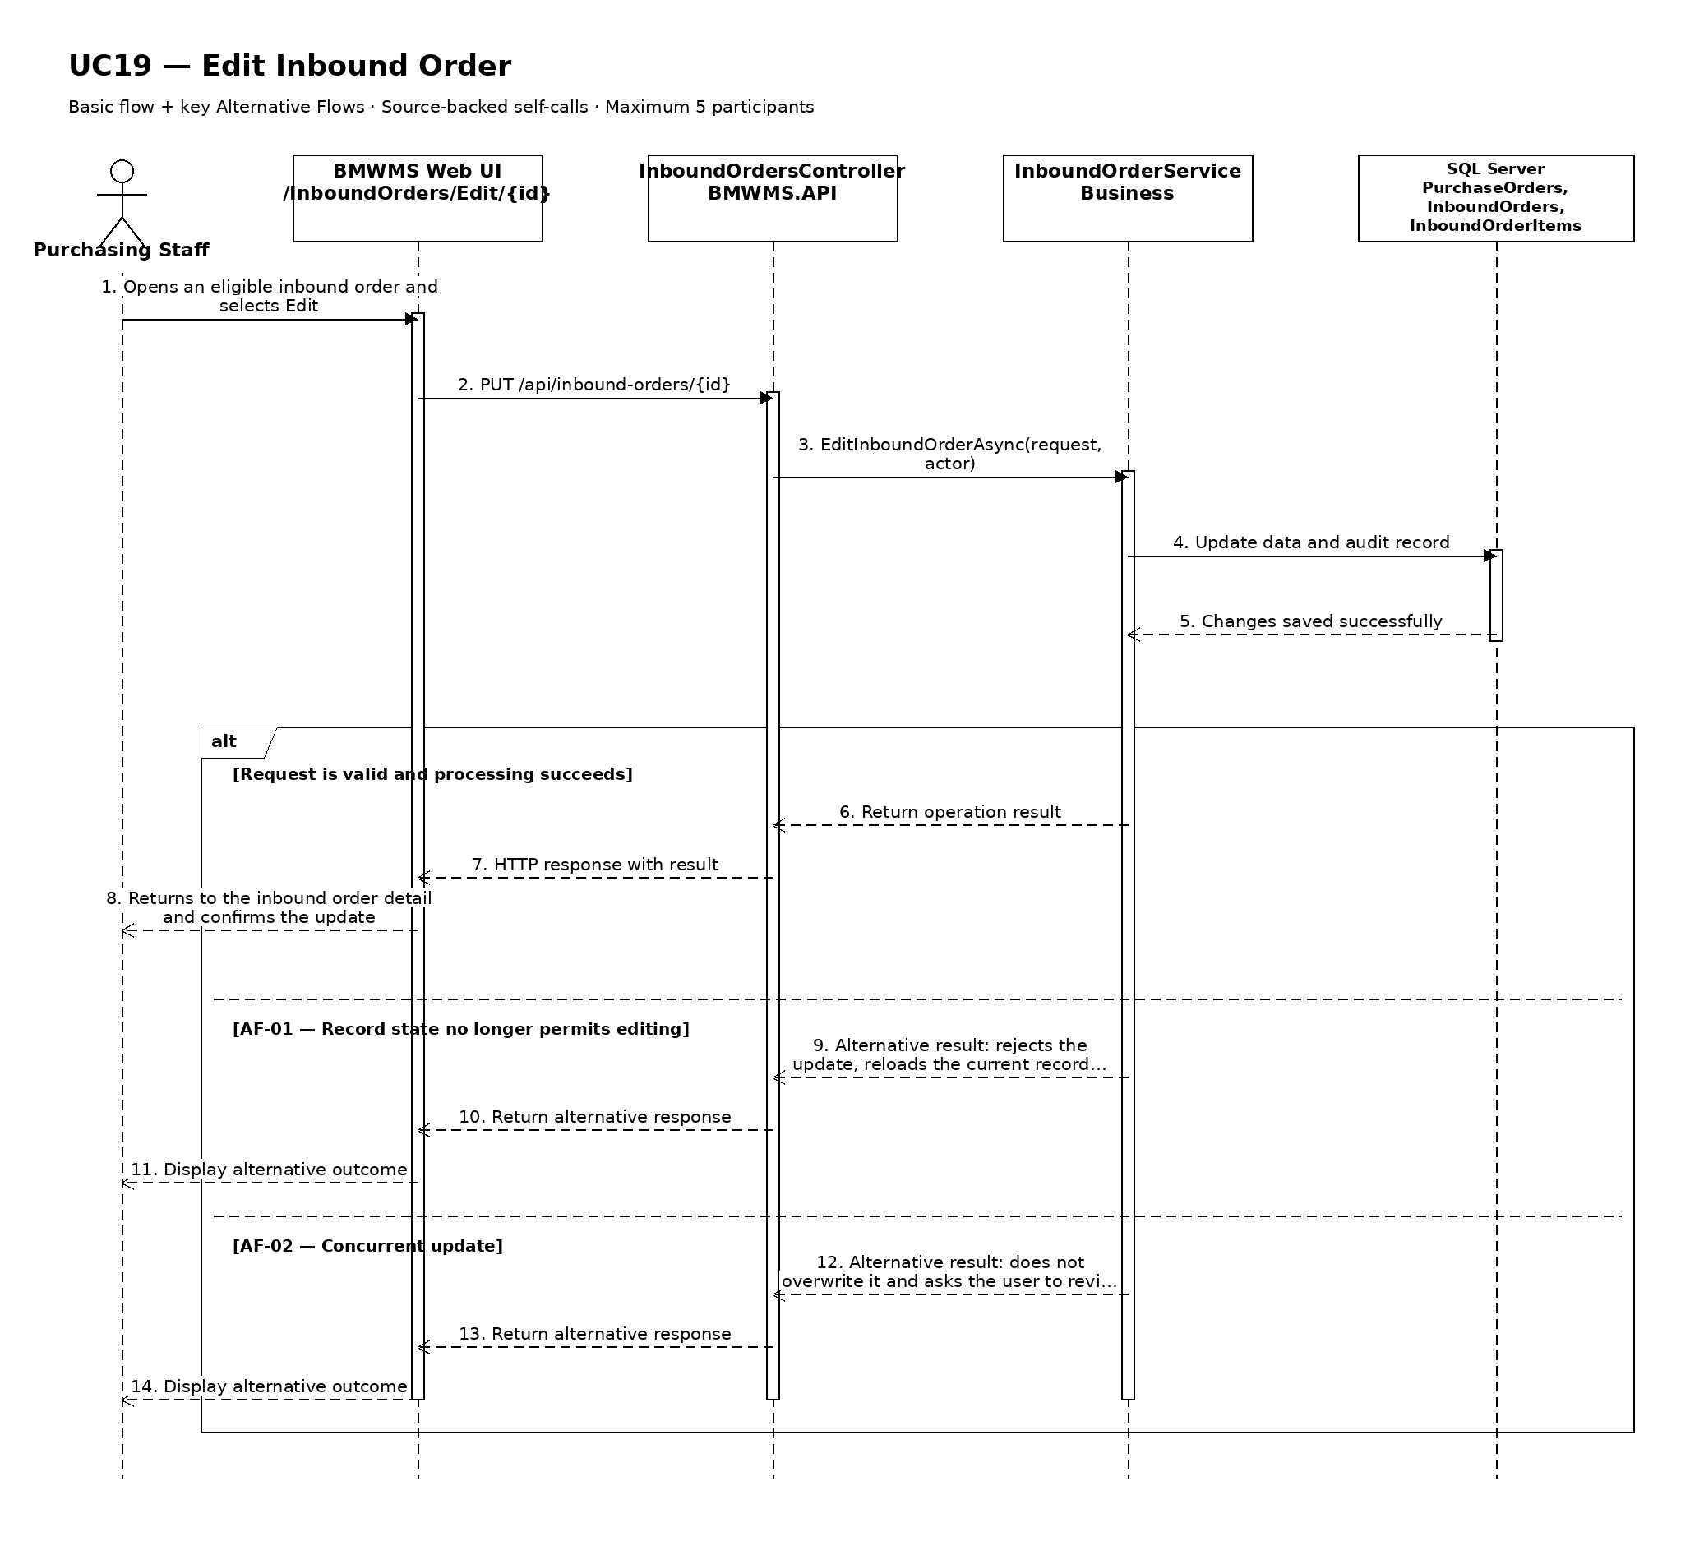

UC20: View Inbound Order Details
Goal: Allows the user to view inbound order references, lines, expected quantities, actual quantities, lots, and status.
Field | Value
Type | UI
Primary Actor | Purchasing Staff
Secondary Actor(s) | Warehouse Staff
Module | M04 - Inbound Management
Business Group | Inbound Order Management
FT-ID Ref | FT-20
Depends On | UC17
Preconditions | An active user is signed in and holds one of the allowed fixed roles. A inbound order record is available to the user.
Postconditions | No business data is changed.

Main Flow
- [U] The user selects a inbound order record from the related list or search result.
- [S] The system verifies that the record exists and is visible to the user's role.
- [S] The system opens Inbound Order Details.
- [S] The system displays inbound number, Purchase Order, supplier, expected date, supplemental references, planned lines, received quantities, lot and condition data, putaway bins, status history, and audit information.
- [S] The system shows only the actions that are valid for the current status and role.
- [U] The user reviews the information and may navigate to an available related view or action.

Alternative Flows
- AF-01 - Record no longer available: After the user selects the record, the inbound order no longer exists or is outside the user's scope. The system returns to the source view and displays a non-destructive notice.
- AF-02 - Historical or inactive record: The record is inactive or completed. The system still displays retained history but hides actions that are not permitted in the current state.

Business Rules
- BR-01: The selected inbound order identifier must resolve to exactly one record.
- BR-02: Displayed actions are determined by the signed-in user's fixed role and the record's current state (see PRD GB-02).
- BR-03: Historical records remain viewable and are not physically deleted (see PRD GB-03).
- BR-04: Expected, received, and putaway quantities are displayed separately.
- BR-05: Confirmed execution rows identify Product/ProductLot + StorageLocation + Quantity (see PRD DR-13).

Request Fields - InboundOrderDetailRequest
Field | Type | Rule
Inbound Order identifier | Text | Required. Must identify an existing record visible to the signed-in user.

On success: Inbound Order Details displays the complete authorized view of the selected inbound order.

Allowed Roles
System Administrator, Warehouse Manager, Warehouse Staff, Purchasing Staff

Verification Criteria
Given | When | Then
a visible inbound order record exists | the user opens that record | inbound number, Purchase Order, supplier, expected date, supplemental references, planned lines, received quantities, lot and condition data, putaway bins, status history, and audit information are displayed and no unauthorized action is offered

Additional scenarios to cover in tests:
- View an active inbound order record.
- View an inactive or completed inbound order record.
- Open a record through a direct authorized link.
- Attempt to open a missing or unauthorized record.

Sequence Diagram
Figure UC20. Sequence Diagram - View Inbound Order Details
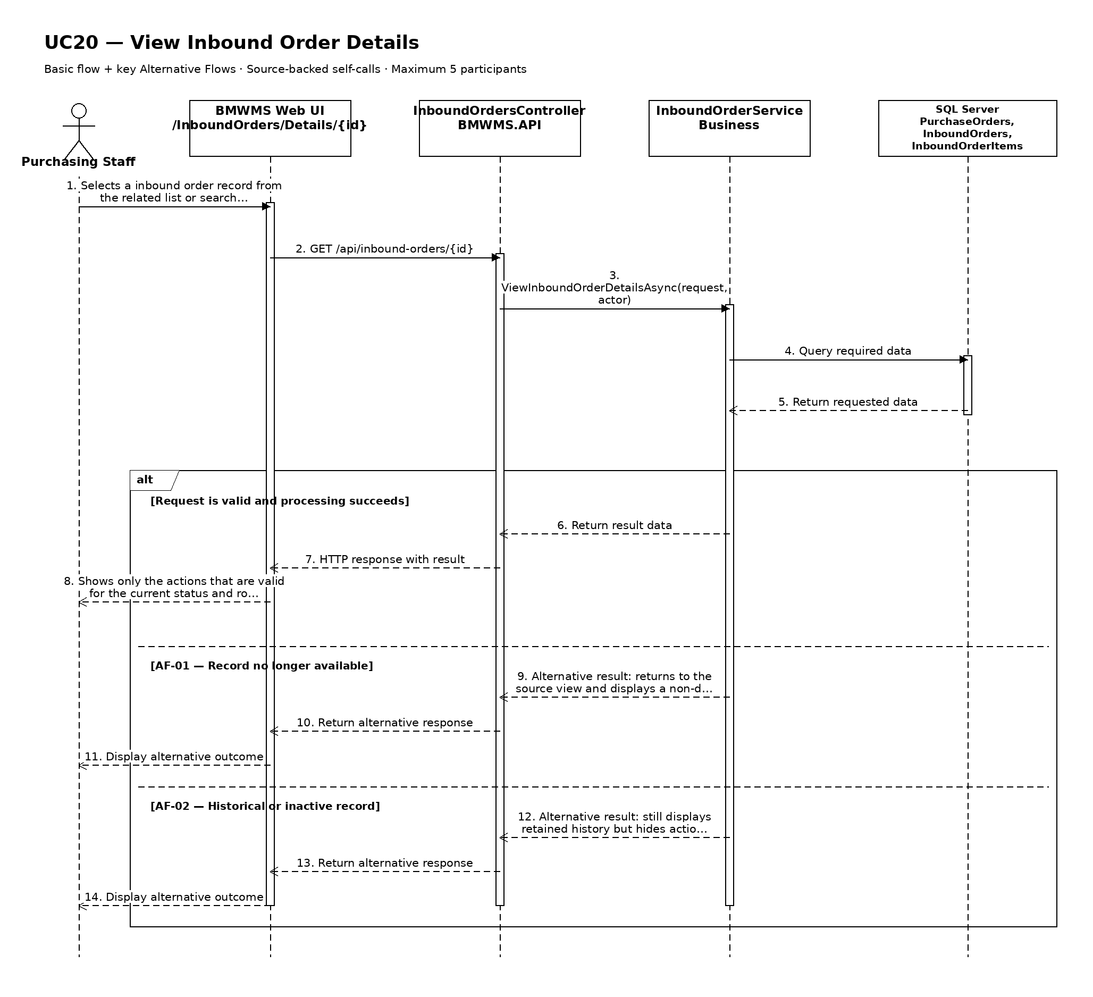

UC21: Cancel Inbound Order
Goal: Allows Purchasing Staff to cancel an inbound order that has not been operationally confirmed.
Field | Value
Type | UI
Primary Actor | Purchasing Staff
Secondary Actor(s) | —
Module | M04 - Inbound Management
Business Group | Inbound Order Management
FT-ID Ref | FT-21
Depends On | UC20
Preconditions | An active user is signed in and holds one of the allowed fixed roles. The selected inbound order is in DRAFT or READY.
Postconditions | The inbound order status is CANCELLED; historical data is retained.

Main Flow
- [U] The user opens the eligible inbound order and selects Cancel.
- [S] The system displays the confirmation, current status, and consequences of the action.
- [U] The user enters the cancellation reason, selects the intended action if applicable, and confirms.
- [S] The system rechecks the current status, blocking dependencies, and the user's permission.
- [S] The system changes the status to CANCELLED and records the reason and actor.
- [S] The system refreshes the record and displays a success confirmation.

Alternative Flows
- AF-01 - Ineligible current state: The record is not in DRAFT or READY. The system does not change its status and displays the currently allowed actions.
- AF-02 - Blocking dependency: The system finds a blocking dependency. The action is rejected because receiving must not have started and no receipt or putaway transaction may exist for the order.
- AF-03 - User cancels confirmation: The user closes the confirmation without submitting. The record remains unchanged and no audit event is created for a completed action.

Business Rules
- BR-01: The action may start only when the inbound order is in DRAFT or READY.
- BR-02: receiving must not have started and no receipt or putaway transaction may exist for the order.
- BR-03: The cancellation reason is required and is retained in history.
- BR-04: The record is not physically deleted; the status change preserves historical references (see PRD GB-03).
- BR-05: The status change is written to the audit log (see PRD GB-20).

Request Fields - InboundOrderCancelRequest
Field | Type | Rule
Inbound Order identifier | Text | Required. Must identify an existing record visible to the user.
Cancellation reason | Text | Required. Between 5 and 500 characters.
Confirmation | Yes/No | Required. The change is applied only when explicitly confirmed.

On success: The inbound order detail is displayed with status CANCELLED.

Allowed Roles
System Administrator, Warehouse Manager, Purchasing Staff

Verification Criteria
Given | When | Then
an eligible inbound order exists with no blocking dependency | the user confirms cancel with a valid reason | the status becomes CANCELLED, history is retained, and an audit event records the change

Additional scenarios to cover in tests:
- Complete cancel from an eligible state.
- Cancel from the confirmation dialog.
- Attempt the action from an ineligible state.
- Attempt the action while a blocking dependency exists.

Sequence Diagram
Figure UC21. Sequence Diagram - Cancel Inbound Order
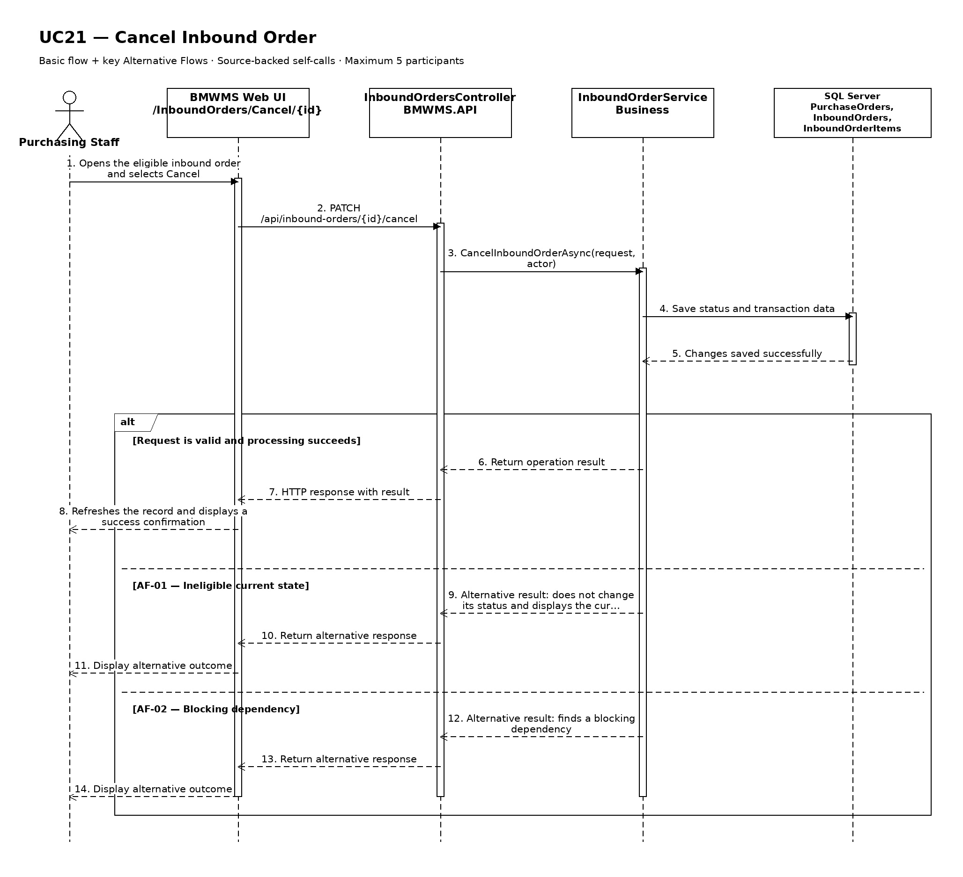

UC22: Confirm Warehouse Receipt
Goal: Allows Warehouse Staff to confirm actual received quantity, lot, expiry information, and item condition.
Field | Value
Type | UI
Primary Actor | Warehouse Staff
Secondary Actor(s) | Purchasing Staff, Warehouse Manager
Module | M04 - Inbound Management
Business Group | Receiving Execution
FT-ID Ref | FT-22
Depends On | UC20
Preconditions | An active user is signed in and holds one of the allowed fixed roles. The selected Inbound Order is READY or RECEIVING and is assigned or available for warehouse execution.
Postconditions | Actual receipt details are confirmed; the Inbound Order is RECEIVED when every planned line has a receipt decision.

Main Flow
- [U] Warehouse Staff opens an eligible Inbound Order and starts receiving.
- [S] The system locks the current execution version, changes READY to RECEIVING, and displays the planned lines.
- [U] Warehouse Staff enters actual delivered quantity, accepted quantity, damaged quantity, lot number, manufacture/expiry information when required, and condition notes for each line.
- [S] The system validates quantities, lot and expiry rules, duplicate lots, and the relationship to the planned lines.
- [U] Warehouse Staff confirms the receipt after reviewing the calculated missing and damaged quantities.
- [S] The system saves immutable receipt execution details, records the actor/time, changes the order to RECEIVED when complete, and notifies the relevant roles.

Alternative Flows
- AF-01 - Missing quantity: Actual delivered quantity is below expected quantity. The system records the actual receipt and missing quantity, completes the receipt decision, and makes the shortage available for a supplemental Inbound Order; it does not reopen the receipt.
- AF-02 - Damaged goods: Some delivered quantity is damaged. Warehouse Staff records the damaged quantity and condition. The system retains the receipt evidence and makes the replacement quantity available for a supplemental Inbound Order.
- AF-03 - Required lot or expiry missing: The product group requires lot or expiry control but a value is absent or invalid. The system blocks confirmation for that line and identifies the missing data.
- AF-04 - Partial working save: Warehouse Staff saves progress without final confirmation. The order remains RECEIVING and no final inventory transaction is posted.
- AF-05 - Concurrent execution: Another staff member is already confirming the same version. The system blocks the second confirmation and reloads the latest execution state.

Business Rules
- BR-01: Actual delivered, accepted, and damaged quantities must be zero or greater, and accepted + damaged may not exceed delivered quantity.
- BR-02: FEFO-controlled products require a lot number and a valid future expiry date; FIFO products require a received date or equivalent sequence (see PRD DR-05 and GB-05).
- BR-03: Missing or damaged quantities are handled through a supplemental Inbound Order referencing the original Purchase Order and Inbound Order (see PRD DR-08).
- BR-04: Receipt confirmation is atomic and writes immutable execution and audit data (see PRD GB-11 and GB-20).
- BR-05: No Invoice or accounting Goods Receipt is created by this use case (see PRD DR-19).

Request Fields - WarehouseReceiptConfirmationRequest
Field | Type | Rule
Inbound Order | Text | Required. READY or RECEIVING and visible to Warehouse Staff.
Product line | Choice | Required. Must belong to the selected Inbound Order.
Actual delivered quantity | Number | Required. Zero or greater.
Accepted quantity | Number | Required. Zero or greater and not greater than delivered quantity.
Damaged quantity | Number | Required. Zero or greater.
Lot number | Text | Required for lot-controlled products; unique per product when new.
Manufacture date | Date | Optional unless configured by the group; not after receipt date.
Expiry date | Date | Required for expiry-controlled products; must be after receipt date.
Condition | Choice | Required. ACCEPTED, DAMAGED, or MIXED.
Condition notes | Text | Required when damage or shortage exists; maximum 1,000 characters.

On success: Inbound Order Details shows actual quantities, lots, conditions, receipt actor/time, and RECEIVED status when complete.

Allowed Roles
System Administrator, Warehouse Manager, Warehouse Staff

Verification Criteria
Given | When | Then
a READY Inbound Order exists with valid planned lines | Warehouse Staff submits valid actual receipt information for every line | the actual receipt is stored once, shortage and damage are recorded, the order becomes RECEIVED, and no accounting Goods Receipt is created

Additional scenarios to cover in tests:
- Confirm a complete undamaged receipt.
- Confirm a receipt with missing quantity.
- Confirm a receipt with damaged quantity.
- Receive an FEFO-controlled product with valid lot and expiry.
- Reject a missing expiry date for an expiry-controlled product.
- Save a partial working receipt and resume it.

Sequence Diagram
Figure UC22. Sequence Diagram - Confirm Warehouse Receipt
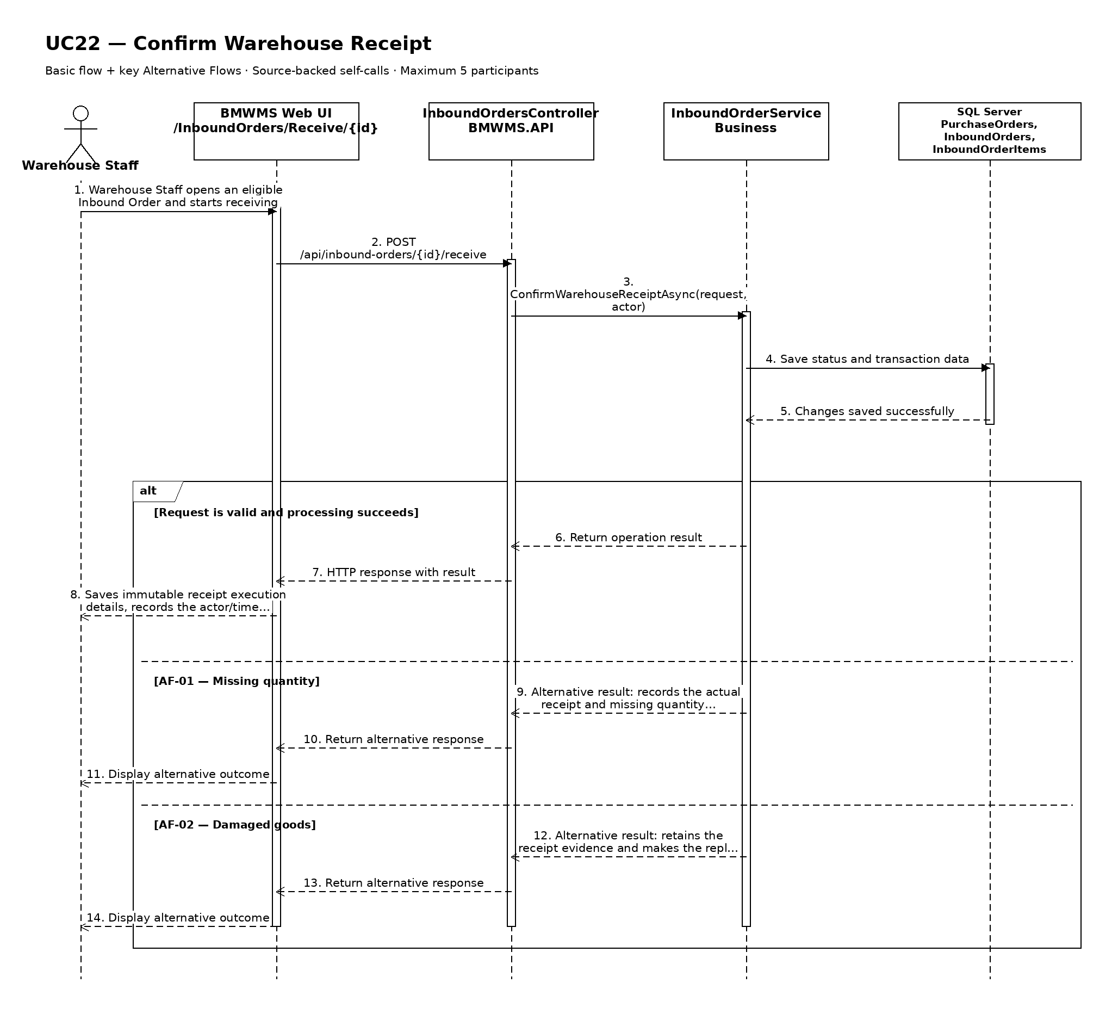

UC23: Confirm Putaway to Fixed Location
Goal: Allows Warehouse Staff to confirm the product, lot, quantity, and fixed storage location used for putaway.
Field | Value
Type | UI
Primary Actor | Warehouse Staff
Secondary Actor(s) | Warehouse Manager
Module | M04 - Inbound Management
Business Group | Fixed Putaway
FT-ID Ref | FT-23
Depends On | UC22
Preconditions | An active user is signed in and holds one of the allowed fixed roles. The Inbound Order is RECEIVED and has accepted quantity not yet assigned to a destination bin.
Postconditions | Accepted quantity is stored in confirmed destination bins; the order is PUTAWAY_COMPLETED when all eligible quantity is assigned.

Main Flow
- [U] Warehouse Staff opens Fixed Putaway Confirmation for a RECEIVED Inbound Order.
- [S] The system displays each accepted product/lot quantity and its configured fixed location or eligible fixed-zone locations.
- [U] Warehouse Staff selects the actual destination bin and enters the quantity placed there; a line may be divided across multiple bins.
- [S] The system validates location status, warehouse ownership, product-location compatibility, quantity totals, and duplicate execution rows.
- [U] Warehouse Staff reviews and confirms the completed destination allocations.
- [S] The system creates InboundOrderDetail rows and posted InventoryTransaction entries, updates Inventory by product + lot + bin, and changes the order to PUTAWAY_COMPLETED when fully allocated.

Alternative Flows
- AF-01 - Configured fixed location unavailable: The default bin is BLOCKED, INACTIVE, or operationally unavailable. Warehouse Staff reports the issue; the Warehouse Manager authorizes another valid fixed location before confirmation.
- AF-02 - Split putaway: One bin cannot hold the full quantity. Warehouse Staff creates multiple destination rows; the sum must equal the eligible received quantity.
- AF-03 - Partial putaway: Only part of the accepted quantity is placed. The system saves confirmed rows and keeps the order RECEIVED until the remaining quantity is assigned.
- AF-04 - Quantity changed concurrently: A confirmed allocation or receipt changes the remaining quantity. The system rejects the stale submission and reloads the current balance.

Business Rules
- BR-01: Fixed Location is the default putaway strategy (see PRD GB-06).
- BR-02: Every confirmed row identifies exactly one Inbound Order line, Product/ProductLot, StorageLocation, and positive Quantity (see PRD DR-13).
- BR-03: Destination locations must belong to the configured warehouse and may not be BLOCKED or INACTIVE.
- BR-04: The total confirmed putaway quantity may not exceed the accepted received quantity.
- BR-05: Inventory detail and ledger posting are atomic (see PRD GB-11).

Request Fields - FixedPutawayConfirmationRequest
Field | Type | Rule
Inbound Order | Text | Required. Must be RECEIVED and have quantity awaiting putaway.
Product and lot | Read-only | Derived from the confirmed receipt line.
Eligible quantity | Read-only | Accepted quantity minus previously confirmed putaway quantity.
Destination location | Choice | Required. Active, non-blocked, compatible bin in the configured warehouse.
Putaway quantity | Number | Required. Greater than zero and not greater than the eligible quantity.
Manager exception authorization | Choice | Required only when the configured fixed location cannot be used.
Notes | Text | Optional; required for an authorized location exception.

On success: Putaway details and updated bin balances are displayed; fully allocated orders show PUTAWAY_COMPLETED.

Allowed Roles
System Administrator, Warehouse Manager, Warehouse Staff

Verification Criteria
Given | When | Then
a RECEIVED Inbound Order has accepted quantity awaiting putaway and a valid destination bin exists | Warehouse Staff confirms destination rows whose quantities equal the eligible received quantity | execution details and inventory transactions are posted atomically and the order becomes PUTAWAY_COMPLETED

Additional scenarios to cover in tests:
- Put all quantity into the configured fixed bin.
- Split one product lot across two bins.
- Save a partial putaway and complete it later.
- Use a manager-authorized alternate bin.
- Reject a BLOCKED or INACTIVE destination.
- Reject a putaway total above accepted quantity.

Sequence Diagram
Figure UC23. Sequence Diagram - Confirm Putaway to Fixed Location
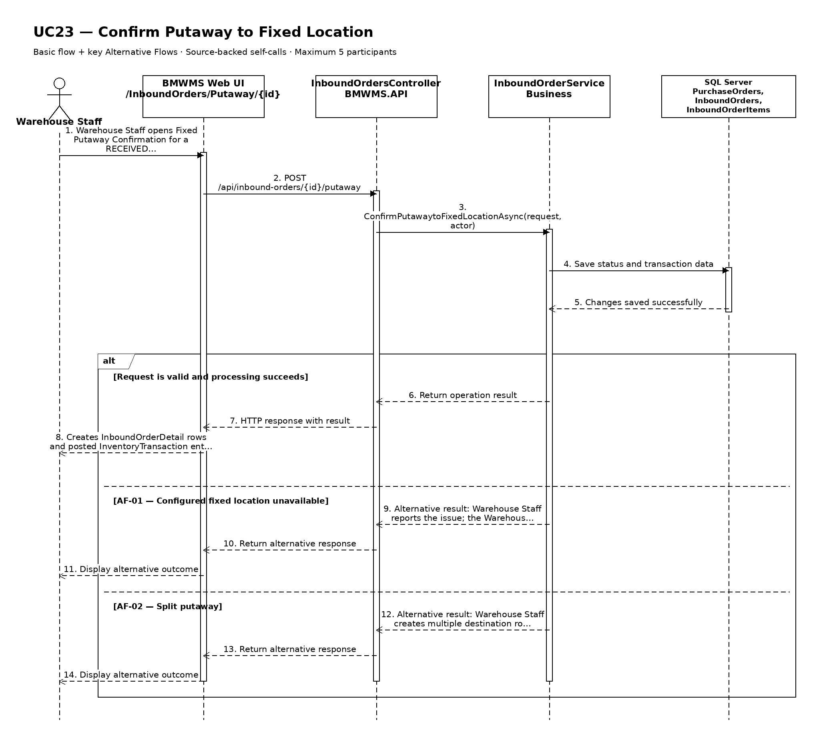

UC24: View Inbound History
Goal: Allows the user to review completed, cancelled, overdue, and supplemental inbound activity.
Field | Value
Type | UI
Primary Actor | Purchasing Staff
Secondary Actor(s) | —
Module | M04 - Inbound Management
Business Group | Inbound History
FT-ID Ref | FT-24
Depends On | UC17
Preconditions | An active user is signed in and holds one of the allowed fixed roles. The selected inbound order is visible to the user.
Postconditions | No business record is changed.

Main Flow
- [U] The user opens Inbound History for the selected inbound order.
- [S] The system displays the latest authorized created, edited, cancelled, received, putaway, overdue, shortage, damage, and supplemental-order events.
- [U] The user enters a date range or selects event, status, product, lot, or location filters when available.
- [S] The system validates the filters and retrieves the retained history.
- [S] The system displays inbound number, Purchase Order, supplier, dates, expected/received/putaway quantities, shortage and damage, status, supplemental references, actor, and event time.
- [U] The user may change sorting, clear filters, or open an available referenced record.

Alternative Flows
- AF-01 - No history in the selected period: No event matches the filters. The system displays a no-history state without changing the selected record or filters.
- AF-02 - Invalid date range: The start date is after the end date or exceeds the allowed reporting range. The system identifies the invalid range and does not run the query.

Business Rules
- BR-01: History is read-only and is ordered newest first by default.
- BR-02: Only posted or retained business events are shown; cancelled records remain visible for traceability.
- BR-03: The displayed history must be reconcilable to immutable transaction or audit records where applicable (see PRD GB-12 and GB-20).
- BR-04: Completed and cancelled records remain visible.
- BR-05: Supplemental orders are cross-linked to the original Purchase Order and Inbound Order.

Request Fields - InboundOrderHistoryFilter
Field | Type | Rule
Inbound Order identifier | Text | Required. Must identify a visible record or history context.
From date | Date | Optional. Must not be later than To date.
To date | Date | Optional. Defaults to the current date.
Event type | Choice | Optional. One of the supported values for created, edited, cancelled, received, putaway, overdue, shortage, damage, and supplemental-order events.
Related reference | Text | Optional. Exact or partial order, transaction, lot, or document reference.

On success: Inbound History displays the matching retained history and active filters.

Allowed Roles
System Administrator, Warehouse Manager, Warehouse Staff, Purchasing Staff

Verification Criteria
Given | When | Then
historical events exist for the selected inbound order | the user submits a valid date range and event filter | the matching events are displayed in chronological order with their actor, reference, quantity or status effect, and time

Additional scenarios to cover in tests:
- View history with default filters.
- Filter by date range.
- Filter by event type and related reference.
- Use a period with no matching history.

Sequence Diagram
Figure UC24. Sequence Diagram - View Inbound History
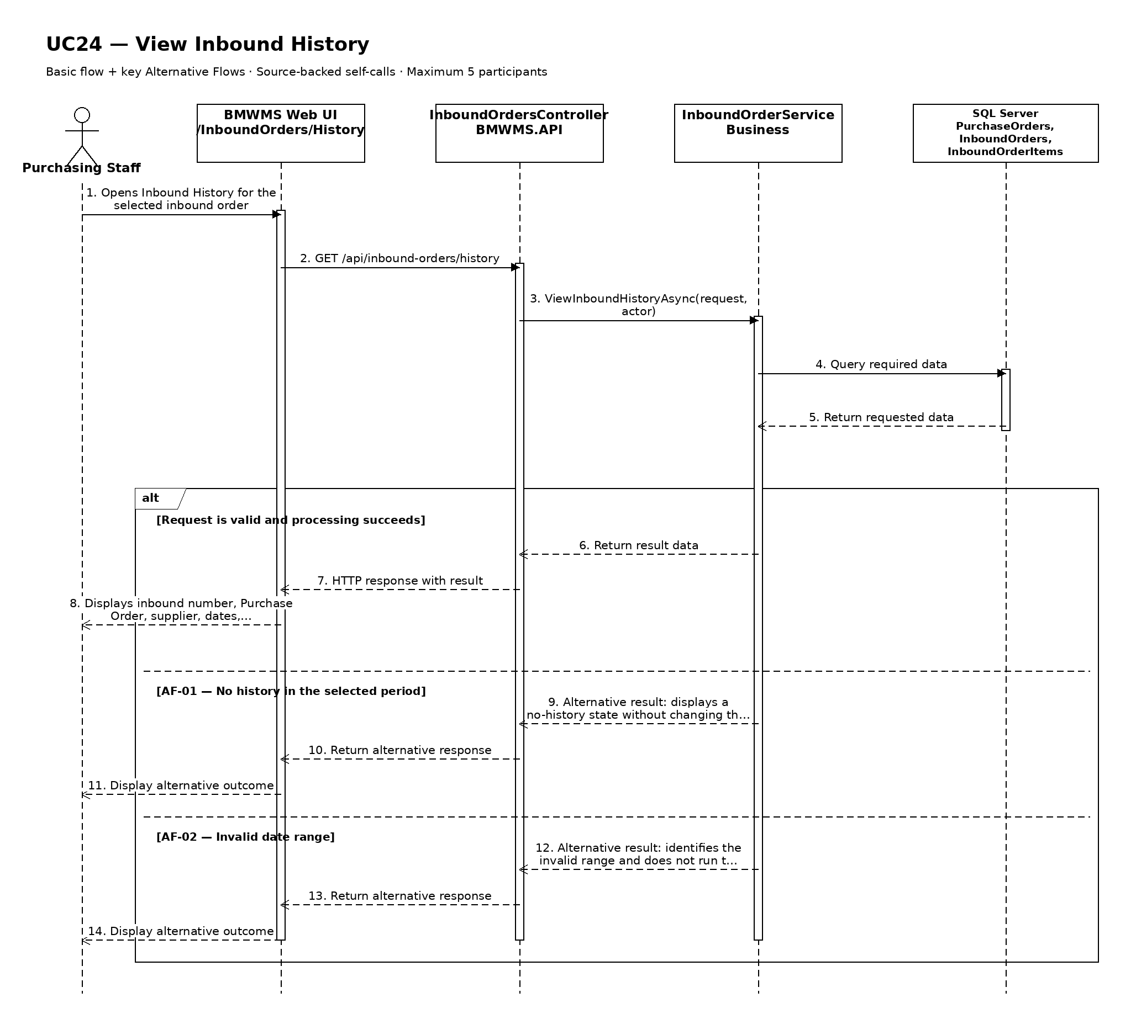

UC25: View Outbound Order List
Goal: Allows the user to search and view outbound orders by reference, customer, date, and status.
Field | Value
Type | UI
Primary Actor | Sales Staff
Secondary Actor(s) | —
Module | M05 - Outbound Management
Business Group | Outbound Order Management
FT-ID Ref | FT-25
Depends On | —
Preconditions | An active user is signed in and holds one of the allowed fixed roles.
Postconditions | No business record is changed. The current filters may remain in the user session.

Main Flow
- [U] The user opens Outbound Order List.
- [S] The system loads the first page of outbound order records allowed for the user's role.
- [U] The user enters or changes one or more search and filter values.
- [S] The system validates the filter values and applies the authorized data scope.
- [S] The system displays outbound number, Sales Order, customer, required date, requested quantity, reserved quantity, issued quantity, and status, the matching-record count, and pagination controls.
- [U] The user may change sorting, move between pages, clear filters, or open an available record/action.

Alternative Flows
- AF-01 - No matching records: At the result step, no record satisfies the active filters. The system displays an explicit no-results state and keeps the filters available for revision.
- AF-02 - Invalid filter combination: When a date range or numeric range is invalid, the system does not run the search and identifies the fields that must be corrected.

Business Rules
- BR-01: Only outbound order records within the signed-in user's authorized scope may be returned (see PRD GB-02).
- BR-02: Results are sorted by required date descending and outbound number descending unless the user selects another supported sort.
- BR-03: Pagination must return a stable result order and a total matching-record count.

Request Fields - OutboundOrderListFilter
Field | Type | Rule
Search reference | Text | Optional. Outbound number or Sales Order number.
Customer | Text | Optional. Customer code or name.
Status | Choice | Optional. DRAFT, RESERVED, READY, ISSUING, ISSUED, or CANCELLED.
Required date from/to | Date range | Optional. From date must not be after To date.
Page | Number | Optional. Starts at 1; values below 1 are rejected.
Page size | Number | Optional. Between 10 and 100; defaults to 20.

On success: Outbound Order List displays the matching records and active filter summary.

Allowed Roles
System Administrator, Warehouse Manager, Warehouse Staff, Sales Staff

Verification Criteria
Given | When | Then
at least one outbound order record exists within the user's authorized scope | the user submits a valid filter combination | only matching outbound order records are displayed in required date descending and outbound number descending order, with an accurate total count

Additional scenarios to cover in tests:
- Open the list with default filters.
- Search using a complete identifier.
- Combine two or more filters.
- Use a filter that returns no results.
- Change page size and verify stable pagination.

Sequence Diagram
Figure UC25. Sequence Diagram - View Outbound Order List
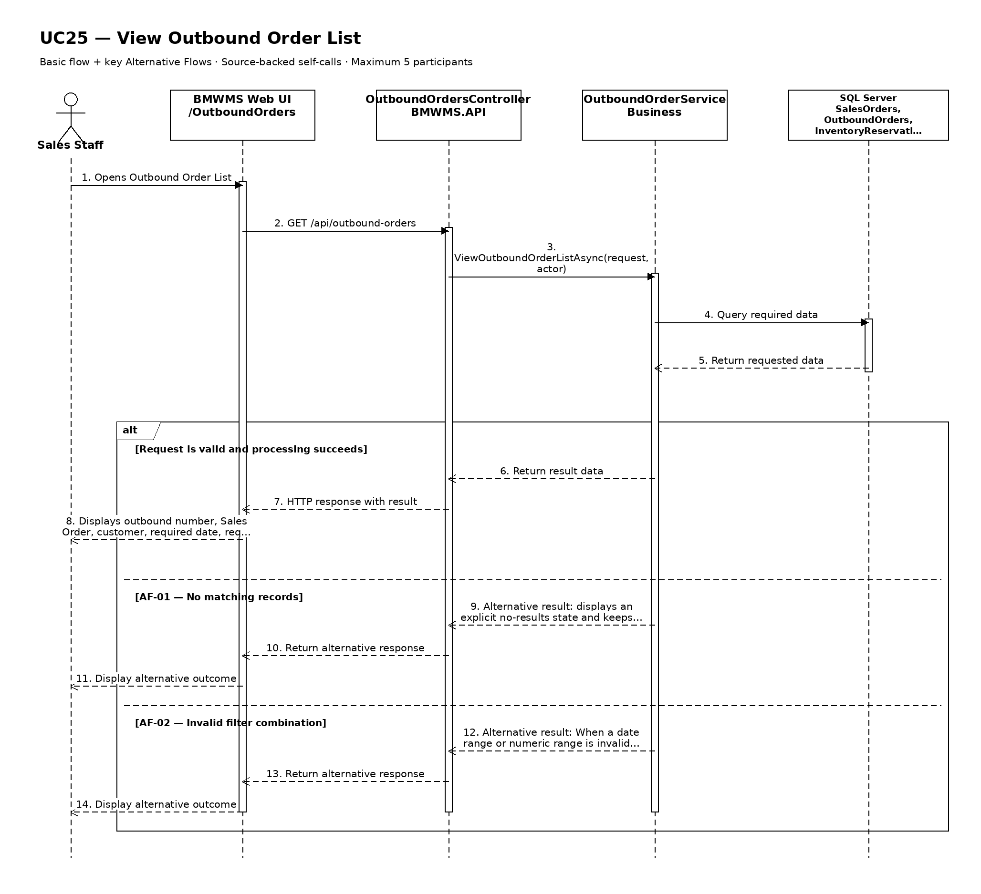

UC26: Create Outbound Order
Goal: Allows Sales Staff to create an outbound order referencing a confirmed sales requirement.
Field | Value
Type | UI
Primary Actor | Sales Staff
Secondary Actor(s) | Warehouse Staff
Module | M05 - Outbound Management
Business Group | Outbound Order Management
FT-ID Ref | FT-26
Depends On | UC30
Preconditions | An active user is signed in and holds one of the allowed fixed roles. Inventory availability has been checked, a Sales Order is CONFIRMED, and eligible reservation data exists.
Postconditions | A new Outbound Order exists in READY status and references the confirmed Sales Order and its reservation.

Main Flow
- [U] Sales Staff opens Outbound Order Create and selects a CONFIRMED Sales Order.
- [S] The system loads the customer, Sales Order lines, active reservations, required date, and remaining issue quantities.
- [U] Sales Staff reviews the lines, enters the required issue date and operational notes, and submits the order.
- [S] The system validates the Sales Order, active reservation, customer, quantities, and duplicate outbound references.
- [S] The system generates a unique outbound number and creates the Outbound Order and lines in READY status.
- [S] The system displays the created order and notifies Warehouse Staff that it is ready for execution.

Alternative Flows
- AF-01 - Sales Order not confirmed: The selected Sales Order is DRAFT or CANCELLED. The system blocks creation and requires a confirmed sales requirement.
- AF-02 - Reservation missing or expired: One or more Sales Order lines have no sufficient ACTIVE reservation. The system returns the user to UC30 to check and reserve inventory.
- AF-03 - Partial outbound order: The Sales Order permits a partial issue. Sales Staff selects reserved quantities not exceeding the remaining Sales Order quantities; the remaining lines stay open.
- AF-04 - Duplicate active outbound: An active Outbound Order already covers the same reserved quantity. The system prevents duplicate allocation.

Business Rules
- BR-01: Inventory availability must be checked before Sales Order confirmation; reservation is created for the confirmed Sales Order (see PRD DR-09).
- BR-02: Outbound number is system-generated and unique (see PRD GB-04).
- BR-03: Every outbound line must reference a Sales Order line and may not exceed its remaining reserved quantity.
- BR-04: A READY Outbound Order is executed using Single Order Picking (see PRD GB-07).
- BR-05: Creating the order does not reduce on-hand inventory.

Request Fields - OutboundOrderCreateRequest
Field | Type | Rule
Sales Order reference | Choice | Required. Must be CONFIRMED with eligible remaining quantity.
Customer | Read-only | Derived from the selected Sales Order.
Required issue date | Date | Required. Today or later for an operational order.
Reserved product lines | Repeating group | Required. At least one line with positive ACTIVE reserved quantity.
Operational notes | Text | Optional. Maximum 1,000 characters.

On success: The Outbound Order detail is displayed with generated number, READY status, and linked reservations.

Allowed Roles
System Administrator, Warehouse Manager, Sales Staff

Verification Criteria
Given | When | Then
a confirmed Sales Order has sufficient active reserved quantity | Sales Staff submits a valid Outbound Order | one READY Outbound Order is created without reducing on-hand quantity and Warehouse Staff is notified

Additional scenarios to cover in tests:
- Create an Outbound Order for a fully reserved Sales Order.
- Create a permitted partial Outbound Order.
- Reject a DRAFT Sales Order.
- Reject an expired or insufficient reservation.
- Prevent duplicate allocation of the same reservation.

Sequence Diagram
Figure UC26. Sequence Diagram - Create Outbound Order
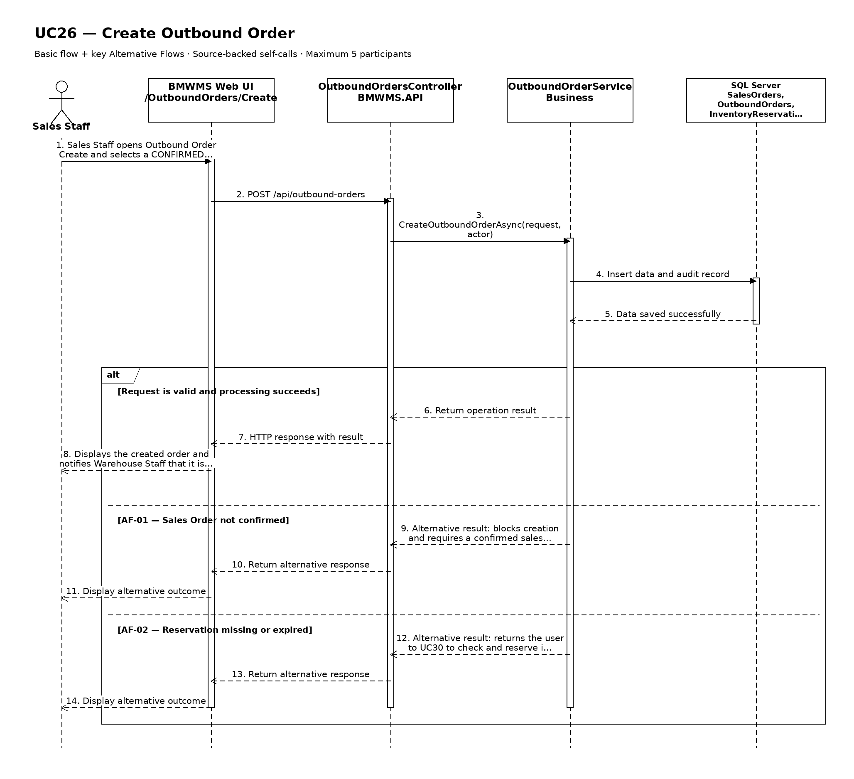

UC27: Edit Outbound Order
Goal: Allows Sales Staff to update an outbound order before warehouse execution.
Field | Value
Type | UI
Primary Actor | Sales Staff
Secondary Actor(s) | Warehouse Staff
Module | M05 - Outbound Management
Business Group | Outbound Order Management
FT-ID Ref | FT-27
Depends On | UC28
Preconditions | An active user is signed in and holds one of the allowed fixed roles. The selected outbound order is in an editable state.
Postconditions | The permitted outbound order information is updated; its history is retained.

Main Flow
- [U] The user opens an eligible outbound order and selects Edit.
- [S] The system opens Outbound Order Edit with the current values and edit restrictions.
- [U] The user changes one or more permitted values and submits the form.
- [S] The system rechecks the current record version, status, field rules, references, and uniqueness.
- [S] The system saves the permitted changes and records the update in the audit log.
- [S] The system returns to the outbound order detail and confirms the update.

Alternative Flows
- AF-01 - Record state no longer permits editing: At save time, the record is no longer in DRAFT, RESERVED, or READY before issue execution starts. The system rejects the update, reloads the current record, and explains why it cannot be edited.
- AF-02 - Concurrent update: Another user saved a newer version after the form was opened. The system does not overwrite it and asks the user to review the latest values.
- AF-03 - Validation failure: One or more changed values fail validation. The system keeps all unsaved changes and identifies the invalid fields.

Business Rules
- BR-01: The record is editable only in DRAFT, RESERVED, or READY before issue execution starts.
- BR-02: Outbound number, Sales Order, customer, and confirmed issue details are immutable.
- BR-03: A successful update records the editor, update time, and before/after audit summary (see PRD GB-20).
- BR-04: A quantity increase requires a successful UC30 availability and reservation update before save.
- BR-05: Removing or decreasing a line releases the unused reservation atomically.

Request Fields - OutboundOrderUpdateRequest
Field | Type | Rule
Required issue date | Date | Required. Today or later for an operational order.
Reserved product lines | Repeating group | Required. Must remain within active reserved quantity.
Operational notes | Text | Optional. Maximum 1,000 characters.

On success: The updated outbound order detail is displayed with a success confirmation.

Allowed Roles
System Administrator, Warehouse Manager, Sales Staff

Verification Criteria
Given | When | Then
an eligible outbound order exists and has not been changed by another user | the user submits valid changes to permitted fields | the outbound order contains the new values, protected values remain unchanged, and the audit trail records the update

Additional scenarios to cover in tests:
- Update one permitted outbound order field.
- Update multiple permitted fields.
- Attempt to change a protected identifier.
- Attempt to update an ineligible state.
- Simulate a concurrent update conflict.

Sequence Diagram
Figure UC27. Sequence Diagram - Edit Outbound Order
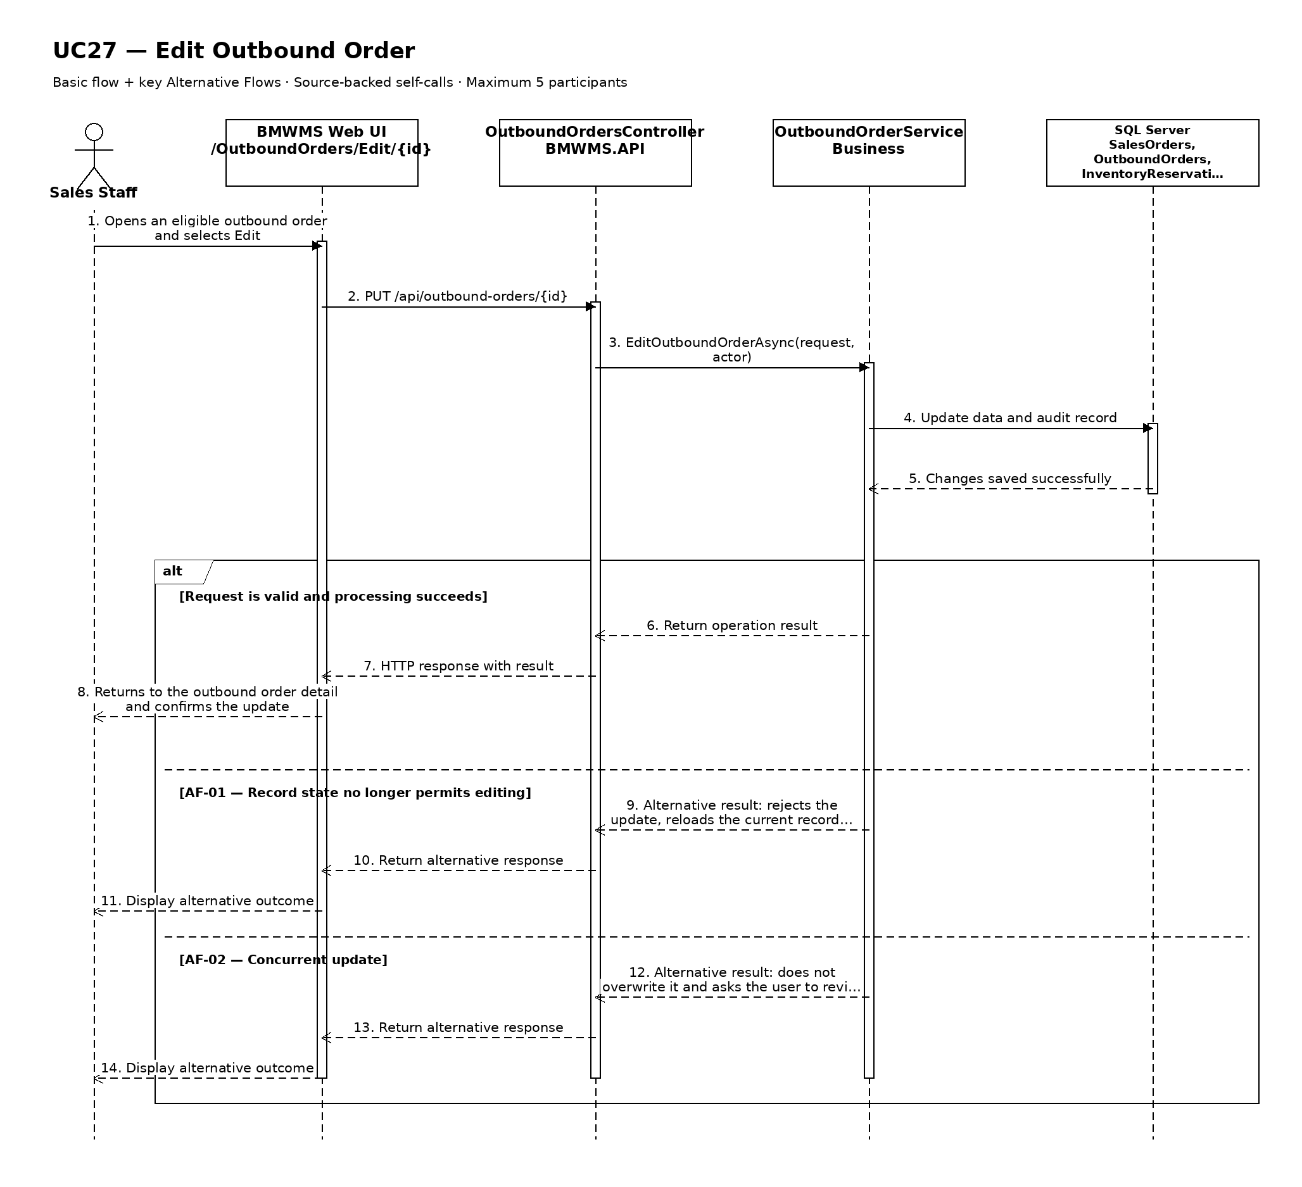

UC28: View Outbound Order Details
Goal: Allows the user to view outbound references, lines, reservations, selected lots and locations, and status.
Field | Value
Type | UI
Primary Actor | Sales Staff
Secondary Actor(s) | Warehouse Staff
Module | M05 - Outbound Management
Business Group | Outbound Order Management
FT-ID Ref | FT-28
Depends On | UC25
Preconditions | An active user is signed in and holds one of the allowed fixed roles. A outbound order record is available to the user.
Postconditions | No business data is changed.

Main Flow
- [U] The user selects a outbound order record from the related list or search result.
- [S] The system verifies that the record exists and is visible to the user's role.
- [S] The system opens Outbound Order Details.
- [S] The system displays outbound number, Sales Order, customer, requested/reserved/issued quantities, selected lots and bins, issue actor/time, status history, cancellation reason, and audit information.
- [S] The system shows only the actions that are valid for the current status and role.
- [U] The user reviews the information and may navigate to an available related view or action.

Alternative Flows
- AF-01 - Record no longer available: After the user selects the record, the outbound order no longer exists or is outside the user's scope. The system returns to the source view and displays a non-destructive notice.
- AF-02 - Historical or inactive record: The record is inactive or completed. The system still displays retained history but hides actions that are not permitted in the current state.

Business Rules
- BR-01: The selected outbound order identifier must resolve to exactly one record.
- BR-02: Displayed actions are determined by the signed-in user's fixed role and the record's current state (see PRD GB-02).
- BR-03: Historical records remain viewable and are not physically deleted (see PRD GB-03).
- BR-04: On-hand, reserved, and available quantities are displayed separately.
- BR-05: Confirmed execution rows identify Product/ProductLot + StorageLocation + Quantity (see PRD DR-13).

Request Fields - OutboundOrderDetailRequest
Field | Type | Rule
Outbound Order identifier | Text | Required. Must identify an existing record visible to the signed-in user.

On success: Outbound Order Details displays the complete authorized view of the selected outbound order.

Allowed Roles
System Administrator, Warehouse Manager, Warehouse Staff, Sales Staff

Verification Criteria
Given | When | Then
a visible outbound order record exists | the user opens that record | outbound number, Sales Order, customer, requested/reserved/issued quantities, selected lots and bins, issue actor/time, status history, cancellation reason, and audit information are displayed and no unauthorized action is offered

Additional scenarios to cover in tests:
- View an active outbound order record.
- View an inactive or completed outbound order record.
- Open a record through a direct authorized link.
- Attempt to open a missing or unauthorized record.

Sequence Diagram
Figure UC28. Sequence Diagram - View Outbound Order Details
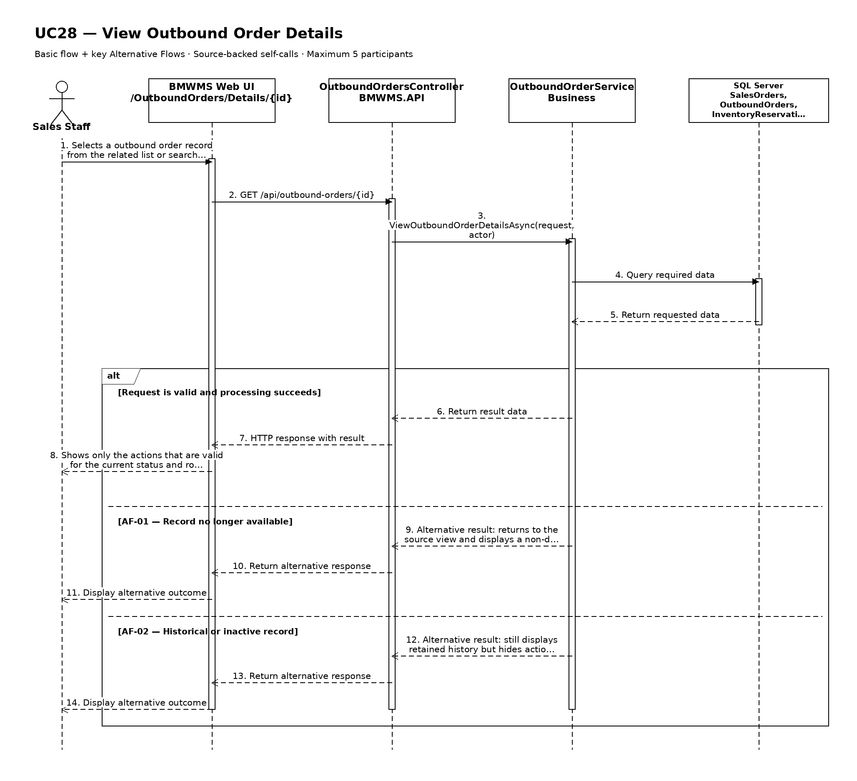

UC29: Cancel Outbound Order
Goal: Allows Sales Staff to cancel an outbound order that has not been confirmed as issued.
Field | Value
Type | UI
Primary Actor | Sales Staff
Secondary Actor(s) | Warehouse Staff
Module | M05 - Outbound Management
Business Group | Outbound Order Management
FT-ID Ref | FT-29
Depends On | UC28
Preconditions | An active user is signed in and holds one of the allowed fixed roles. The Outbound Order is DRAFT, RESERVED, or READY and no issue quantity has been confirmed.
Postconditions | The Outbound Order is CANCELLED and all unused ACTIVE reservations linked only to it are RELEASED.

Main Flow
- [U] Sales Staff opens the eligible Outbound Order and selects Cancel.
- [S] The system displays the current order status, reserved quantities, and the reservations that will be released.
- [U] Sales Staff enters a cancellation reason and confirms.
- [S] The system rechecks that issue execution has not started and identifies the releasable reservations.
- [S] The system atomically changes the order to CANCELLED, changes unused reservations to RELEASED, and recalculates available quantity.
- [S] The system displays the cancelled order and records the action in the audit log.

Alternative Flows
- AF-01 - Issue already started: The order is ISSUING or has confirmed issue detail. Cancellation is rejected; any correction must use an authorized compensating process outside this use case.
- AF-02 - Reservation already consumed or released: The reservation state has changed. The system reloads current values and releases only eligible ACTIVE quantity.
- AF-03 - User cancels confirmation: The dialog is closed without confirmation. No status or reservation changes occur.

Business Rules
- BR-01: Only DRAFT, RESERVED, or READY orders with zero issued quantity may be cancelled.
- BR-02: Unused reservation release and order cancellation are one atomic operation (see PRD GB-09 and GB-11).
- BR-03: Cancellation reason is required and retained with the order.
- BR-04: Cancelled orders and released reservations remain visible historically (see PRD GB-03).

Request Fields - OutboundOrderCancellationRequest
Field | Type | Rule
Outbound Order | Text | Required. Eligible visible order.
Cancellation reason | Text | Required. Between 5 and 500 characters.
Confirmation | Yes/No | Required. Cancellation is applied only when explicitly confirmed.

On success: The order displays CANCELLED and previously unused reservation quantity is available again.

Allowed Roles
System Administrator, Warehouse Manager, Sales Staff

Verification Criteria
Given | When | Then
a READY Outbound Order has active unused reservations and zero issued quantity | Sales Staff confirms cancellation with a valid reason | the order becomes CANCELLED, unused reservations become RELEASED, available quantity increases correctly, and an audit event is recorded

Additional scenarios to cover in tests:
- Cancel a READY order with full unused reservation.
- Cancel a partially allocated but unissued order.
- Reject cancellation after issue starts.
- Cancel the confirmation dialog without changes.
- Verify released quantity returns to available inventory.

Sequence Diagram
Figure UC29. Sequence Diagram - Cancel Outbound Order
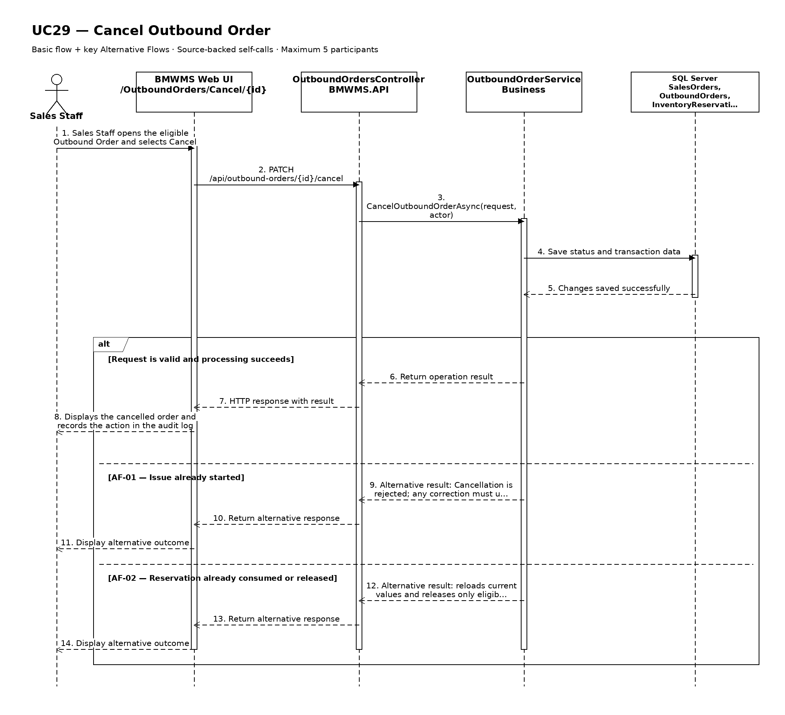

UC30: Check and Reserve Inventory
Goal: Allows Sales Staff to check available inventory and reserve quantity for a confirmed sales requirement.
Field | Value
Type | UI
Primary Actor | Sales Staff
Secondary Actor(s) | —
Module | M05 - Outbound Management
Business Group | Inventory Check and Reservation
FT-ID Ref | FT-30
Depends On | UC03
Preconditions | An active user is signed in and holds one of the allowed fixed roles. A proposed sales requirement or CONFIRMED Sales Order exists.
Postconditions | Availability is displayed; when a confirmed Sales Order is supplied, valid quantity is reserved without changing on-hand quantity.

Main Flow
- [U] Sales Staff enters the proposed product quantities before confirming the Sales Order.
- [S] The system calculates on-hand, reserved, and available quantity by valid lot and bin.
- [S] The system proposes allocation using nearest valid location first, then FEFO or FIFO according to the product group.
- [U] Sales Staff reviews availability and confirms the sales requirement outside the physical issue step.
- [U] After the Sales Order is CONFIRMED, Sales Staff submits the confirmed reference to reserve the proposed quantities.
- [S] The system rechecks availability and atomically creates ACTIVE reservations linked to the Sales Order lines.

Alternative Flows
- AF-01 - Insufficient available quantity: One or more products cannot be fully covered. The system shows the shortage and creates no partial reservation unless Sales Staff explicitly submits a permitted reduced quantity.
- AF-02 - Availability changes before reservation: Another transaction reduces available quantity after the initial check. The system rejects the stale allocation and presents a newly calculated proposal.
- AF-03 - No suitable lot or bin: Quantity exists only in BLOCKED, INACTIVE, EXPIRED, or otherwise ineligible stock. The system excludes it and explains why it is unavailable.
- AF-04 - Existing active reservation: The Sales Order line already has an ACTIVE reservation. The system updates only the permitted difference and prevents duplicate held quantity.

Business Rules
- BR-01: The availability check must occur before the Sales Order is confirmed (see PRD DR-09).
- BR-02: A reservation may be created only for a CONFIRMED Sales Order and may not exceed available quantity (see PRD GB-09).
- BR-03: Reservation reduces available quantity but does not reduce on-hand quantity (see PRD DR-10).
- BR-04: Allocation uses nearest valid location first, then FEFO for expiry-controlled groups or FIFO otherwise (see PRD GB-05 and GB-08).
- BR-05: Inventory may not become negative, and reservation creation is atomic (see PRD DR-11 and GB-11).

Request Fields - InventoryAvailabilityAndReservationRequest
Field | Type | Rule
Sales requirement reference | Text | Required for the availability check; may be a working reference.
Sales Order reference | Text | Required for reservation; must be CONFIRMED.
Product lines | Repeating group | Required. Product and positive requested quantity.
Permit reduced quantity | Yes/No | Optional. Defaults to No.
Reservation expiry | Date/time | Optional. Must be later than current time and within configured policy.

On success: Availability and allocation are displayed; confirmed reservation rows show ACTIVE status and updated available quantity.

Allowed Roles
System Administrator, Warehouse Manager, Sales Staff

Verification Criteria
Given | When | Then
eligible stock exists for every proposed product and the Sales Order is CONFIRMED before reservation | Sales Staff submits the confirmed Sales Order for reservation | ACTIVE reservations are created exactly once, on-hand quantity is unchanged, and available quantity is reduced by the reserved amount

Additional scenarios to cover in tests:
- Check full availability before Sales Order confirmation.
- Reserve the full confirmed Sales Order quantity.
- Handle insufficient quantity without partial reservation.
- Reserve a permitted reduced quantity.
- Apply nearest location plus FIFO.
- Apply nearest location plus FEFO.
- Recalculate after concurrent inventory change.

Sequence Diagram
Figure UC30. Sequence Diagram - Check and Reserve Inventory
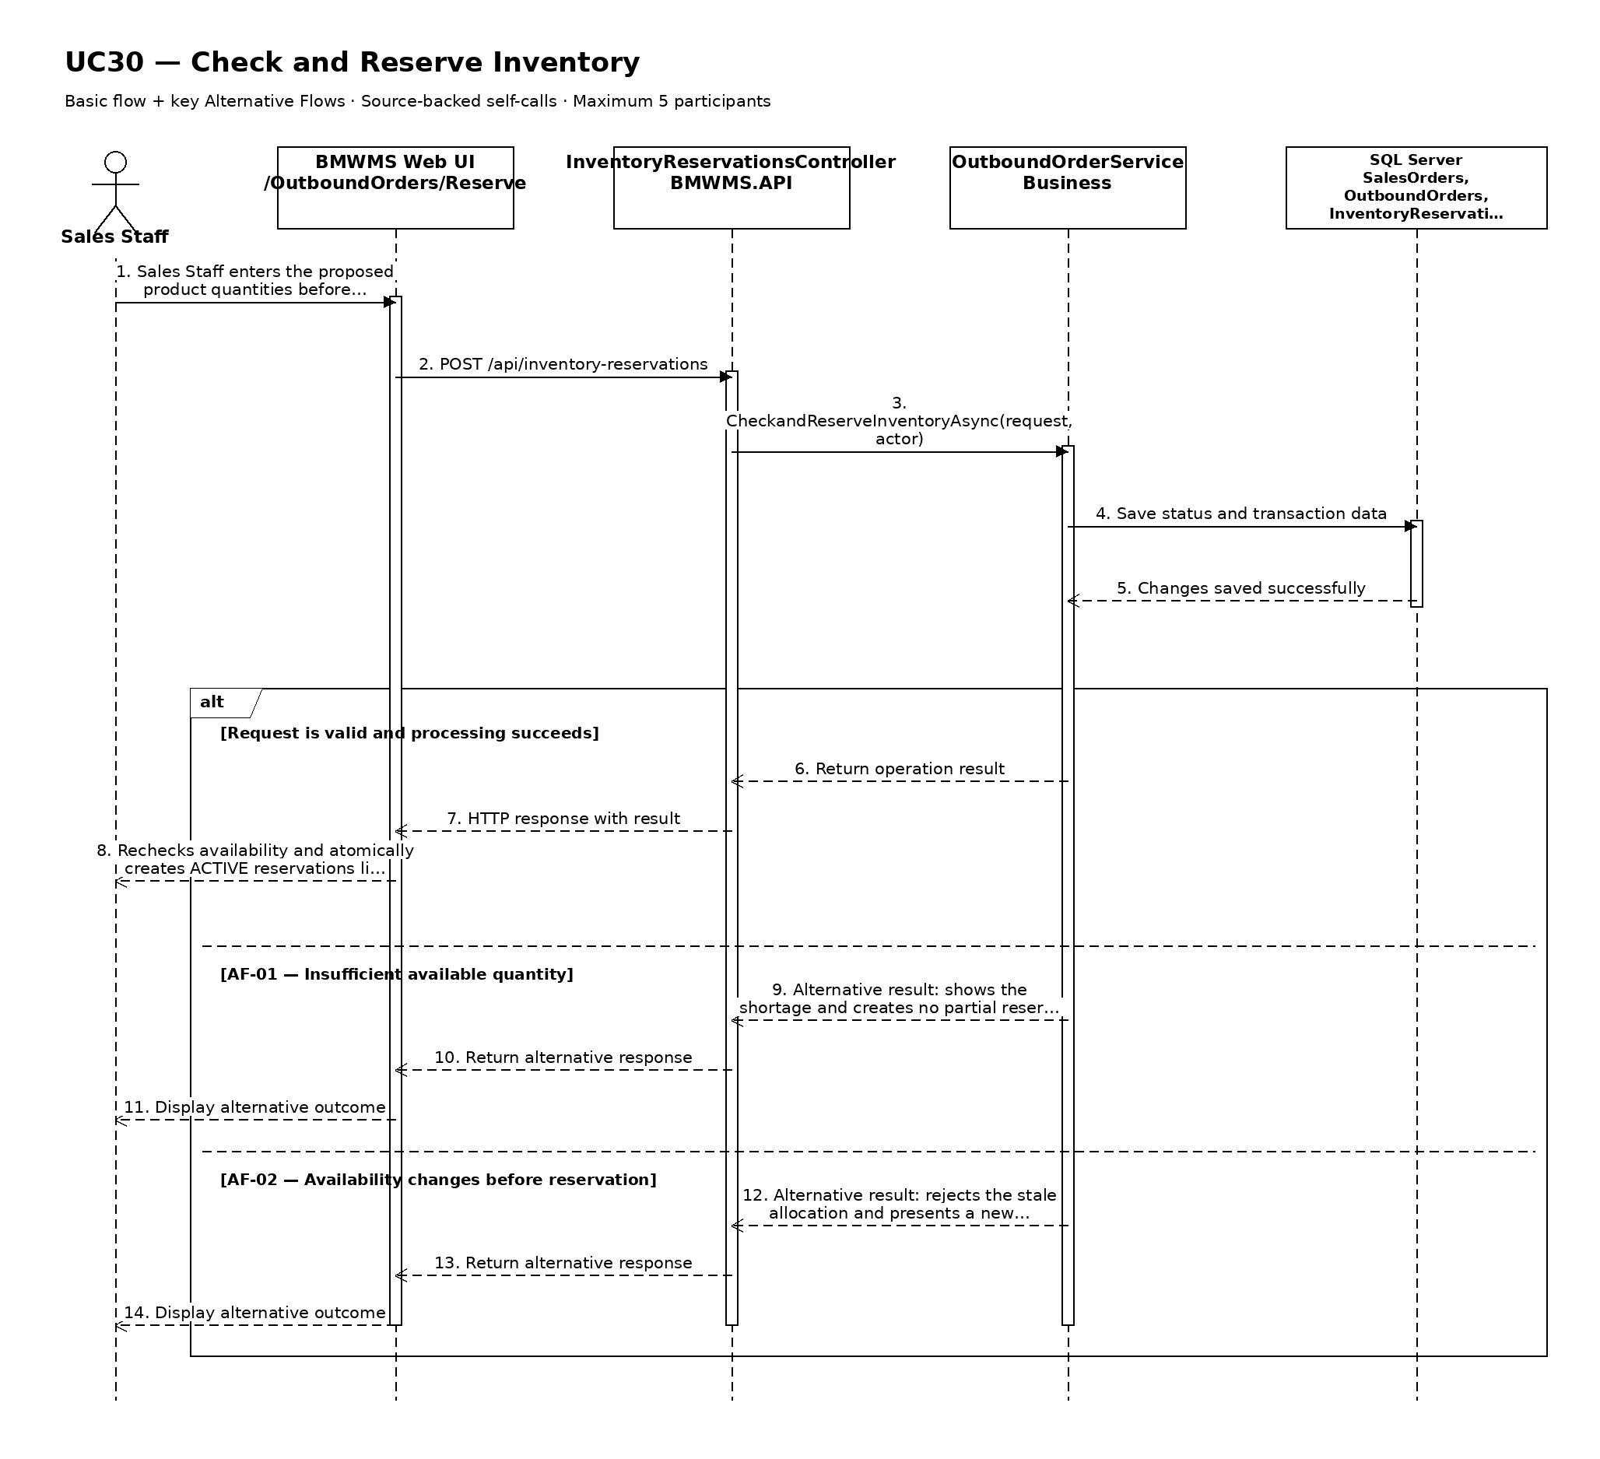

UC31: Confirm Warehouse Issue
Goal: Allows Warehouse Staff to confirm the product, lot, quantity, and location from which goods were picked and issued.
Field | Value
Type | UI
Primary Actor | Warehouse Staff
Secondary Actor(s) | Warehouse Manager, Sales Staff
Module | M05 - Outbound Management
Business Group | Outbound Execution
FT-ID Ref | FT-31
Depends On | UC28
Preconditions | An active user is signed in and holds one of the allowed fixed roles. The Outbound Order is READY or ISSUING, has ACTIVE reservations, and is available for warehouse execution.
Postconditions | Confirmed quantity is issued from identified lots and bins; reservations are consumed and on-hand inventory is reduced atomically.

Main Flow
- [U] Warehouse Staff opens one READY Outbound Order and starts issue execution.
- [S] The system changes the order to ISSUING and displays reserved allocation by product, lot, and source bin.
- [U] Warehouse Staff picks the goods and enters the actual issued quantity for each source bin and lot.
- [S] The system validates location, lot eligibility, reservation ownership, available on-hand quantity, rotation order, and total issue quantity.
- [U] Warehouse Staff reviews and confirms the issue.
- [S] The system atomically creates OutboundOrderDetail and InventoryTransaction rows, reduces on-hand and reserved quantity, changes reservations to CONSUMED, and changes the order to ISSUED when complete.

Alternative Flows
- AF-01 - Selected bin or lot unavailable: The reserved location is inaccessible or the lot is unsuitable. Warehouse Staff reports the issue; an authorized user selects another eligible allocation before confirmation.
- AF-02 - Actual quantity below reserved quantity: Warehouse Staff enters a lower actual quantity. The system requires an exception reason, consumes only issued quantity, and releases or retains the remainder according to the authorized decision.
- AF-03 - Rotation exception: Warehouse Staff selects a later FIFO lot or later-expiring FEFO lot while an earlier eligible lot exists. The system requires Warehouse Manager authorization and a reason.
- AF-04 - Concurrent balance change: On-hand or reservation quantity changed after the screen loaded. The system rejects the stale confirmation and reloads the current allocation.

Business Rules
- BR-01: Single Order Picking applies: one issue confirmation handles one Outbound Order at a time (see PRD GB-07).
- BR-02: Source selection prioritizes nearest valid location, then FEFO or FIFO (see PRD GB-05 and GB-08).
- BR-03: Every execution row identifies one Outbound Order line, Product/ProductLot, source StorageLocation, and positive Quantity (see PRD DR-13).
- BR-04: Issued quantity may not exceed reserved or on-hand quantity, and inventory may not become negative.
- BR-05: Issue posting, reservation consumption, inventory update, status change, and audit write are atomic (see PRD GB-11 and GB-20).

Request Fields - WarehouseIssueConfirmationRequest
Field | Type | Rule
Outbound Order | Text | Required. READY or ISSUING and visible to Warehouse Staff.
Product and lot | Choice | Required. Eligible allocation belonging to the order.
Source location | Choice | Required. Active, accessible bin holding the selected lot.
Actual issued quantity | Number | Required. Greater than zero and within reserved and on-hand quantity.
Exception reason | Text | Required for quantity or rotation exceptions; maximum 500 characters.
Manager authorization | Choice | Required only for an authorized allocation or rotation exception.

On success: Outbound Order Details displays issued rows, consumed reservations, updated bin balances, actor/time, and ISSUED status when complete.

Allowed Roles
System Administrator, Warehouse Manager, Warehouse Staff

Verification Criteria
Given | When | Then
a READY Outbound Order has valid active reservations and sufficient on-hand quantity | Warehouse Staff confirms valid actual issue rows | issue and inventory ledger rows are posted once, reservation quantity is consumed, on-hand quantity decreases, and the order becomes ISSUED

Additional scenarios to cover in tests:
- Issue the full reserved quantity from one bin.
- Issue one line from multiple bins.
- Apply FEFO allocation.
- Apply FIFO allocation.
- Use a manager-authorized location exception.
- Reject quantity above reservation.
- Reject confirmation after concurrent balance change.

Sequence Diagram
Figure UC31. Sequence Diagram - Confirm Warehouse Issue
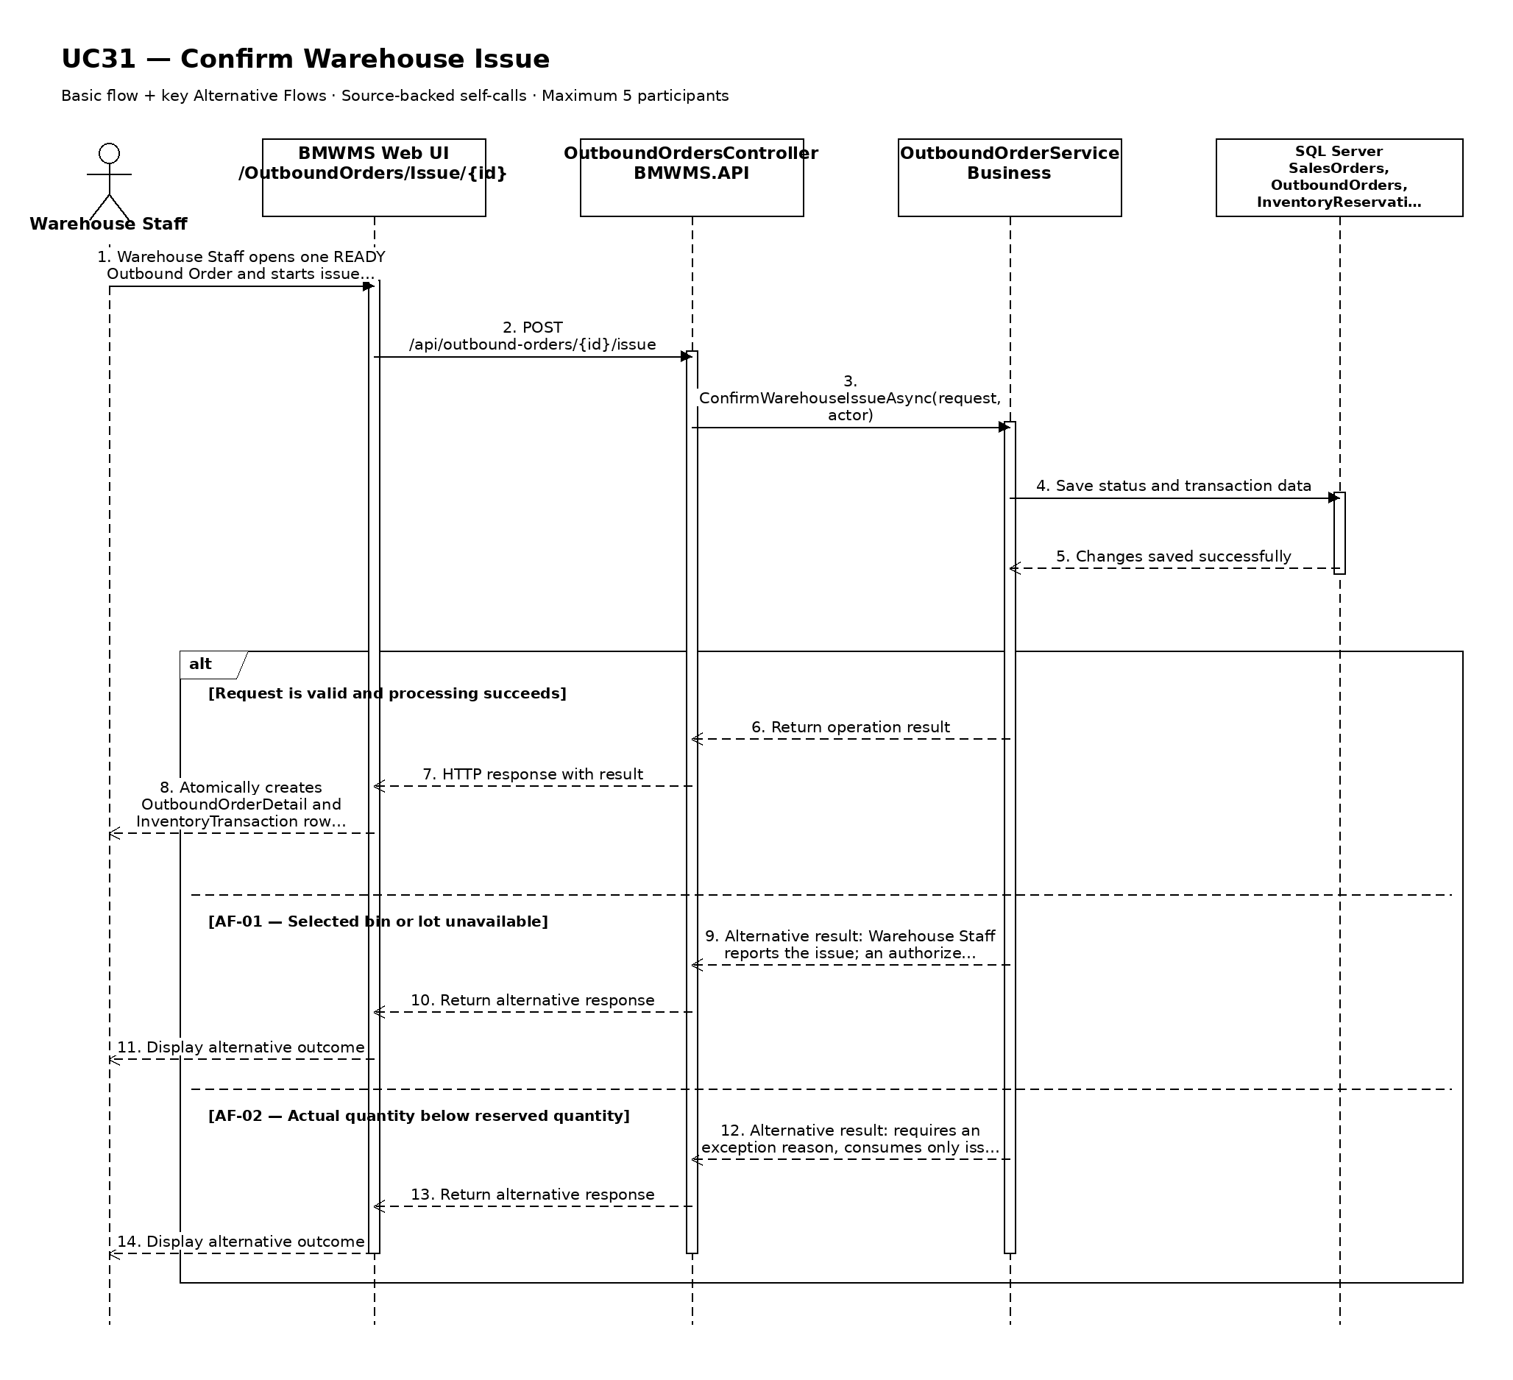

UC32: View Outbound History
Goal: Allows the user to review completed, cancelled, and overdue outbound activity.
Field | Value
Type | UI
Primary Actor | Sales Staff
Secondary Actor(s) | —
Module | M05 - Outbound Management
Business Group | Outbound History
FT-ID Ref | FT-32
Depends On | UC25
Preconditions | An active user is signed in and holds one of the allowed fixed roles. The selected outbound order is visible to the user.
Postconditions | No business record is changed.

Main Flow
- [U] The user opens Outbound History for the selected outbound order.
- [S] The system displays the latest authorized created, edited, reserved, released, cancelled, issued, overdue, and exception events.
- [U] The user enters a date range or selects event, status, product, lot, or location filters when available.
- [S] The system validates the filters and retrieves the retained history.
- [S] The system displays outbound number, Sales Order, customer, dates, requested/reserved/issued quantities, lots, source bins, status, actor, and event time.
- [U] The user may change sorting, clear filters, or open an available referenced record.

Alternative Flows
- AF-01 - No history in the selected period: No event matches the filters. The system displays a no-history state without changing the selected record or filters.
- AF-02 - Invalid date range: The start date is after the end date or exceeds the allowed reporting range. The system identifies the invalid range and does not run the query.

Business Rules
- BR-01: History is read-only and is ordered newest first by default.
- BR-02: Only posted or retained business events are shown; cancelled records remain visible for traceability.
- BR-03: The displayed history must be reconcilable to immutable transaction or audit records where applicable (see PRD GB-12 and GB-20).
- BR-04: Cancelled orders and released reservations remain visible.
- BR-05: Issued totals include only posted issue transactions.

Request Fields - OutboundOrderHistoryFilter
Field | Type | Rule
Outbound Order identifier | Text | Required. Must identify a visible record or history context.
From date | Date | Optional. Must not be later than To date.
To date | Date | Optional. Defaults to the current date.
Event type | Choice | Optional. One of the supported values for created, edited, reserved, released, cancelled, issued, overdue, and exception events.
Related reference | Text | Optional. Exact or partial order, transaction, lot, or document reference.

On success: Outbound History displays the matching retained history and active filters.

Allowed Roles
System Administrator, Warehouse Manager, Warehouse Staff, Sales Staff

Verification Criteria
Given | When | Then
historical events exist for the selected outbound order | the user submits a valid date range and event filter | the matching events are displayed in chronological order with their actor, reference, quantity or status effect, and time

Additional scenarios to cover in tests:
- View history with default filters.
- Filter by date range.
- Filter by event type and related reference.
- Use a period with no matching history.

Sequence Diagram
Figure UC32. Sequence Diagram - View Outbound History
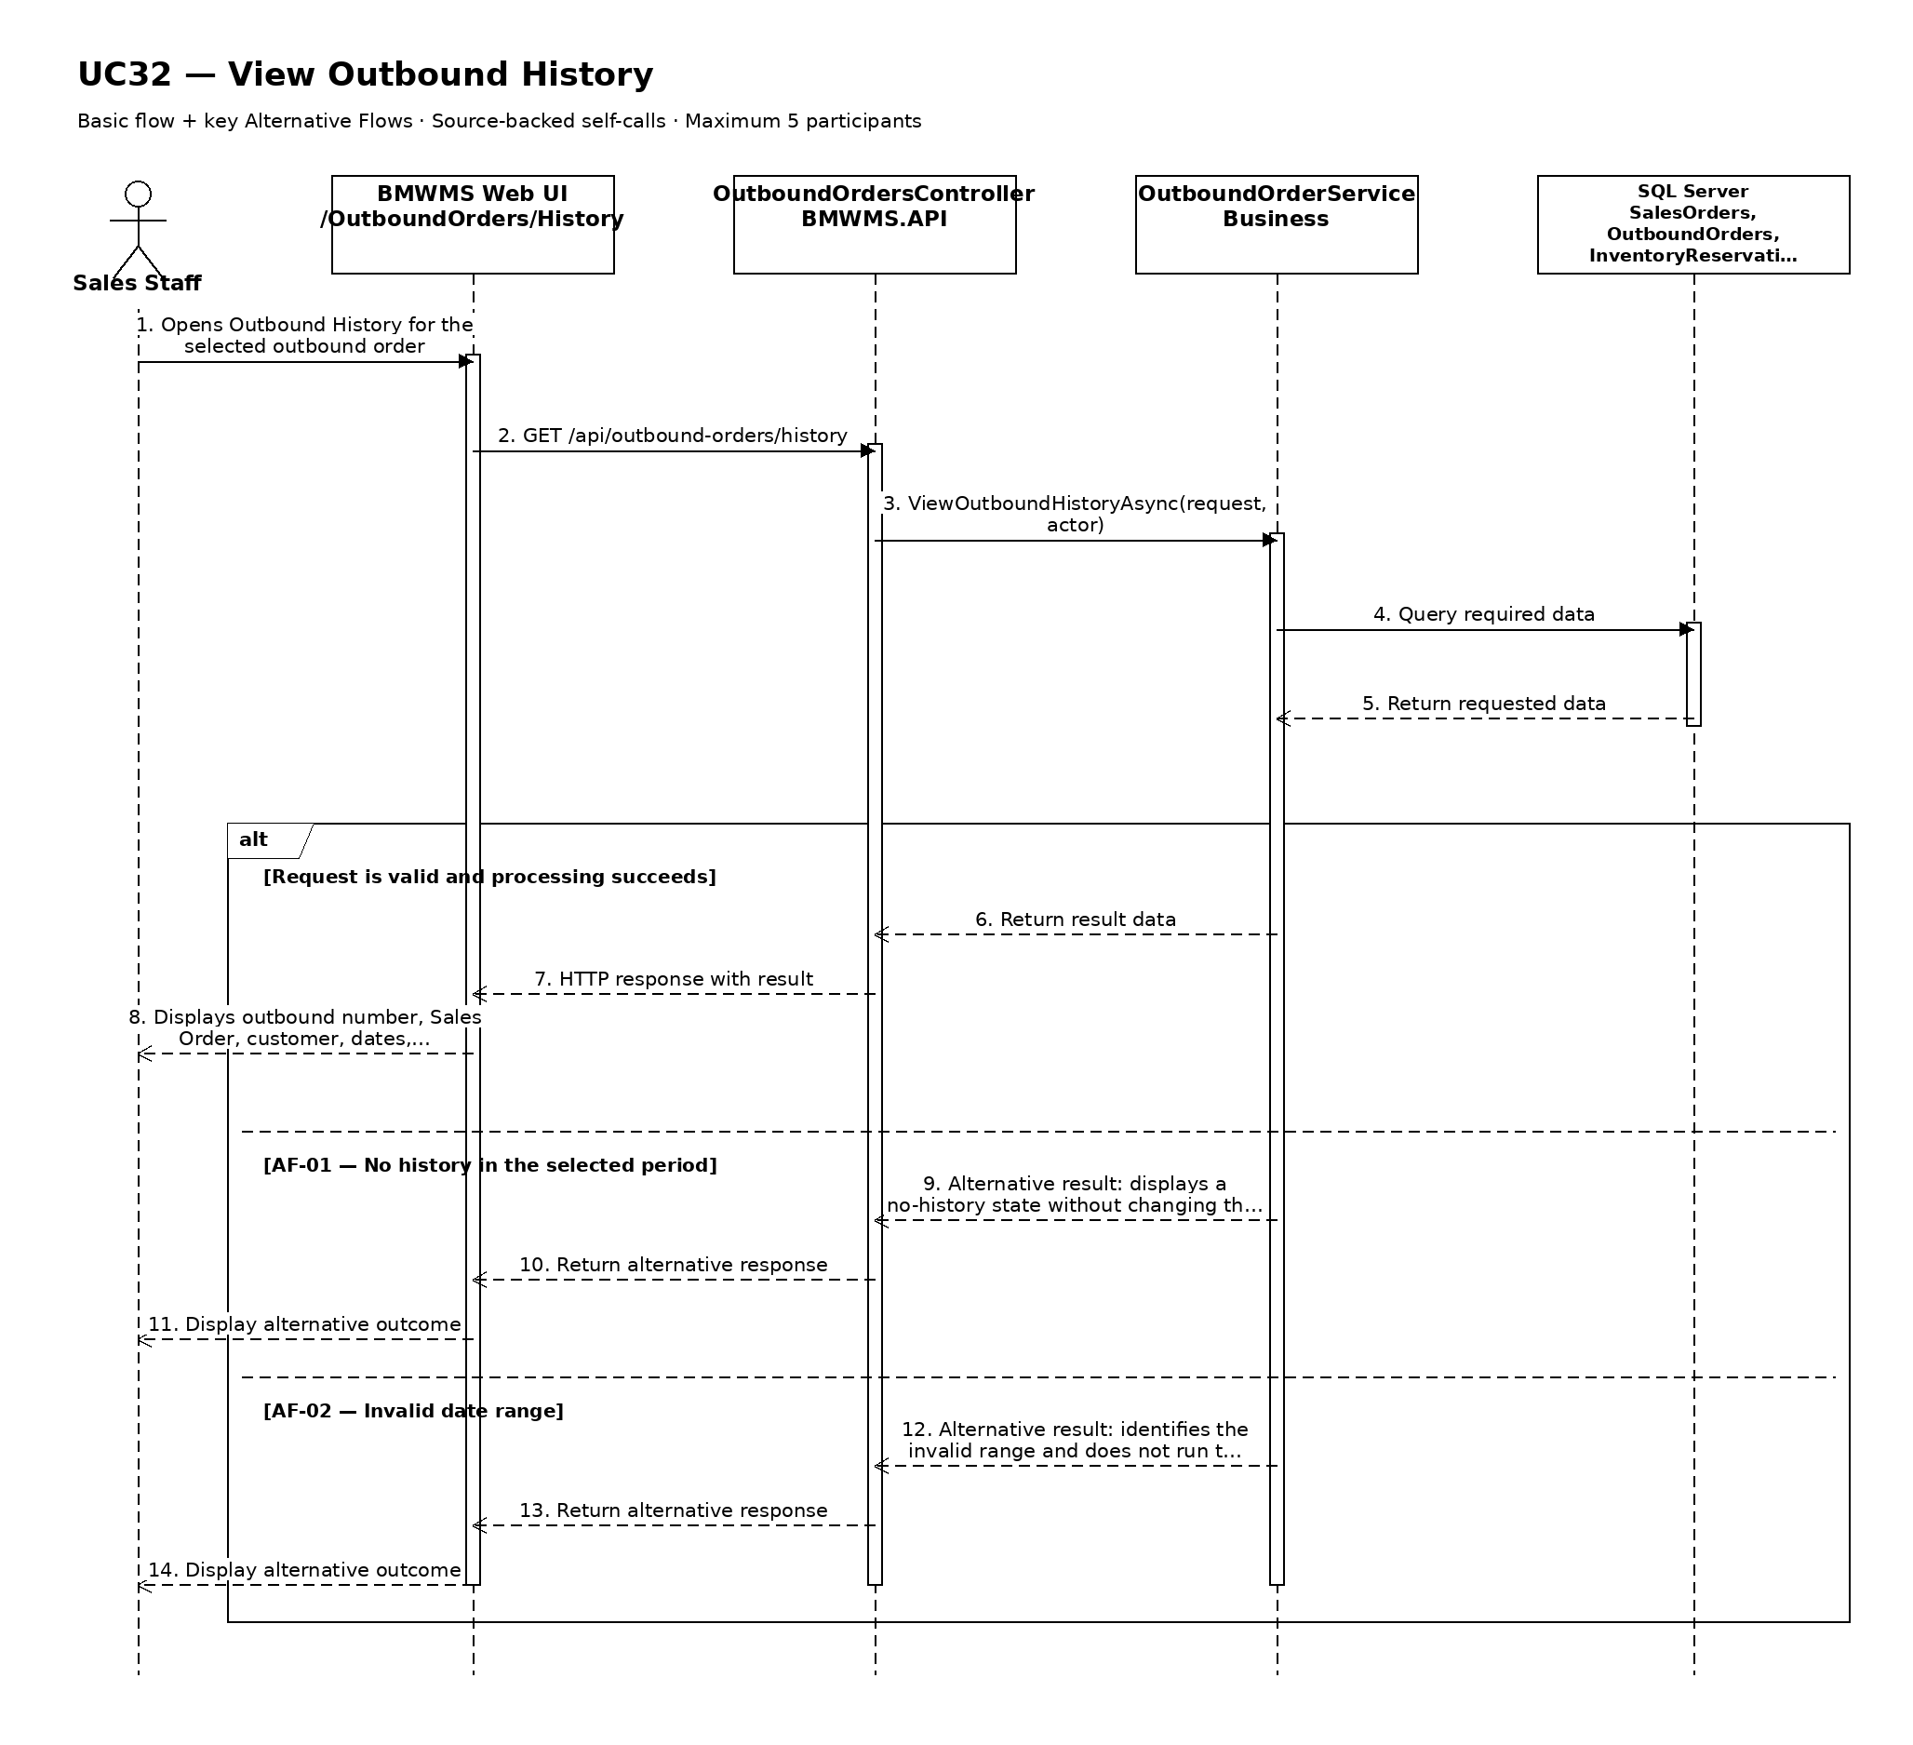

UC33: View Stocktake Session List
Goal: Allows the user to view full-count and cycle-count sessions generated from the configured schedule or request.
Field | Value
Type | UI
Primary Actor | Warehouse Manager
Secondary Actor(s) | —
Module | M06 - Stocktaking
Business Group | Stocktake Monitoring
FT-ID Ref | FT-33
Depends On | —
Preconditions | An active user is signed in and holds one of the allowed fixed roles.
Postconditions | No business record is changed. The current filters may remain in the user session.

Main Flow
- [U] The user opens Stocktake Session List.
- [S] The system loads the first page of stocktake session records allowed for the user's role.
- [U] The user enters or changes one or more search and filter values.
- [S] The system validates the filter values and applies the authorized data scope.
- [S] The system displays session number, count type, scope, scheduled date, assigned staff, bins completed/total, discrepancy count, and status, the matching-record count, and pagination controls.
- [U] The user may change sorting, move between pages, clear filters, or open an available record/action.

Alternative Flows
- AF-01 - No matching records: At the result step, no record satisfies the active filters. The system displays an explicit no-results state and keeps the filters available for revision.
- AF-02 - Invalid filter combination: When a date range or numeric range is invalid, the system does not run the search and identifies the fields that must be corrected.

Business Rules
- BR-01: Only stocktake session records within the signed-in user's authorized scope may be returned (see PRD GB-02).
- BR-02: Results are sorted by scheduled date descending and session number descending unless the user selects another supported sort.
- BR-03: Pagination must return a stable result order and a total matching-record count.
- BR-04: A full count covers all active bins; a cycle count covers every bin in the selected area or product scope (see PRD GB-13).
- BR-05: Selected bins remain listed even when expected quantity is zero (see PRD DR-15).

Request Fields - StocktakeSessionListFilter
Field | Type | Rule
Session reference | Text | Optional. Exact or partial session number.
Count type | Choice | Optional. FULL_COUNT or CYCLE_COUNT.
Status | Choice | Optional. PLANNED, IN_PROGRESS, COUNTED, APPROVED, COMPLETED, or CANCELLED.
Scheduled date from/to | Date range | Optional. From date must not be after To date.
Assigned counter | Choice | Optional. Active or historical Warehouse Staff.
Page | Number | Optional. Starts at 1; values below 1 are rejected.
Page size | Number | Optional. Between 10 and 100; defaults to 20.

On success: Stocktake Session List displays the matching records and active filter summary.

Allowed Roles
System Administrator, Warehouse Manager, Warehouse Staff

Verification Criteria
Given | When | Then
at least one stocktake session record exists within the user's authorized scope | the user submits a valid filter combination | only matching stocktake session records are displayed in scheduled date descending and session number descending order, with an accurate total count

Additional scenarios to cover in tests:
- Open the list with default filters.
- Search using a complete identifier.
- Combine two or more filters.
- Use a filter that returns no results.
- Change page size and verify stable pagination.

Sequence Diagram
Figure UC33. Sequence Diagram - View Stocktake Session List
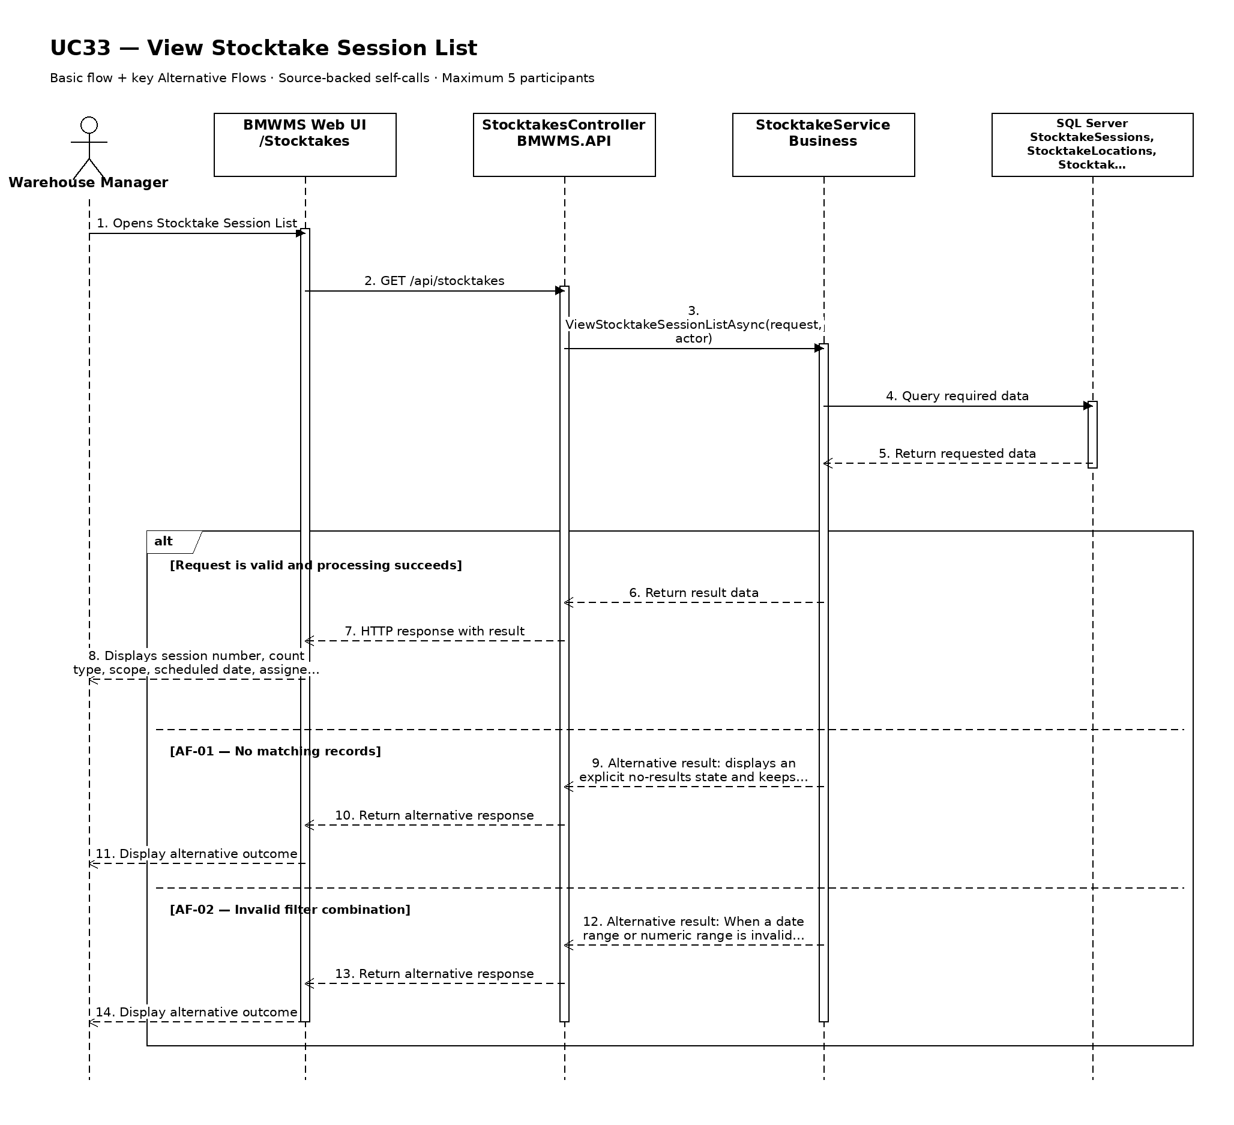

UC34: Perform Stock Count
Goal: Allows Warehouse Staff to enter actual counted quantity for each product and lot at each assigned bin.
Field | Value
Type | UI
Primary Actor | Warehouse Staff
Secondary Actor(s) | Warehouse Manager
Module | M06 - Stocktaking
Business Group | Stocktake Execution
FT-ID Ref | FT-34
Depends On | UC33
Preconditions | An active user is signed in and holds one of the allowed fixed roles. The Stocktake Session is PLANNED or IN_PROGRESS and the user is assigned to at least one PENDING or IN_PROGRESS bin.
Postconditions | Actual counts are stored for the assigned bin; a completed bin has status COMPLETED and is ready for discrepancy calculation.

Main Flow
- [U] Warehouse Staff opens the assigned stocktake session and selects a PENDING bin.
- [S] The system changes the bin assignment to IN_PROGRESS and displays the physical bin identity while withholding book quantity until count submission.
- [U] Warehouse Staff counts every product and lot physically present, including unexpected stock, and enters actual quantities.
- [U] Warehouse Staff confirms that the bin has been checked completely, including the case where it is empty.
- [S] The system validates duplicate products/lots, non-negative quantities, assignment ownership, and count completeness.
- [S] The system stores the count rows, changes the bin to COMPLETED, and starts UC35 discrepancy calculation.

Alternative Flows
- AF-01 - Empty bin: No product is present. Warehouse Staff explicitly confirms Empty bin; the system records completion with zero actual quantity for expected stock.
- AF-02 - Unexpected product or lot: Physical stock is not in the expected list. Warehouse Staff scans or selects the product/lot and enters the actual quantity; the row is retained for discrepancy review.
- AF-03 - Save and resume: Warehouse Staff saves incomplete work. The bin remains IN_PROGRESS and may be resumed only by the assigned counter or an authorized reassignment.
- AF-04 - Recount required: The bin has status RECOUNT_REQUIRED. The system creates a new count attempt while preserving the previous submitted values.

Business Rules
- BR-01: Stocktake is performed bin by bin, including selected empty bins (see PRD DR-15).
- BR-02: Actual quantity must be zero or greater and is recorded in the product's unit of measure.
- BR-03: Book quantity is not edited by Warehouse Staff and is not revealed until the count is submitted.
- BR-04: The counter who submits the count cannot approve its discrepancy (see PRD GB-14).
- BR-05: Previous count attempts are retained when a recount is requested.

Request Fields - StockCountEntryRequest
Field | Type | Rule
Stocktake Session | Text | Required. PLANNED or IN_PROGRESS and assigned to the user.
Storage location | Choice | Required. Assigned PENDING, IN_PROGRESS, or RECOUNT_REQUIRED bin.
Product | Choice/scan | Required for each physical item row.
Lot number | Choice/scan | Required for lot-controlled products.
Actual counted quantity | Number | Required. Zero or greater.
Empty bin confirmation | Yes/No | Required only when no physical product row is entered.
Count notes | Text | Optional. Maximum 1,000 characters.
Evidence attachment | File | Optional. JPG, PNG, or PDF within configured size limit.

On success: The bin displays COMPLETED with retained count rows, counter, completion time, and a link to calculated discrepancies.

Allowed Roles
System Administrator, Warehouse Manager, Warehouse Staff

Verification Criteria
Given | When | Then
Warehouse Staff is assigned a PENDING bin in an active Stocktake Session | the staff member submits complete non-negative actual counts and confirms the bin is fully checked | the count is stored once, the bin becomes COMPLETED, and the counter cannot approve the resulting discrepancy

Additional scenarios to cover in tests:
- Count a bin whose physical quantities match expected stock.
- Count a bin with missing quantity.
- Count a bin with excess quantity.
- Complete an empty bin.
- Add an unexpected product or lot.
- Save and resume an incomplete bin.
- Submit a requested recount.

Sequence Diagram
Figure UC34. Sequence Diagram - Perform Stock Count
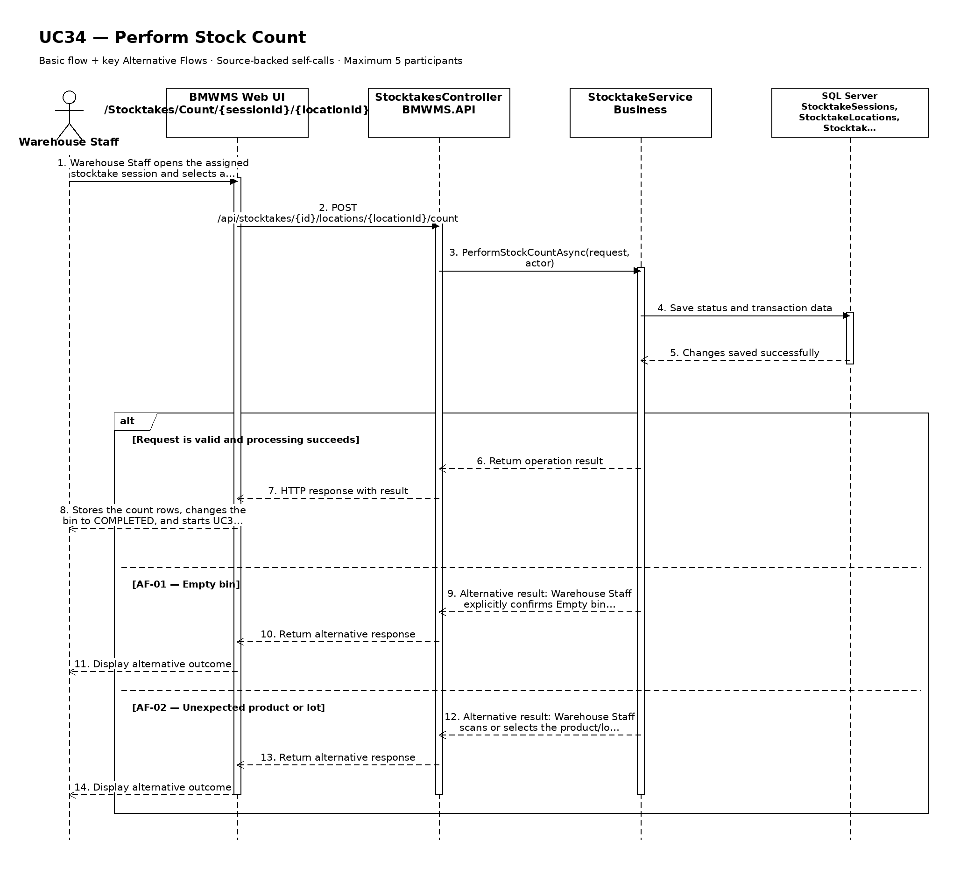

UC35: Record Inventory Discrepancy
Goal: Allows the system to calculate and the counter to record the difference between book quantity and actual quantity.
Field | Value
Type | UI
Primary Actor | Warehouse Staff
Secondary Actor(s) | Warehouse Manager
Module | M06 - Stocktaking
Business Group | Stocktake Execution
FT-ID Ref | FT-35
Depends On | UC34
Preconditions | An active user is signed in and holds one of the allowed fixed roles. A stocktake bin has a submitted actual count.
Postconditions | Every count row has a calculated difference and a COUNTED or RECOUNT_REQUIRED review state; no inventory balance is changed.

Main Flow
- [S] After UC34 submission, the system captures the book quantity for the same product, lot, and bin at the controlled stocktake cut-off.
- [S] The system calculates difference quantity as actual counted quantity minus book quantity.
- [S] The system classifies each row as match, shortage, excess, or unexpected stock.
- [S] The system displays book quantity, actual quantity, signed difference, and any prior recount attempt.
- [U] Warehouse Staff reviews the calculated difference and enters a discrepancy note or evidence when required.
- [S] The system records the review information and makes the discrepancy available to Warehouse Manager in UC36.

Alternative Flows
- AF-01 - No discrepancy: Difference is zero. The system marks the row as matched and requires no discrepancy explanation.
- AF-02 - Movement during count window: A posted transaction occurred within the controlled count window. The system flags the row for manager review and shows the relevant transaction reference without changing the formula.
- AF-03 - Counter reports input mistake: Warehouse Staff identifies an incorrect actual count before approval. The system requires a recount rather than overwriting the submitted count.

Business Rules
- BR-01: Difference quantity = actual counted quantity - book quantity.
- BR-02: This use case records and explains the difference; it does not change Inventory.
- BR-03: Book quantity is derived from posted transactions and the controlled stocktake cut-off.
- BR-04: Investigation of loss transactions is outside stocktake scope; the use case shows count history and quantity difference only.
- BR-05: Submitted count and discrepancy history are retained and cannot be silently overwritten.

Request Fields - StocktakeDiscrepancyRecordRequest
Field | Type | Rule
Stocktake item | Text | Required. Identifies one submitted product/lot/bin count row.
Book quantity | Read-only | Captured by the system at the controlled cut-off.
Actual quantity | Read-only | Submitted through UC34.
Difference quantity | Read-only | Calculated as actual minus book.
Discrepancy note | Text | Required for non-zero differences; maximum 1,000 characters.
Evidence attachment | File | Optional. JPG, PNG, or PDF within configured size limit.

On success: The discrepancy view displays book, actual, signed difference, classification, note, evidence, and review state.

Allowed Roles
System Administrator, Warehouse Manager, Warehouse Staff

Verification Criteria
Given | When | Then
a completed bin contains a submitted stocktake item | the system calculates and the counter reviews the difference | the signed discrepancy and retained explanation are available for manager approval and Inventory remains unchanged

Additional scenarios to cover in tests:
- Record a zero difference.
- Record a shortage.
- Record an excess.
- Record an unexpected product.
- Flag movement during the count window.
- Request recount after an input mistake.

Sequence Diagram
Figure UC35. Sequence Diagram - Record Inventory Discrepancy
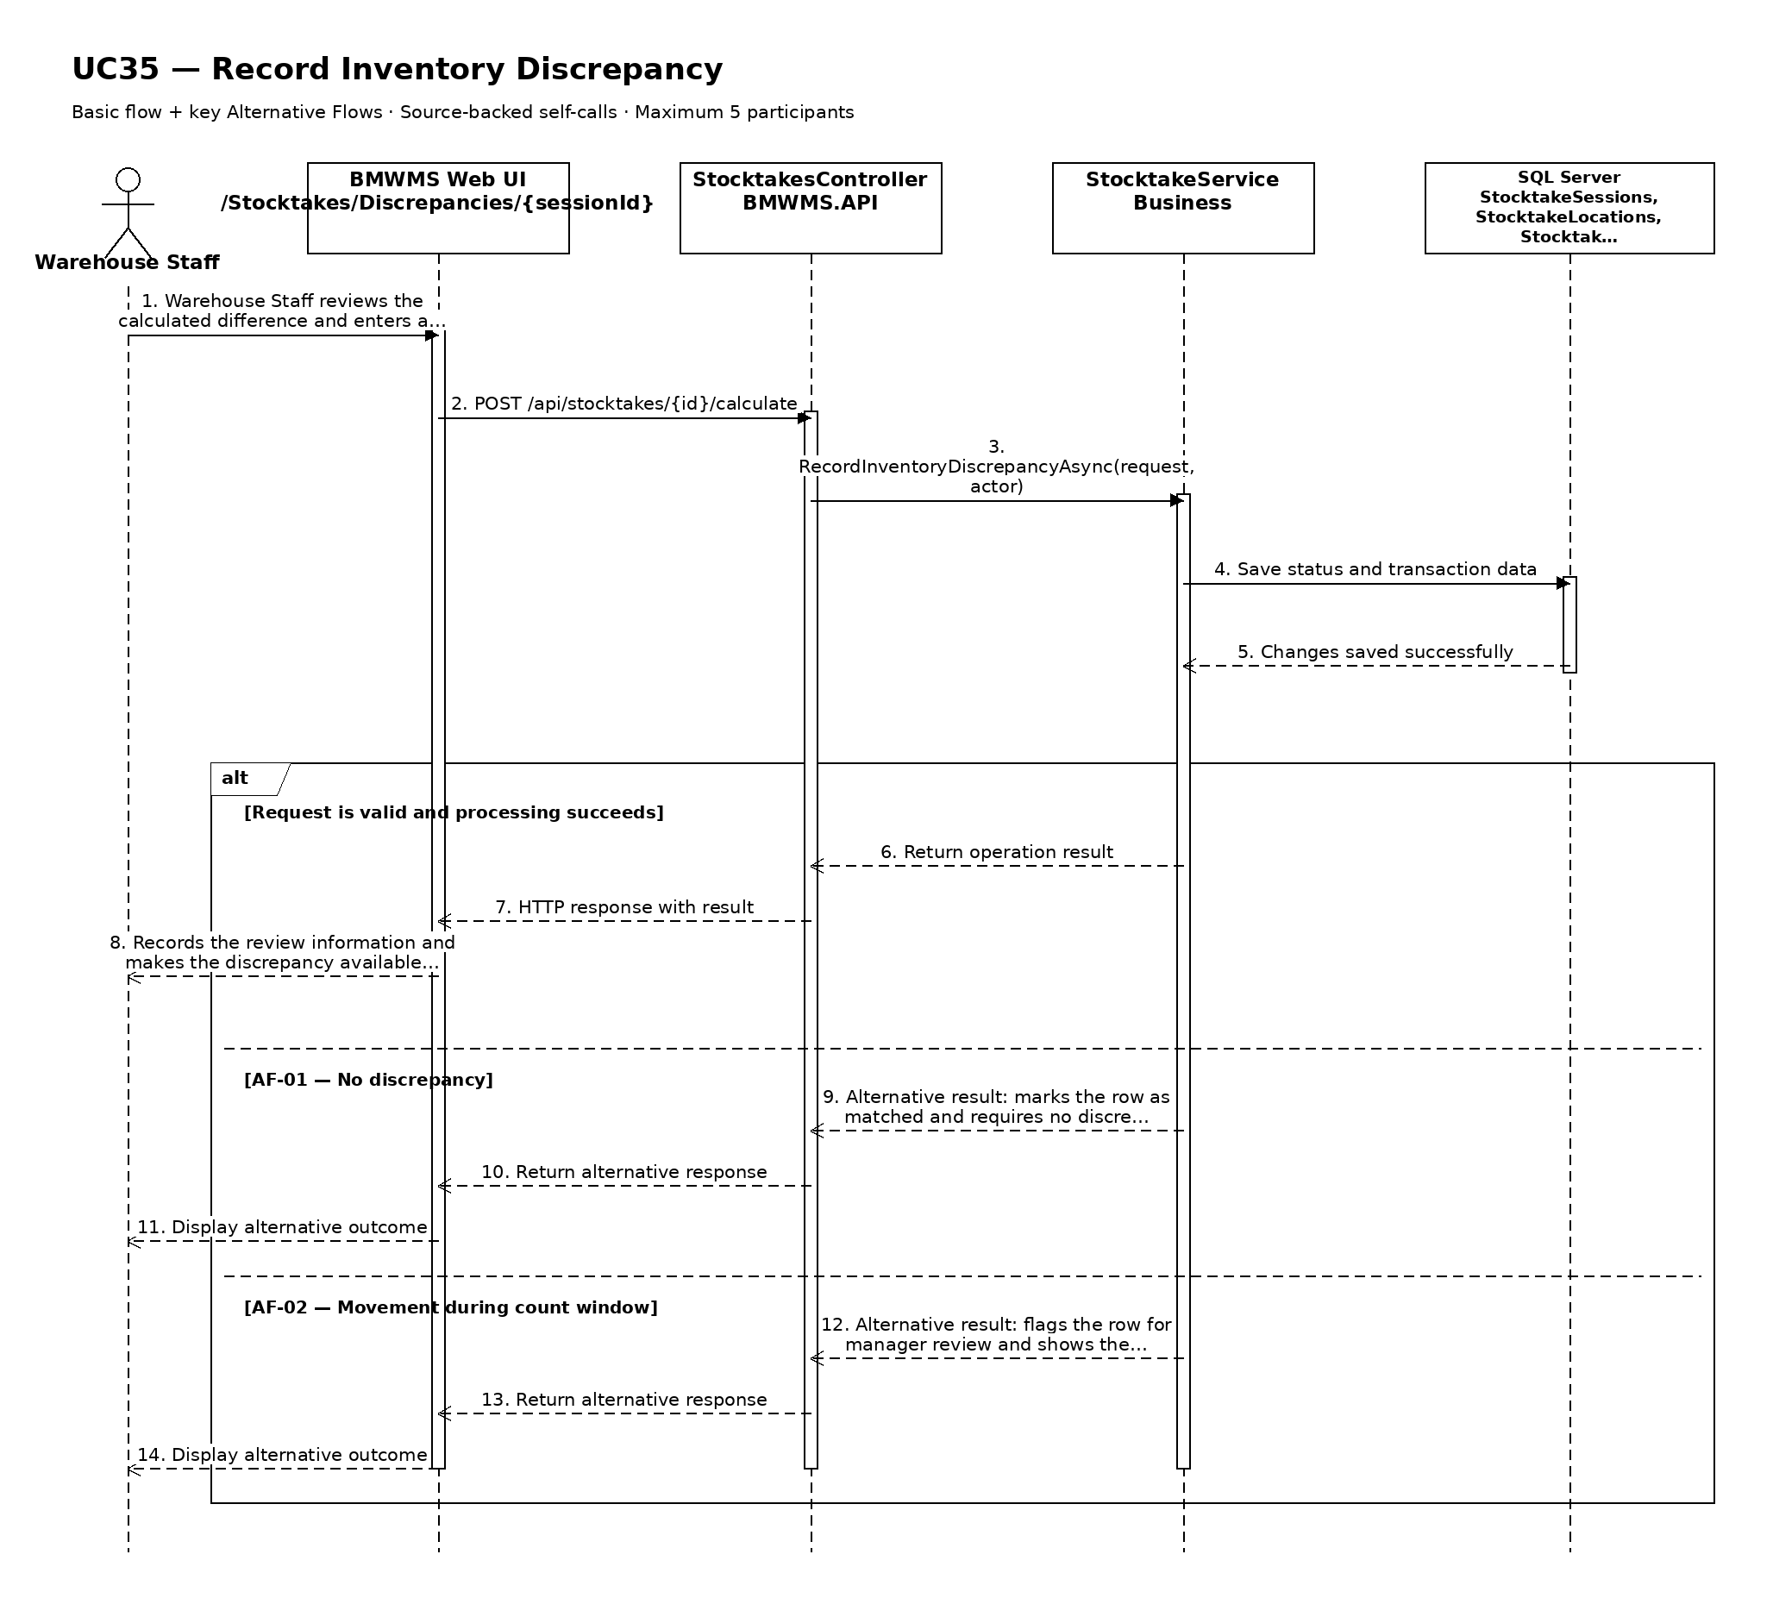

UC36: Approve and Adjust Inventory
Goal: Allows the Warehouse Manager to approve discrepancies and generate the corresponding inventory adjustment transactions.
Field | Value
Type | UI
Primary Actor | Warehouse Manager
Secondary Actor(s) | Warehouse Staff
Module | M06 - Stocktaking
Business Group | Inventory Reconciliation
FT-ID Ref | FT-36
Depends On | UC35
Preconditions | An active user is signed in and holds one of the allowed fixed roles. Every selected bin is COMPLETED and every discrepancy is available for decision.
Postconditions | Approved discrepancies create immutable adjustment transactions; the session becomes COMPLETED when all decisions and postings succeed.

Main Flow
- [U] Warehouse Manager opens Stocktake Approval for a COUNTED session.
- [S] The system verifies that every selected bin is COMPLETED and the manager did not perform the relevant count.
- [S] The system displays each product/lot/bin with book quantity, actual quantity, signed difference, notes, evidence, and prior recounts.
- [U] Warehouse Manager approves each discrepancy or requests a recount with a reason.
- [S] For approved differences, the system creates immutable STOCKTAKE_ADJUSTMENT InventoryTransaction entries and updates derived Inventory atomically.
- [S] When every bin and discrepancy is resolved, the system records approval data and changes the session through APPROVED to COMPLETED.

Alternative Flows
- AF-01 - Incomplete bin: At least one selected bin is PENDING, IN_PROGRESS, or RECOUNT_REQUIRED. The system blocks session approval and identifies every incomplete bin.
- AF-02 - Recount requested: The manager does not accept the evidence. The selected bin becomes RECOUNT_REQUIRED, the reason is recorded, and no adjustment is posted for its rows.
- AF-03 - Same person counted and approves: The manager is also the recorded counter for the item. The system blocks that approval and requires another authorized Warehouse Manager or administrative oversight.
- AF-04 - Inventory changed before posting: The current controlled balance no longer matches the approval basis. The system stops the atomic transaction and requires review or recount.

Business Rules
- BR-01: A session cannot be approved until every selected bin is completed and every discrepancy has a decision (see PRD DR-16).
- BR-02: The counter cannot approve the same discrepancy (see PRD GB-14).
- BR-03: Approved differences create InventoryTransaction entries; no standalone StockAdjustment business entity is created (see PRD DR-17).
- BR-04: Adjustment posting and derived Inventory update are atomic (see PRD GB-11).
- BR-05: Rejected evidence must lead to a retained recount request, not direct alteration of the submitted count.

Request Fields - StocktakeApprovalRequest
Field | Type | Rule
Stocktake Session | Text | Required. COUNTED and fully submitted.
Discrepancy decision | Choice | Required for each difference. APPROVE or RECOUNT_REQUIRED.
Decision reason | Text | Required for RECOUNT_REQUIRED and for policy-defined material adjustments.
Approval confirmation | Yes/No | Required before posting approved adjustments.

On success: The session displays completed decisions, posted adjustment references, approver/time, and COMPLETED status when fully resolved.

Allowed Roles
System Administrator, Warehouse Manager

Verification Criteria
Given | When | Then
a COUNTED Stocktake Session has all bins completed and the Warehouse Manager did not perform the counts being approved | the manager approves all valid discrepancies and confirms posting | one immutable adjustment transaction is posted per approved difference, derived inventory matches approved actual quantity, and the session becomes COMPLETED

Additional scenarios to cover in tests:
- Approve a shortage adjustment.
- Approve an excess adjustment.
- Complete a session with no differences.
- Request a recount for one bin.
- Block approval while a bin is incomplete.
- Block self-approval by the counter.
- Roll back all postings after an atomic validation failure.

Sequence Diagram
Figure UC36. Sequence Diagram - Approve and Adjust Inventory
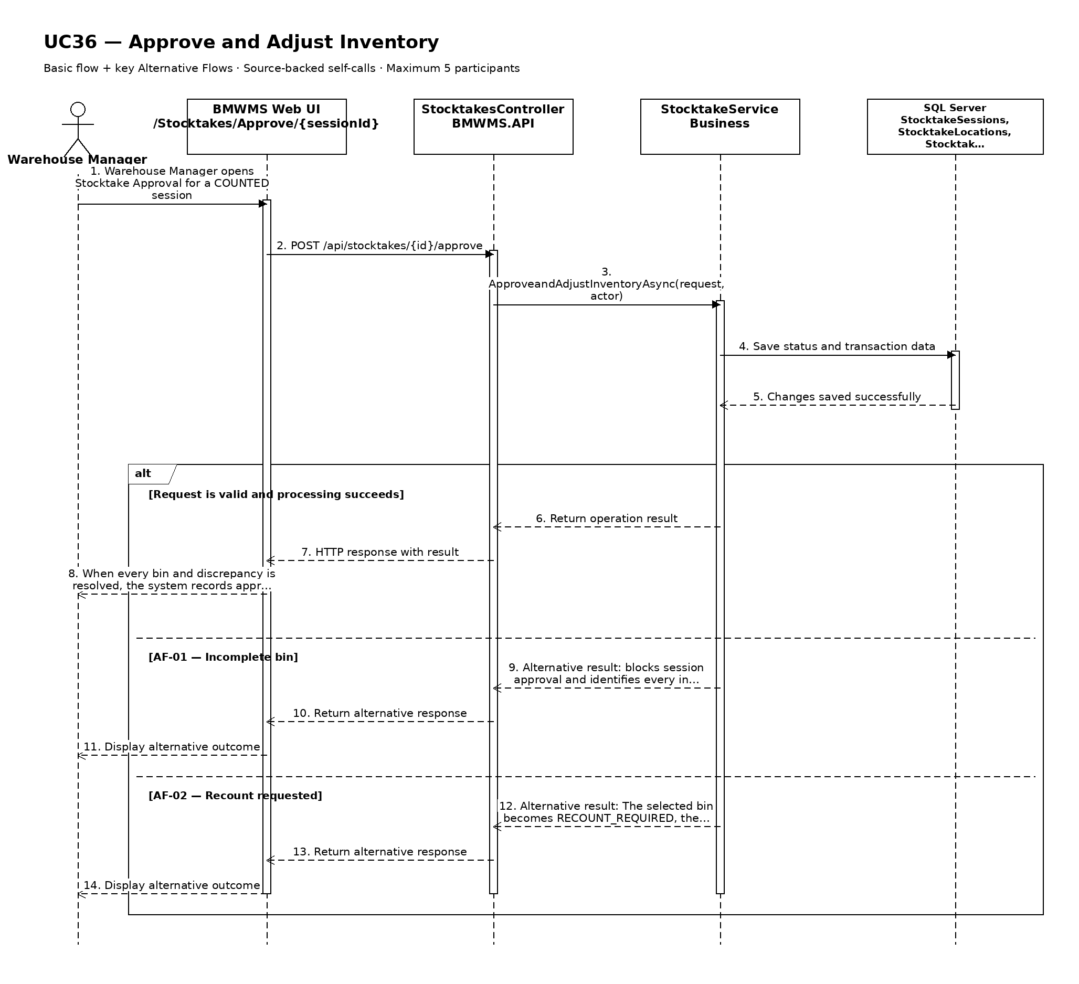

UC37: View Stocktake History
Goal: Allows the user to review completed stocktake sessions, counts, discrepancies, approvals, and adjustment quantities.
Field | Value
Type | UI
Primary Actor | Warehouse Manager
Secondary Actor(s) | —
Module | M06 - Stocktaking
Business Group | Stocktake History
FT-ID Ref | FT-37
Depends On | UC33
Preconditions | An active user is signed in and holds one of the allowed fixed roles. The selected stocktake session is visible to the user.
Postconditions | No business record is changed.

Main Flow
- [U] The user opens Stocktake History for the selected stocktake session.
- [S] The system displays the latest authorized session generation, assignment, count, recount, discrepancy, approval, cancellation, and adjustment events.
- [U] The user enters a date range or selects event, status, product, lot, or location filters when available.
- [S] The system validates the filters and retrieves the retained history.
- [S] The system displays session scope, bin count progress, counters, book/actual/difference quantities, evidence, decisions, adjustment references, approver, and event time.
- [U] The user may change sorting, clear filters, or open an available referenced record.

Alternative Flows
- AF-01 - No history in the selected period: No event matches the filters. The system displays a no-history state without changing the selected record or filters.
- AF-02 - Invalid date range: The start date is after the end date or exceeds the allowed reporting range. The system identifies the invalid range and does not run the query.

Business Rules
- BR-01: History is read-only and is ordered newest first by default.
- BR-02: Only posted or retained business events are shown; cancelled records remain visible for traceability.
- BR-03: The displayed history must be reconcilable to immutable transaction or audit records where applicable (see PRD GB-12 and GB-20).
- BR-04: Count attempts, recounts, approval decisions, and adjustment references are retained.
- BR-05: Loss-transaction investigation is outside this view; only stocktake history and quantities are displayed.

Request Fields - StocktakeSessionHistoryFilter
Field | Type | Rule
Stocktake Session identifier | Text | Required. Must identify a visible record or history context.
From date | Date | Optional. Must not be later than To date.
To date | Date | Optional. Defaults to the current date.
Event type | Choice | Optional. One of the supported values for session generation, assignment, count, recount, discrepancy, approval, cancellation, and adjustment events.
Related reference | Text | Optional. Exact or partial order, transaction, lot, or document reference.

On success: Stocktake History displays the matching retained history and active filters.

Allowed Roles
System Administrator, Warehouse Manager, Warehouse Staff

Verification Criteria
Given | When | Then
historical events exist for the selected stocktake session | the user submits a valid date range and event filter | the matching events are displayed in chronological order with their actor, reference, quantity or status effect, and time

Additional scenarios to cover in tests:
- View history with default filters.
- Filter by date range.
- Filter by event type and related reference.
- Use a period with no matching history.

Sequence Diagram
Figure UC37. Sequence Diagram - View Stocktake History
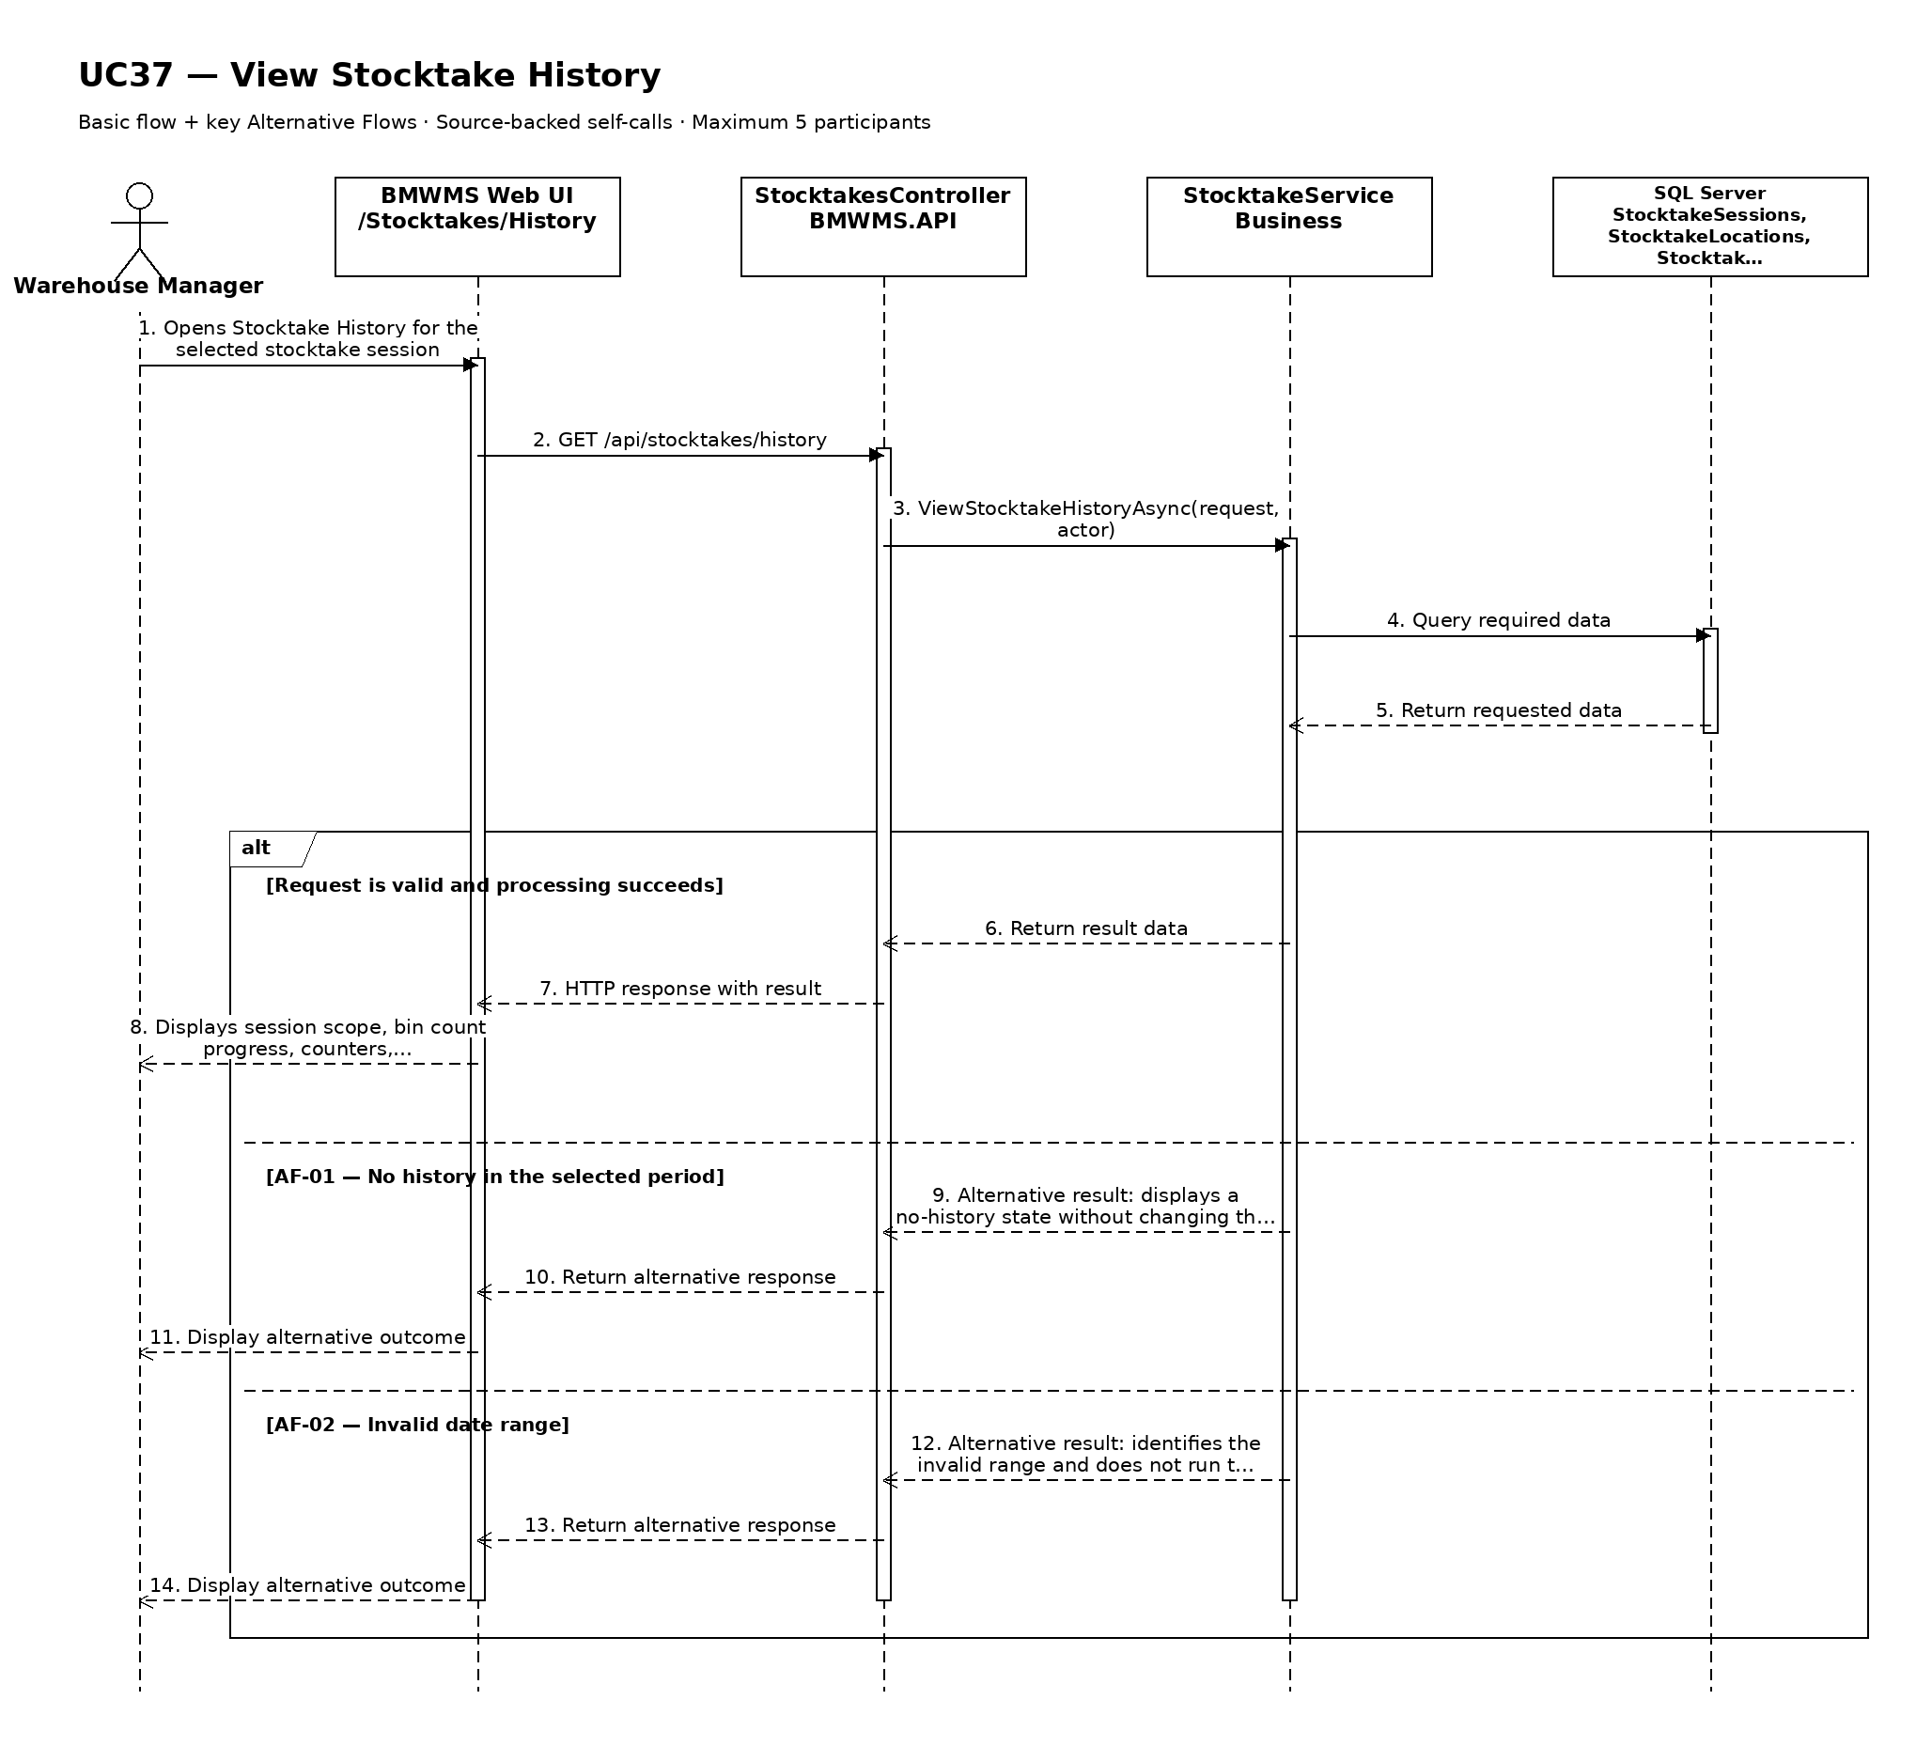

UC38: View Inventory Report
Goal: Allows the user to view current on-hand, reserved, and available quantity by product, lot, and location.
Field | Value
Type | UI
Primary Actor | Warehouse Manager
Secondary Actor(s) | —
Module | M07 - Reporting, Dashboard and Alerts
Business Group | Inventory Report
FT-ID Ref | FT-38
Depends On | —
Preconditions | An active user is signed in and holds one of the allowed fixed roles.
Postconditions | No operational record is changed. The filter state may be retained for export.

Main Flow
- [U] The user opens Inventory Report.
- [S] The system loads the default permitted period and report scope.
- [U] The user enters the period, filters, and supported grouping or sort options.
- [S] The system validates the request and calculates the report from posted data.
- [S] The system displays on-hand, reserved, and available quantity by product, lot, and storage location, totals, the data cut-off time, and the active filters.
- [U] The user may drill into supported detail, change the filters, or start UC45 Export Report to Excel or PDF.

Alternative Flows
- AF-01 - No report data: No posted data matches the filters. The system displays a zero-result report with the selected period and does not fabricate totals.
- AF-02 - Invalid or excessive date range: The date range is invalid or exceeds the permitted interactive range. The system identifies the issue and asks the user to shorten or correct the period.
- AF-03 - Data updated during viewing: New transactions are posted after the report loads. The displayed cut-off time remains unchanged until the user refreshes the report.

Business Rules
- BR-01: Report values are calculated from posted inventory transactions and the current derived balance at the selected cut-off (see PRD GB-15).
- BR-02: Date ranges use the warehouse business timezone and include the full selected end date.
- BR-03: Totals must reconcile with the displayed detail rows for on-hand, reserved, and available quantity by product, lot, and storage location.
- BR-04: Available quantity equals on-hand minus active reserved quantity and may not be negative.
- BR-05: Current results use Inventory; historical results are reconstructed from posted InventoryTransaction data.

Request Fields - InventoryReportFilter
Field | Type | Rule
As-of time | Date/time | Optional. Defaults to current time; historical cut-off is limited by retention policy.
Product search | Text | Optional. Product code, name, or barcode.
Product group | Choice | Optional. Active or inactive group.
Storage location | Choice | Optional. Area, rack, or bin in the configured warehouse.
Lot number | Text | Optional. Exact or partial lot number.
Positive stock only | Yes/No | Optional. Defaults to Yes.
Group by | Choice | Optional. Supported grouping: product; product group; location; lot.

On success: Inventory Report displays reconciled totals, detail, cut-off time, and active filters.

Allowed Roles
System Administrator, Warehouse Manager, Sales Staff

Verification Criteria
Given | When | Then
posted data exists for the selected reporting scope | the user submits a valid report filter | the report displays accurate on-hand, reserved, and available quantity by product, lot, and storage location and the totals reconcile with the detail rows

Additional scenarios to cover in tests:
- Open the report using its default period.
- Filter to a single product or business partner where supported.
- Use the largest permitted interactive period.
- Use filters that return no data.
- Refresh after a new posted transaction.

Sequence Diagram
Figure UC38. Sequence Diagram - View Inventory Report
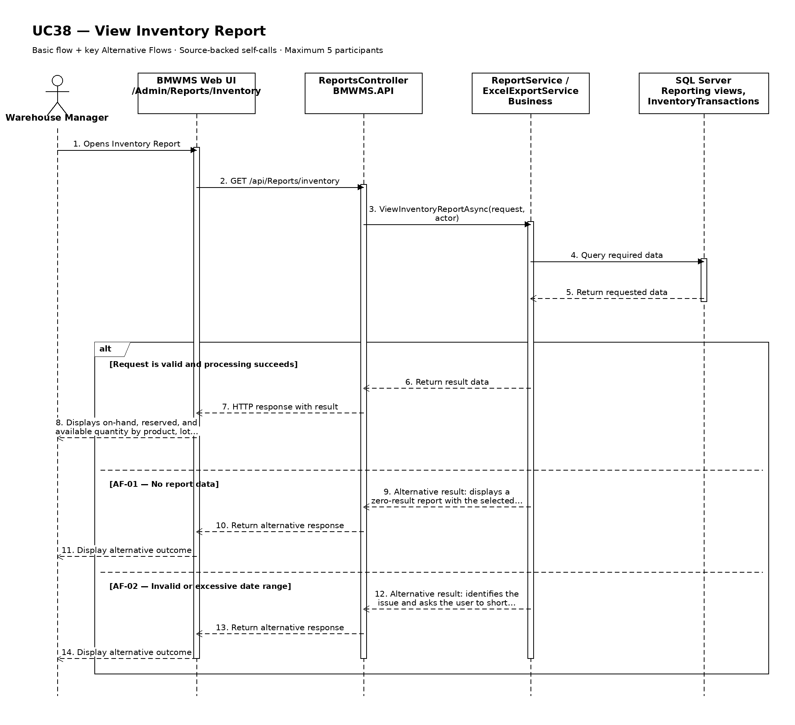

UC39: View Inbound Report
Goal: Allows the user to analyze inbound quantity and activity over a selected period.
Field | Value
Type | UI
Primary Actor | Warehouse Manager
Secondary Actor(s) | —
Module | M07 - Reporting, Dashboard and Alerts
Business Group | Inbound Report
FT-ID Ref | FT-39
Depends On | —
Preconditions | An active user is signed in and holds one of the allowed fixed roles.
Postconditions | No operational record is changed. The filter state may be retained for export.

Main Flow
- [U] The user opens Inbound Report.
- [S] The system loads the default permitted period and report scope.
- [U] The user enters the period, filters, and supported grouping or sort options.
- [S] The system validates the request and calculates the report from posted data.
- [S] The system displays expected, delivered, accepted, damaged, missing, and putaway quantity with order completion timing, totals, the data cut-off time, and the active filters.
- [U] The user may drill into supported detail, change the filters, or start UC45 Export Report to Excel or PDF.

Alternative Flows
- AF-01 - No report data: No posted data matches the filters. The system displays a zero-result report with the selected period and does not fabricate totals.
- AF-02 - Invalid or excessive date range: The date range is invalid or exceeds the permitted interactive range. The system identifies the issue and asks the user to shorten or correct the period.
- AF-03 - Data updated during viewing: New transactions are posted after the report loads. The displayed cut-off time remains unchanged until the user refreshes the report.

Business Rules
- BR-01: Report values are calculated from posted inventory transactions and the current derived balance at the selected cut-off (see PRD GB-15).
- BR-02: Date ranges use the warehouse business timezone and include the full selected end date.
- BR-03: Totals must reconcile with the displayed detail rows for expected, delivered, accepted, damaged, missing, and putaway quantity with order completion timing.
- BR-04: Cancelled orders are listed when requested but contribute zero to received totals.
- BR-05: Supplemental quantity is reported separately and remains linked to the original references.

Request Fields - InboundReportFilter
Field | Type | Rule
From date | Date | Required. Not after To date.
To date | Date | Required. Defaults to current date.
Supplier | Choice | Optional. Active or historical supplier.
Product | Choice | Optional. Active or historical product.
Inbound status | Choice | Optional. Any supported Inbound Order status.
Supplemental only | Yes/No | Optional. Defaults to No.
Group by | Choice | Optional. Supported grouping: day; week; month; supplier; product; inbound status.

On success: Inbound Report displays reconciled totals, detail, cut-off time, and active filters.

Allowed Roles
System Administrator, Warehouse Manager, Purchasing Staff

Verification Criteria
Given | When | Then
posted data exists for the selected reporting scope | the user submits a valid report filter | the report displays accurate expected, delivered, accepted, damaged, missing, and putaway quantity with order completion timing and the totals reconcile with the detail rows

Additional scenarios to cover in tests:
- Open the report using its default period.
- Filter to a single product or business partner where supported.
- Use the largest permitted interactive period.
- Use filters that return no data.
- Refresh after a new posted transaction.

Sequence Diagram
Figure UC39. Sequence Diagram - View Inbound Report
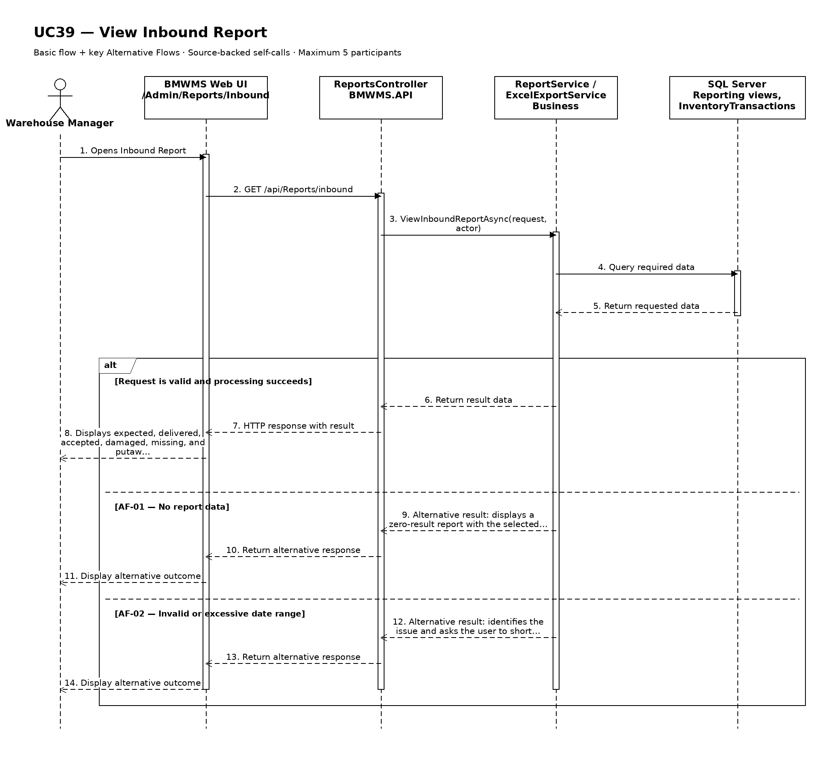

UC40: View Outbound Report
Goal: Allows the user to analyze outbound quantity and activity over a selected period.
Field | Value
Type | UI
Primary Actor | Warehouse Manager
Secondary Actor(s) | —
Module | M07 - Reporting, Dashboard and Alerts
Business Group | Outbound Report
FT-ID Ref | FT-40
Depends On | —
Preconditions | An active user is signed in and holds one of the allowed fixed roles.
Postconditions | No operational record is changed. The filter state may be retained for export.

Main Flow
- [U] The user opens Outbound Report.
- [S] The system loads the default permitted period and report scope.
- [U] The user enters the period, filters, and supported grouping or sort options.
- [S] The system validates the request and calculates the report from posted data.
- [S] The system displays requested, reserved, released, and issued quantity with order completion timing, totals, the data cut-off time, and the active filters.
- [U] The user may drill into supported detail, change the filters, or start UC45 Export Report to Excel or PDF.

Alternative Flows
- AF-01 - No report data: No posted data matches the filters. The system displays a zero-result report with the selected period and does not fabricate totals.
- AF-02 - Invalid or excessive date range: The date range is invalid or exceeds the permitted interactive range. The system identifies the issue and asks the user to shorten or correct the period.
- AF-03 - Data updated during viewing: New transactions are posted after the report loads. The displayed cut-off time remains unchanged until the user refreshes the report.

Business Rules
- BR-01: Report values are calculated from posted inventory transactions and the current derived balance at the selected cut-off (see PRD GB-15).
- BR-02: Date ranges use the warehouse business timezone and include the full selected end date.
- BR-03: Totals must reconcile with the displayed detail rows for requested, reserved, released, and issued quantity with order completion timing.
- BR-04: Cancelled orders are listed when requested but contribute zero to issued totals.
- BR-05: Issued quantity is calculated only from posted issue transactions.

Request Fields - OutboundReportFilter
Field | Type | Rule
From date | Date | Required. Not after To date.
To date | Date | Required. Defaults to current date.
Customer | Text | Optional. Customer code or name.
Product | Choice | Optional. Active or historical product.
Outbound status | Choice | Optional. Any supported Outbound Order status.
Group by | Choice | Optional. Supported grouping: day; week; month; customer; product; outbound status.

On success: Outbound Report displays reconciled totals, detail, cut-off time, and active filters.

Allowed Roles
System Administrator, Warehouse Manager, Sales Staff

Verification Criteria
Given | When | Then
posted data exists for the selected reporting scope | the user submits a valid report filter | the report displays accurate requested, reserved, released, and issued quantity with order completion timing and the totals reconcile with the detail rows

Additional scenarios to cover in tests:
- Open the report using its default period.
- Filter to a single product or business partner where supported.
- Use the largest permitted interactive period.
- Use filters that return no data.
- Refresh after a new posted transaction.

Sequence Diagram
Figure UC40. Sequence Diagram - View Outbound Report
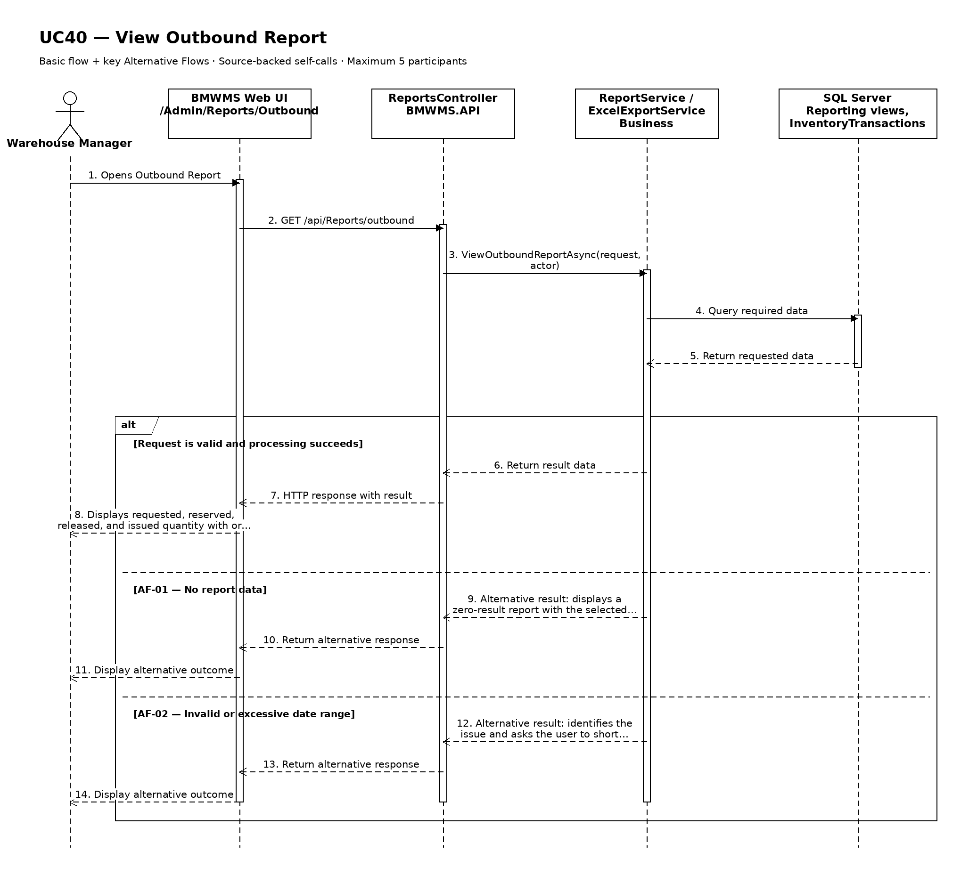

UC41: View In-Out-Stock Report
Goal: Allows the user to view opening, inbound, outbound, adjustment, and closing quantity by product.
Field | Value
Type | UI
Primary Actor | Warehouse Manager
Secondary Actor(s) | —
Module | M07 - Reporting, Dashboard and Alerts
Business Group | In-Out-Stock Report
FT-ID Ref | FT-41
Depends On | —
Preconditions | An active user is signed in and holds one of the allowed fixed roles.
Postconditions | No operational record is changed. The filter state may be retained for export.

Main Flow
- [U] The user opens In-Out-Stock Report.
- [S] The system loads the default permitted period and report scope.
- [U] The user enters the period, filters, and supported grouping or sort options.
- [S] The system validates the request and calculates the report from posted data.
- [S] The system displays opening, inbound, outbound, approved adjustment, and closing quantity by product, totals, the data cut-off time, and the active filters.
- [U] The user may drill into supported detail, change the filters, or start UC45 Export Report to Excel or PDF.

Alternative Flows
- AF-01 - No report data: No posted data matches the filters. The system displays a zero-result report with the selected period and does not fabricate totals.
- AF-02 - Invalid or excessive date range: The date range is invalid or exceeds the permitted interactive range. The system identifies the issue and asks the user to shorten or correct the period.
- AF-03 - Data updated during viewing: New transactions are posted after the report loads. The displayed cut-off time remains unchanged until the user refreshes the report.

Business Rules
- BR-01: Report values are calculated from posted inventory transactions and the current derived balance at the selected cut-off (see PRD GB-15).
- BR-02: Date ranges use the warehouse business timezone and include the full selected end date.
- BR-03: Totals must reconcile with the displayed detail rows for opening, inbound, outbound, approved adjustment, and closing quantity by product.
- BR-04: Closing quantity = opening + inbound - outbound + approved adjustment.
- BR-05: Reservations do not change on-hand movement totals and are reported separately when shown.

Request Fields - In-Out-StockReportFilter
Field | Type | Rule
From date | Date | Required. Not after To date.
To date | Date | Required. Defaults to current date.
Product | Choice | Optional. Active or historical product.
Product group | Choice | Optional. Active or historical group.
Storage location | Choice | Optional. Area, rack, or bin.
Group by | Choice | Optional. Supported grouping: product; product group; day; month; location.

On success: In-Out-Stock Report displays reconciled totals, detail, cut-off time, and active filters.

Allowed Roles
System Administrator, Warehouse Manager, Sales Staff

Verification Criteria
Given | When | Then
posted data exists for the selected reporting scope | the user submits a valid report filter | the report displays accurate opening, inbound, outbound, approved adjustment, and closing quantity by product and the totals reconcile with the detail rows

Additional scenarios to cover in tests:
- Open the report using its default period.
- Filter to a single product or business partner where supported.
- Use the largest permitted interactive period.
- Use filters that return no data.
- Refresh after a new posted transaction.

Sequence Diagram
Figure UC41. Sequence Diagram - View In-Out-Stock Report
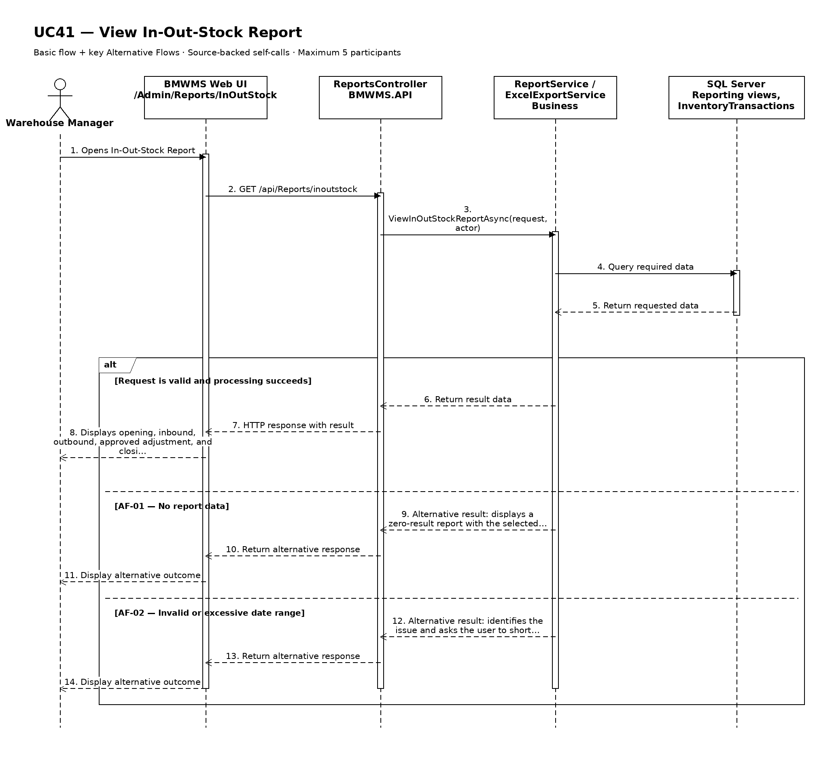

UC42: View Product Statistics
Goal: Allows the user to analyze stock levels and movement trends for each product.
Field | Value
Type | UI
Primary Actor | Warehouse Manager
Secondary Actor(s) | —
Module | M07 - Reporting, Dashboard and Alerts
Business Group | Product Analytics
FT-ID Ref | FT-42
Depends On | —
Preconditions | An active user is signed in and holds one of the allowed fixed roles.
Postconditions | No operational record is changed. The filter state may be retained for export.

Main Flow
- [U] The user opens Product Statistics.
- [S] The system loads the default permitted period and report scope.
- [U] The user enters the period, filters, and supported grouping or sort options.
- [S] The system validates the request and calculates the report from posted data.
- [S] The system displays current stock, inbound quantity, outbound quantity, movement frequency, average inventory, days since last movement, and low-stock occurrence, totals, the data cut-off time, and the active filters.
- [U] The user may drill into supported detail, change the filters, or start UC45 Export Report to Excel or PDF.

Alternative Flows
- AF-01 - No report data: No posted data matches the filters. The system displays a zero-result report with the selected period and does not fabricate totals.
- AF-02 - Invalid or excessive date range: The date range is invalid or exceeds the permitted interactive range. The system identifies the issue and asks the user to shorten or correct the period.
- AF-03 - Data updated during viewing: New transactions are posted after the report loads. The displayed cut-off time remains unchanged until the user refreshes the report.

Business Rules
- BR-01: Report values are calculated from posted inventory transactions and the current derived balance at the selected cut-off (see PRD GB-15).
- BR-02: Date ranges use the warehouse business timezone and include the full selected end date.
- BR-03: Totals must reconcile with the displayed detail rows for current stock, inbound quantity, outbound quantity, movement frequency, average inventory, days since last movement, and low-stock occurrence.
- BR-04: Statistics use posted events only and visibly identify the calculation period.
- BR-05: Products with no movement may still be included when the user selects Include inactive movement.

Request Fields - ProductStatisticsFilter
Field | Type | Rule
From date | Date | Required. Not after To date.
To date | Date | Required. Defaults to current date.
Product | Choice | Optional. Active or historical product.
Product group | Choice | Optional. Active or historical group.
Movement type | Choice | Optional. Inbound, outbound, adjustment, or all.
Group by | Choice | Optional. Supported grouping: product; product group; day; week; month.

On success: Product Statistics displays reconciled totals, detail, cut-off time, and active filters.

Allowed Roles
System Administrator, Warehouse Manager, Sales Staff

Verification Criteria
Given | When | Then
posted data exists for the selected reporting scope | the user submits a valid report filter | the report displays accurate current stock, inbound quantity, outbound quantity, movement frequency, average inventory, days since last movement, and low-stock occurrence and the totals reconcile with the detail rows

Additional scenarios to cover in tests:
- Open the report using its default period.
- Filter to a single product or business partner where supported.
- Use the largest permitted interactive period.
- Use filters that return no data.
- Refresh after a new posted transaction.

Sequence Diagram
Figure UC42. Sequence Diagram - View Product Statistics
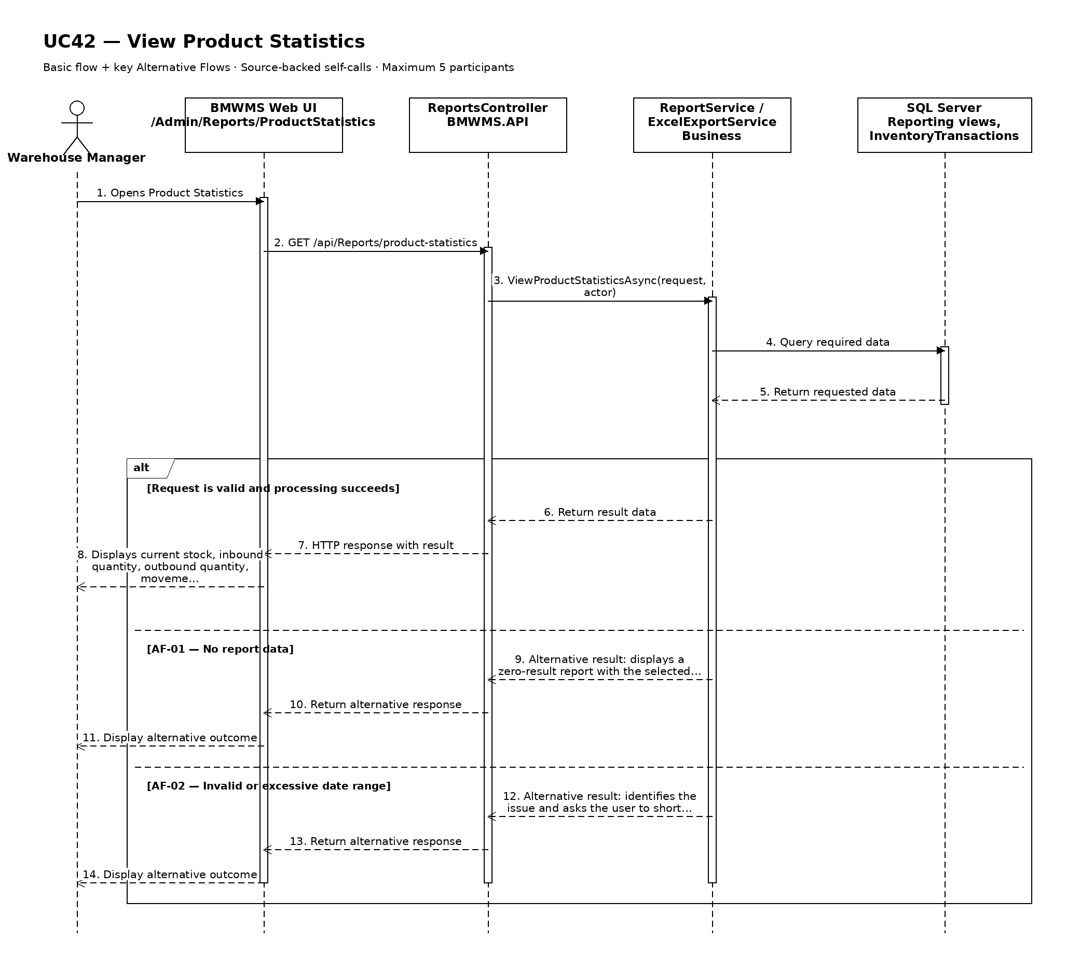

UC43: View Supplier Statistics
Goal: Allows the user to analyze inbound frequency and quantity by supplier.
Field | Value
Type | UI
Primary Actor | Warehouse Manager
Secondary Actor(s) | —
Module | M07 - Reporting, Dashboard and Alerts
Business Group | Supplier Analytics
FT-ID Ref | FT-43
Depends On | —
Preconditions | An active user is signed in and holds one of the allowed fixed roles.
Postconditions | No operational record is changed. The filter state may be retained for export.

Main Flow
- [U] The user opens Supplier Statistics.
- [S] The system loads the default permitted period and report scope.
- [U] The user enters the period, filters, and supported grouping or sort options.
- [S] The system validates the request and calculates the report from posted data.
- [S] The system displays inbound order count, received quantity, damaged quantity, missing quantity, supplemental quantity, and completion performance by supplier, totals, the data cut-off time, and the active filters.
- [U] The user may drill into supported detail, change the filters, or start UC45 Export Report to Excel or PDF.

Alternative Flows
- AF-01 - No report data: No posted data matches the filters. The system displays a zero-result report with the selected period and does not fabricate totals.
- AF-02 - Invalid or excessive date range: The date range is invalid or exceeds the permitted interactive range. The system identifies the issue and asks the user to shorten or correct the period.
- AF-03 - Data updated during viewing: New transactions are posted after the report loads. The displayed cut-off time remains unchanged until the user refreshes the report.

Business Rules
- BR-01: Report values are calculated from posted inventory transactions and the current derived balance at the selected cut-off (see PRD GB-15).
- BR-02: Date ranges use the warehouse business timezone and include the full selected end date.
- BR-03: Totals must reconcile with the displayed detail rows for inbound order count, received quantity, damaged quantity, missing quantity, supplemental quantity, and completion performance by supplier.
- BR-04: Cancelled orders do not contribute to received quantities.
- BR-05: Supplier performance values are operational indicators and do not represent accounting invoice settlement.

Request Fields - SupplierStatisticsFilter
Field | Type | Rule
From date | Date | Required. Not after To date.
To date | Date | Required. Defaults to current date.
Supplier | Choice | Optional. Active or historical supplier.
Product | Choice | Optional. Active or historical product.
Include cancelled orders | Yes/No | Optional. Defaults to No.
Group by | Choice | Optional. Supported grouping: supplier; product; day; month.

On success: Supplier Statistics displays reconciled totals, detail, cut-off time, and active filters.

Allowed Roles
System Administrator, Warehouse Manager, Purchasing Staff

Verification Criteria
Given | When | Then
posted data exists for the selected reporting scope | the user submits a valid report filter | the report displays accurate inbound order count, received quantity, damaged quantity, missing quantity, supplemental quantity, and completion performance by supplier and the totals reconcile with the detail rows

Additional scenarios to cover in tests:
- Open the report using its default period.
- Filter to a single product or business partner where supported.
- Use the largest permitted interactive period.
- Use filters that return no data.
- Refresh after a new posted transaction.

Sequence Diagram
Figure UC43. Sequence Diagram - View Supplier Statistics
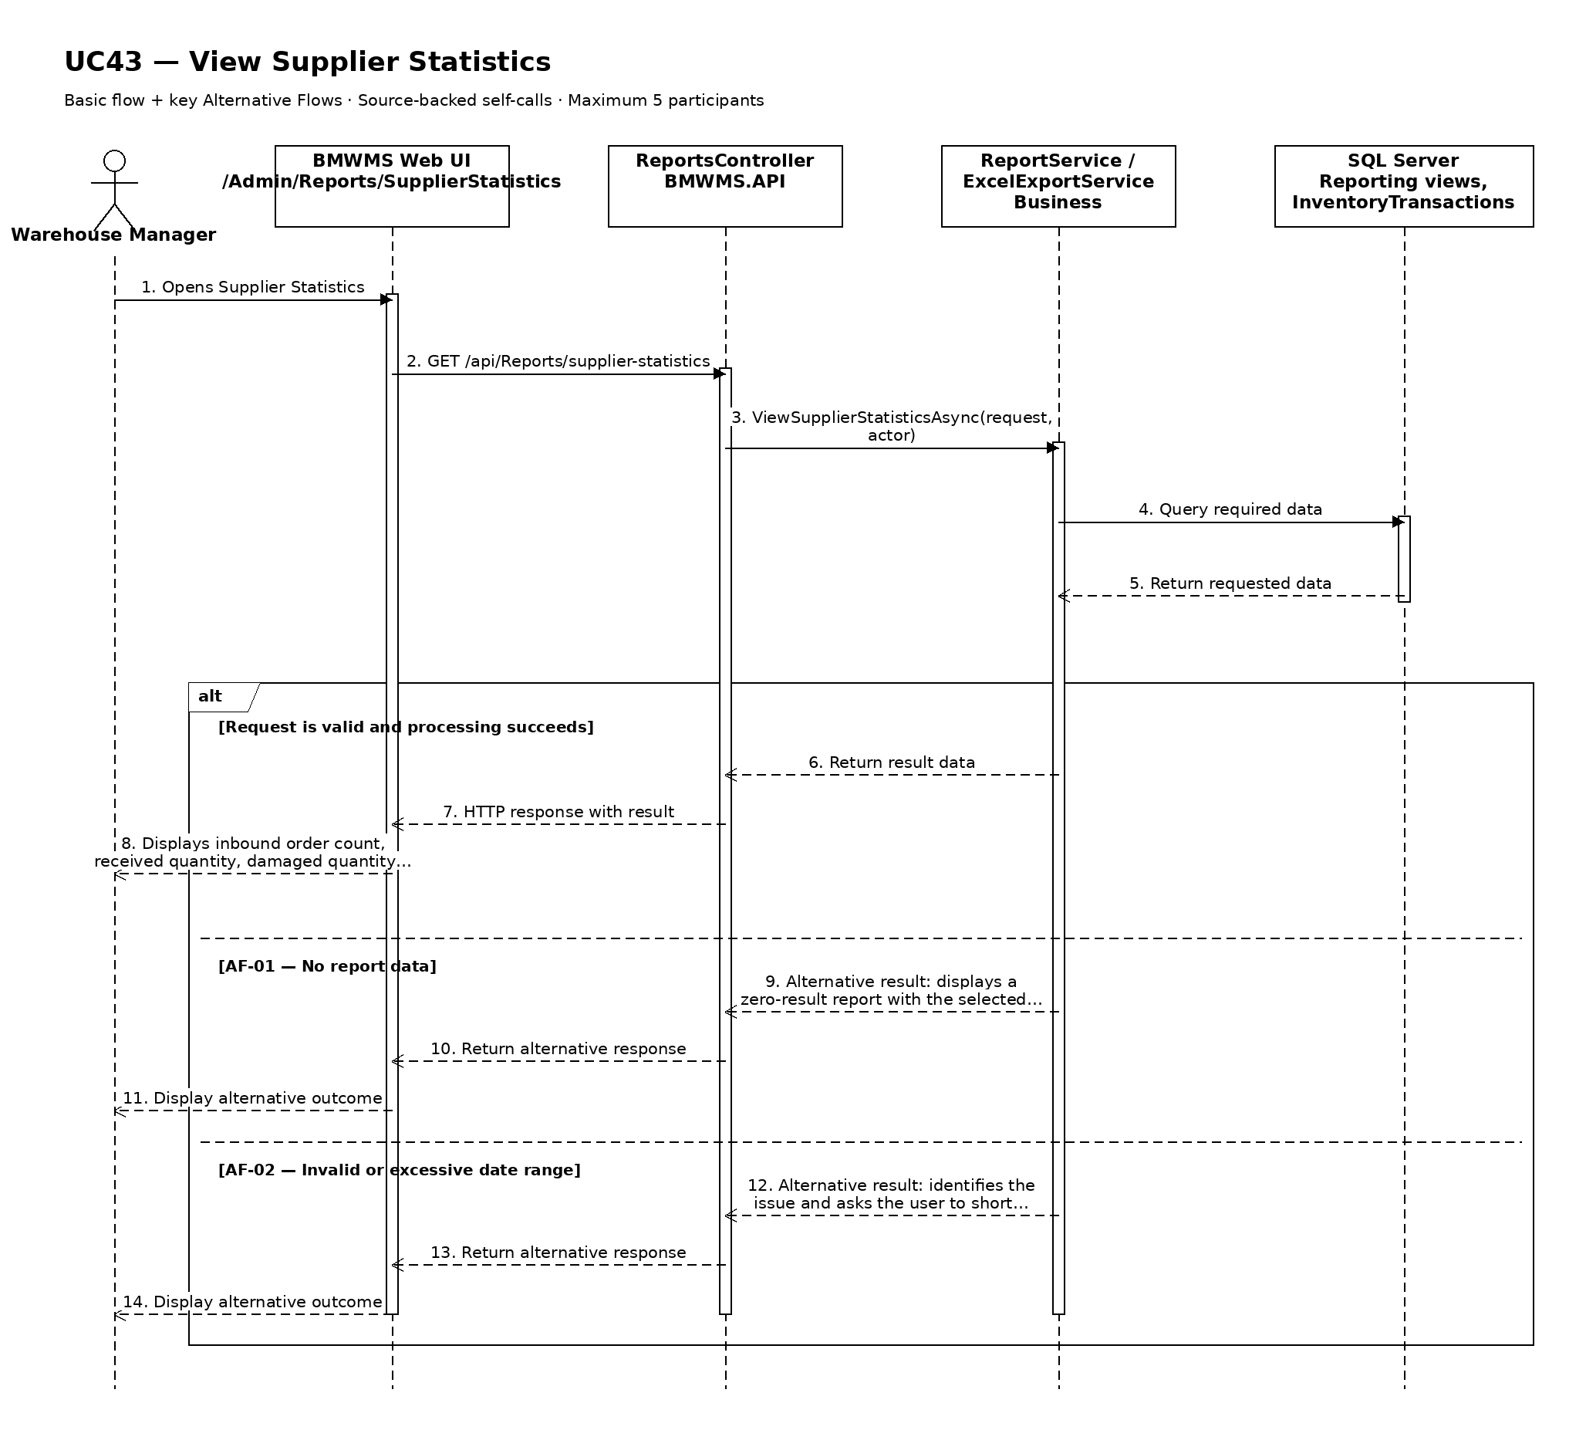

UC44: View Stocktake Result Statistics
Goal: Allows the user to analyze stocktake frequency, discrepancy quantity, and adjustment quantity.
Field | Value
Type | UI
Primary Actor | Warehouse Manager
Secondary Actor(s) | —
Module | M07 - Reporting, Dashboard and Alerts
Business Group | Stocktake Analytics
FT-ID Ref | FT-44
Depends On | —
Preconditions | An active user is signed in and holds one of the allowed fixed roles.
Postconditions | No operational record is changed. The filter state may be retained for export.

Main Flow
- [U] The user opens Stocktake Result Statistics.
- [S] The system loads the default permitted period and report scope.
- [U] The user enters the period, filters, and supported grouping or sort options.
- [S] The system validates the request and calculates the report from posted data.
- [S] The system displays session count, bins counted, matched items, shortage quantity, excess quantity, recount count, approved adjustment quantity, and stock accuracy rate, totals, the data cut-off time, and the active filters.
- [U] The user may drill into supported detail, change the filters, or start UC45 Export Report to Excel or PDF.

Alternative Flows
- AF-01 - No report data: No posted data matches the filters. The system displays a zero-result report with the selected period and does not fabricate totals.
- AF-02 - Invalid or excessive date range: The date range is invalid or exceeds the permitted interactive range. The system identifies the issue and asks the user to shorten or correct the period.
- AF-03 - Data updated during viewing: New transactions are posted after the report loads. The displayed cut-off time remains unchanged until the user refreshes the report.

Business Rules
- BR-01: Report values are calculated from posted inventory transactions and the current derived balance at the selected cut-off (see PRD GB-15).
- BR-02: Date ranges use the warehouse business timezone and include the full selected end date.
- BR-03: Totals must reconcile with the displayed detail rows for session count, bins counted, matched items, shortage quantity, excess quantity, recount count, approved adjustment quantity, and stock accuracy rate.
- BR-04: Stock accuracy rate is calculated using the approved project formula and shows its numerator and denominator.
- BR-05: Only approved adjustment transactions contribute to adjustment totals.

Request Fields - StocktakeResultStatisticsFilter
Field | Type | Rule
From date | Date | Required. Not after To date.
To date | Date | Required. Defaults to current date.
Count type | Choice | Optional. FULL_COUNT or CYCLE_COUNT.
Storage area | Choice | Optional. Area within the configured warehouse.
Product group | Choice | Optional. Active or historical group.
Session status | Choice | Optional. Any supported Stocktake Session status.
Group by | Choice | Optional. Supported grouping: session; count type; area; product group; month.

On success: Stocktake Result Statistics displays reconciled totals, detail, cut-off time, and active filters.

Allowed Roles
System Administrator, Warehouse Manager

Verification Criteria
Given | When | Then
posted data exists for the selected reporting scope | the user submits a valid report filter | the report displays accurate session count, bins counted, matched items, shortage quantity, excess quantity, recount count, approved adjustment quantity, and stock accuracy rate and the totals reconcile with the detail rows

Additional scenarios to cover in tests:
- Open the report using its default period.
- Filter to a single product or business partner where supported.
- Use the largest permitted interactive period.
- Use filters that return no data.
- Refresh after a new posted transaction.

Sequence Diagram
Figure UC44. Sequence Diagram - View Stocktake Result Statistics
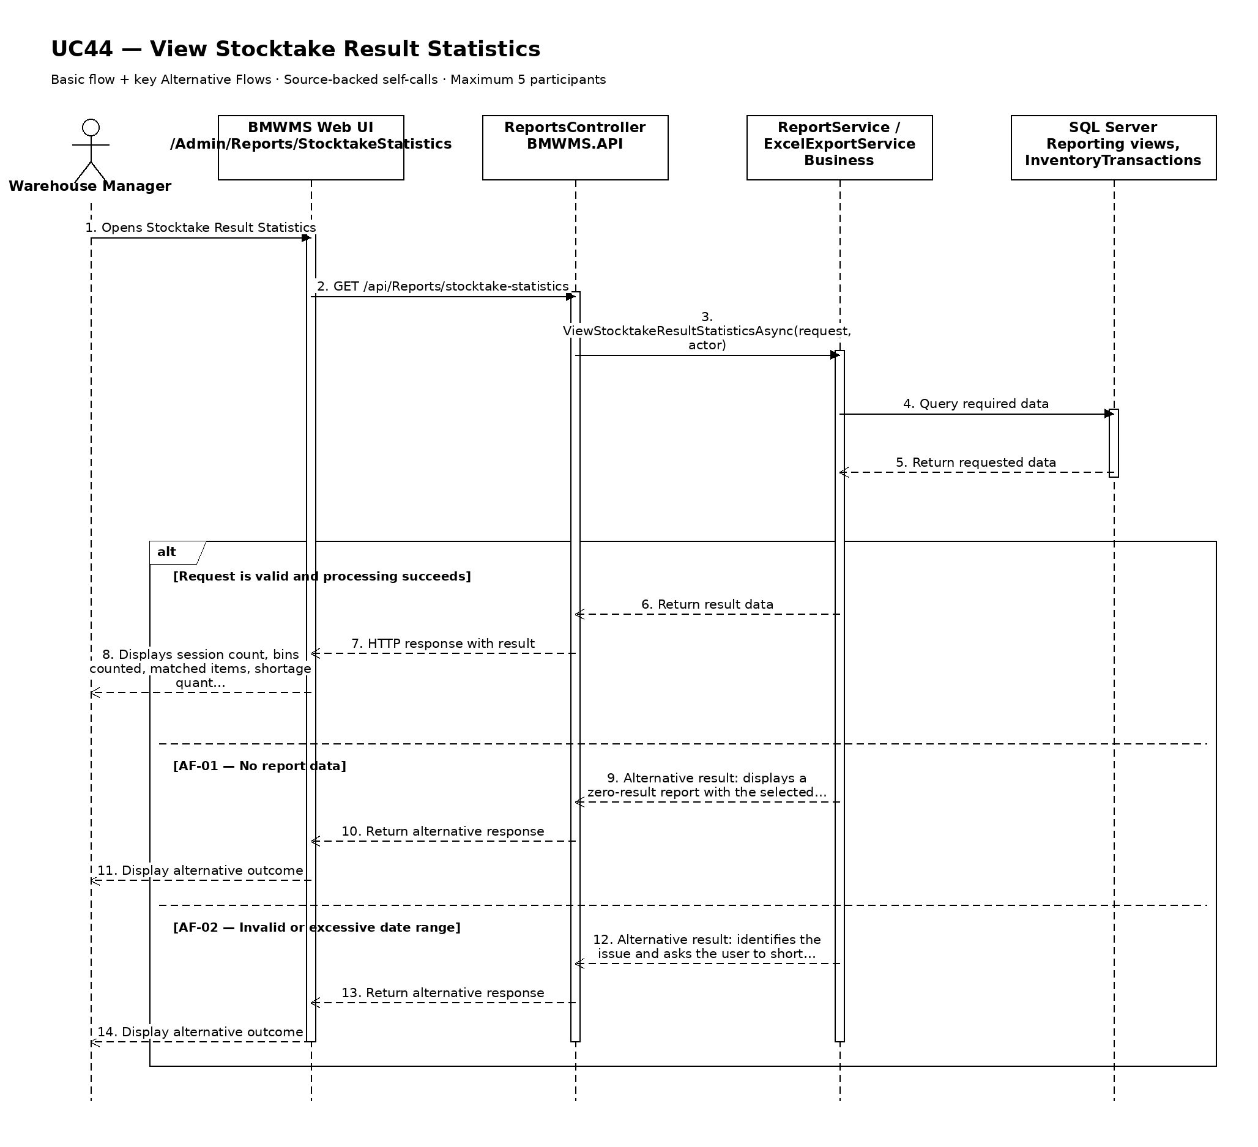

UC45: Export Report to Excel or PDF
Goal: Allows the user to export the currently filtered report to Excel or PDF.
Field | Value
Type | UI
Primary Actor | Warehouse Manager
Secondary Actor(s) | —
Module | M07 - Reporting, Dashboard and Alerts
Business Group | Report Export
FT-ID Ref | FT-45
Depends On | UC38-UC44
Preconditions | An active user is signed in and holds one of the allowed fixed roles. A supported report or statistics view is open with a valid filter state.
Postconditions | An Excel or PDF file representing the current report is downloaded or queued for generation.

Main Flow
- [U] The user selects Export from a supported report.
- [S] The system opens the Export dialog with the active report title, filters, columns, row count estimate, and supported formats.
- [U] The user selects Excel or PDF, confirms the columns and export scope, and submits.
- [S] The system revalidates permission, filter state, estimated size, and report data cut-off.
- [S] The system generates the file immediately when within the interactive threshold or queues a controlled export job when larger.
- [S] The system records the export audit event and either downloads the file or notifies the requester when the queued file is ready.

Alternative Flows
- AF-01 - No data to export: The active report contains no data rows. The system warns the user and does not create an empty file unless the user explicitly selects Export headers only.
- AF-02 - Large export queued: The estimated row count exceeds the interactive threshold. The system queues generation, returns the user to the report, and sends a notification when the file is available.
- AF-03 - Permission or data scope changed: The user's permission changes before generation. The system cancels the export and does not include data the user can no longer access.
- AF-04 - Generation failure: File generation fails. The system records the failure, provides a retry-safe notification, and does not expose a partial file.

Business Rules
- BR-01: Exported content must reflect the active filters, selected columns, report title, generation time, and requesting user (see PRD GB-16).
- BR-02: Excel and PDF are the only supported formats in this baseline.
- BR-03: Export uses the same authorized data scope and calculation cut-off as the source report.
- BR-04: Large exports are queued and made available only to the requester.
- BR-05: Every export request and result is written to the audit log (see PRD GB-20).

Request Fields - ReportExportRequest
Field | Type | Rule
Source report | Read-only | Required. One supported report from UC38-UC44.
Active filters | Read-only | Captured from the current report.
File format | Choice | Required. Excel or PDF.
Export scope | Choice | Required. Current page or all matching rows, subject to limits.
Selected columns | Multi-select | Required. At least one permitted column.
Export headers only | Yes/No | Optional. Used only when no data rows match.

On success: The browser downloads a complete file or the user receives a queued-export confirmation and later a private ready notification.

Allowed Roles
System Administrator, Warehouse Manager, Purchasing Staff, Sales Staff

Verification Criteria
Given | When | Then
a supported report contains authorized data and valid active filters | the user submits a valid Excel or PDF export request | the generated file matches the report filters and columns, identifies the requester and generation time, and the export is audited

Additional scenarios to cover in tests:
- Export a small report to Excel.
- Export a small report to PDF.
- Export all matching rows using active filters.
- Queue a large export.
- Attempt export with no data.
- Handle permission change before generation.
- Retry after a generation failure without duplicating files.

Sequence Diagram
Figure UC45. Sequence Diagram - Export Report to Excel or PDF
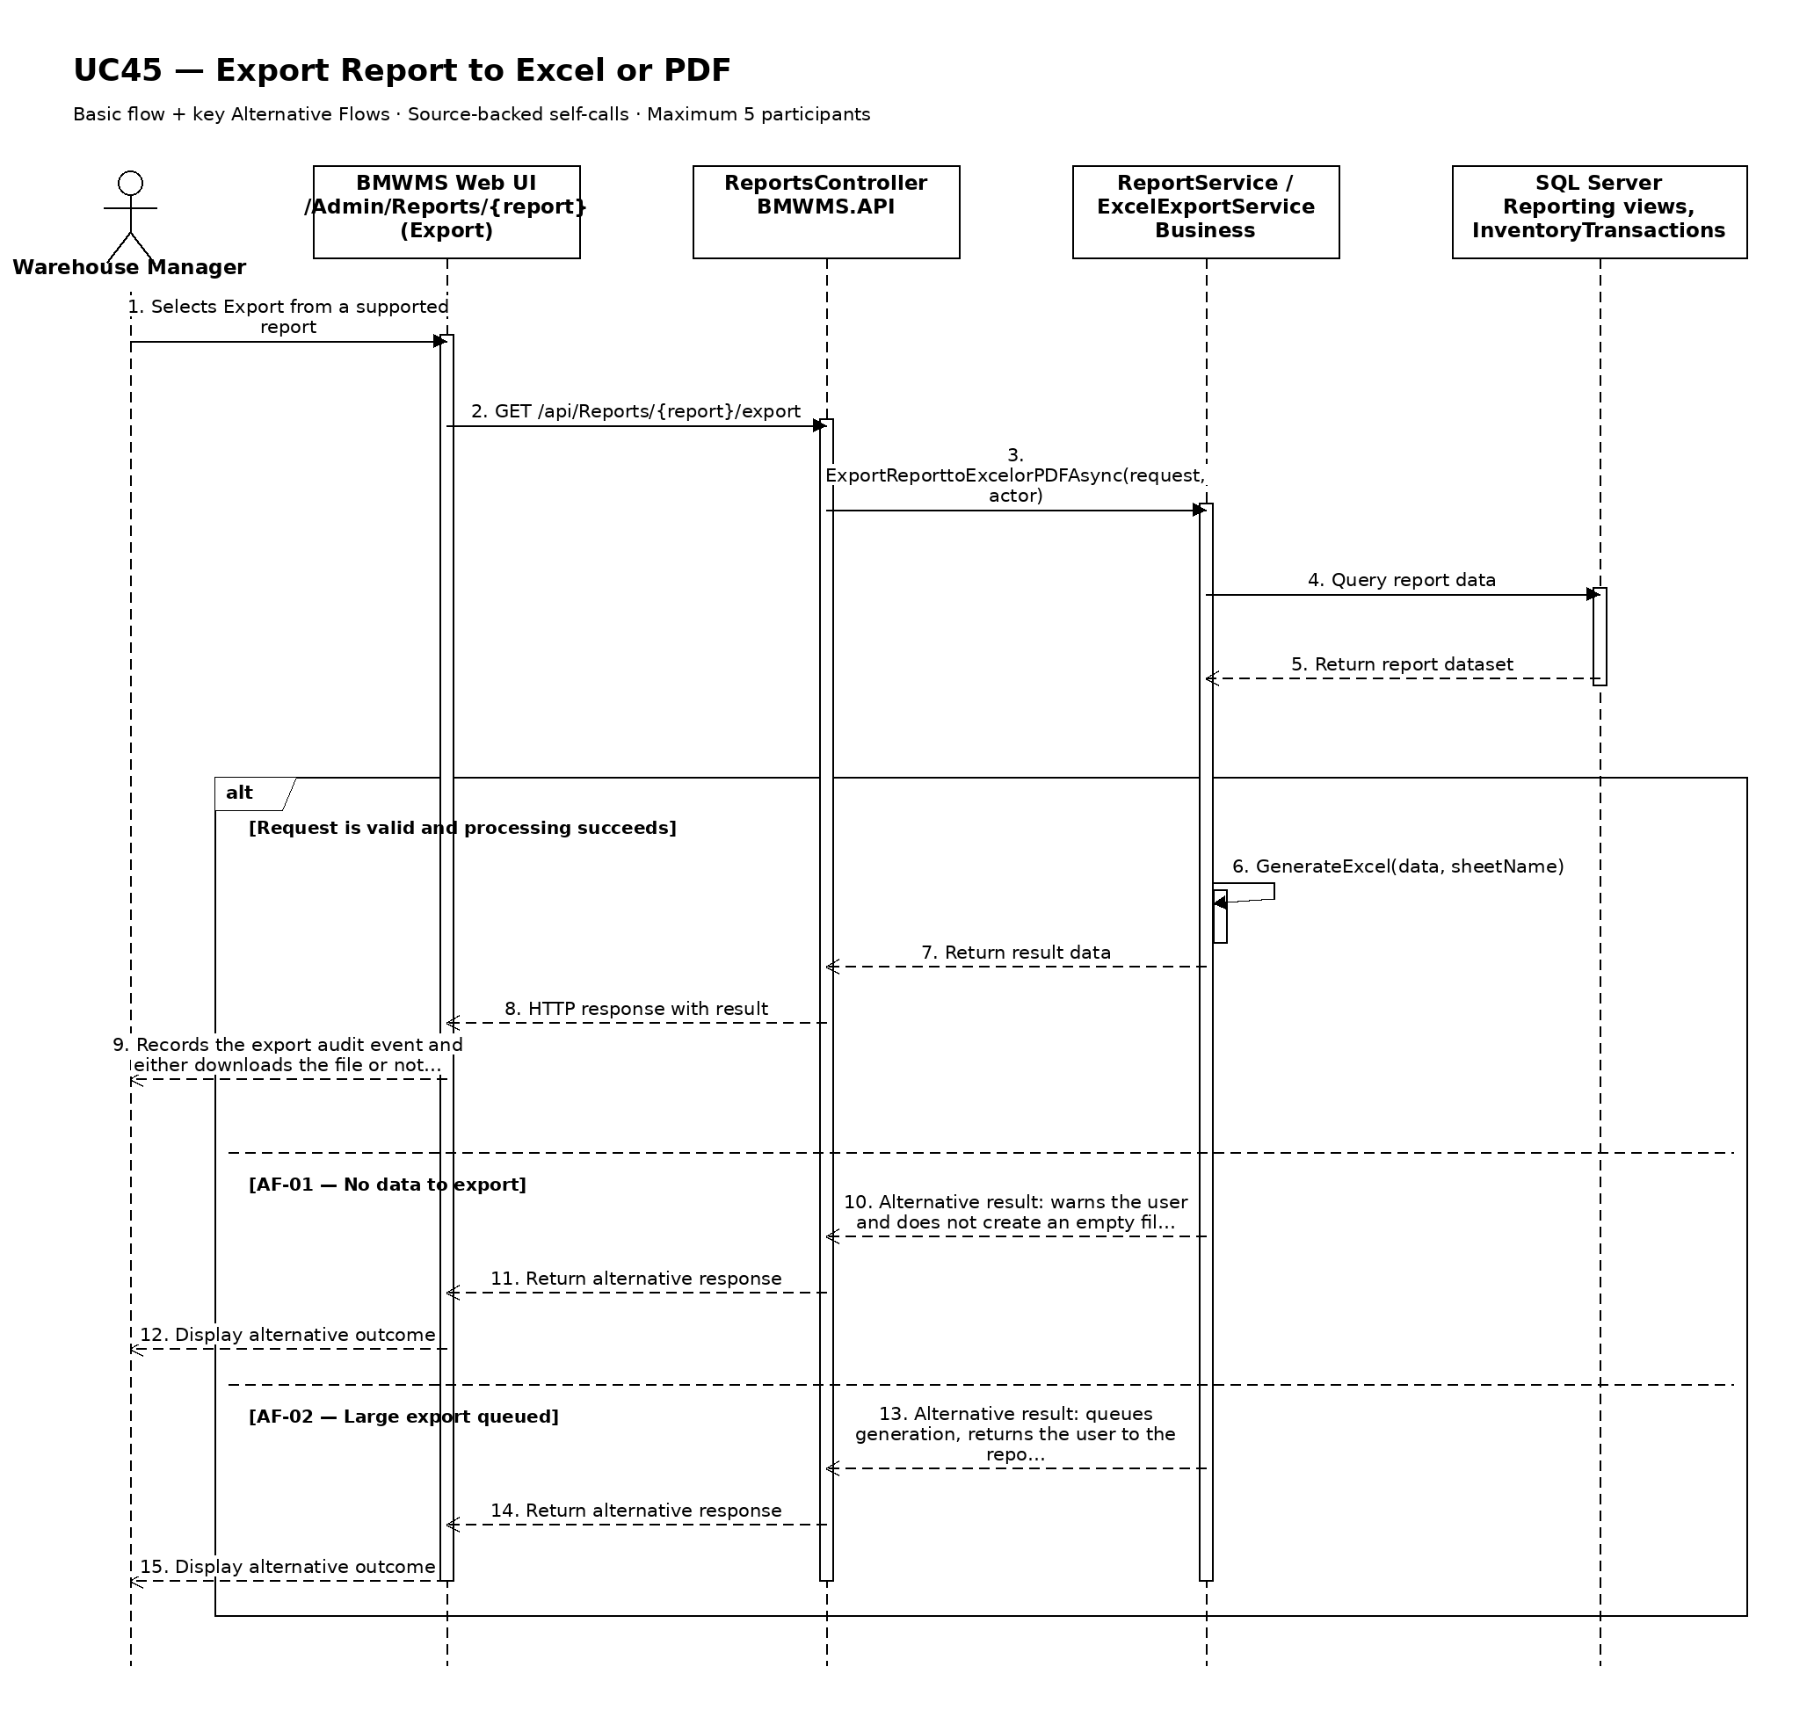

UC46: View Operational Dashboard
Goal: Allows the user to view summary indicators for warehouse operations.
Field | Value
Type | UI
Primary Actor | Warehouse Manager
Secondary Actor(s) | —
Module | M07 - Reporting, Dashboard and Alerts
Business Group | Dashboard
FT-ID Ref | FT-46
Depends On | —
Preconditions | An active user is signed in and holds one of the allowed fixed roles.
Postconditions | No operational record is changed; the selected dashboard period may remain in session.

Main Flow
- [U] The user opens Operational Dashboard.
- [S] The system applies the user's authorized scope and default current-day/rolling-period settings.
- [S] The system calculates inventory, inbound, outbound, stocktake, alert, and workload summary cards from posted data.
- [S] The system displays trend charts, exception counts, data cut-off time, and links to permitted details.
- [U] The user changes the supported period or selects a card, chart point, or alert summary.
- [S] The system refreshes the dashboard or opens the related authorized report, alert, notification, or KPI view.

Alternative Flows
- AF-01 - No activity in period: No posted activity exists. The system displays zero-value cards and an explicit no-activity chart state rather than hiding the metric.
- AF-02 - One widget unavailable: A widget calculation fails. The system keeps other widgets available, marks the affected widget unavailable, and records an operational error.
- AF-03 - Data refreshed: New posted data exists. The user selects Refresh and the system recalculates all widgets using a new visible cut-off time.

Business Rules
- BR-01: Dashboard values use posted transactions and current derived balances (see PRD GB-15).
- BR-02: Every widget displays or inherits a visible calculation cut-off time.
- BR-03: Dashboard links and data are restricted by fixed role and operational scope.
- BR-04: System Administrator has full visibility; Warehouse Manager sees all operational widgets; other roles see only permitted widgets.

Request Fields - OperationalDashboardRequest
Field | Type | Rule
Dashboard period | Choice/Date range | Optional. Defaults to current day and rolling 30 days.
Refresh | Action | Optional. Recalculates widgets using a new cut-off time.

On success: The dashboard displays authorized reconciled summary values, trends, exceptions, and data cut-off time.

Allowed Roles
System Administrator, Warehouse Manager, Sales Staff

Verification Criteria
Given | When | Then
the user has dashboard permission and posted operational data exists | the user opens or refreshes the dashboard | all permitted widgets display reconciled values for the same cut-off and link only to authorized detail

Additional scenarios to cover in tests:
- Open the dashboard with current-day data.
- Change to the rolling 30-day period.
- Open a report from a dashboard card.
- Open an alert summary.
- View a period with no activity.
- Handle one unavailable widget without losing the entire dashboard.

Sequence Diagram
Figure UC46. Sequence Diagram - View Operational Dashboard
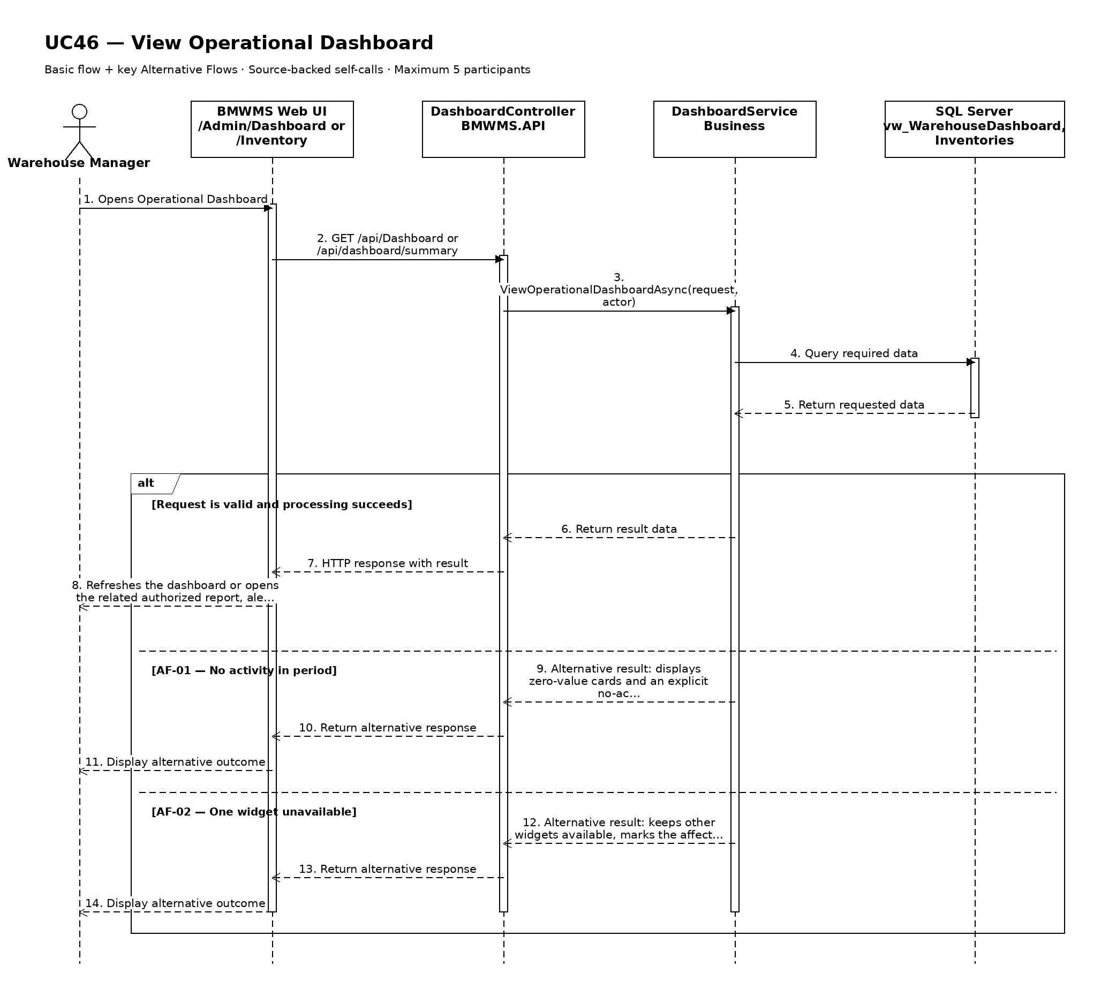

UC47: View Low-Stock Alerts
Goal: Allows the user to identify products whose available quantity is below the configured safety stock.
Field | Value
Type | UI
Primary Actor | Warehouse Manager
Secondary Actor(s) | —
Module | M07 - Reporting, Dashboard and Alerts
Business Group | Low-Stock Alert
FT-ID Ref | FT-47
Depends On | UC46
Preconditions | An active user is signed in and holds one of the allowed fixed roles.
Postconditions | No related operational record is changed.

Main Flow
- [U] The user opens Low-Stock Alerts from the dashboard or Alert Center.
- [S] The system applies the user's authorized scope and the default active-alert filter.
- [U] The user changes the supported filters or sorting.
- [S] The system validates the filters and recalculates the active alert set.
- [S] The system displays product, group, unit, on-hand, reserved, available, safety stock, shortage quantity, default location, severity, and calculation time, the alert count, and the calculation time.
- [U] The user may open the related authorized product, lot, order, or report.

Alternative Flows
- AF-01 - No active alerts: No record currently meets the alert condition. The system displays a clear all-normal state and the calculation time.
- AF-02 - Related record no longer eligible: A record is resolved between list and open. The system refreshes the alert set and explains that the alert is no longer active.

Business Rules
- BR-01: An alert is active when a product's available quantity is below its configured safety stock (see PRD GB-10).
- BR-02: Alerts are restricted to the user's role and authorized operational scope (see PRD GB-17).
- BR-03: Opening an alert does not itself modify the related product, lot, or order.
- BR-04: Products with safety stock equal to zero do not generate a low-stock alert unless explicitly included for review.

Request Fields - Low-StockAlertsFilter
Field | Type | Rule
Product search | Text | Optional. Product code, name, or barcode.
Product group | Choice | Optional. Active or historical group.
Severity | Choice | Optional. Out of stock, critical, or below safety stock.
Include zero safety stock | Yes/No | Optional. Defaults to No.

On success: Low-Stock Alerts displays the active authorized alerts and related navigation.

Allowed Roles
System Administrator, Warehouse Manager, Sales Staff

Verification Criteria
Given | When | Then
at least one authorized record meets the alert condition | the user opens the alert view with valid filters | every displayed row meets the defined condition and records outside the user's scope are excluded

Additional scenarios to cover in tests:
- View one active alert.
- View multiple alerts and change sorting.
- Apply filters that return no alerts.
- Open an eligible related record.
- Refresh after an alert condition is resolved.

Sequence Diagram
Figure UC47. Sequence Diagram - View Low-Stock Alerts
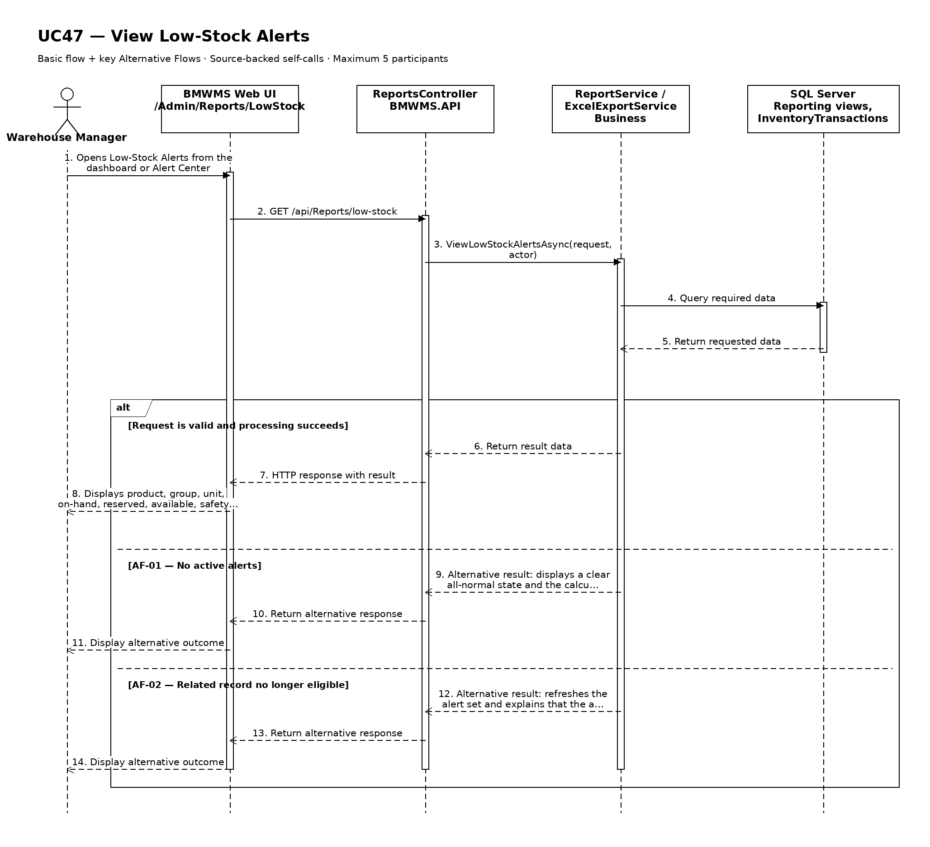

UC48: View Expiring-Lot Alerts
Goal: Allows the user to identify paint, adhesives, admixtures, and other controlled lots approaching expiry.
Field | Value
Type | UI
Primary Actor | Warehouse Manager
Secondary Actor(s) | —
Module | M07 - Reporting, Dashboard and Alerts
Business Group | Expiry Alert
FT-ID Ref | FT-48
Depends On | UC46
Preconditions | An active user is signed in and holds one of the allowed fixed roles.
Postconditions | No related operational record is changed.

Main Flow
- [U] The user opens Expiring-Lot Alerts from the dashboard or Alert Center.
- [S] The system applies the user's authorized scope and the default active-alert filter.
- [U] The user changes the supported filters or sorting.
- [S] The system validates the filters and recalculates the active alert set.
- [S] The system displays product, lot, expiry date, days remaining, on-hand, reserved, available, bins, lot status, severity, and calculation time, the alert count, and the calculation time.
- [U] The user may open the related authorized product, lot, order, or report.

Alternative Flows
- AF-01 - No active alerts: No record currently meets the alert condition. The system displays a clear all-normal state and the calculation time.
- AF-02 - Related record no longer eligible: A record is resolved between list and open. The system refreshes the alert set and explains that the alert is no longer active.

Business Rules
- BR-01: An alert is active when a positive-balance lot has an expiry date within the configured warning window or is already EXPIRED.
- BR-02: Alerts are restricted to the user's role and authorized operational scope (see PRD GB-17).
- BR-03: Opening an alert does not itself modify the related product, lot, or order.
- BR-04: Only expiry-controlled products with positive on-hand balance are included.
- BR-05: EXPIRED or BLOCKED lots are never proposed for normal reservation or issue.

Request Fields - Expiring-LotAlertsFilter
Field | Type | Rule
Product search | Text | Optional. Product code, name, or barcode.
Product group | Choice | Optional. Typically paint, adhesive, admixture, or another expiry-controlled group.
Expiry within | Number of days | Required. Between 0 and the configured maximum; defaults to 30.
Lot status | Choice | Optional. ACTIVE or EXPIRED.
Storage location | Choice | Optional. Area, rack, or bin.

On success: Expiring-Lot Alerts displays the active authorized alerts and related navigation.

Allowed Roles
System Administrator, Warehouse Manager, Sales Staff

Verification Criteria
Given | When | Then
at least one authorized record meets the alert condition | the user opens the alert view with valid filters | every displayed row meets the defined condition and records outside the user's scope are excluded

Additional scenarios to cover in tests:
- View one active alert.
- View multiple alerts and change sorting.
- Apply filters that return no alerts.
- Open an eligible related record.
- Refresh after an alert condition is resolved.

Sequence Diagram
Figure UC48. Sequence Diagram - View Expiring-Lot Alerts
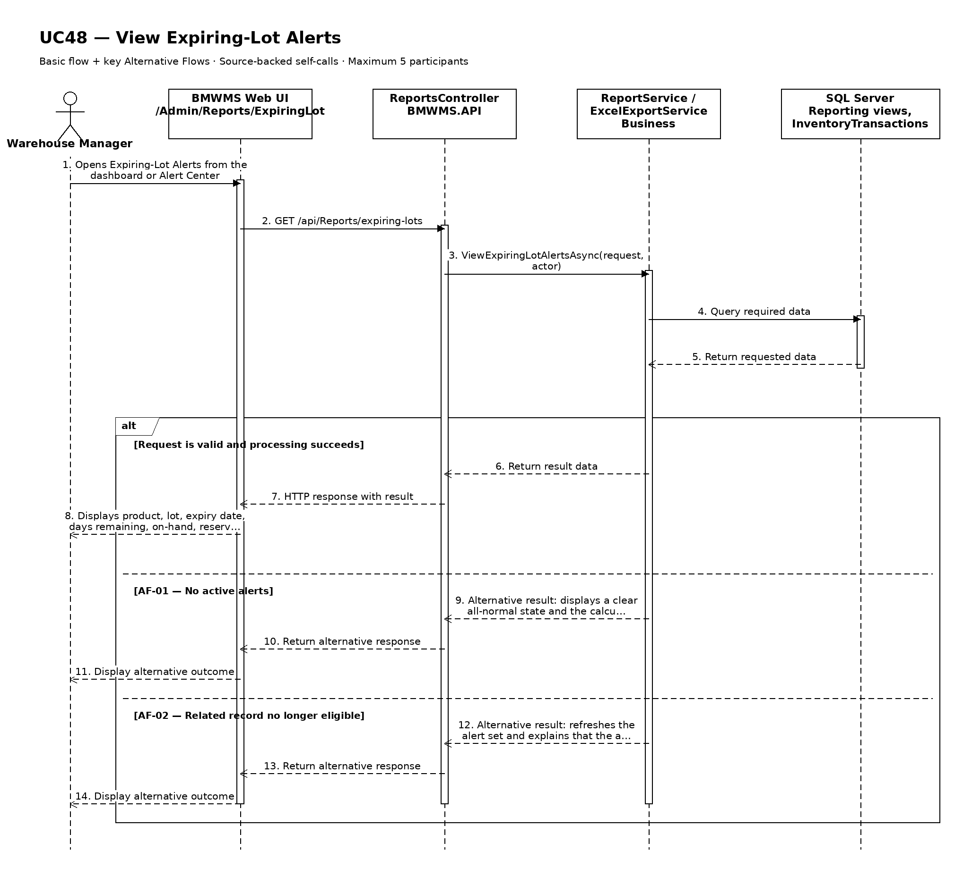

UC49: View Overdue Inbound and Outbound Alerts
Goal: Allows the user to identify inbound or outbound orders that remain incomplete after the allowed processing time.
Field | Value
Type | UI
Primary Actor | Warehouse Manager
Secondary Actor(s) | —
Module | M07 - Reporting, Dashboard and Alerts
Business Group | Overdue Order Alert
FT-ID Ref | FT-49
Depends On | UC46
Preconditions | An active user is signed in and holds one of the allowed fixed roles.
Postconditions | No related operational record is changed.

Main Flow
- [U] The user opens Overdue Inbound and Outbound Alerts from the dashboard or Alert Center.
- [S] The system applies the user's authorized scope and the default active-alert filter.
- [U] The user changes the supported filters or sorting.
- [S] The system validates the filters and recalculates the active alert set.
- [S] The system displays order number, direction, source reference, partner, current status, responsible role, required date, days overdue, and last activity, the alert count, and the calculation time.
- [U] The user may open the related authorized product, lot, order, or report.

Alternative Flows
- AF-01 - No active alerts: No record currently meets the alert condition. The system displays a clear all-normal state and the calculation time.
- AF-02 - Related record no longer eligible: A record is resolved between list and open. The system refreshes the alert set and explains that the alert is no longer active.

Business Rules
- BR-01: An alert is active when an uncompleted Inbound or Outbound Order remains past its required processing date or configured status-duration threshold.
- BR-02: Alerts are restricted to the user's role and authorized operational scope (see PRD GB-17).
- BR-03: Opening an alert does not itself modify the related product, lot, or order.
- BR-04: PUTAWAY_COMPLETED, ISSUED, and CANCELLED orders are terminal and are excluded from active overdue alerts.
- BR-05: Overdue calculation uses warehouse business time.

Request Fields - OverdueInboundandOutboundAlertsFilter
Field | Type | Rule
Order direction | Choice | Optional. Inbound, outbound, or all.
Status | Choice | Optional. One or more non-terminal order statuses.
Overdue by at least | Number of days | Optional. Zero or greater.
Supplier or customer | Text | Optional. Code or name.
Responsible role | Choice | Optional. Purchasing Staff, Sales Staff, Warehouse Staff, or Warehouse Manager.

On success: Overdue Inbound and Outbound Alerts displays the active authorized alerts and related navigation.

Allowed Roles
System Administrator, Warehouse Manager, Sales Staff

Verification Criteria
Given | When | Then
at least one authorized record meets the alert condition | the user opens the alert view with valid filters | every displayed row meets the defined condition and records outside the user's scope are excluded

Additional scenarios to cover in tests:
- View one active alert.
- View multiple alerts and change sorting.
- Apply filters that return no alerts.
- Open an eligible related record.
- Refresh after an alert condition is resolved.

Sequence Diagram
Figure UC49. Sequence Diagram - View Overdue Inbound and Outbound Alerts
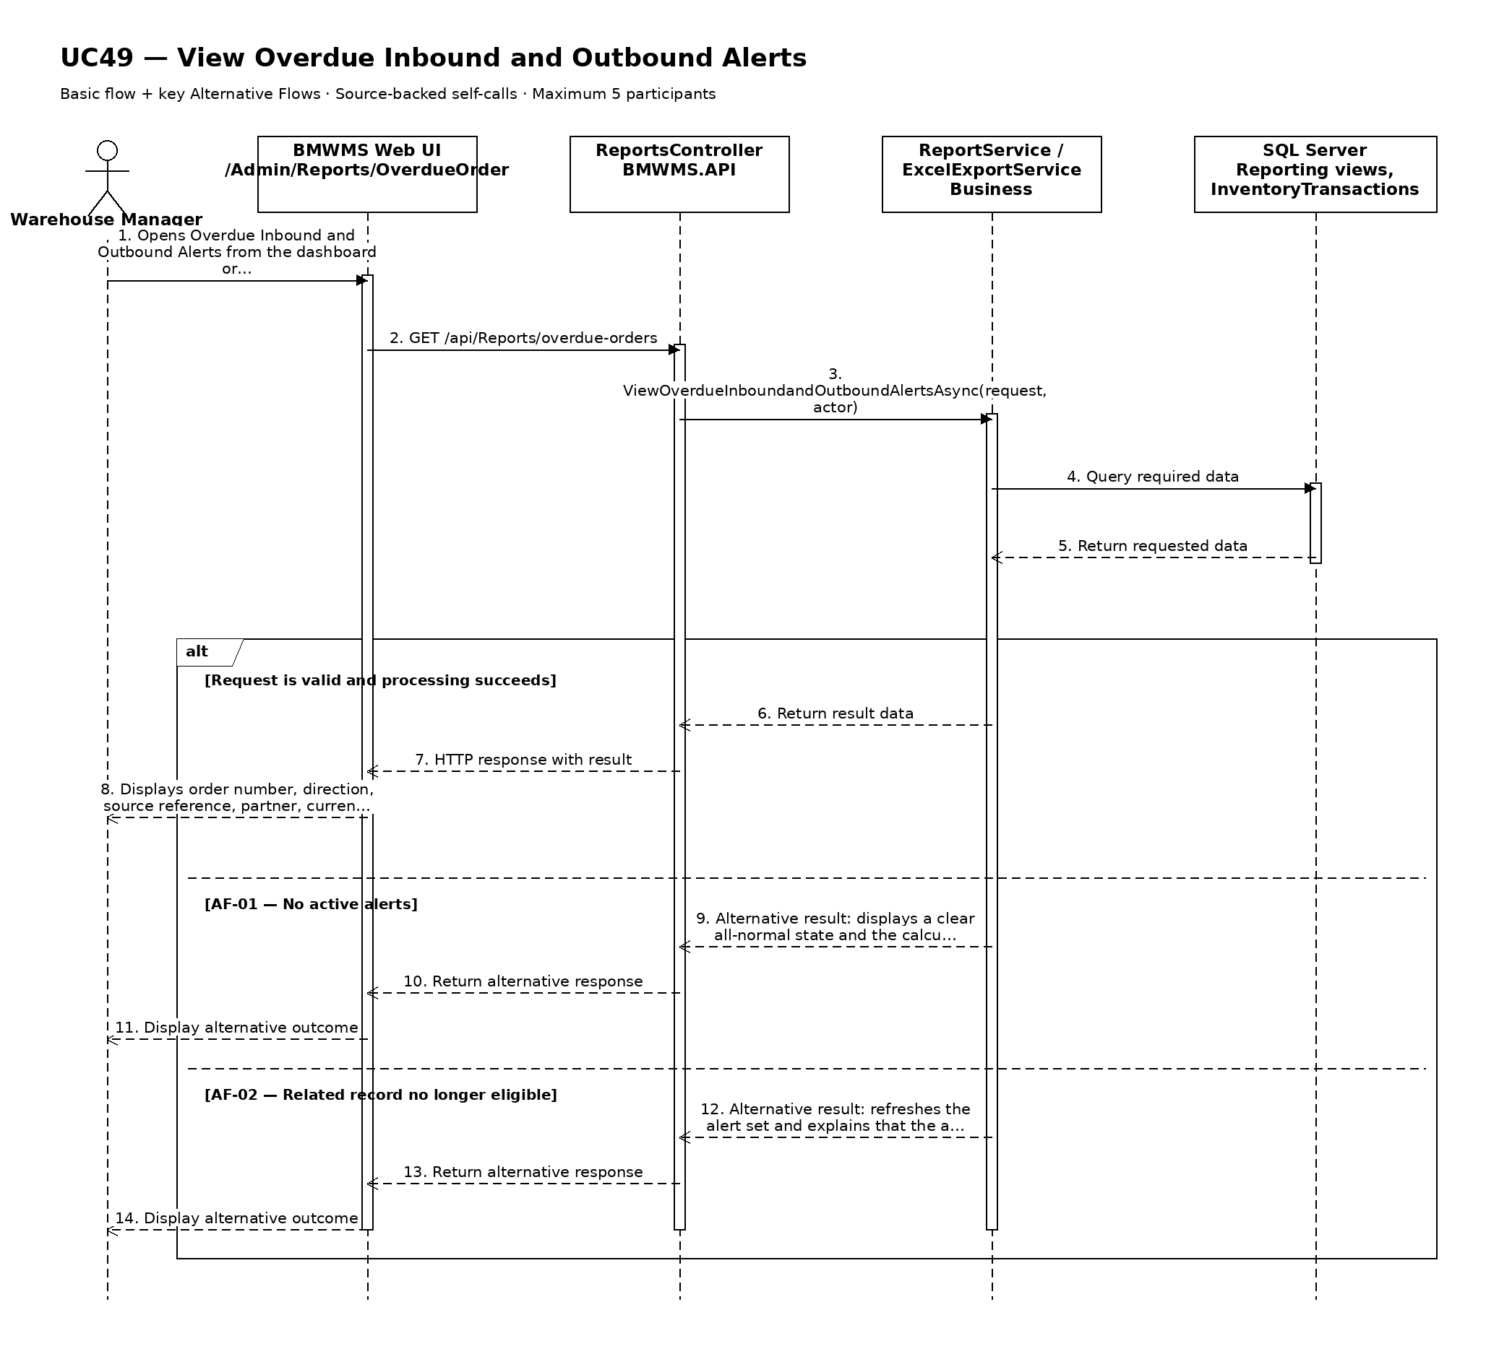

UC50: View System Notifications
Goal: Allows each user to view notifications relevant to their assigned work and role.
Field | Value
Type | UI
Primary Actor | Warehouse Manager
Secondary Actor(s) | —
Module | M07 - Reporting, Dashboard and Alerts
Business Group | System Notifications
FT-ID Ref | FT-50
Depends On | —
Preconditions | An active user is signed in and holds one of the allowed fixed roles.
Postconditions | Opening a notification changes only that recipient's notification state from UNREAD to READ; related business records are unchanged.

Main Flow
- [U] The user opens Notification Center.
- [S] The system loads notifications addressed to the signed-in user or fixed role.
- [U] The user filters by UNREAD, READ, type, date, or related reference.
- [S] The system displays title, short message, type, sent time, read state, and authorized related link.
- [U] The user opens a notification.
- [S] The system marks that recipient copy READ and opens the related record only when the user currently has access.

Alternative Flows
- AF-01 - No notifications: No notification matches the filters. The system displays an empty state and keeps the selected filters.
- AF-02 - Related record unavailable: The user may read the notification but no longer has access to the related record. The system hides the link and does not reveal restricted data.
- AF-03 - Notification already read: Opening a READ notification does not create another state change or duplicate audit activity.
- AF-04 - Expired notification: An EXPIRED notification remains available only according to retention policy and cannot open an obsolete action.

Business Rules
- BR-01: Users may read only their own or role-addressed notification copies (see PRD GB-17).
- BR-02: Read state is maintained per recipient.
- BR-03: Opening a notification may change UNREAD to READ but never changes the related operational record.
- BR-04: Notification links are re-authorized at click time.

Request Fields - NotificationListRequest
Field | Type | Rule
Read status | Choice | Optional. UNREAD, READ, or all.
Notification type | Choice | Optional. One supported operational notification type.
From date | Date | Optional. Not after To date.
To date | Date | Optional. Defaults to current date.
Related reference | Text | Optional. Exact or partial order, stocktake, product, or export reference.

On success: Notification Center displays only authorized notifications and opening one updates only the recipient's read state.

Allowed Roles
System Administrator, Warehouse Manager, Warehouse Staff, Purchasing Staff, Sales Staff

Verification Criteria
Given | When | Then
the signed-in user has at least one UNREAD notification with an authorized related record | the user opens the notification | the notification becomes READ for that recipient and the authorized related record opens without changing its business state

Additional scenarios to cover in tests:
- View unread notifications.
- Filter by notification type and date.
- Open an unread notification.
- Open an already read notification.
- Open a notification whose related record is no longer authorized.
- View an expired notification according to retention.

Sequence Diagram
Figure UC50. Sequence Diagram - View System Notifications
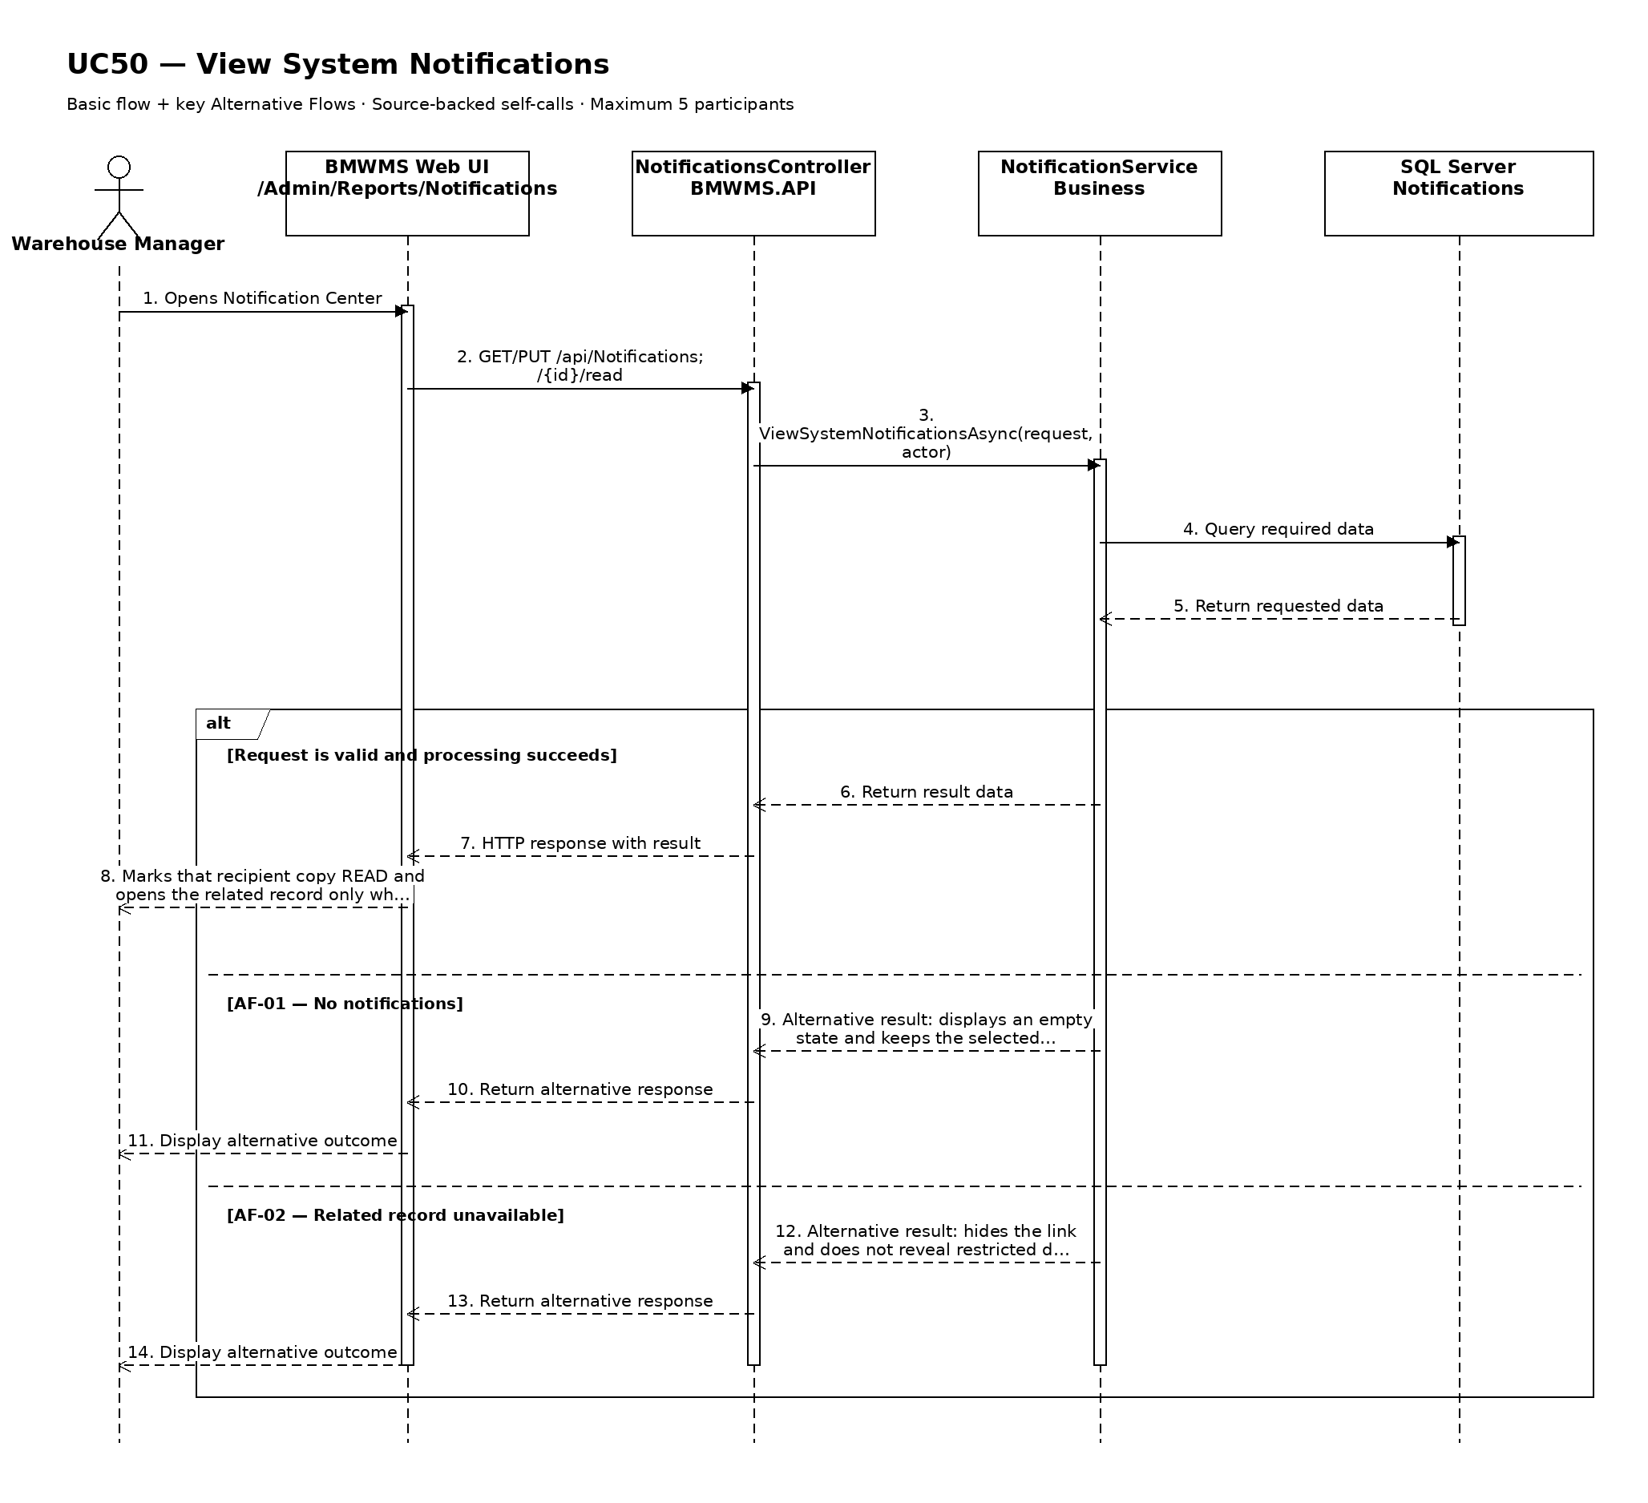

UC51: View Warehouse Operational KPIs
Goal: Allows the Warehouse Manager to monitor agreed operational performance indicators.
Field | Value
Type | UI
Primary Actor | Warehouse Manager
Secondary Actor(s) | —
Module | M07 - Reporting, Dashboard and Alerts
Business Group | Warehouse KPI
FT-ID Ref | FT-51
Depends On | UC46
Preconditions | An active user is signed in and holds one of the allowed fixed roles. The user is a Warehouse Manager or System Administrator.
Postconditions | No operational record is changed.

Main Flow
- [U] Warehouse Manager opens Warehouse Operational KPIs from the dashboard.
- [S] The system loads the default KPI period and authorized warehouse scope.
- [U] The manager selects a supported period and comparison period.
- [S] The system calculates agreed KPI values from posted transactions and completed operational events.
- [S] The system displays each KPI value, target where configured, trend, numerator, denominator, and calculation cut-off.
- [U] The manager may open the supporting report or exception list for a KPI.

Alternative Flows
- AF-01 - Insufficient data: A KPI lacks the required complete events or denominator. The system displays Not enough data and does not substitute zero.
- AF-02 - Target not configured: The KPI value is calculated, but no target comparison is shown. The system identifies that the target is not configured.
- AF-03 - Supporting detail restricted: A supporting record is outside the user's current scope. The aggregate remains visible only when policy permits, and restricted detail is not opened.

Business Rules
- BR-01: KPIs use posted transactions and completed operational timestamps (see PRD GB-15).
- BR-02: Each KPI must expose its calculation period, numerator, denominator, unit, and cut-off time.
- BR-03: Baseline KPIs include receiving completion time, putaway completion time, issue completion time, stock accuracy rate, overdue-order rate, and count completion rate.
- BR-04: A missing denominator displays Not enough data rather than zero.

Request Fields - WarehouseKpiRequest
Field | Type | Rule
From date | Date | Required. Not after To date.
To date | Date | Required. Defaults to current date.
Comparison period | Choice | Optional. Previous period or same period last year when data exists.
KPI | Multi-select | Optional. Defaults to all permitted KPI definitions.

On success: The KPI view displays transparent reconciled calculations, targets where configured, trends, and supporting links.

Allowed Roles
System Administrator, Warehouse Manager

Verification Criteria
Given | When | Then
completed operational data exists for the selected KPI period | Warehouse Manager submits a valid period | each KPI displays an accurate value with its numerator, denominator, unit, target or target-not-configured state, and calculation cut-off

Additional scenarios to cover in tests:
- View all KPIs for the default period.
- Compare with the previous period.
- Open supporting detail for a KPI.
- View a KPI with insufficient data.
- View a KPI without a configured target.

Sequence Diagram
Figure UC51. Sequence Diagram - View Warehouse Operational KPIs
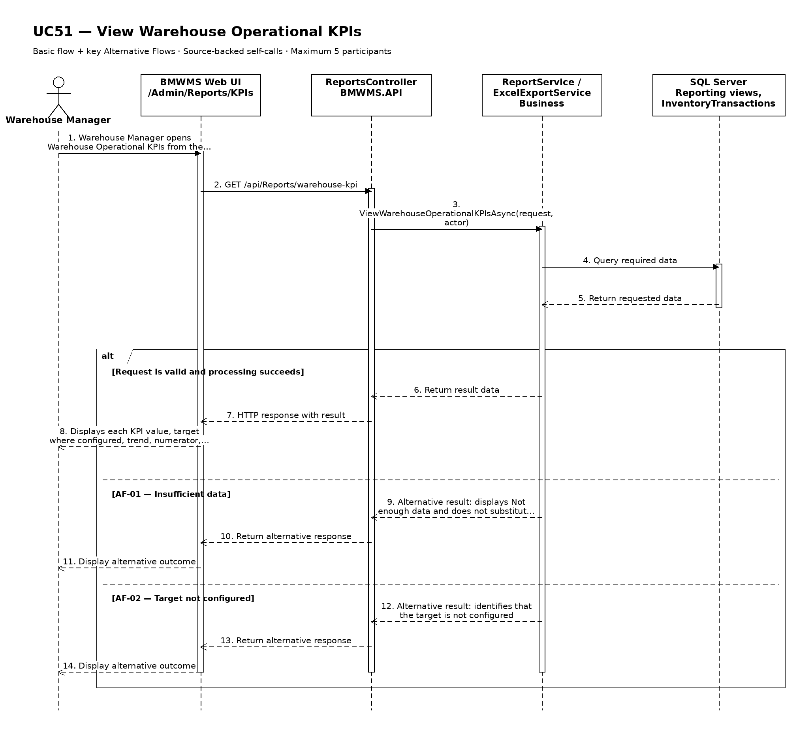

UC52: View User List
Goal: Allows the System Administrator to search and review user accounts.
Field | Value
Type | UI
Primary Actor | System Administrator
Secondary Actor(s) | —
Module | M08 - Users and Security
Business Group | User Management
FT-ID Ref | FT-52
Depends On | —
Preconditions | An active user is signed in and holds one of the allowed fixed roles.
Postconditions | No business record is changed. The current filters may remain in the user session.

Main Flow
- [U] The user opens User List.
- [S] The system loads the first page of user account records allowed for the user's role.
- [U] The user enters or changes one or more search and filter values.
- [S] The system validates the filter values and applies the authorized data scope.
- [S] The system displays user code, full name, username, email, fixed role, account status, last sign-in time, and last update, the matching-record count, and pagination controls.
- [U] The user may change sorting, move between pages, clear filters, or open an available record/action.

Alternative Flows
- AF-01 - No matching records: At the result step, no record satisfies the active filters. The system displays an explicit no-results state and keeps the filters available for revision.
- AF-02 - Invalid filter combination: When a date range or numeric range is invalid, the system does not run the search and identifies the fields that must be corrected.

Business Rules
- BR-01: Only user account records within the signed-in user's authorized scope may be returned (see PRD GB-02).
- BR-02: Results are sorted by full name ascending unless the user selects another supported sort.
- BR-03: Pagination must return a stable result order and a total matching-record count.
- BR-04: Only System Administrator may access the user list.
- BR-05: Sensitive password and reset-token data is never displayed.

Request Fields - UserAccountListFilter
Field | Type | Rule
Search keyword | Text | Optional. Matches user code, full name, username, email, or phone.
Fixed role | Choice | Optional. One of the five fixed roles.
Account status | Choice | Optional. ACTIVE, LOCKED, or INACTIVE.
Page | Number | Optional. Starts at 1; values below 1 are rejected.
Page size | Number | Optional. Between 10 and 100; defaults to 20.

On success: User List displays the matching records and active filter summary.

Allowed Roles
System Administrator

Verification Criteria
Given | When | Then
at least one user account record exists within the user's authorized scope | the user submits a valid filter combination | only matching user account records are displayed in full name ascending order, with an accurate total count

Additional scenarios to cover in tests:
- Open the list with default filters.
- Search using a complete identifier.
- Combine two or more filters.
- Use a filter that returns no results.
- Change page size and verify stable pagination.

Sequence Diagram
Figure UC52. Sequence Diagram - View User List
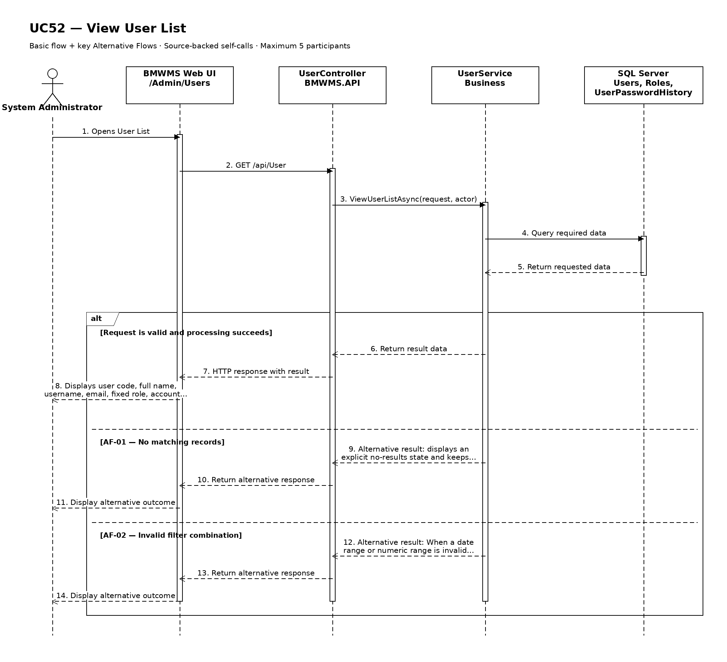

UC53: Create User
Goal: Allows the System Administrator to create a new internal user account.
Field | Value
Type | UI
Primary Actor | System Administrator
Secondary Actor(s) | —
Module | M08 - Users and Security
Business Group | User Management
FT-ID Ref | FT-53
Depends On | UC52
Preconditions | An active user is signed in and holds one of the allowed fixed roles.
Postconditions | A new user account record exists with status ACTIVE.

Main Flow
- [U] The user opens User Create and selects Create.
- [S] The system displays a blank user account form and the permitted reference values.
- [U] The user enters the required and optional information and submits the form.
- [S] The system validates field rules, uniqueness, references, and the user's permission.
- [S] The system creates the user account with status ACTIVE and records audit information.
- [S] The system opens the created user account and displays a success confirmation.

Alternative Flows
- AF-01 - Required or invalid value: At validation, one or more required values are missing or invalid. The system keeps the form data and identifies every field that must be corrected.
- AF-02 - Duplicate business identifier: The system finds a record that violates this uniqueness rule: User code, username, and email must each be unique (see PRD GB-04). No duplicate is created and the conflicting field is identified.
- AF-03 - Invalid reference: A selected reference is unavailable or ineligible. The system keeps the form open and explains that the selected fixed role must be one of the five active system roles.

Business Rules
- BR-01: User code, username, and email must each be unique (see PRD GB-04).
- BR-02: All required fields must pass business validation before the record is saved.
- BR-03: A successful creation stores the user account with status ACTIVE and records the creator and creation time.
- BR-04: The creation action is written to the audit log (see PRD GB-20).
- BR-05: the selected fixed role must be one of the five active system roles.
- BR-06: Each account has exactly one active fixed role (see PRD GB-01).
- BR-07: The system generates a one-time activation or temporary credential; administrators do not view a reusable password.

Request Fields - UserAccountCreateRequest
Field | Type | Rule
User code | Text | Required. Unique. 2-30 uppercase letters, numbers, hyphen, or underscore.
Full name | Text | Required. Between 2 and 150 characters.
Username | Text | Required. Unique. Between 4 and 50 characters.
Email | Text | Required. Valid and unique email address.
Phone number | Text | Optional. Valid phone format; maximum 20 characters.
Fixed role | Choice | Required. Exactly one of the five active fixed roles.
Account status | Choice | Required. ACTIVE or INACTIVE at creation; defaults to ACTIVE.

On success: The new user account detail is displayed with status ACTIVE.

Allowed Roles
System Administrator

Verification Criteria
Given | When | Then
the user has create permission and all referenced master data is eligible | the user submits valid user account information | exactly one user account record is created with status ACTIVE and an audit event is recorded

Additional scenarios to cover in tests:
- Create a user account with all valid required values.
- Create a user account with valid optional values.
- Submit with a required field missing.
- Submit a duplicate business identifier.
- Cancel creation before saving.

Sequence Diagram
Figure UC53. Sequence Diagram - Create User
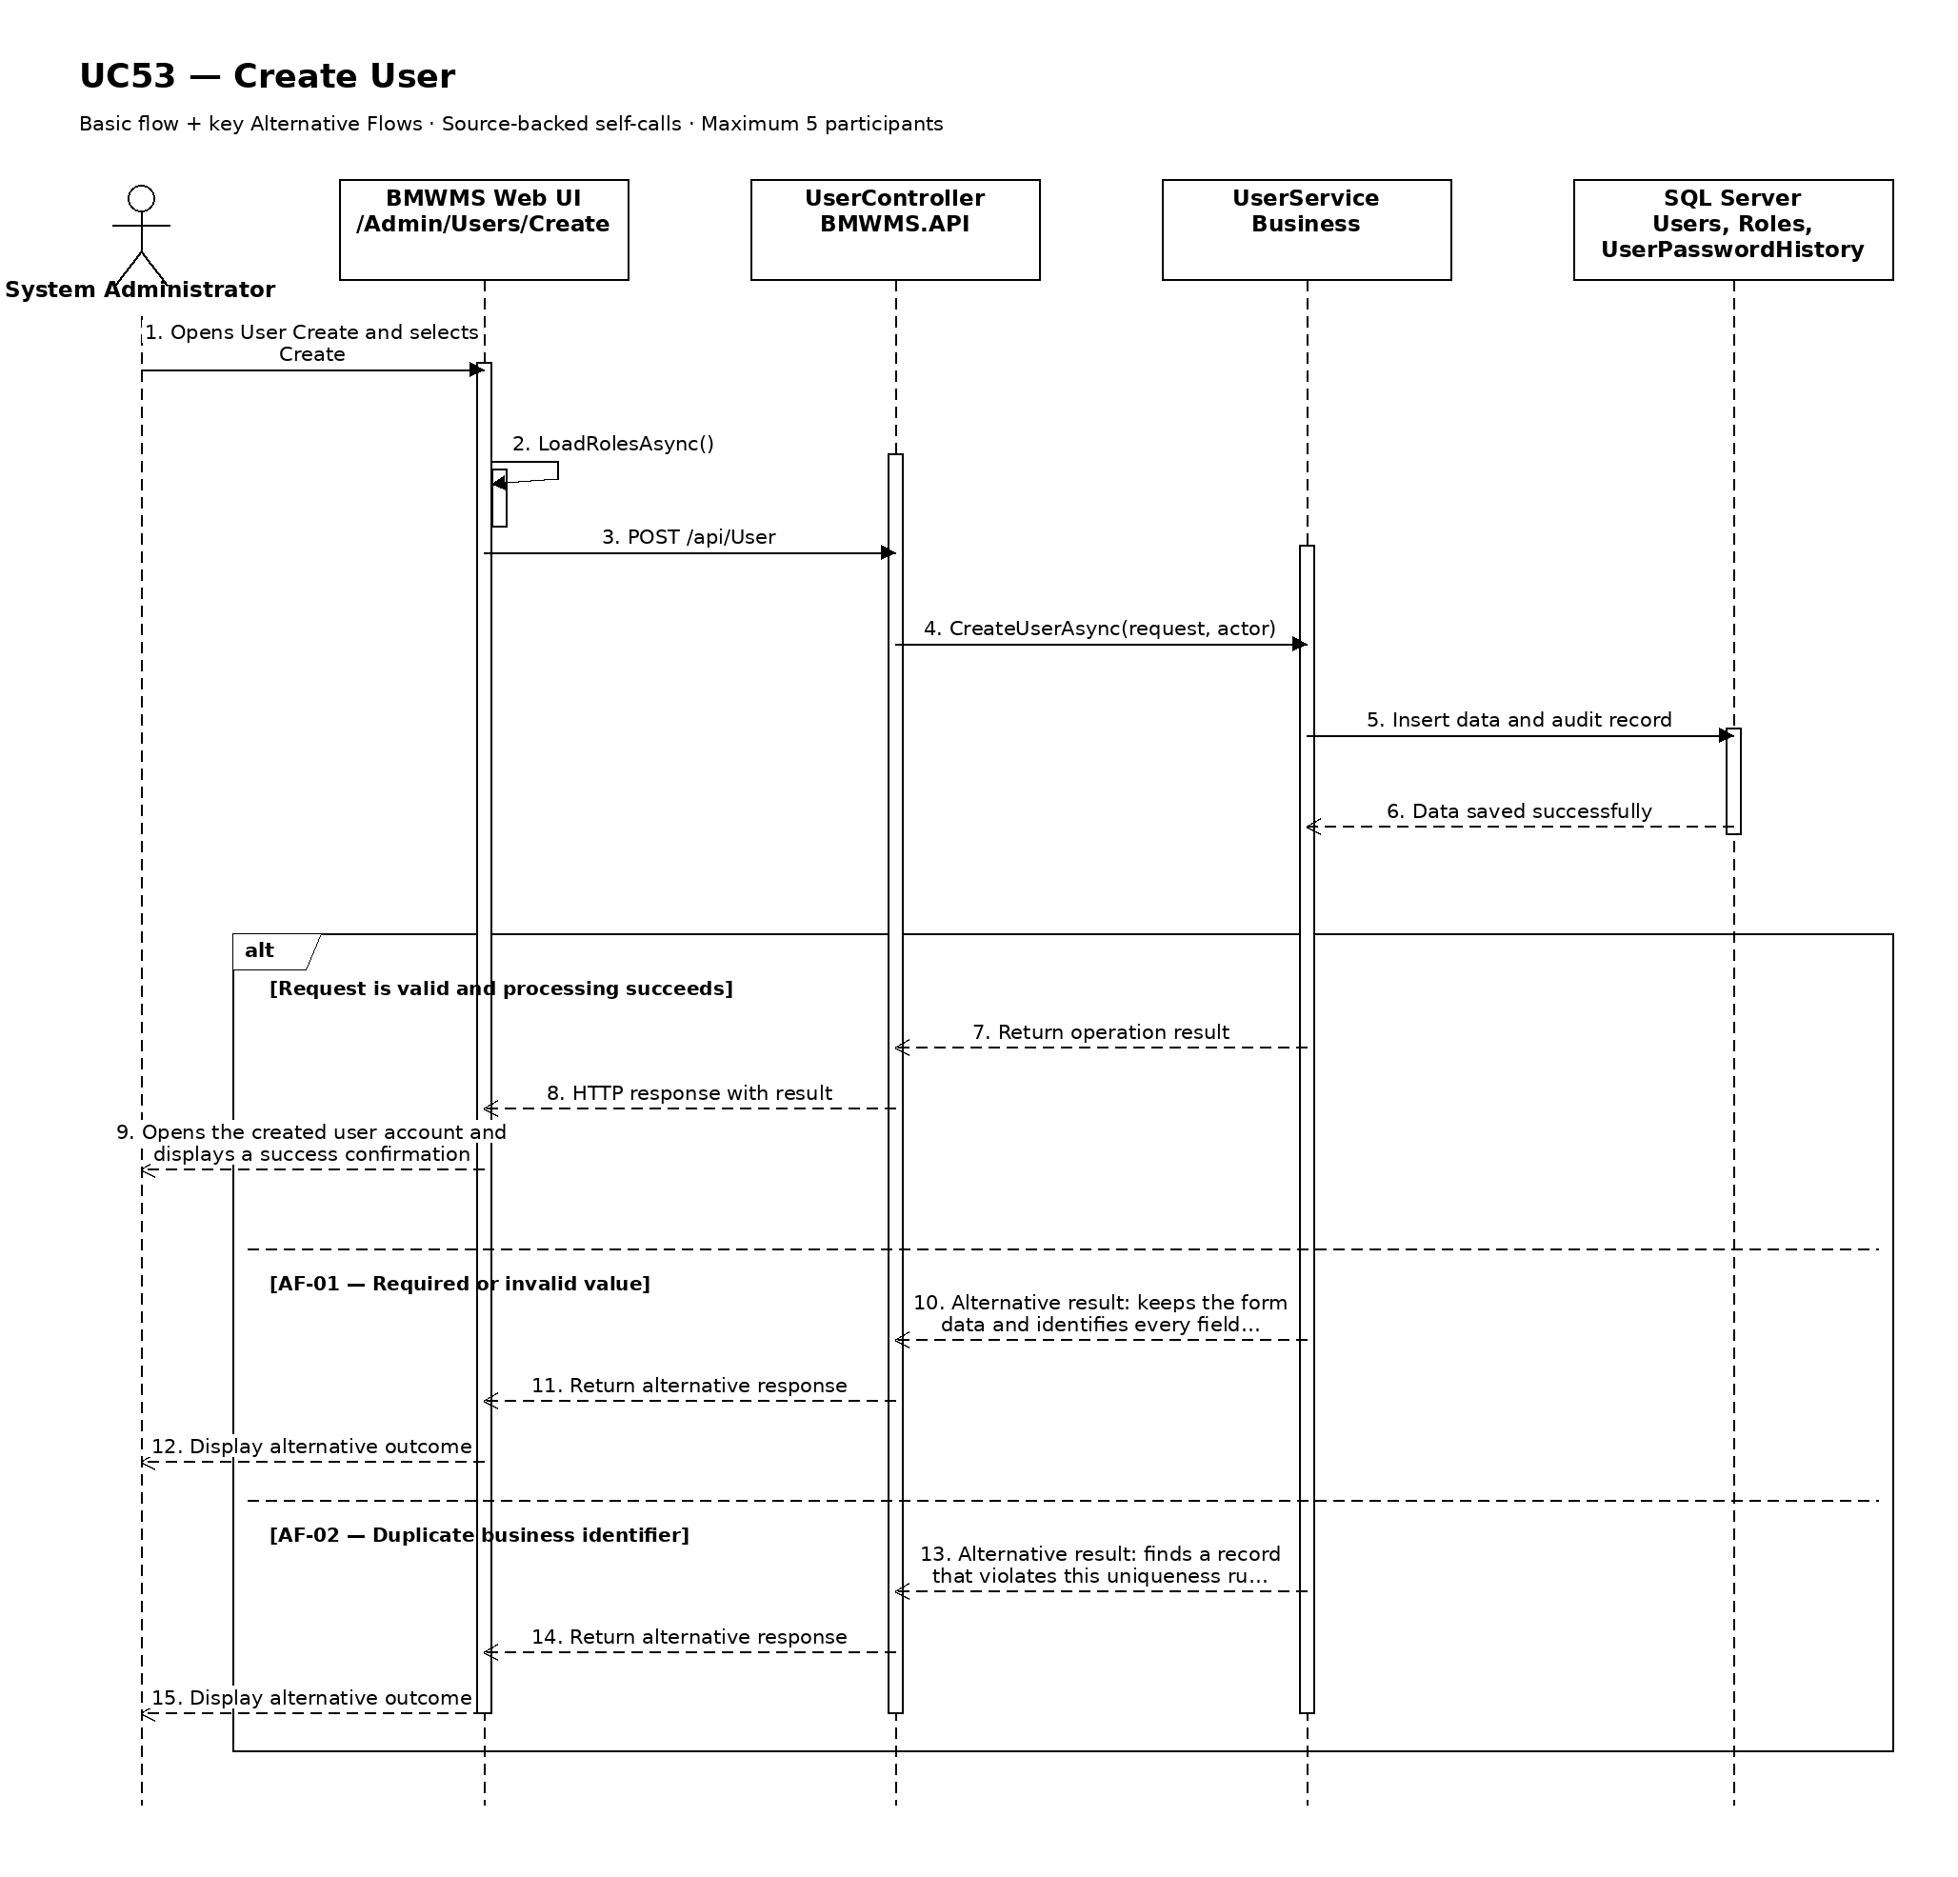

UC54: Edit User
Goal: Allows the System Administrator to update permitted user account information.
Field | Value
Type | UI
Primary Actor | System Administrator
Secondary Actor(s) | —
Module | M08 - Users and Security
Business Group | User Management
FT-ID Ref | FT-54
Depends On | UC55
Preconditions | An active user is signed in and holds one of the allowed fixed roles. The selected user account is in an editable state.
Postconditions | The permitted user account information is updated; its history is retained.

Main Flow
- [U] The user opens an eligible user account and selects Edit.
- [S] The system opens User Edit with the current values and edit restrictions.
- [U] The user changes one or more permitted values and submits the form.
- [S] The system rechecks the current record version, status, field rules, references, and uniqueness.
- [S] The system saves the permitted changes and records the update in the audit log.
- [S] The system returns to the user account detail and confirms the update.

Alternative Flows
- AF-01 - Record state no longer permits editing: At save time, the record is no longer in ACTIVE, LOCKED, or INACTIVE. The system rejects the update, reloads the current record, and explains why it cannot be edited.
- AF-02 - Concurrent update: Another user saved a newer version after the form was opened. The system does not overwrite it and asks the user to review the latest values.
- AF-03 - Validation failure: One or more changed values fail validation. The system keeps all unsaved changes and identifies the invalid fields.

Business Rules
- BR-01: The record is editable only in ACTIVE, LOCKED, or INACTIVE.
- BR-02: User code and username are immutable after account creation; role changes are handled only by UC57.
- BR-03: A successful update records the editor, update time, and before/after audit summary (see PRD GB-20).
- BR-04: An administrator cannot deactivate the only usable System Administrator account.
- BR-05: Changing email requires uniqueness validation and may require re-verification.

Request Fields - UserAccountUpdateRequest
Field | Type | Rule
Full name | Text | Required. Between 2 and 150 characters.
Email | Text | Required. Valid and unique email address.
Phone number | Text | Optional. Valid format; maximum 20 characters.
Account status | Choice | Required. ACTIVE or INACTIVE; lock/unlock is handled in UC56.

On success: The updated user account detail is displayed with a success confirmation.

Allowed Roles
System Administrator

Verification Criteria
Given | When | Then
an eligible user account exists and has not been changed by another user | the user submits valid changes to permitted fields | the user account contains the new values, protected values remain unchanged, and the audit trail records the update

Additional scenarios to cover in tests:
- Update one permitted user account field.
- Update multiple permitted fields.
- Attempt to change a protected identifier.
- Attempt to update an ineligible state.
- Simulate a concurrent update conflict.

Sequence Diagram
Figure UC54. Sequence Diagram - Edit User
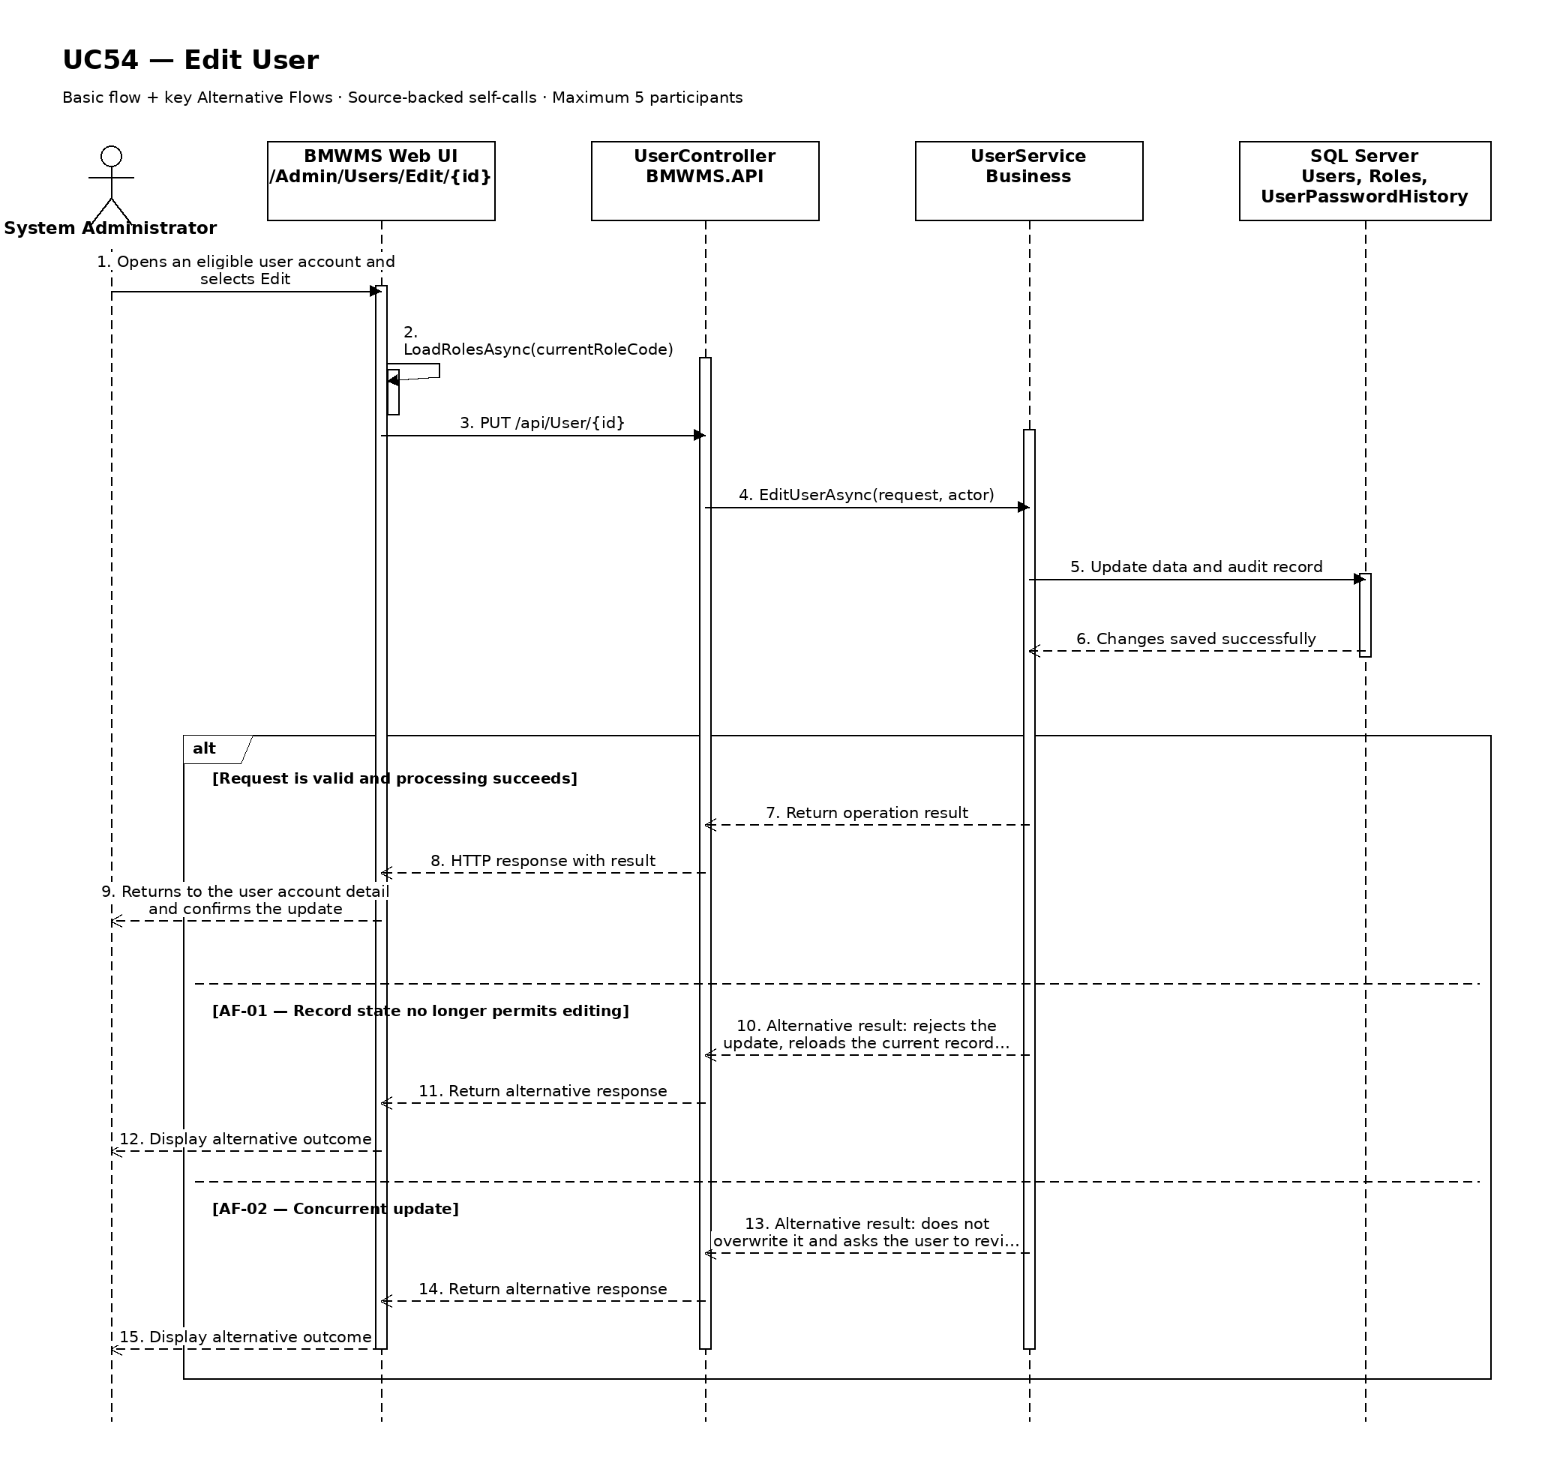

UC55: View User Details
Goal: Allows the System Administrator to view user profile, fixed role, status, and account activity.
Field | Value
Type | UI
Primary Actor | System Administrator
Secondary Actor(s) | —
Module | M08 - Users and Security
Business Group | User Management
FT-ID Ref | FT-55
Depends On | UC52
Preconditions | An active user is signed in and holds one of the allowed fixed roles. A user account record is available to the user.
Postconditions | No business data is changed.

Main Flow
- [U] The user selects a user account record from the related list or search result.
- [S] The system verifies that the record exists and is visible to the user's role.
- [S] The system opens User Details.
- [S] The system displays user code, full name, username, email, phone, fixed role, account status, last sign-in, failed-attempt summary, lock information, and security-relevant audit activity.
- [S] The system shows only the actions that are valid for the current status and role.
- [U] The user reviews the information and may navigate to an available related view or action.

Alternative Flows
- AF-01 - Record no longer available: After the user selects the record, the user account no longer exists or is outside the user's scope. The system returns to the source view and displays a non-destructive notice.
- AF-02 - Historical or inactive record: The record is inactive or completed. The system still displays retained history but hides actions that are not permitted in the current state.

Business Rules
- BR-01: The selected user account identifier must resolve to exactly one record.
- BR-02: Displayed actions are determined by the signed-in user's fixed role and the record's current state (see PRD GB-02).
- BR-03: Historical records remain viewable and are not physically deleted (see PRD GB-03).
- BR-04: Password hashes, reset codes, and credential secrets are never displayed.
- BR-05: Displayed administrative actions depend on current account status and self-protection rules.

Request Fields - UserAccountDetailRequest
Field | Type | Rule
User Account identifier | Text | Required. Must identify an existing record visible to the signed-in user.

On success: User Details displays the complete authorized view of the selected user account.

Allowed Roles
System Administrator

Verification Criteria
Given | When | Then
a visible user account record exists | the user opens that record | user code, full name, username, email, phone, fixed role, account status, last sign-in, failed-attempt summary, lock information, and security-relevant audit activity are displayed and no unauthorized action is offered

Additional scenarios to cover in tests:
- View an active user account record.
- View an inactive or completed user account record.
- Open a record through a direct authorized link.
- Attempt to open a missing or unauthorized record.

Sequence Diagram
Figure UC55. Sequence Diagram - View User Details
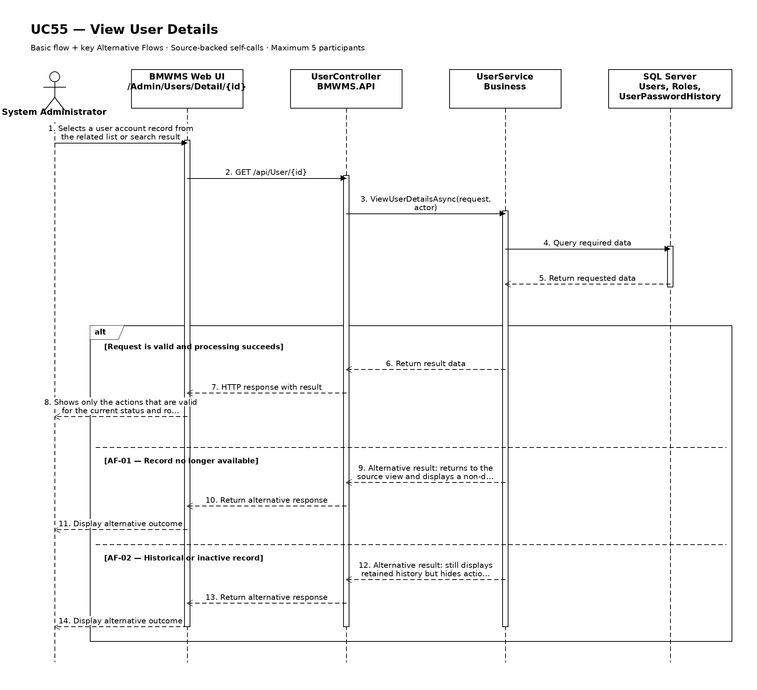

UC56: Lock or Unlock Account
Goal: Allows the System Administrator to lock or unlock an internal account.
Field | Value
Type | UI
Primary Actor | System Administrator
Secondary Actor(s) | —
Module | M08 - Users and Security
Business Group | User Management
FT-ID Ref | FT-56
Depends On | UC55
Preconditions | An active user is signed in and holds one of the allowed fixed roles. The selected account exists and the administrator is permitted to change its lock state.
Postconditions | The account is LOCKED or ACTIVE according to the confirmed action; active sessions are revoked when locked.

Main Flow
- [U] System Administrator opens User Details and selects Lock Account or Unlock Account.
- [S] The system displays the current status, lock reason, failed-attempt information, and effect on active sessions.
- [U] The administrator enters the action reason and confirms.
- [S] The system verifies self-protection, last-administrator protection, current account state, and permission.
- [S] The system changes ACTIVE to LOCKED or LOCKED to ACTIVE and records the actor, reason, and time.
- [S] For a lock action, the system revokes active sessions; then it refreshes User Details and confirms success.

Alternative Flows
- AF-01 - Account already in target state: The account is already LOCKED or ACTIVE as requested. The system performs no duplicate change and displays the current state.
- AF-02 - Protected administrator account: The action would lock the current administrator or the only usable System Administrator account. The system rejects the action.
- AF-03 - Automatic temporary lock: Five consecutive failed sign-in attempts have already locked the account. The administrator may unlock it before the 15-minute automatic release.

Business Rules
- BR-01: Five consecutive failed sign-in attempts lock an account for 15 minutes or until an administrator unlocks it (see PRD GB-18).
- BR-02: An administrator cannot lock the only usable System Administrator account.
- BR-03: Locking revokes active sessions and prevents new sign-in.
- BR-04: Lock/unlock reason is required and the action is audited (see PRD GB-20).

Request Fields - AccountLockStateRequest
Field | Type | Rule
User account | Text | Required. Existing account visible to System Administrator.
Action | Choice | Required. LOCK or UNLOCK according to current status.
Reason | Text | Required. Between 5 and 500 characters.
Confirmation | Yes/No | Required. The state changes only after explicit confirmation.

On success: User Details displays the new LOCKED or ACTIVE state and the lock history.

Allowed Roles
System Administrator

Verification Criteria
Given | When | Then
an eligible user account exists and changing its lock state will not remove the last usable administrator | System Administrator confirms a valid lock or unlock action | the account changes to the intended state, lock actions revoke sessions, and an audit event records the reason

Additional scenarios to cover in tests:
- Lock an ACTIVE user account.
- Unlock a LOCKED user account.
- Unlock an automatically locked account.
- Attempt to lock an account already LOCKED.
- Attempt to lock the only usable System Administrator.
- Verify lock revokes an active session.

Sequence Diagram
Figure UC56. Sequence Diagram - Lock or Unlock Account
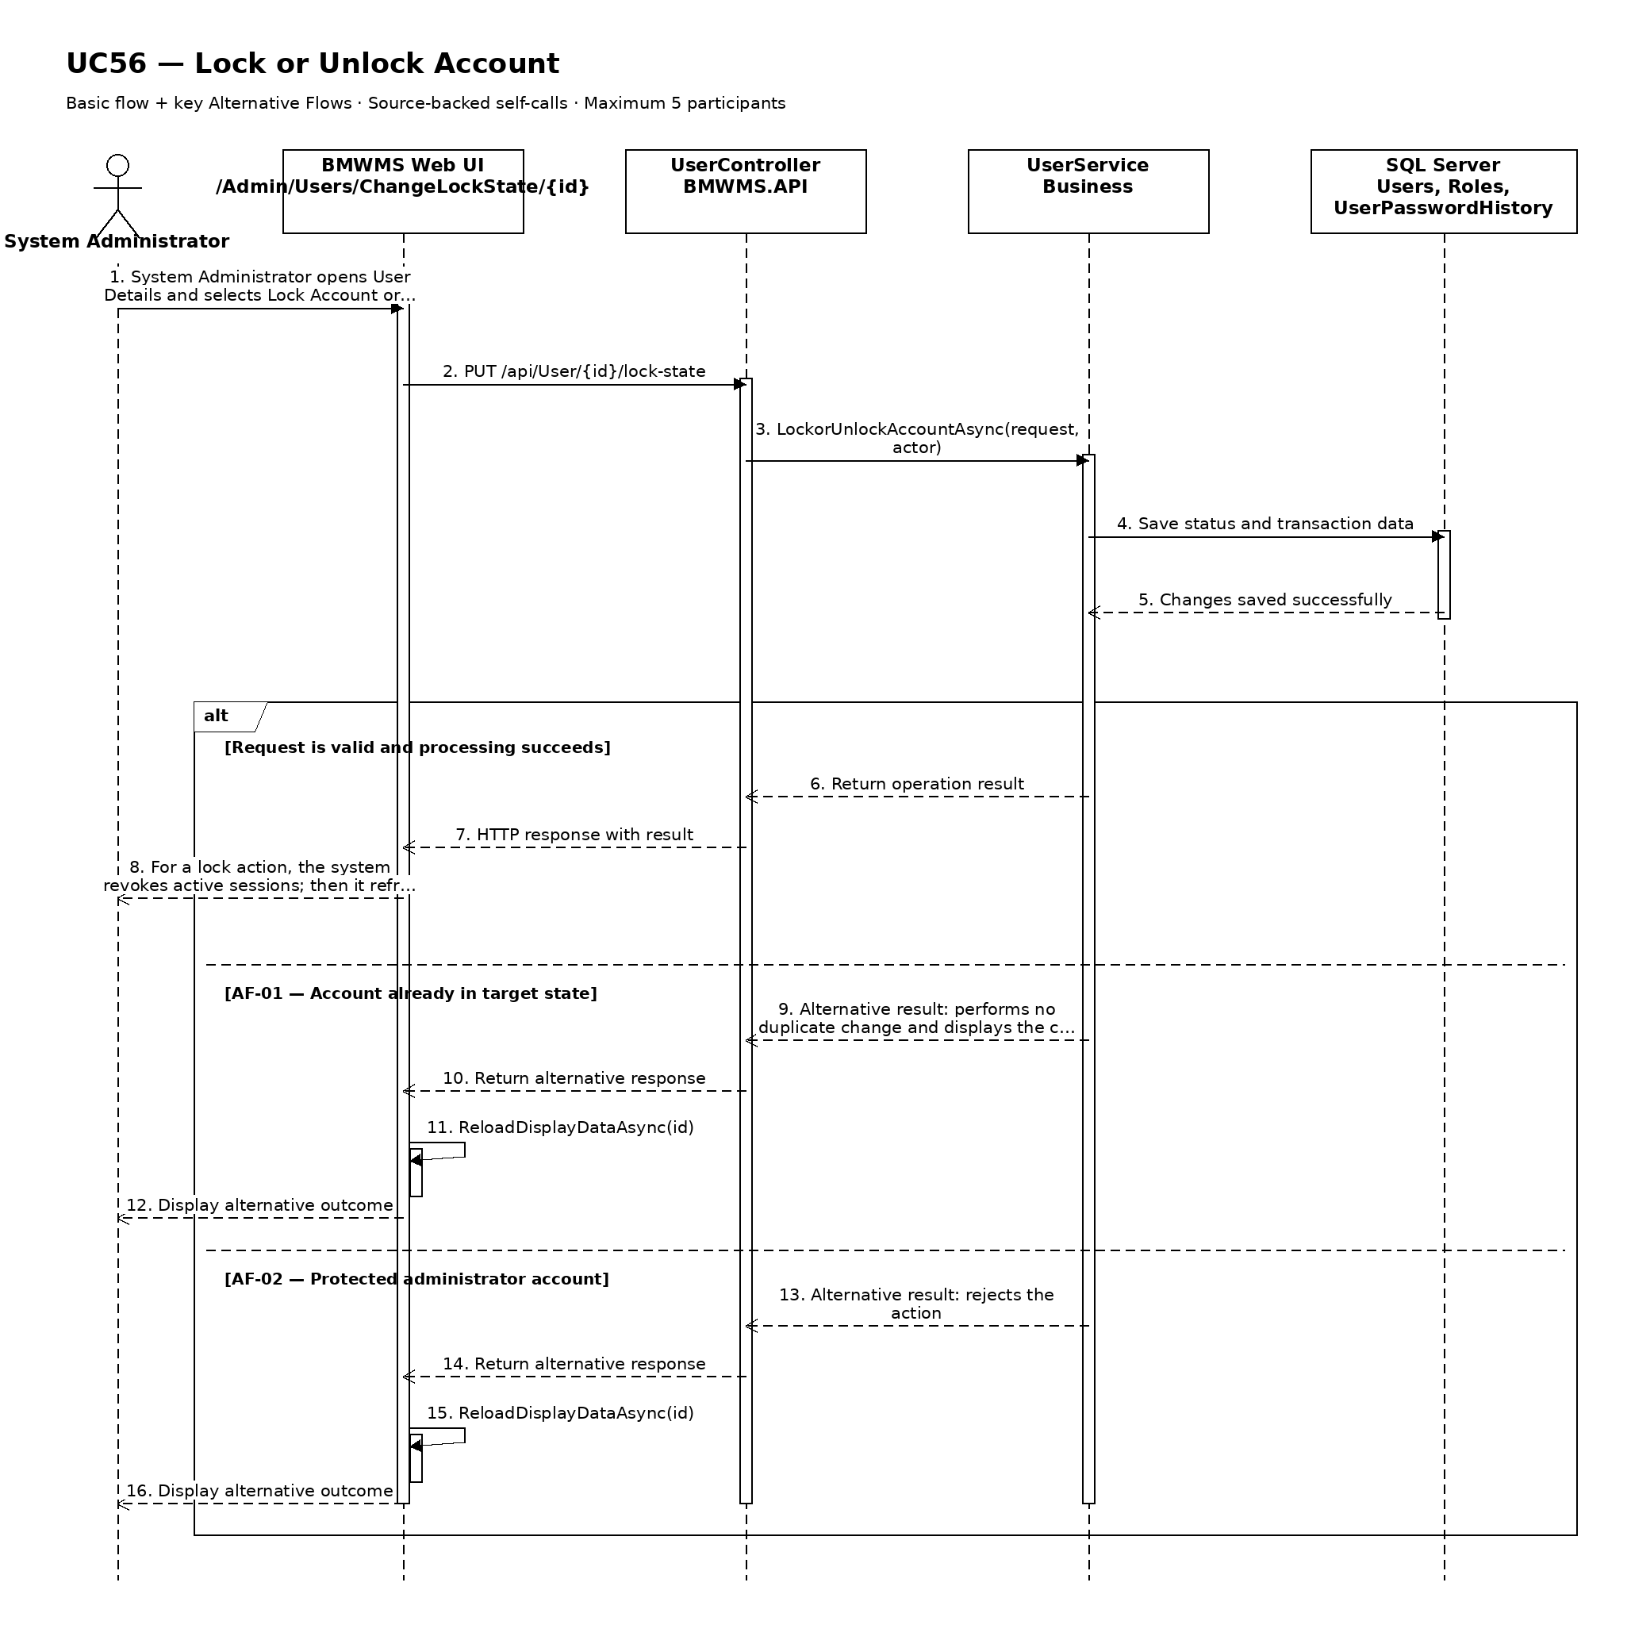

UC57: Assign Fixed Role to User
Goal: Allows the System Administrator to assign one of the five fixed roles to a user.
Field | Value
Type | UI
Primary Actor | System Administrator
Secondary Actor(s) | —
Module | M08 - Users and Security
Business Group | Fixed Role Assignment
FT-ID Ref | FT-57
Depends On | UC55
Preconditions | An active user is signed in and holds one of the allowed fixed roles. The selected account and target fixed role are active.
Postconditions | The user account is assigned exactly one target fixed role and subsequent authorization uses that role.

Main Flow
- [U] System Administrator opens User Details and selects Assign Role.
- [S] The system displays the current role and the five fixed roles.
- [U] The administrator selects the target role, enters a reason, and confirms.
- [S] The system validates the account, target role, last-administrator protection, and any incompatible active work.
- [S] The system replaces the current role assignment with the target role in one atomic operation.
- [S] The system revokes or refreshes active sessions as configured, displays the new role, and records the audit event.

Alternative Flows
- AF-01 - Same role selected: The target role is already assigned. The system makes no duplicate assignment and displays the current role.
- AF-02 - Last administrator protection: Changing this account would leave no usable System Administrator. The system rejects the assignment.
- AF-03 - Incompatible active work: The account owns active assigned work that the target role cannot perform. The system identifies the items and requires reassignment before the role change.

Business Rules
- BR-01: Each user has exactly one active fixed role at a time (see PRD GB-01).
- BR-02: The only roles are System Administrator, Warehouse Manager, Warehouse Staff, Purchasing Staff, and Sales Staff.
- BR-03: The system must retain role-assignment history and never create overlapping active assignments.
- BR-04: The only usable System Administrator cannot be reassigned.
- BR-05: Role changes are audited and take effect on the next authorization check.

Request Fields - FixedRoleAssignmentRequest
Field | Type | Rule
User account | Text | Required. Existing account.
Target fixed role | Choice | Required. One of the five active fixed roles.
Assignment reason | Text | Required. Between 5 and 500 characters.
Confirmation | Yes/No | Required. Assignment changes only after explicit confirmation.

On success: User Details displays exactly one active target role and the role-assignment history records the change.

Allowed Roles
System Administrator

Verification Criteria
Given | When | Then
an eligible user account and target fixed role exist and last-administrator protection is satisfied | System Administrator confirms the role assignment | the previous assignment ends, exactly one target role is active, authorization reflects the new role, and an audit event is recorded

Additional scenarios to cover in tests:
- Assign Warehouse Staff to a new account.
- Change Purchasing Staff to Sales Staff.
- Select the role already assigned.
- Attempt to reassign the only System Administrator.
- Resolve incompatible active work before role change.

Sequence Diagram
Figure UC57. Sequence Diagram - Assign Fixed Role to User
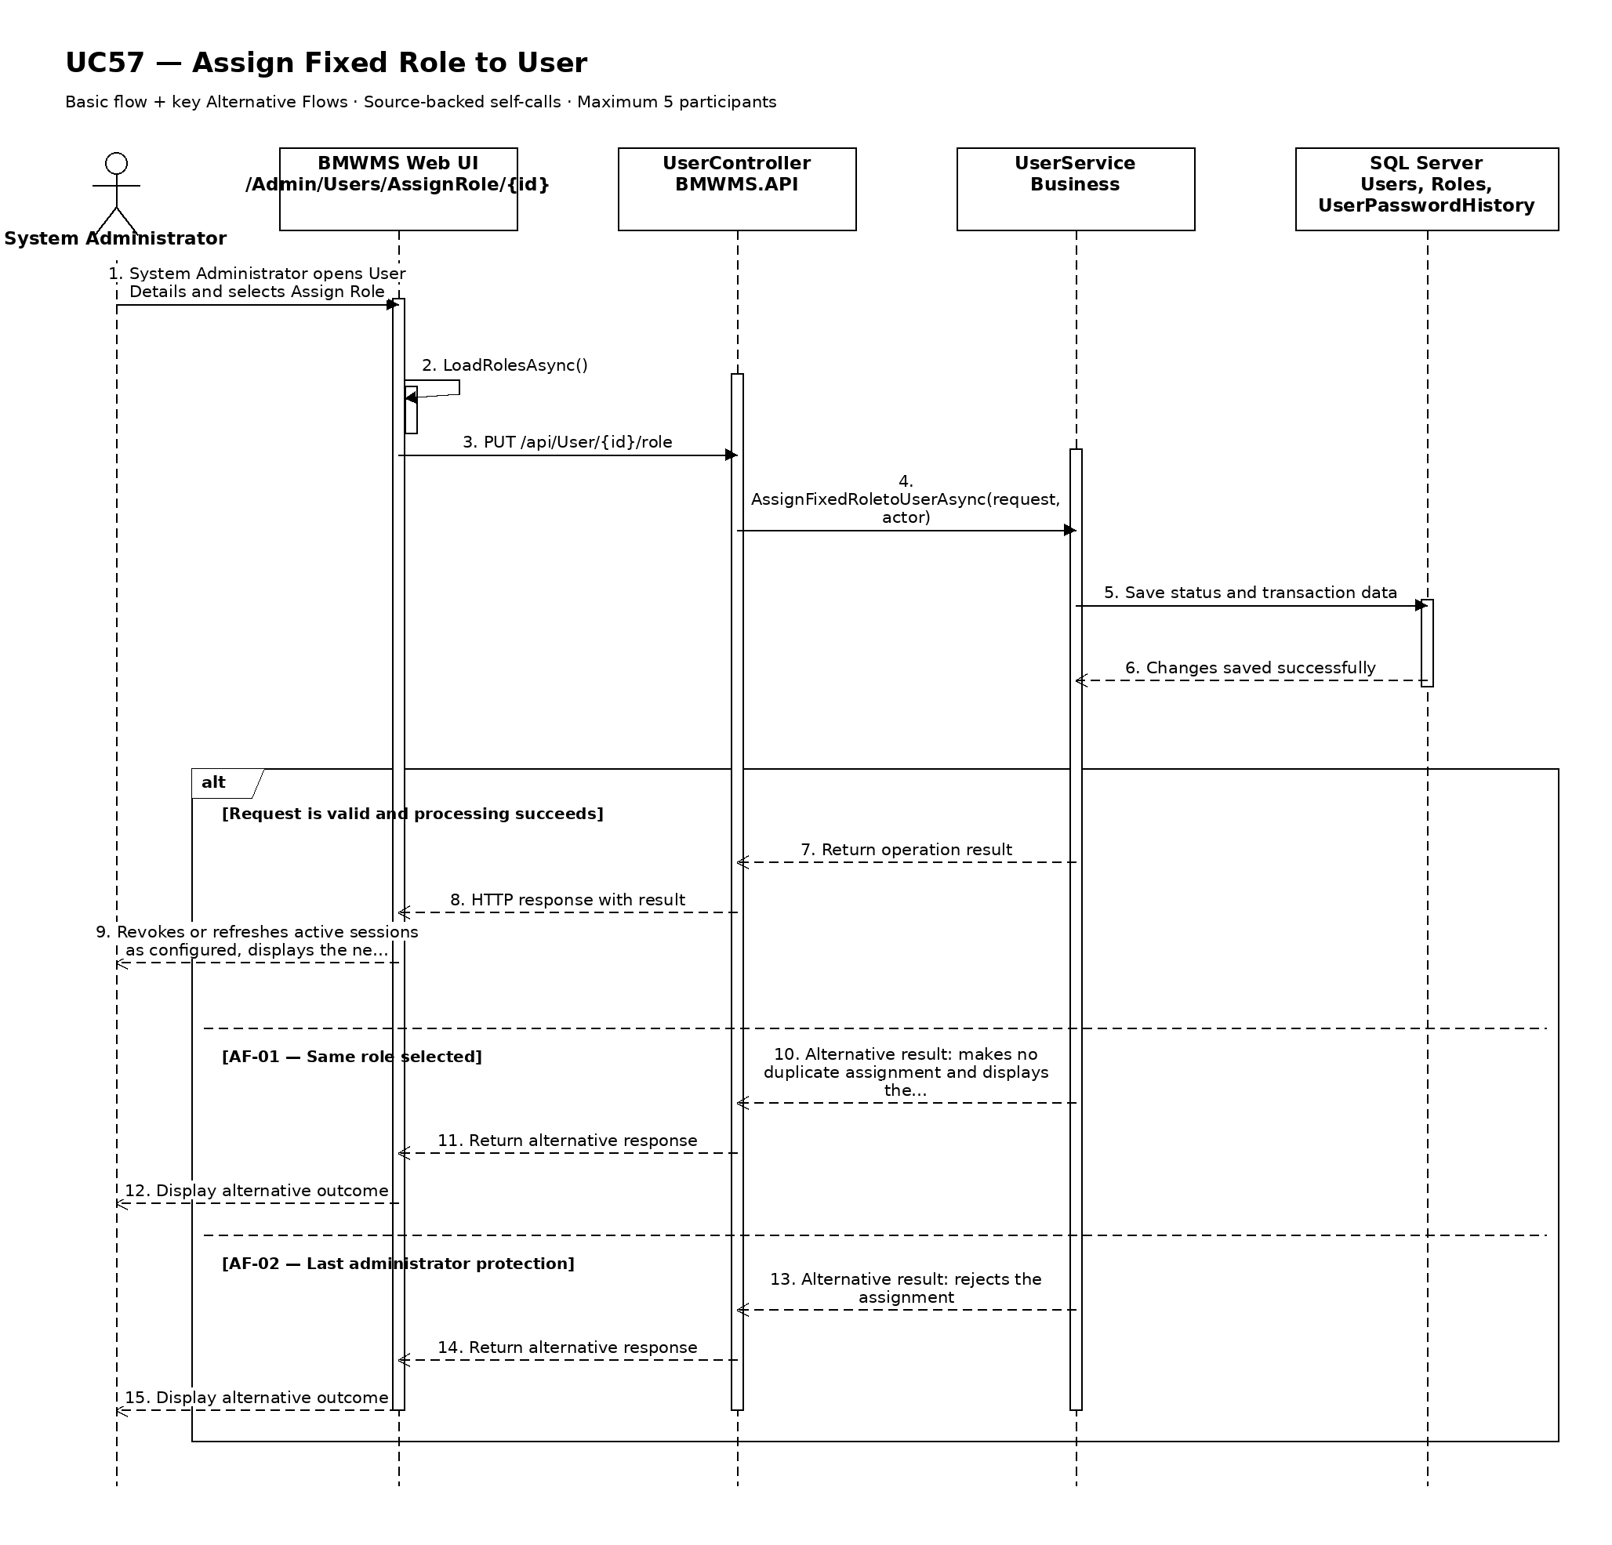

UC58: View Personal Profile
Goal: Allows an authenticated user to view their own profile and assigned role.
Field | Value
Type | UI
Primary Actor | Authenticated User
Secondary Actor(s) | —
Module | M08 - Users and Security
Business Group | Personal Profile
FT-ID Ref | FT-58
Depends On | —
Preconditions | An active user is signed in and holds one of the allowed fixed roles.
Postconditions | No profile or security data is changed.

Main Flow
- [U] The authenticated user opens My Profile.
- [S] The system resolves the profile associated with the active session.
- [S] The system displays user code, full name, username, email, phone, fixed role, account status, and last sign-in information.
- [S] The system identifies which fields are self-editable and keeps role and account-state fields read-only.
- [U] The user reviews the information.
- [U] The user may start UC59 Update Personal Profile or UC60 Change Password.

Alternative Flows
- AF-01 - Session expired: The session is no longer valid. The system redirects to sign-in without displaying profile data.
- AF-02 - Profile inconsistency: The active session has no corresponding profile record. The system stops the view, records an operational error, and instructs the user to contact the administrator.

Business Rules
- BR-01: A user may view only the profile linked to the active session.
- BR-02: Password and reset-token data is never displayed.
- BR-03: Fixed role and account status are read-only in self-service.

Request Fields - PersonalProfileRequest
Field | Type | Rule
Active session | System selected | Required. Resolves the signed-in user's own profile.

On success: My Profile displays the signed-in user's authorized personal, role, and sign-in information.

Allowed Roles
System Administrator, Warehouse Manager, Warehouse Staff, Purchasing Staff, Sales Staff

Verification Criteria
Given | When | Then
an authenticated session is linked to an active profile | the user opens My Profile | only that user's profile is displayed and protected security values are not exposed

Additional scenarios to cover in tests:
- View profile as each fixed role.
- Verify role and status are read-only.
- Attempt access after session expiry.
- Verify credential secrets are absent.

Sequence Diagram
Figure UC58. Sequence Diagram - View Personal Profile
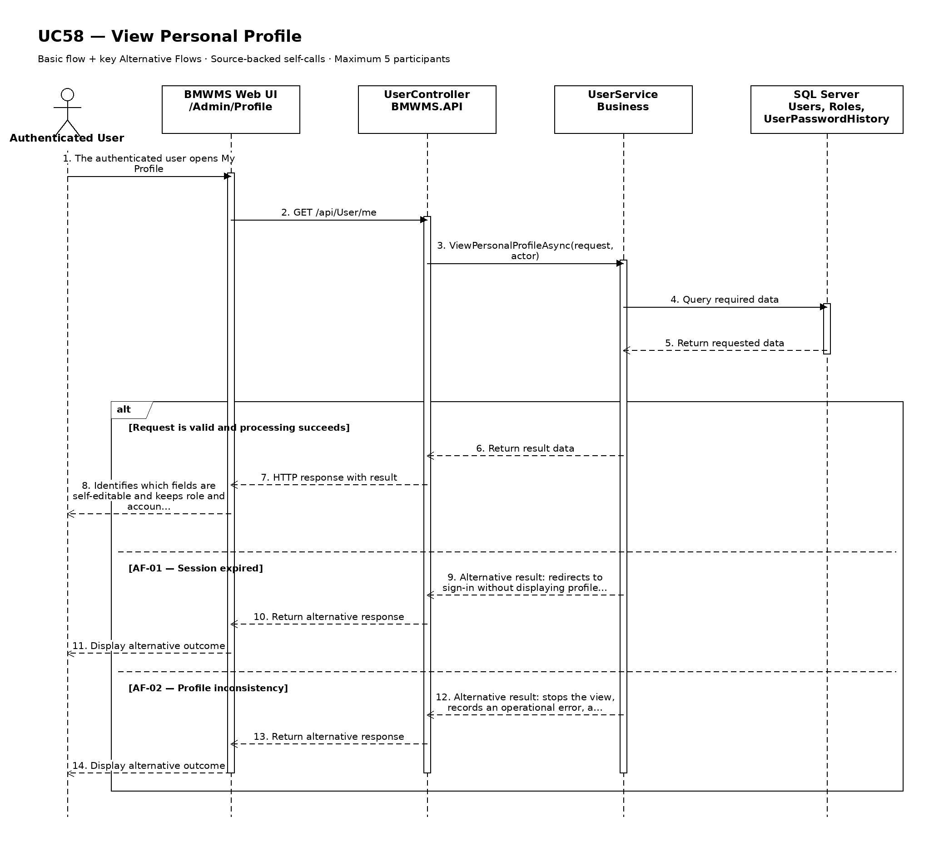

UC59: Update Personal Profile
Goal: Allows an authenticated user to update the profile fields that are permitted for self-service.
Field | Value
Type | UI
Primary Actor | Authenticated User
Secondary Actor(s) | —
Module | M08 - Users and Security
Business Group | Personal Profile
FT-ID Ref | FT-59
Depends On | UC58
Preconditions | An active user is signed in and holds one of the allowed fixed roles. The active session is linked to the user's profile.
Postconditions | Permitted self-service profile fields are updated; protected identity, role, and status fields remain unchanged.

Main Flow
- [U] The user opens My Profile and selects Edit Profile.
- [S] The system displays permitted editable values and protected read-only values.
- [U] The user changes full name, phone number, or other configured self-service fields and submits.
- [S] The system validates field formats, uniqueness where applicable, active session, and current profile version.
- [S] The system saves permitted changes and records the before/after audit summary.
- [S] The system returns to My Profile and confirms the update.

Alternative Flows
- AF-01 - Protected field submitted: The request attempts to change user code, username, fixed role, or account status. The system ignores or rejects the protected change and identifies the field.
- AF-02 - Invalid contact value: Email or phone format is invalid, or an editable email conflicts with another account. The system keeps the form data and identifies the issue.
- AF-03 - Concurrent administrator update: An administrator changed the account after the form opened. The system does not overwrite the newer version and asks the user to review it.

Business Rules
- BR-01: Self-service fields are limited to full name, phone number, and other explicitly configured personal fields.
- BR-02: User code, username, fixed role, account status, and lock state are not self-editable.
- BR-03: A successful update is audited (see PRD GB-20).

Request Fields - PersonalProfileUpdateRequest
Field | Type | Rule
Full name | Text | Required. Between 2 and 150 characters.
Phone number | Text | Optional. Valid phone format; maximum 20 characters.
Email | Text | Editable only when enabled; must be valid, unique, and re-verified when policy requires.

On success: My Profile displays the updated permitted values and unchanged protected values.

Allowed Roles
System Administrator, Warehouse Manager, Warehouse Staff, Purchasing Staff, Sales Staff

Verification Criteria
Given | When | Then
the authenticated user has an unchanged current profile version | the user submits valid changes only to permitted self-service fields | the permitted values are updated, protected fields remain unchanged, and an audit event is recorded

Additional scenarios to cover in tests:
- Update full name.
- Update phone number.
- Submit an invalid phone number.
- Attempt to change fixed role.
- Handle a concurrent administrator update.

Sequence Diagram
Figure UC59. Sequence Diagram - Update Personal Profile
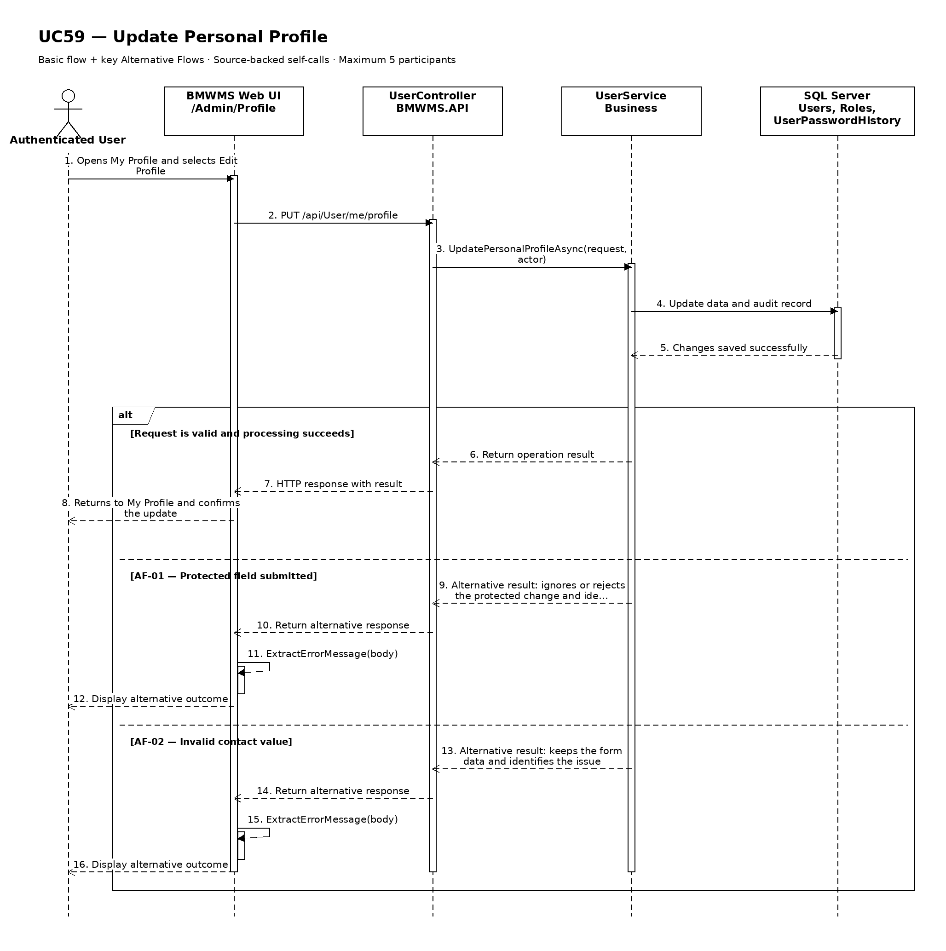

UC60: Change Password
Goal: Allows an authenticated user to change their sign-in password.
Field | Value
Type | UI
Primary Actor | Authenticated User
Secondary Actor(s) | —
Module | M08 - Users and Security
Business Group | Account Security
FT-ID Ref | FT-60
Depends On | —
Preconditions | An active user is signed in and holds one of the allowed fixed roles. The user's account is ACTIVE and the current password can be verified.
Postconditions | The new password is active, prior credential sessions are handled according to policy, and the password-change event is audited.

Main Flow
- [U] The user opens Account Security and selects Change Password.
- [U] The user enters the current password, new password, and confirmation.
- [S] The system verifies the current password and validates the new password policy.
- [S] The system confirms the new password is not equal to the current password and is not prohibited by retained password history.
- [S] The system securely replaces the credential and records the password-change audit event without storing plaintext.
- [S] The system confirms success and keeps or revokes other sessions according to the configured security policy.

Alternative Flows
- AF-01 - Current password incorrect: Verification fails. The system does not change the credential and displays a generic incorrect-current-password message.
- AF-02 - New password fails policy: The password is too short, lacks required character categories, is prohibited, or was recently used. The system identifies the policy conditions without exposing stored passwords.
- AF-03 - Confirmation mismatch: New password and confirmation differ. The system keeps the user on the form and requests correction.
- AF-04 - Session expired: The active session expires before submission. The system requires sign-in again before changing the password.

Business Rules
- BR-01: Current password verification is required for an authenticated password change.
- BR-02: The new password must be at least 12 characters and include uppercase, lowercase, number, and special character.
- BR-03: The new password must differ from the current password and the last five retained password hashes.
- BR-04: Plaintext passwords are never stored or written to logs.
- BR-05: Password changes are audited without credential content.

Request Fields - PasswordChangeRequest
Field | Type | Rule
Current password | Password | Required. Must match the active credential.
New password | Password | Required. At least 12 characters and must satisfy password policy.
Confirm new password | Password | Required. Must exactly match New password.
Sign out other sessions | Yes/No | Optional. Defaults according to security policy.

On success: The user sees a password-changed confirmation; no password value is displayed or logged.

Allowed Roles
System Administrator, Warehouse Manager, Warehouse Staff, Purchasing Staff, Sales Staff

Verification Criteria
Given | When | Then
an ACTIVE user is authenticated and knows the current password | the user submits the correct current password and a valid matching new password | the new credential becomes active, plaintext is never stored, session policy is applied, and an audit event is recorded

Additional scenarios to cover in tests:
- Change to a valid new password.
- Reject an incorrect current password.
- Reject a weak new password.
- Reject reuse of a recent password.
- Reject mismatched confirmation.
- Change password and revoke other sessions.

Sequence Diagram
Figure UC60. Sequence Diagram - Change Password
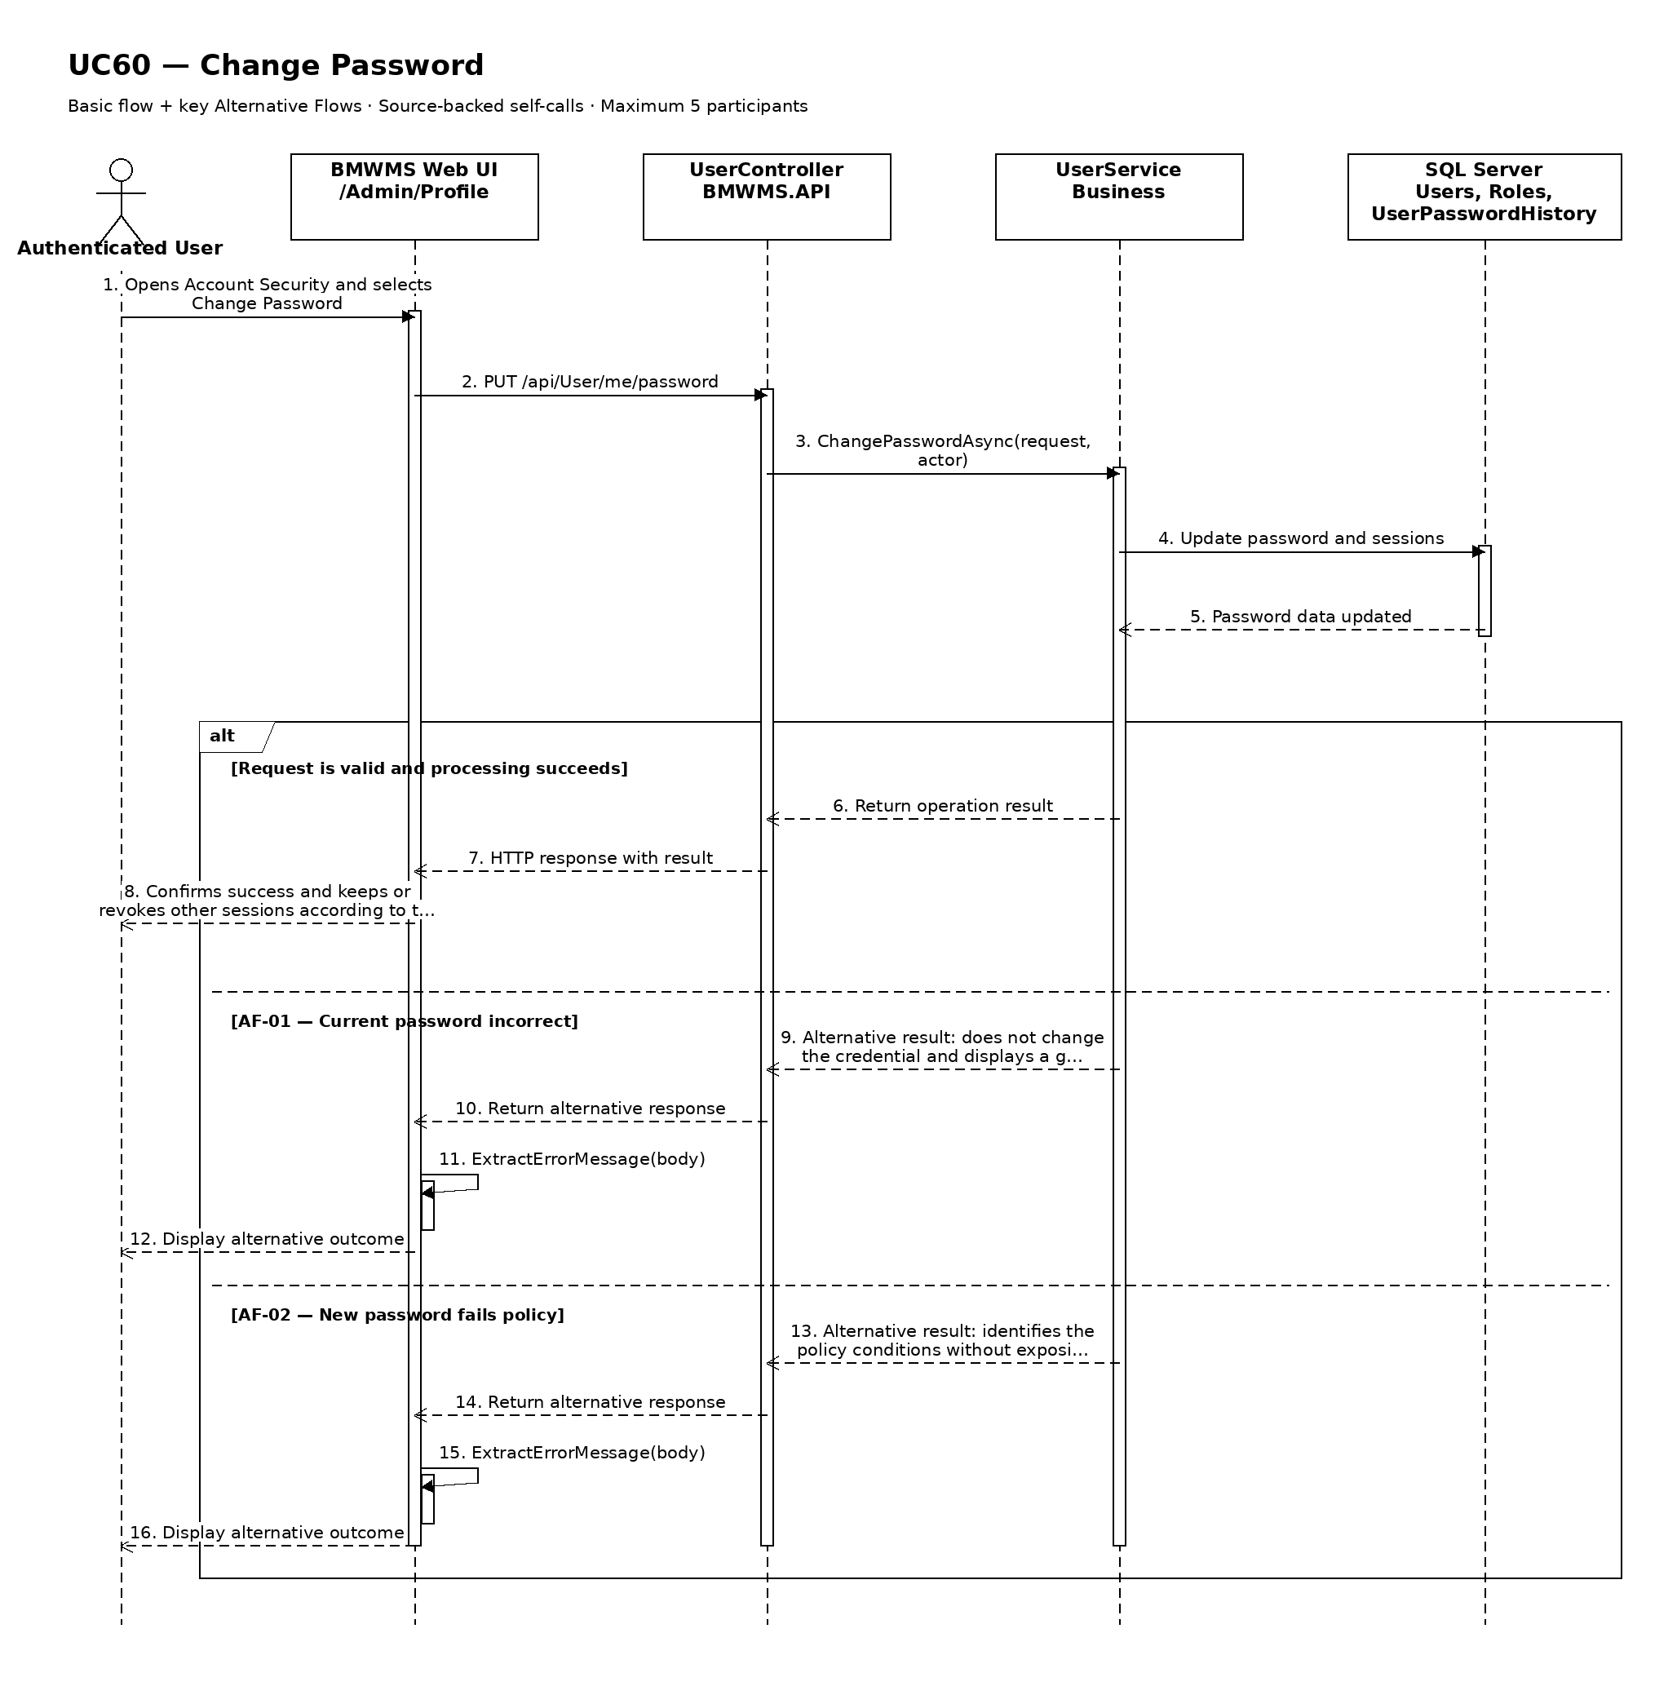

UC61: Sign In
Goal: Allows a registered user to authenticate and access the role-appropriate workspace.
Field | Value
Type | UI
Primary Actor | Registered User
Secondary Actor(s) | —
Module | M08 - Users and Security
Business Group | Authentication
FT-ID Ref | FT-61
Depends On | —
Preconditions | The user has a registered account and is not already authenticated in the current browser session.
Postconditions | On success, an authenticated session exists and the role-appropriate workspace is displayed.

Main Flow
- [U] The user opens the BMWMS Sign In screen.
- [U] The user enters username or email and password, then selects Sign In.
- [S] The system validates the request format and verifies the account and password using a generic failure path.
- [S] The system verifies account status, temporary lock expiry, and the assigned fixed role.
- [S] The system creates an authenticated session, resets the consecutive failed-attempt count, and records the sign-in event.
- [S] The system opens the role-appropriate dashboard or landing page.

Alternative Flows
- AF-01 - Invalid credentials: Username/email or password is incorrect. The system displays a generic failure message, increments the consecutive failed-attempt count, and does not reveal which value failed.
- AF-02 - Account temporarily locked: Five consecutive failures have locked the account. The system denies access and displays a generic message until 15 minutes pass or an administrator unlocks it.
- AF-03 - Account inactive: The account is INACTIVE. The system denies access and instructs the user to contact the administrator without revealing security details.
- AF-04 - Password recovery selected: The user selects Forgot password and the system opens UC63 Reset Forgotten Password.

Business Rules
- BR-01: Authentication failure messages do not reveal whether the username/email or password was incorrect.
- BR-02: Five consecutive failed sign-in attempts change the account to LOCKED for 15 minutes or until UC56 unlocks it (see PRD GB-18).
- BR-03: Only ACTIVE accounts with one active fixed role may receive a session.
- BR-04: Successful and failed sign-in attempts are recorded in security audit history.
- BR-05: Session configuration and credential mechanisms are defined in the TDS; this UCS defines only observable behavior.

Request Fields - SignInRequest
Field | Type | Rule
Username or email | Text | Required. Between 4 and 254 characters.
Password | Password | Required. Not displayed in clear text.
Remember username | Yes/No | Optional. May remember only the identifier, never the password.

On success: The role-appropriate workspace opens and an authenticated session is active.

Allowed Roles
System Administrator, Warehouse Manager, Warehouse Staff, Purchasing Staff, Sales Staff

Verification Criteria
Given | When | Then
a registered account is ACTIVE, not locked, and has one active fixed role | the user submits the correct username/email and password | one authenticated session is created, failed-attempt count resets, the role-appropriate workspace opens, and the success is audited

Additional scenarios to cover in tests:
- Sign in successfully with username.
- Sign in successfully with email.
- Submit an incorrect password.
- Lock the account after five consecutive failures.
- Sign in after the 15-minute lock expires.
- Deny an INACTIVE account.
- Open forgotten-password recovery.

Sequence Diagram
Figure UC61. Sequence Diagram - Sign In
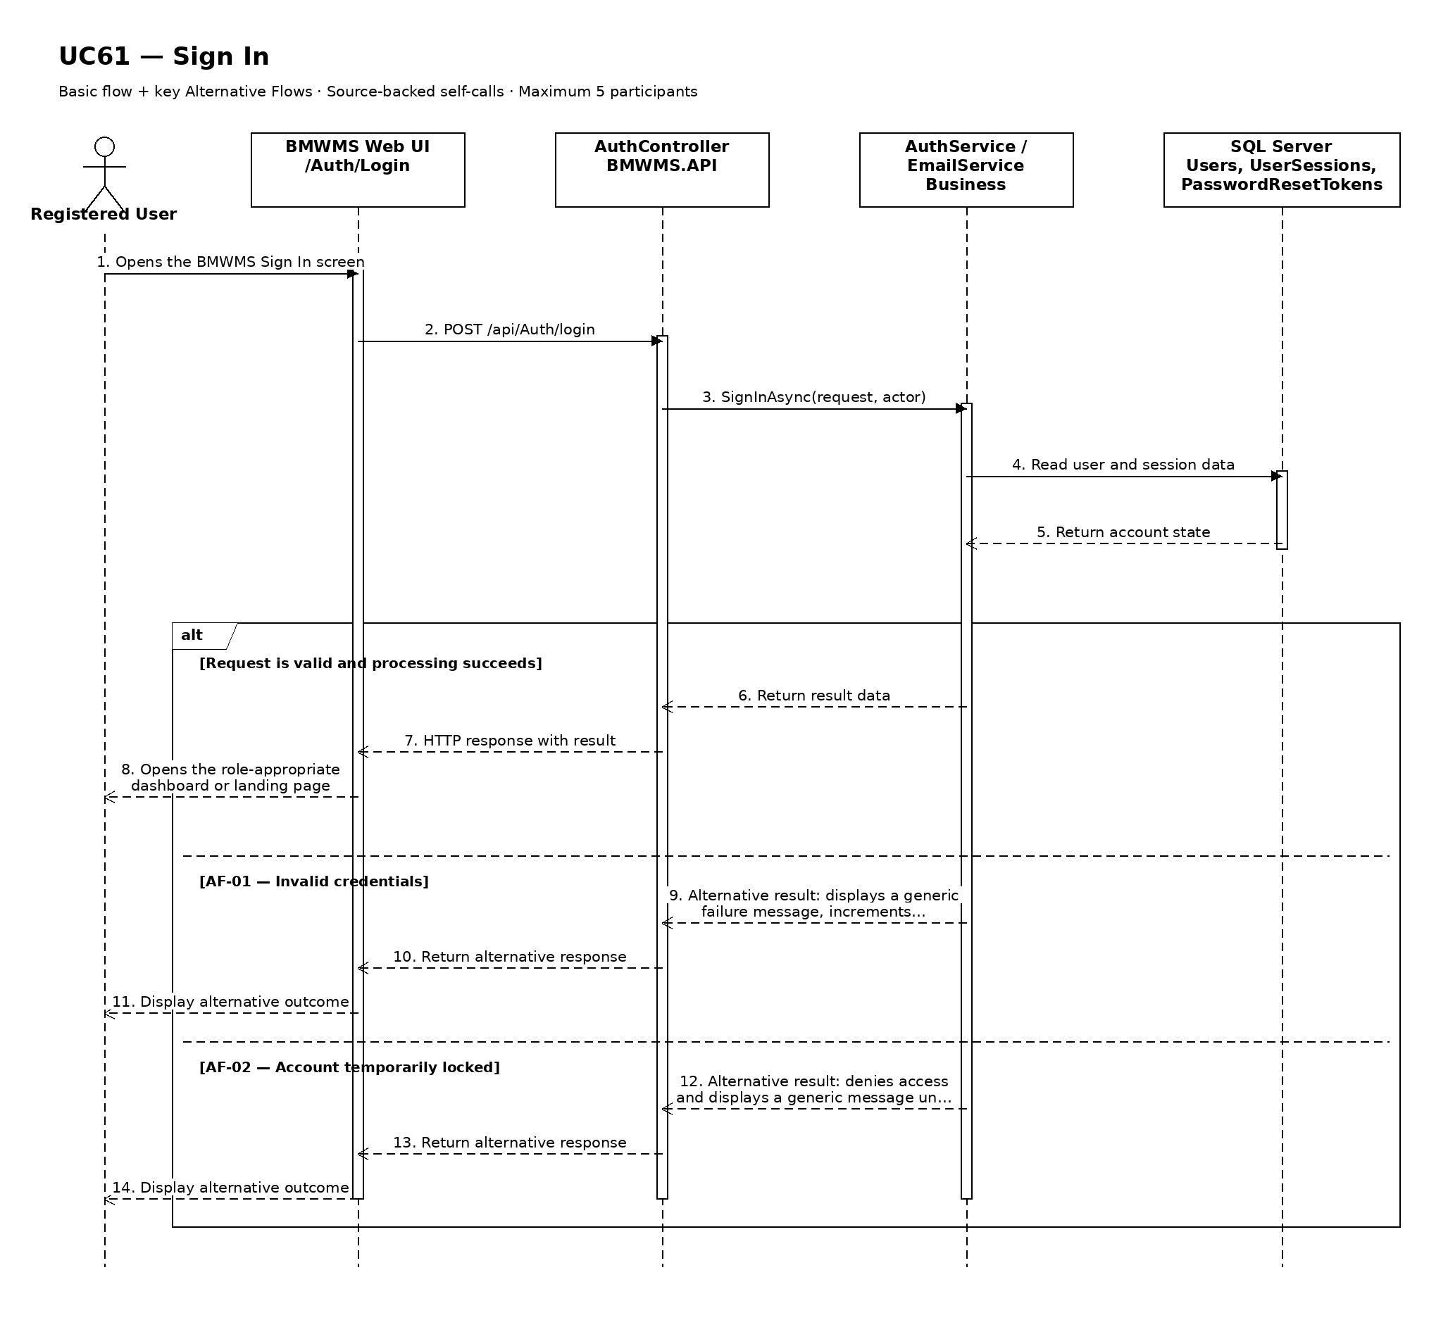

UC62: Sign Out
Goal: Allows an authenticated user to end the active session.
Field | Value
Type | UI
Primary Actor | Authenticated User
Secondary Actor(s) | —
Module | M08 - Users and Security
Business Group | Authentication
FT-ID Ref | FT-62
Depends On | UC61
Preconditions | The user has an active authenticated session.
Postconditions | The current session is invalidated and protected BMWMS pages require authentication again.

Main Flow
- [U] The authenticated user selects Sign Out.
- [S] The system identifies the current authenticated session.
- [S] The system invalidates the session and clears session-bound authorization context.
- [S] The system records the sign-out event.
- [S] The system redirects to the Sign In screen.
- [U] If the user attempts to return to a protected page, the system requires a new sign-in.

Alternative Flows
- AF-01 - Session already expired: The system has no active session to invalidate. It still redirects to Sign In and does not display protected data.
- AF-02 - Multiple sessions: Normal sign-out invalidates only the current session unless the user explicitly selected a security action that revokes all sessions.

Business Rules
- BR-01: Only an authenticated session can be signed out.
- BR-02: After sign-out, browser navigation must not restore protected page content from the application.
- BR-03: Current-session invalidation succeeds even when the session is already expired.

Request Fields - SignOutRequest
Field | Type | Rule
Current session | System selected | Required. Derived from the authenticated browser session.

On success: The Sign In screen is displayed and the prior session cannot access protected resources.

Allowed Roles
System Administrator, Warehouse Manager, Warehouse Staff, Purchasing Staff, Sales Staff

Verification Criteria
Given | When | Then
the user has an active authenticated session | the user selects Sign Out | the current session is invalidated, the Sign In screen opens, and protected pages require authentication

Additional scenarios to cover in tests:
- Sign out from an active session.
- Sign out after session expiry.
- Verify browser Back cannot restore protected application data.
- Sign out one of multiple sessions.

Sequence Diagram
Figure UC62. Sequence Diagram - Sign Out
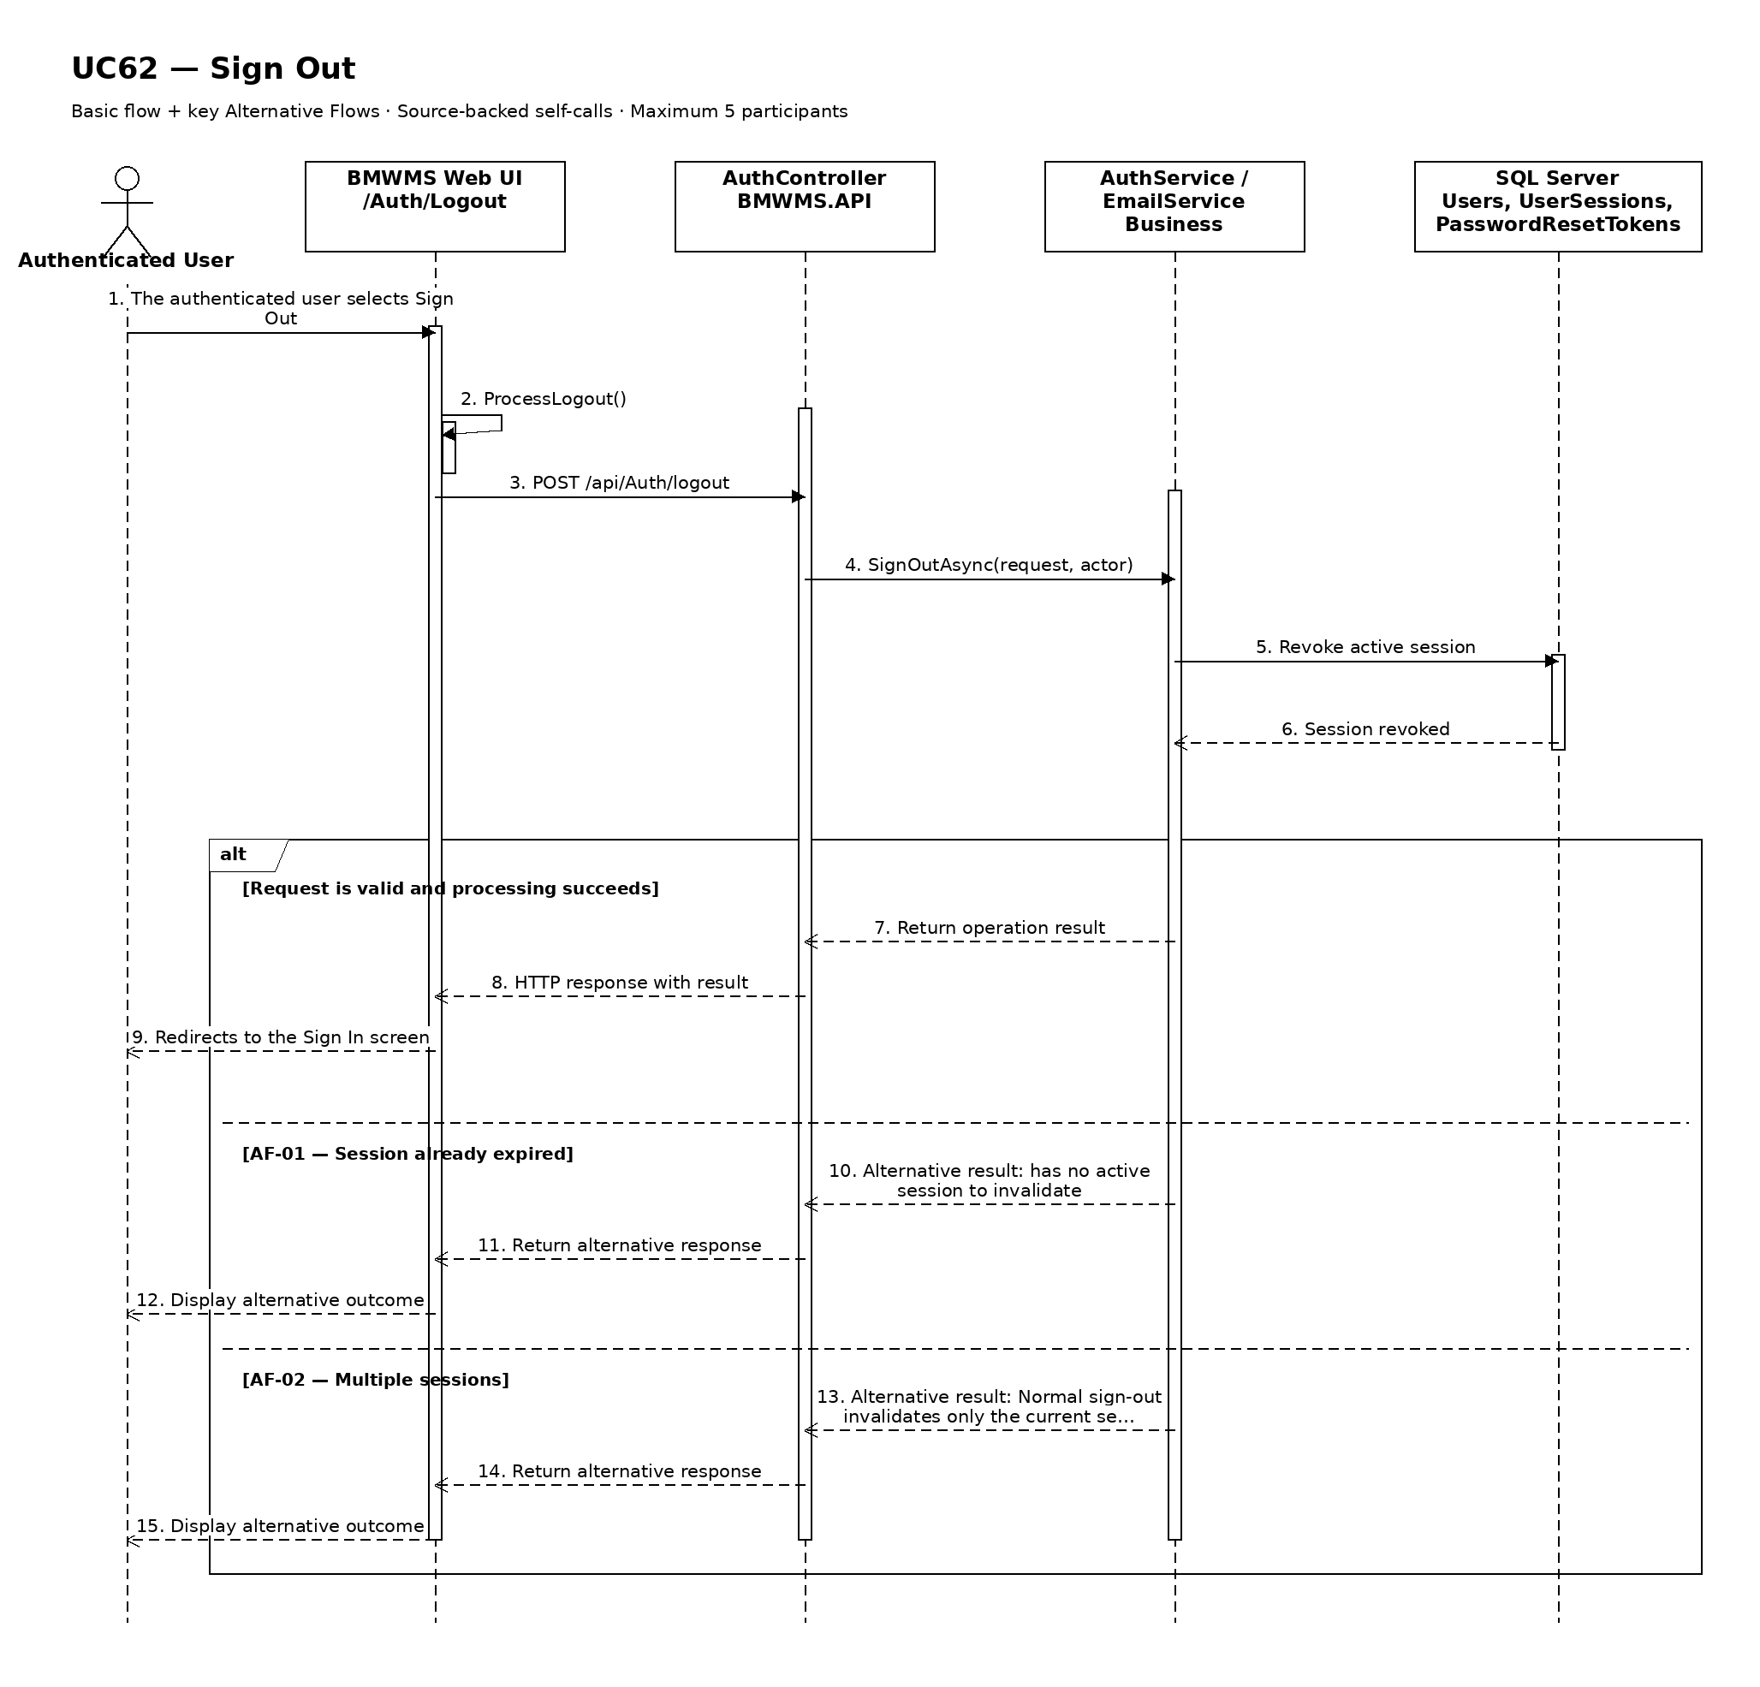

UC63: Reset Forgotten Password
Goal: Allows a registered user to request and complete password recovery.
Field | Value
Type | UI
Primary Actor | Registered User
Secondary Actor(s) | —
Module | M08 - Users and Security
Business Group | Authentication
FT-ID Ref | FT-63
Depends On | —
Preconditions | The user is not required to be signed in and has access to the registered email channel.
Postconditions | On success, the account has a new password, all reset tokens are invalid, and the user can return to Sign In.

Main Flow
- [U] The user opens Forgot Password and enters the registered username or email.
- [S] The system returns the same generic acknowledgement whether or not a matching account is found.
- [S] For an eligible account, the system invalidates prior unused tokens and sends a single-use reset link or code to the registered email.
- [U] The user opens the link or submits the code, then enters and confirms a new password.
- [S] The system validates token identity, single-use state, 15-minute expiry, account eligibility, and password policy.
- [S] The system replaces the credential, invalidates the token and active sessions according to policy, records the event, and directs the user to Sign In.

Alternative Flows
- AF-01 - Unknown username or email: No eligible account matches. The system still displays the generic acknowledgement and sends no message.
- AF-02 - Expired or already used token: The token is invalid. The system does not change the password and offers to start a new reset request.
- AF-03 - New reset requested: A second request is issued. The system invalidates every earlier unused token and sends only the new token.
- AF-04 - Password fails policy or confirmation: The token remains usable until expiry, but the credential is not changed. The system identifies the password-policy or mismatch issue.
- AF-05 - Account inactive: The system keeps the public response generic and does not issue a usable reset token for an INACTIVE account.

Business Rules
- BR-01: Public reset requests always return a generic acknowledgement to prevent account discovery.
- BR-02: Reset links or codes are single-use and expire after 15 minutes; a new token invalidates prior unused tokens (see PRD GB-19).
- BR-03: The new password must satisfy the same policy as UC60 and must not be a prohibited recent password.
- BR-04: Plaintext passwords and reset token values are never written to logs.
- BR-05: Successful and failed reset completion attempts are recorded in security audit history.

Request Fields - ForgottenPasswordResetRequest
Field | Type | Rule
Username or email | Text | Required for reset request. Generic response regardless of match.
Reset code or token | Secret text | Required for completion. Single-use and valid for 15 minutes.
New password | Password | Required. At least 12 characters and must satisfy password policy.
Confirm new password | Password | Required. Must exactly match New password.

On success: The password is reset, the token is invalidated, and the user is directed to Sign In with a generic success message.

Allowed Roles
System Administrator, Warehouse Manager, Warehouse Staff, Purchasing Staff, Sales Staff

Verification Criteria
Given | When | Then
an ACTIVE registered account receives a valid unexpired single-use reset token | the user submits that token with a valid matching new password | the credential is replaced once, all reset tokens are invalidated, security policy is applied, and the user can sign in with the new password

Additional scenarios to cover in tests:
- Request reset for a registered email.
- Request reset for an unknown email and receive the same public response.
- Complete reset with a valid token.
- Reject an expired token.
- Reject a previously used token.
- Invalidate an old token after requesting a new one.
- Reject a weak or mismatched new password.

Sequence Diagram
Figure UC63. Sequence Diagram - Reset Forgotten Password
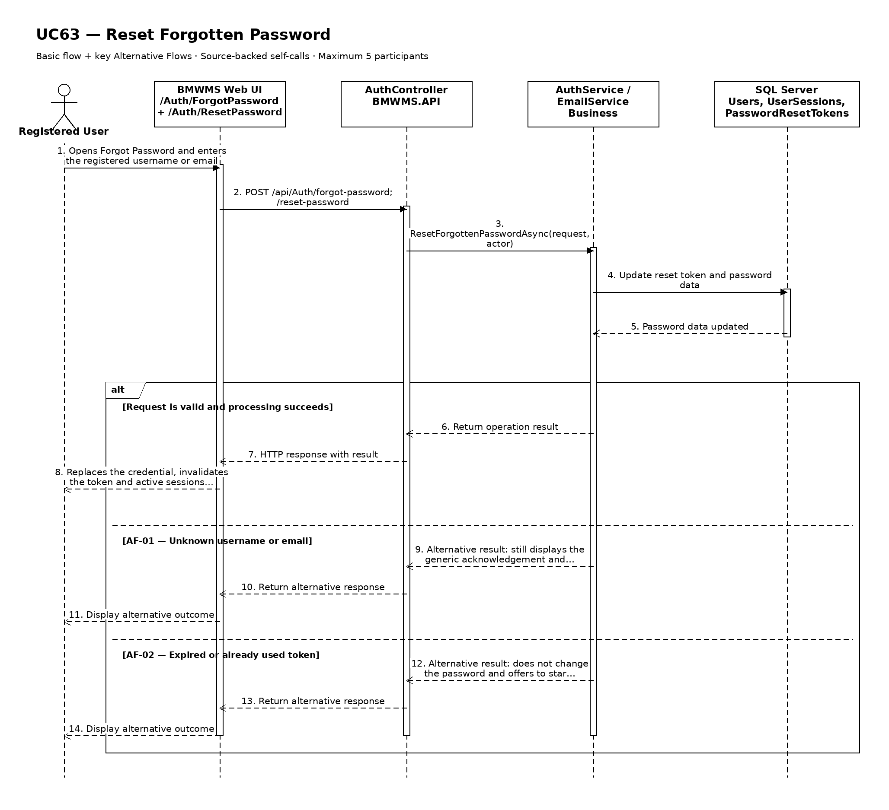

UC64: Create Sale Order
Goal: Allows Sales Staff to create a draft Sales Order for an active customer with one or more product lines.
Field | Value
Type | UI
Primary Actor | Sales Staff
Secondary Actor(s) | -
Module | M05 - Outbound Management
Business Group | Sales Orders
FT-ID Ref | FT-64
Depends On | UC04
Preconditions | The user has an active session with an allowed role; at least one active customer and one active product exist.
Postconditions | On success, a DRAFT Sales Order and its detail lines are stored with audit data; inventory is not reserved until UC30.

Implementation status: Data model / planned. SalesOrder and SalesOrderDetail entities exist, but the dedicated Web/API/Business creation flow is not implemented in the current source.

Main Flow
- [U] The Sales Staff opens Create Sale Order.
- [S] The system loads active customers and active products available for selection.
- [U] The user selects a customer, enters the order date and optional expected issue date, and adds one or more product lines.
- [U] For each line, the user enters a positive ordered quantity and optional unit price and notes.
- [S] The system validates the customer, products, dates, duplicate lines, quantities, and the user's authorization.
- [U] The user submits the order.
- [S] The system generates a unique Sales Order number, saves the order and detail lines in DRAFT status, records the creator and timestamp, and displays the created order.

Alternative Flows
- AF-01 - Required information missing or invalid: The customer, order date, or a required line value is missing or invalid. The system identifies the affected fields and does not create the order.
- AF-02 - Inactive master data: The selected customer or product is INACTIVE. The system rejects the submission and requires an active selection.
- AF-03 - Duplicate product line: The same product appears more than once. The system asks the user to merge the quantities into one line.
- AF-04 - Invalid expected issue date: The expected issue date is earlier than the order date. The system rejects the date and keeps the entered form data.
- AF-05 - Save failure: The order or any detail line cannot be saved. The system rolls back the complete creation operation and displays an error without a partial Sales Order.

Business Rules
- BR-01: The system generates a unique Sales Order number; users cannot edit the generated number.
- BR-02: A Sales Order must reference one ACTIVE customer and contain at least one ACTIVE product line.
- BR-03: Each product may appear only once per Sales Order, and Ordered quantity must be greater than zero.
- BR-04: Expected issue date is optional but cannot be earlier than Order date.
- BR-05: A newly created Sales Order starts in DRAFT status with Reserved quantity and Fulfilled quantity equal to zero.
- BR-06: Creation of the header, all detail lines, and audit data is atomic; pricing approval, payment, and invoicing are outside this use case.

Request Fields - CreateSaleOrderRequest
Field | Type | Rule
Customer | Selection | Required. Must reference an ACTIVE customer.
Order date | Date | Required. Business date on which the Sales Order is created.
Expected issue date | Date | Optional. Must be on or after Order date.
Order lines | Collection | Required. Must contain at least one product line.
Product | Selection | Required per line. Must be ACTIVE and unique within the order.
Ordered quantity | Decimal | Required per line. Must be greater than zero.
Unit price | Decimal | Optional. When supplied, must be zero or greater.
Line notes | Text | Optional. Operational note for one product line.
Order notes | Text | Optional. General operational note for the Sales Order.

On success: The Sales Order is stored once in DRAFT status with all validated detail lines and audit information, then displayed to the user.

Allowed Roles
System Administrator, Warehouse Manager, Sales Staff

Verification Criteria
Given | When | Then
an allowed user, an ACTIVE customer, and at least one ACTIVE product exist | the user submits valid Sales Order data with one or more positive-quantity lines | one DRAFT Sales Order with a unique number, complete detail lines, zero reserved/fulfilled quantities, and creator audit data is saved atomically

Additional scenarios to cover in tests:
- Create a Sales Order with one product line.
- Create a Sales Order with multiple distinct product lines.
- Reject a missing customer or empty order-line collection.
- Reject an INACTIVE customer or product.
- Reject duplicate products and non-positive quantities.
- Verify a save failure creates neither header nor detail records.

Sequence Diagram
Figure UC64. Sequence Diagram - Create Sale Order
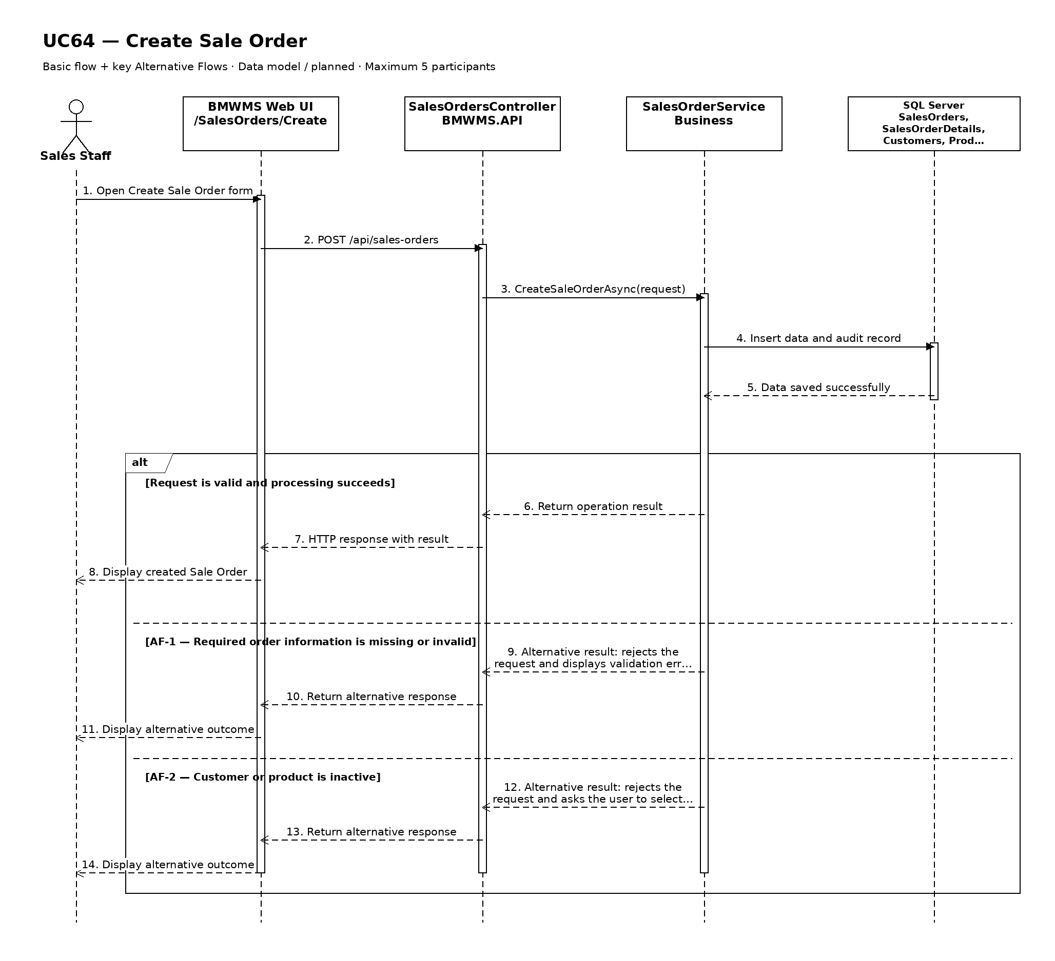

UC65: Create Purchase Order
Goal: Allows Purchasing Staff to create a draft Purchase Order for an active supplier with one or more product lines.
Field | Value
Type | UI
Primary Actor | Purchasing Staff
Secondary Actor(s) | -
Module | M04 - Inbound Management
Business Group | Purchase Orders
FT-ID Ref | FT-65
Depends On | UC04, UC10
Preconditions | The user has an active session with an allowed role; at least one active supplier and one active product exist.
Postconditions | On success, a DRAFT Purchase Order and its detail lines are stored with audit data; no Inbound Order or receipt is created automatically.

Implementation status: Data model / planned. PurchaseOrder and PurchaseOrderDetail entities exist, but the dedicated Web/API/Business creation flow is not implemented in the current source.

Main Flow
- [U] The Purchasing Staff opens Create Purchase Order.
- [S] The system loads active suppliers and active products available for selection.
- [U] The user selects a supplier, enters the order date and optional expected delivery date, and adds one or more product lines.
- [U] For each line, the user enters a positive ordered quantity and optional unit price and notes.
- [S] The system validates the supplier, products, dates, duplicate lines, quantities, and the user's authorization.
- [U] The user submits the order.
- [S] The system generates a unique Purchase Order number, saves the order and detail lines in DRAFT status, records the creator and timestamp, and displays the created order.

Alternative Flows
- AF-01 - Required information missing or invalid: The supplier, order date, or a required line value is missing or invalid. The system identifies the affected fields and does not create the order.
- AF-02 - Inactive master data: The selected supplier or product is INACTIVE. The system rejects the submission and requires an active selection.
- AF-03 - Duplicate product line: The same product appears more than once. The system asks the user to merge the quantities into one line.
- AF-04 - Invalid expected delivery date: The expected delivery date is earlier than the order date. The system rejects the date and keeps the entered form data.
- AF-05 - Save failure: The order or any detail line cannot be saved. The system rolls back the complete creation operation and displays an error without a partial Purchase Order.

Business Rules
- BR-01: The system generates a unique Purchase Order number; users cannot edit the generated number.
- BR-02: A Purchase Order must reference one ACTIVE supplier and contain at least one ACTIVE product line.
- BR-03: Each product may appear only once per Purchase Order, and Ordered quantity must be greater than zero.
- BR-04: Expected delivery date is optional but cannot be earlier than Order date.
- BR-05: A newly created Purchase Order starts in DRAFT status and has no confirmed user or confirmed timestamp.
- BR-06: Creation of the header, all detail lines, and audit data is atomic; commercial approval, payment, and invoicing are outside this use case.

Request Fields - CreatePurchaseOrderRequest
Field | Type | Rule
Supplier | Selection | Required. Must reference an ACTIVE supplier.
Order date | Date | Required. Business date on which the Purchase Order is created.
Expected delivery date | Date | Optional. Must be on or after Order date.
Order lines | Collection | Required. Must contain at least one product line.
Product | Selection | Required per line. Must be ACTIVE and unique within the order.
Ordered quantity | Decimal | Required per line. Must be greater than zero.
Unit price | Decimal | Optional. When supplied, must be zero or greater.
Line notes | Text | Optional. Operational note for one product line.
Order notes | Text | Optional. General operational note for the Purchase Order.

On success: The Purchase Order is stored once in DRAFT status with all validated detail lines and audit information, then displayed to the user.

Allowed Roles
System Administrator, Warehouse Manager, Purchasing Staff

Verification Criteria
Given | When | Then
an allowed user, an ACTIVE supplier, and at least one ACTIVE product exist | the user submits valid Purchase Order data with one or more positive-quantity lines | one DRAFT Purchase Order with a unique number, complete detail lines, no confirmation data, and creator audit data is saved atomically

Additional scenarios to cover in tests:
- Create a Purchase Order with one product line.
- Create a Purchase Order with multiple distinct product lines.
- Reject a missing supplier or empty order-line collection.
- Reject an INACTIVE supplier or product.
- Reject duplicate products and non-positive quantities.
- Verify a save failure creates neither header nor detail records.

Sequence Diagram
Figure UC65. Sequence Diagram - Create Purchase Order
